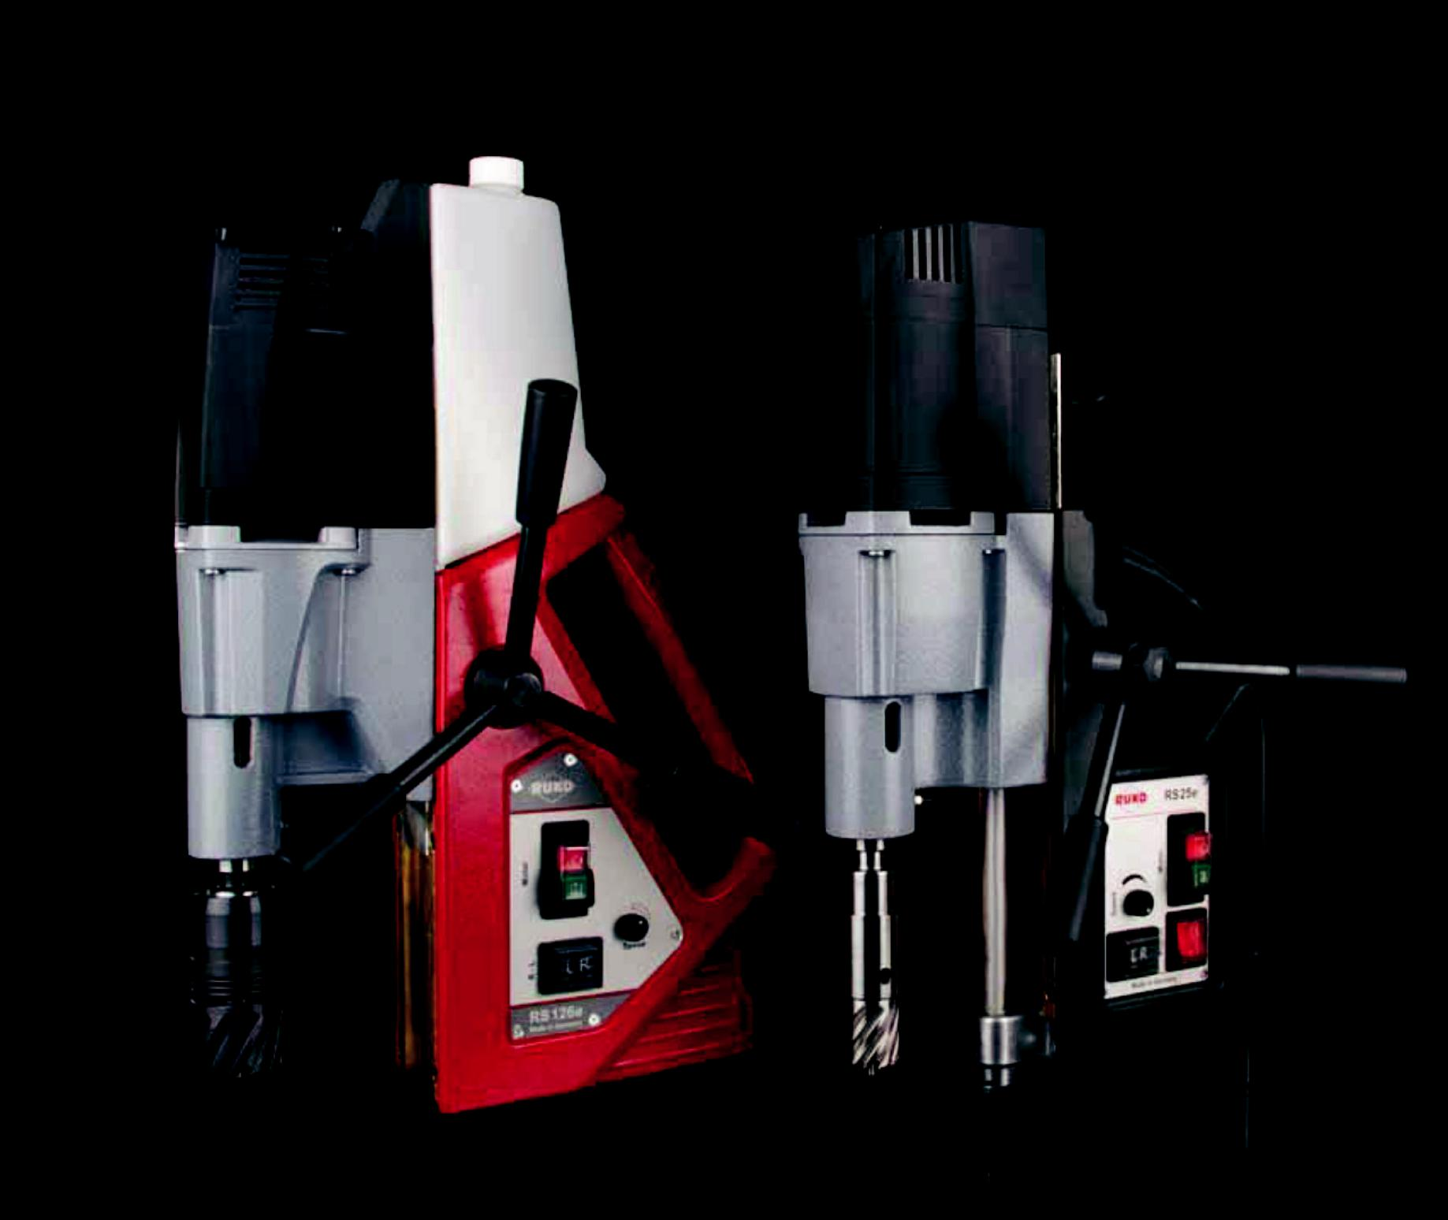

Core drilling teChnology catalogue

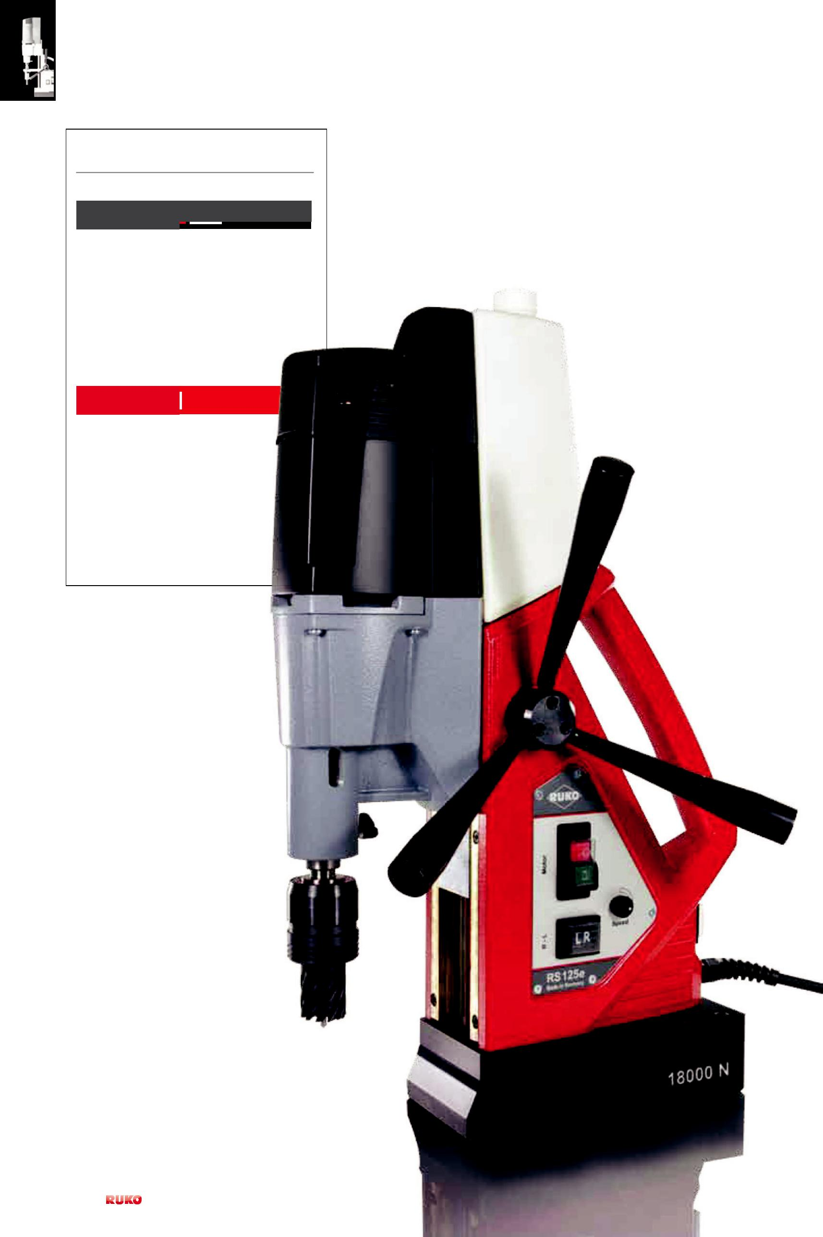

rUKo Core drilling machines

PreMiUMline

• RS125e

• RS126e

• RS140e

• RSH1300
BASiCline RS125e

- RS5e

- RS10

- RS25e

- RS40e

- A10

2 | PreCiSion toolS

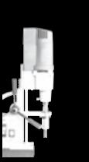
overview of symbols

HSS
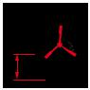
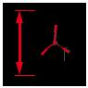

HSSE

Co 5

TC

Magnetic |  |  |  |  |  |  |  |  |  | mm
clamping force |  |  |  |  | length and width |  |  | drill chuck |  |  | Cutting depth core drills
total Power
 |  | +/- 5,0 mm |  |  | turn field |  |  | twist drills
consumption |  |  |  |  |  |  |  |  |  |  | input voltage
rotation speeds |  | +/- 5,0 mm |  |  | Moveable field |  |  | Core drills |  |  | Conformity with
height |  |  | kg |  | Weight |  |  | Countersinkers
 |  |  |  |  | Adapter |  |  | thread cutting
lift
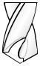

high-speed steel |  | Weldon shank |  | drilling depth |  |  | bright surface
 |  |  |  | e.g. 30,0 mm
high-speed steel
with 5 % Cobalt content,
ground |  | Quick in-adapter |  | right hand cutting |  |  | tiAln coating
tungsten carbide |  |  |  | Ø tolerance:
 |  | threaded retainer |  | work´s specification |  |  | tecrona coating
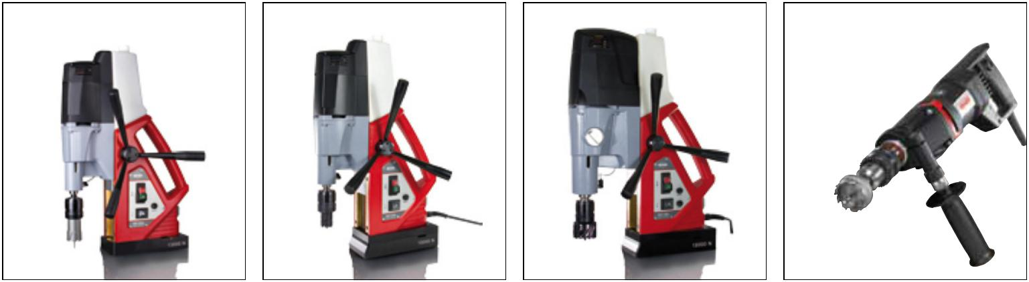

rS126e rS125e rS140e RSH1300
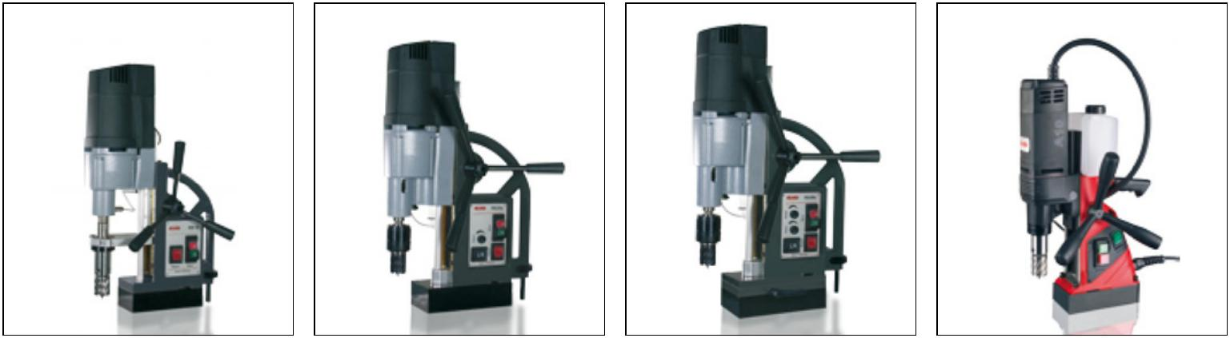

RS10 RS25e RS40e A10

PreCiSion toolS | 3

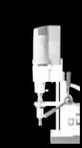
rUKo core drilling machines and their uses
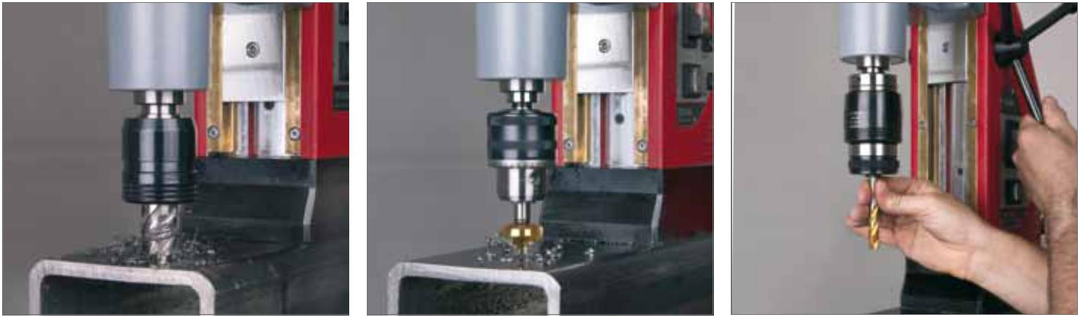

Core drills: Ø 12,0 - 60,0 mm
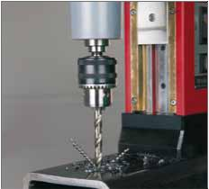

Countersinker: Ø 4,3 - 40,0 mm Countersinker: Ø 19,0 - 50,0 mm with MT 2 or MT 3 shank
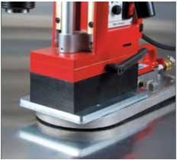

thread cutting:

right-/ left-handed rotation

Reversible for threaded cutters up to M 30.
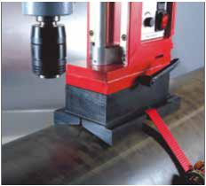

twist drills: | the vacuum clamping plate enables the | the pipe clamping device enables
DIN 338 + DIN 1897: max. Ø 16,0 mm | use of magnetic stand drills on non-magnetic | the use of magnetic stand drills on pipes
DIN 345: max. Ø 31,5 mm | surfaces. | 50,0 to 500,0 mm in diameter.
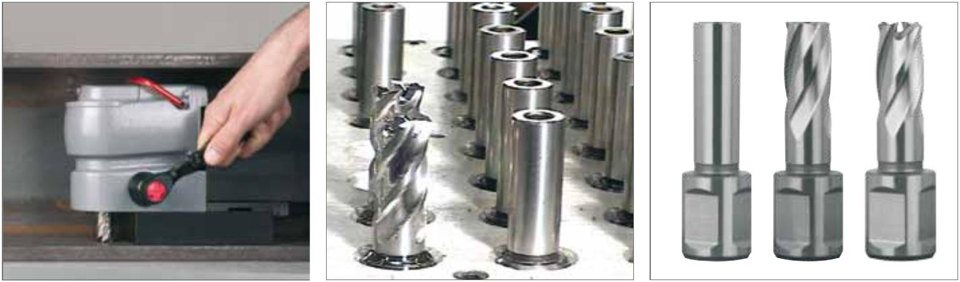

RUKO RS5e angle core drills -

the solution when you run out of space.

it comes into play in the smallest of spaces.

RUKO currently produces 200,000 core drills every year in various qualities including HSS, HSSE Co5 and HM. These are available to the customers with Weldon, Quick-IN and threaded mounting shafts.

4 | PreCiSion toolS

Accessories for magnetic-stand drilling machine RS140e
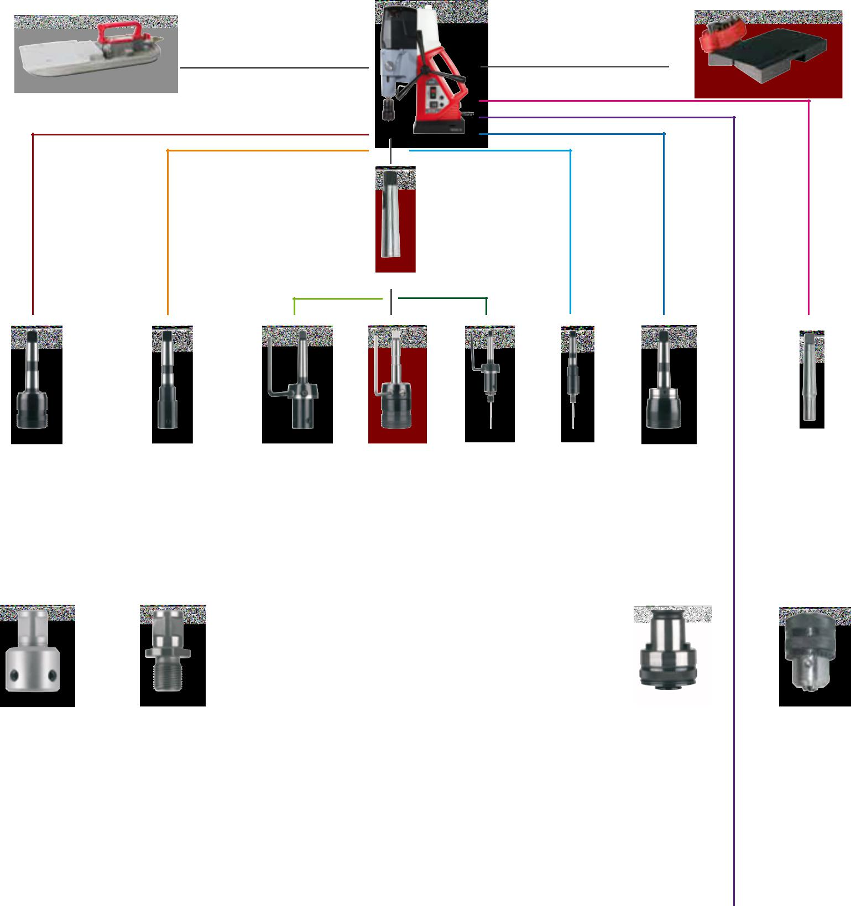

Vacuum plate Art. no. 108 113 Pipe clamping device 500 Art. no. 108 114

Sleeve to reduce MT 3 down to MT 2

Art. no. 108 125

Arbor holder | Arbor holder | Arbor holder | Arbor holder | Arbor holder | Arbor holder | Thread tap quick- | Spike cone
easylock | MT 3 | Mt 2 | easylock | Mt 2 | MT 3 | acting holder MT 3 | MT 3
Art. no. 108 318 | Art. no. 108 316 | Art. no. 108 302 | Art. no. 108 312 | Art. no. 108 102 | Art. no. 108 105 | Art. no. 108 160 | Art. no. 108 121

Adapter |  |  | Adapter |  |  |  |  |  |  |  |  |  | Thread tap quick- |  |  | drill chuck
 |  |  |  |  |  |  |  |  |  |  |  |  | change insert with and
Art. no. 108 126 |  |  | Art. no. 108 108 |  |  |  |  |  |  |  |  |  | without safety coupling |  | Art. no. 108 117

Quick-in Weldon threaded retainer Weldon threaded retainer

PreCiSion toolS | 5

Comparison of technical data

PreMiUMline

0 2 4

1 3 5

L
R

kg

mm

+/- 5,0 mm

+/- 5,0 mm

 | Technical data |  | RSH 1300 |  |  | Page 18 |  |  | RS125e |  | Page 08 |  |  | RS126e |  | Page 09 |  |  | RS140e |  |  | Page 10
 | Article no. |  | 108 1300 RSH |  |  |  |  |  | 108 0125 RS |  |  |  |  | 108 0126 RS |  |  |  | 108 0140 RS
 | Mag. clamping force: |  |  |  |  |  |  |  | 18.000 N |  |  |  |  | 13.000 N |  |  |  | 18.000 N
 | Power consumption: |  | 1.300 Watt |  |  |  |  | 1.200 Watt |  |  |  |  | 1.200 Watt |  |  |  |  | 1.840 Watt
 | gears: |  |  |  |  |  |  | 2 gear |  |  |  |  | 2 gear |  |  |  |  | 4 gear
 | rotation speeds r.p.m.: |  | 0 - 2000 r.p.m. |  |  |  |  | 100-250 / 180-450 r.p.m. |  |  |  |  | 100-250 / 180-450 r.p.m. |  |  |  |  | 40-120 / |  | 70-180 /
 |  |  |  |  |  |  |  |  |  |  |  |  |  |  |  |  |  | 160-450 / 300-700 r.p.m.
 | electrical rotation controller: |  | ✓infinitely variable |  |  |  |  |  | ✓ |  |  |  |  | ✓ |  |  |  |  | ✓
 | Torque controller: |  |  |  |  |  |  |  |  |  |  |  |  |  |  |  |  | ✓
 | right-left-handed rotation: |  | ✓ |  |  |  |  |  | ✓ |  |  |  |  | ✓ |  |  |  |  | ✓
 | height: |  |  |  |  |  |  | 600,0 - 675,0 mm |  |  |  |  |  | 580,0 - 655,0 mm |  |  |  | 600,0 - 680,0 mm
 | Width: |  |  |  |  |  |  | 240 x 108,0 mm |  |  |  |  | 230 x 108,0 mm |  |  |  |  | 240 x 108,0 mm
 | Weight: |  | 3,4 kg |  |  |  |  | 23,0 kg |  |  |  |  | 19,0 kg |  |  |  |  | 26,0 kg
 | lift: |  |  |  |  |  |  | 200,0 mm |  |  |  |  | 200,0 mm |  |  |  |  | 200,0 mm
 | Adapter: |  | flexibel 5/8 x 16 |  |  |  |  | Morse taper Mt 2 |  |  |  |  | Morse taper Mt 2 |  |  |  |  | Morse taper MT 3
 | Core drills: |  | MhS Ø 15,0 - 30,0 mm |  |  |  |  | Ø 12,0 - 60,0 mm |  |  |  |  | Ø 12,0 - 60,0 mm |  |  |  |  | Ø 12,0 - 100,0 mm
 | drill chuck: |  | 3,0 - 16,0 mm |  |  |  |  | 3,0 - 16,0 mm |  |  |  |  | 3,0 - 16,0 mm |  |  |  |  | 3,0 - 16,0 mm
 | Twist drills DIN 338: |  | max. Ø 16,0 mm |  |  |  |  | max. Ø 16,0 mm |  |  |  |  | max. Ø 16,0 mm |  |  |  |  | max. Ø 16,0 mm
 | Twist drills DIN 1897: |  | max. Ø 16,0 mm |  |  |  |  | max. Ø 16,0 mm |  |  |  |  | max. Ø 16,0 mm |  |  |  |  | max. Ø 16,0 mm
 | Twist drills DIN 345: |  |  |  |  |  |  | max. Ø 23,0 mm |  |  |  |  | max. Ø 23,0 mm |  |  |  |  | max. Ø 31,5 mm
 | Cutting depth core drills: |  | MhS up to 20,0 mm |  |  |  |  | up to 110,0 mm |  |  |  |  | up to 110,0 mm |  |  |  |  | up to 110,0 mm
 | input voltage: |  | 220 – 240 V |  |  |  |  | 220 – 240 V |  |  |  |  | 220 – 240 V |  |  |  |  | 220 – 240 V
 | Conformity with: |  | VDE, CEE |  |  |  |  | VDE, CEE |  |  |  |  | VDE, CEE |  |  |  |  | VDE, CEE
 | Moveable field: |  |  |  |  |  |  | +/- 5,0 mm |  |  |  |  |  |  |  |  |  | +/- 5,0 mm
 | Turn field: |  |  |  |  |  |  | +/- 5° |  |  |  |  |  |  |  |  |  | +/- 5°
 | thread cutting: |  | ✓ |  |  |  |  |  | ✓ |  |  |  |  | ✓ |  |  |  |  | ✓
 | Accessoires |  | RSH1300 |  |  |  |  |  | RS125e |  |  |  |  | RS126e |  |  |  |  | RS140e
 |  |  | Plastic tool case |  |  |  |  | Plastic tool case |  |  |  |  | Plastic tool case |  |  |  |  | Plastic tool case
 |  |  |  |  |  |  |  | + trolley |  |  |  |  |  |  |  |  |  | + trolley
 |  |  |  |  |  |  |  | drill drift |  |  |  |  | drill drift |  |  |  |  | drill drift
 |  |  |  |  |  |  |  | Safety belt |  |  |  |  | Safety belt |  |  |  |  | Safety belt
 |  |  | Drill chuck, Art. no. 108 100 |  |  |  |  | Drill chuck, Art. no. 108 117 |  |  |  |  | Drill chuck, Art. no. 108 117 |  |  |  |  | Drill chuck, Art. no. 108 117
 |  |  | P16M - 5/8" x 16 |  |  |  |  | 3,0 - 16,0 mm |  |  |  |  | 3,0 - 16,0 mm |  |  |  |  | 3,0 - 16,0 mm
 |  |  | 1 Cutting spray 200 ml |  |  |  |  | Coolant bottle |  |  |  |  | Coolant bottle |  |  |  |  | Coolant bottle
 |  |  | Art. no. 101 025 |  |  |  |  | + sprayer |  |  |  |  | + sprayer |  |  |  |  | + sprayer
 |  |  |  |  |  |  |  | Protective work gloves |  |  |  |  | Protective work gloves |  |  |  |  | Protective work gloves
 |  |  |  |  |  |  |  | Safety goggles |  |  |  |  | Safety goggles |  |  |  |  | Safety goggles
 |  |  |  |  |  |  |  | ear protectors |  |  |  |  | ear protectors |  |  |  |  | ear protectors
 |  |  |  |  |  |  |  | EasyLock, |  |  |  |  | EasyLock, |  |  |  |  | EasyLock,
 |  |  |  |  |  |  |  | Art. no. 108 317 |  |  |  |  | Art. no. 108 317 |  |  |  |  | Art. no. 108 318

6 | PreCiSion toolS

BASiCline

0 2 4

1 3 5

L
R

kg

mm

+/- 5,0 mm

+/- 5,0 mm

 | Technical data |  | RS5e | Page 15 |  | RS10 |  | Page 12 |  |  | RS25e | Page 13 |  |  | RS40e | Page 14 |  |  | A10 |  |  | Page 16
 | Article no. |  | 108 006 RS |  |  |  | 108 001 RS |  |  | 108 005 RS |  |  |  | 108 004 RS |  |  |  |  | 108 010 A
 | Mag. clamping force: |  | 10.000 N |  |  |  | 10.000 N |  |  | 13.000 N |  |  |  |  | 13.000 N |  |  |  | 10.000 N
 | Power consumption: |  | 1.200 Watt |  |  | 1.120 Watt |  |  |  | 1.200 Watt |  |  |  |  | 1.840 Watt |  |  |  | 1.100 Watt
 | gears: |  | 1 gear |  |  | 1 gear |  |  |  | 2 gear |  |  |  |  | 2 gear |  |  |  | 1 gear
 | rotation speeds r.p.m.: |  | 140 - 350 r.p.m. |  |  | 450 r.p.m. |  |  |  | 100-250 / |  |  |  | 60-140 / |  |  |  | 700 |  | r.p.m.
 |  |  |  |  |  |  |  |  |  | 180-450 r.p.m. |  |  |  |  | 200-470 r.p.m.
 | electrical rotation controller: |  | ✓ |  |  |  |  |  |  | ✓ |  |  |  | ✓
 | Torque controller: |  |  |  |  |  |  |  |  |  |  |  |  | ✓
 | right-left-handed rotation: |  |  |  |  |  |  |  |  | ✓ |  |  |  | ✓
 | height: |  | 182,0 mm |  |  | 413,0 - 548,0 mm |  |  |  | 408,0 - 598,0 mm |  |  |  |  | 450,0 - 640,0 mm |  |  |  | 400,0 - 580,0 mm
 | Width: |  | 160,0 x 80,0 mm |  |  | 160,0 x 80,0 mm |  |  |  | 190,0 x 90,0 mm |  |  |  |  | 190,0 x 90,0 mm |  |  |  | 160,0 x 80,0 mm
 | Weight: |  | 11,0 kg |  |  | 13,0 kg |  |  |  | 18,0 kg |  |  |  |  | 24,0 kg |  |  |  | 10,5 kg
 | lift: |  | 38,0 mm |  |  | 135,0 mm |  |  |  | 190,0 mm |  |  |  |  | 190,0 mm |  |  |  | 120,0 / 195,0 mm
 | Adapter: |  | Weldon 19,0 mm |  |  | Weldon 19,0 mm |  |  |  | Morse taper Mt 2 |  |  |  |  | Morse taper Mt 3 |  |  |  | Weldon 19,0 mm
 | Core drills: |  | Ø 12,0 - 35,0 mm |  |  | Ø 12,0 - 35,0 mm |  |  |  | Ø 12,0 - 60,0 mm |  |  |  |  | Ø 12,0 - 100,0 mm |  |  |  | 12,0 - 35,0 mm
 | drill chuck: |  |  |  |  | 1,0 - 13,0 mm |  |  |  | 3,0 - 16,0 mm |  |  |  |  | 3,0 - 16,0 mm |  |  |  | 3,0 - 16,0 mm
 | Twist drills DIN 338: |  |  |  |  | max. Ø 10,0 mm |  |  |  | max. Ø 13,0 mm |  |  |  |  | max. Ø 16,0 mm |  |  |  | max. Ø 13,0 mm
 | Twist drills DIN 1897: |  |  |  |  | max. Ø 13,0 mm |  |  |  | max. Ø 16,0 mm |  |  |  |  | max. Ø 16,0 mm |  |  |  | max. Ø 13,0 mm
 | Twist drills DIN 345: |  |  |  |  |  |  |  |  | max. Ø 20,0 mm |  |  |  |  | max. Ø 31,5 mm
 | Cutting depth core drills: |  | 30,0 mm |  |  | 30,0 mm |  |  |  | 30,0 / 55,0 mm |  |  |  |  | 30,0 / 55,0 mm |  |  |  | 50,0 mm
 | input voltage: |  | 220 – 240 V |  |  | 220 – 240 V |  |  |  | 220 – 240 V |  |  |  |  | 220 – 240 V |  |  |  | 220 – 240 V
 | Conformity with: |  | VDE, CEE |  |  | VDE, CEE |  |  |  | VDE, CEE |  |  |  |  | VDE, CEE |  |  |  | VDE, CEE
 | Moveable field: |  |  |  |  |  |  |  |  |  |  |  |  |  | +/- 7,5 mm
 | Turn field: |  |  |  |  |  |  |  |  |  |  |  |  | +/- 20°
 | thread cutting: |  |  |  |  |  |  |  |  | ✓ |  |  |  | ✓
 | Accessoires |  | RS5e |  |  | RS10 |  |  |  |  | RS25e |  |  |  | RS40e |  |  |  | A10
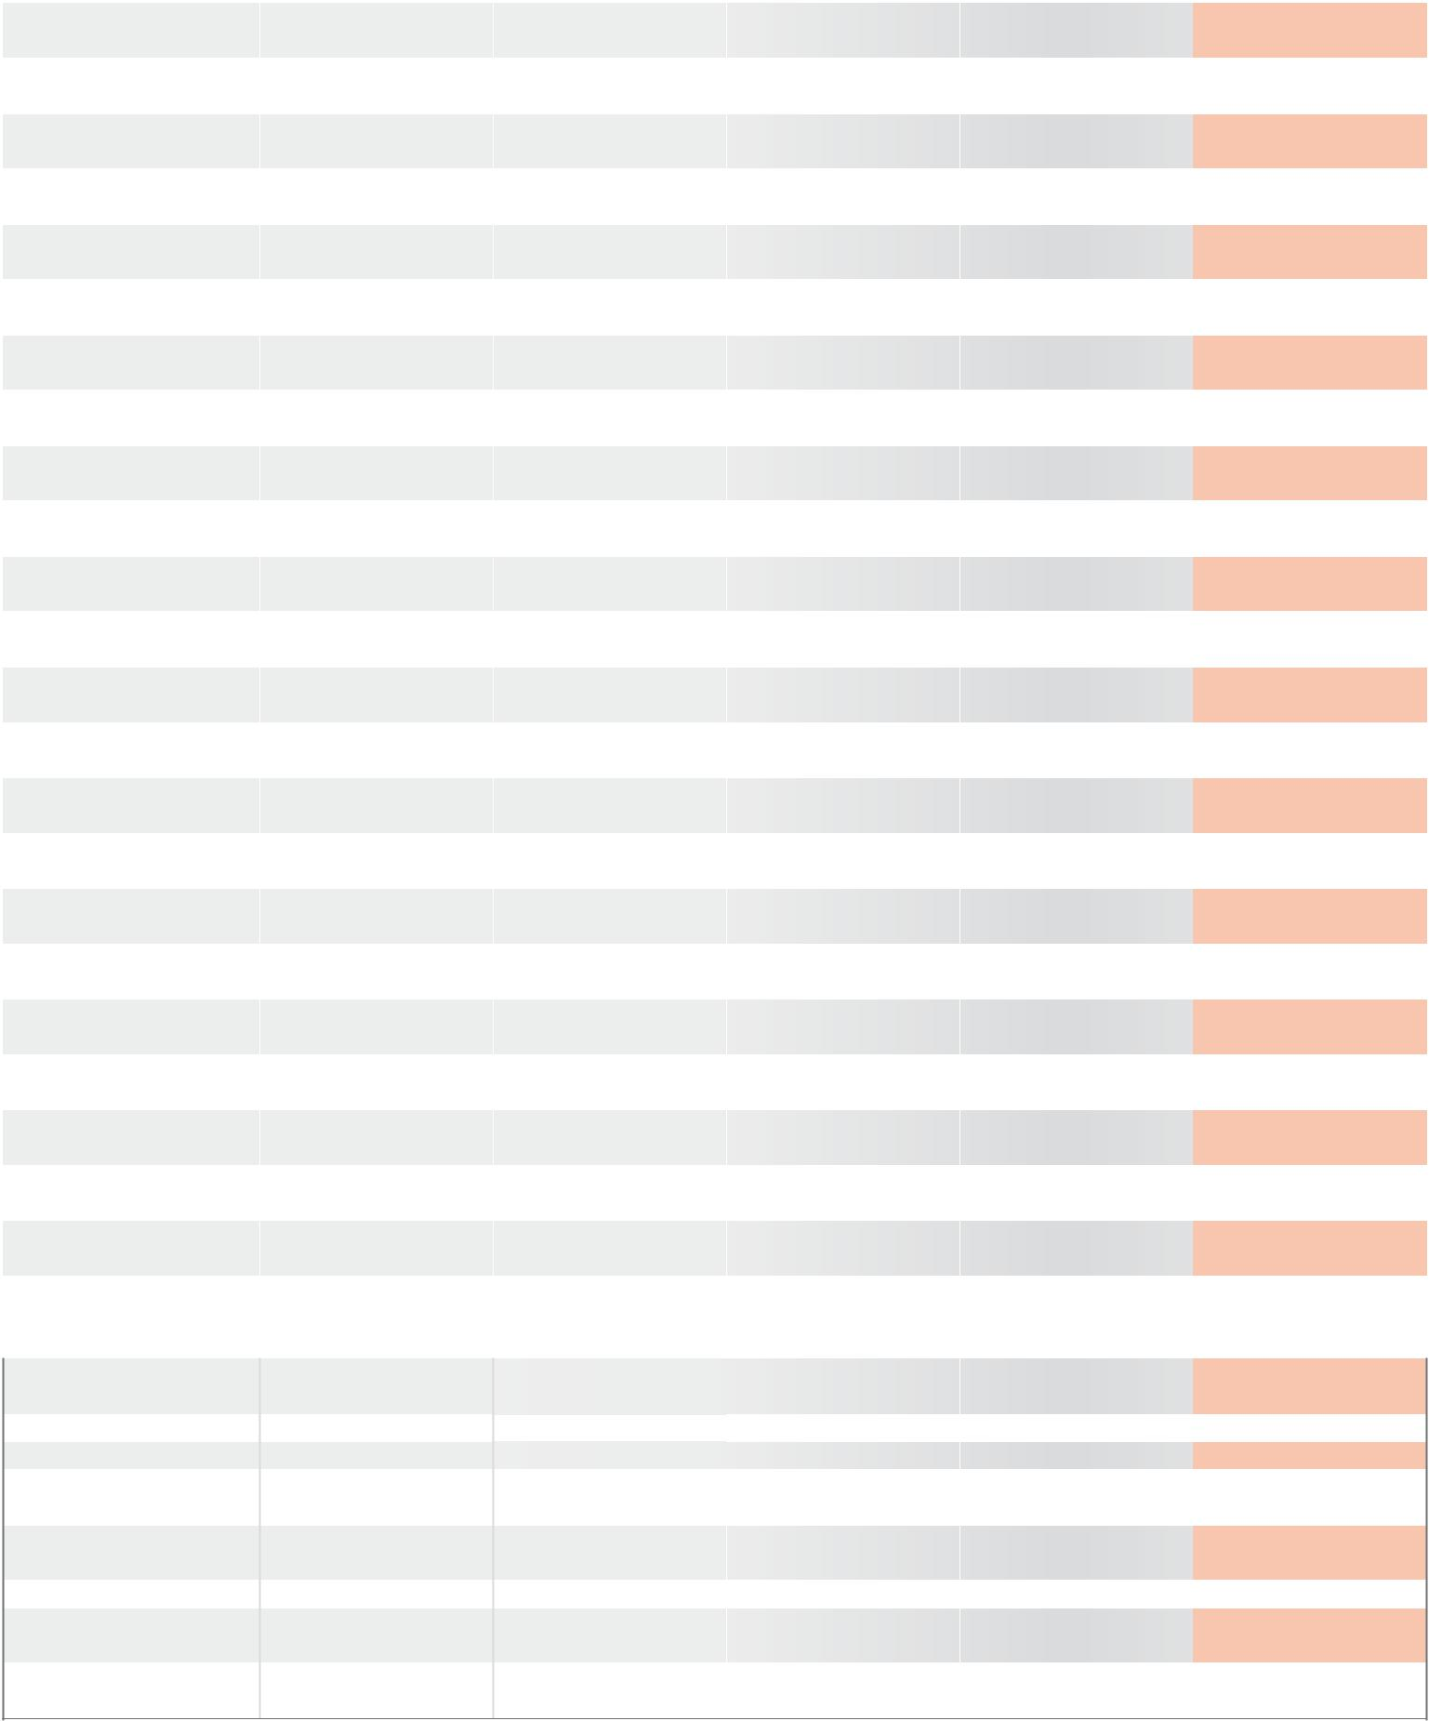

Carrying bag incl.

2 plastic boxes

Allen key

Safety belt

Coolant bottle

+ sprayer

Plastic tool case | Plastic tool case | Plastic tool case | Plastic tool case
Allen key | drill drift | drill drift | 3 Allen key
Safety belt | Safety belt | Safety belt | Safety belt
Drill chuck, No.108 116 | Drill chuck, No.108 117 | Drill chuck, No.108 117
1,0 - 13,0 mm | 3,0 - 16,0 mm | 3,0 - 16,0 mm
Coolant bottle | Coolant bottle | Coolant bottle | Coolant bottle
+ sprayer | + sprayer | + sprayer | + sprayer
drill chuck adapter | Spike cone MT 2 / B16 | Spike cone MT 3 / B16
 | Protective work gloves + | Protective work gloves +
 | Safety goggles | Safety goggles
Arbor holder, | EasyLock, | EasyLock,
Art. no. 108 159 | Art. no. 108 317 | Art. no. 108 318

PreCiSion toolS | 7

RS125e
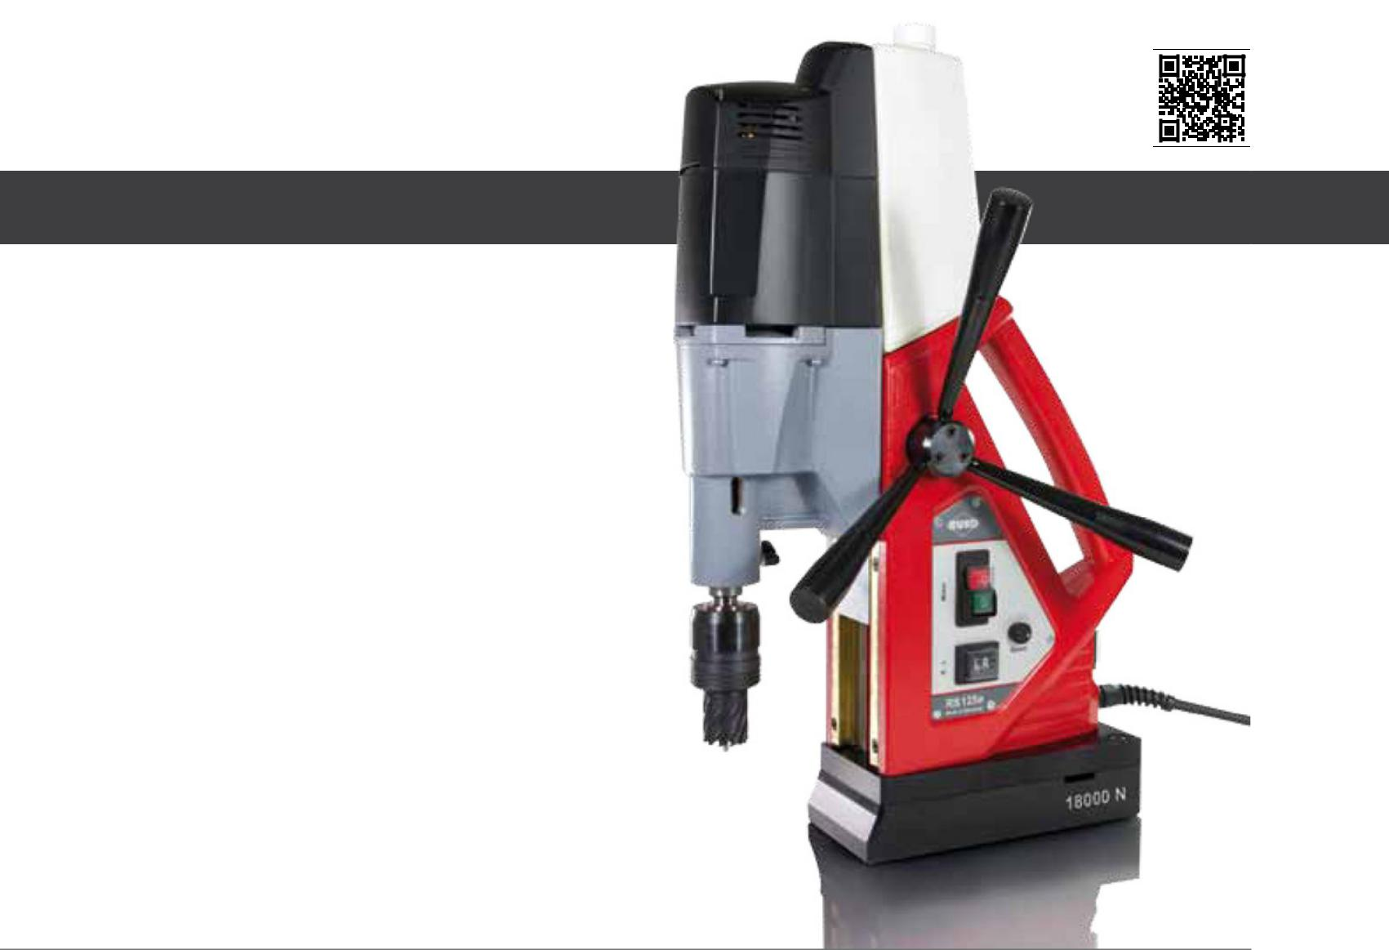

PreMiUMline

- 18.000 N clamping force

- Right-/ left-handed rotation

- Speed controller

- Fine adjustment

- Automatic coolant supply

- High-performance motor

Art. no. 108 0125 RS

Price on request.

Technical data:

Magnetic clamping force: | kg | Weight: |  |  | thread cutting:
18.000 N |  | 23,0 kg |  |  | up to M 20
total Power consumption: |  | Adapter: |  |  | Cutting depth core drills:
 |  |  |  | mm
1.200 Watt |  | Morse taper Mt 2 |  |  | up to 110,0 mm
rotation speeds:
1st gear: 100 - 250 r.p.m. |  | drill chuck: |  |  | input voltage:
2nd gear: 180 - 450 r.p.m. |  | 3,0 - 16,0 mm |  |  | 220 - 240 Volt
height: |  | Core drills: |  |  | Conformity with:
600,0 - 675,0 mm |  | Ø 12,0 - 60,0 mm |  |  | VDE, CEE
 |  | Countersinkers:
lift: |  | Ø 4,3 - 40,0 mm
200,0 mm |  | Countersink with Mt 2 shank
length and width: |  | twist drills:
 |  | DIN 338: max. Ø 16,0 mm
240,0 x 108,0 mm |  | DIN 1897: max. Ø 16,0 mm
 |  | DIN 345: max. Ø 23,0 mm
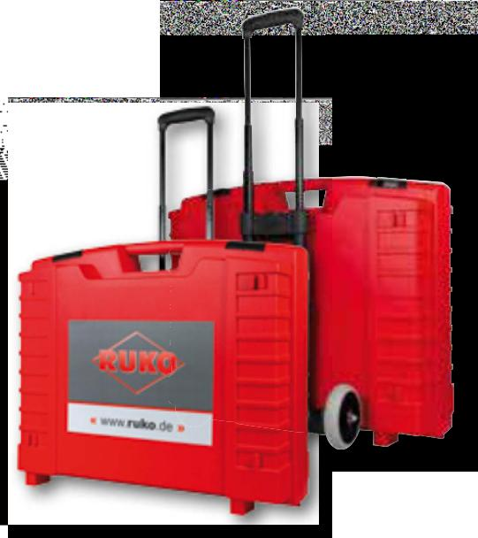
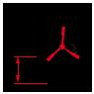
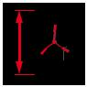
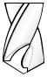

Accessories

1 | Plastic shipping case + trolley | 1 | Safety goggles
1 drill drift |  | 1 | Ear protectors
1 | Safety belt | 1 EasyLock article no. 108317
1 drill chuck Ø 3,0 - 16,0 mm, article no. 108 117 |  | 1 Cuttting paste 30 g article no.101 035
- Coolant bottle + sprayer

- Protective work gloves

8 | PreCiSion toolS

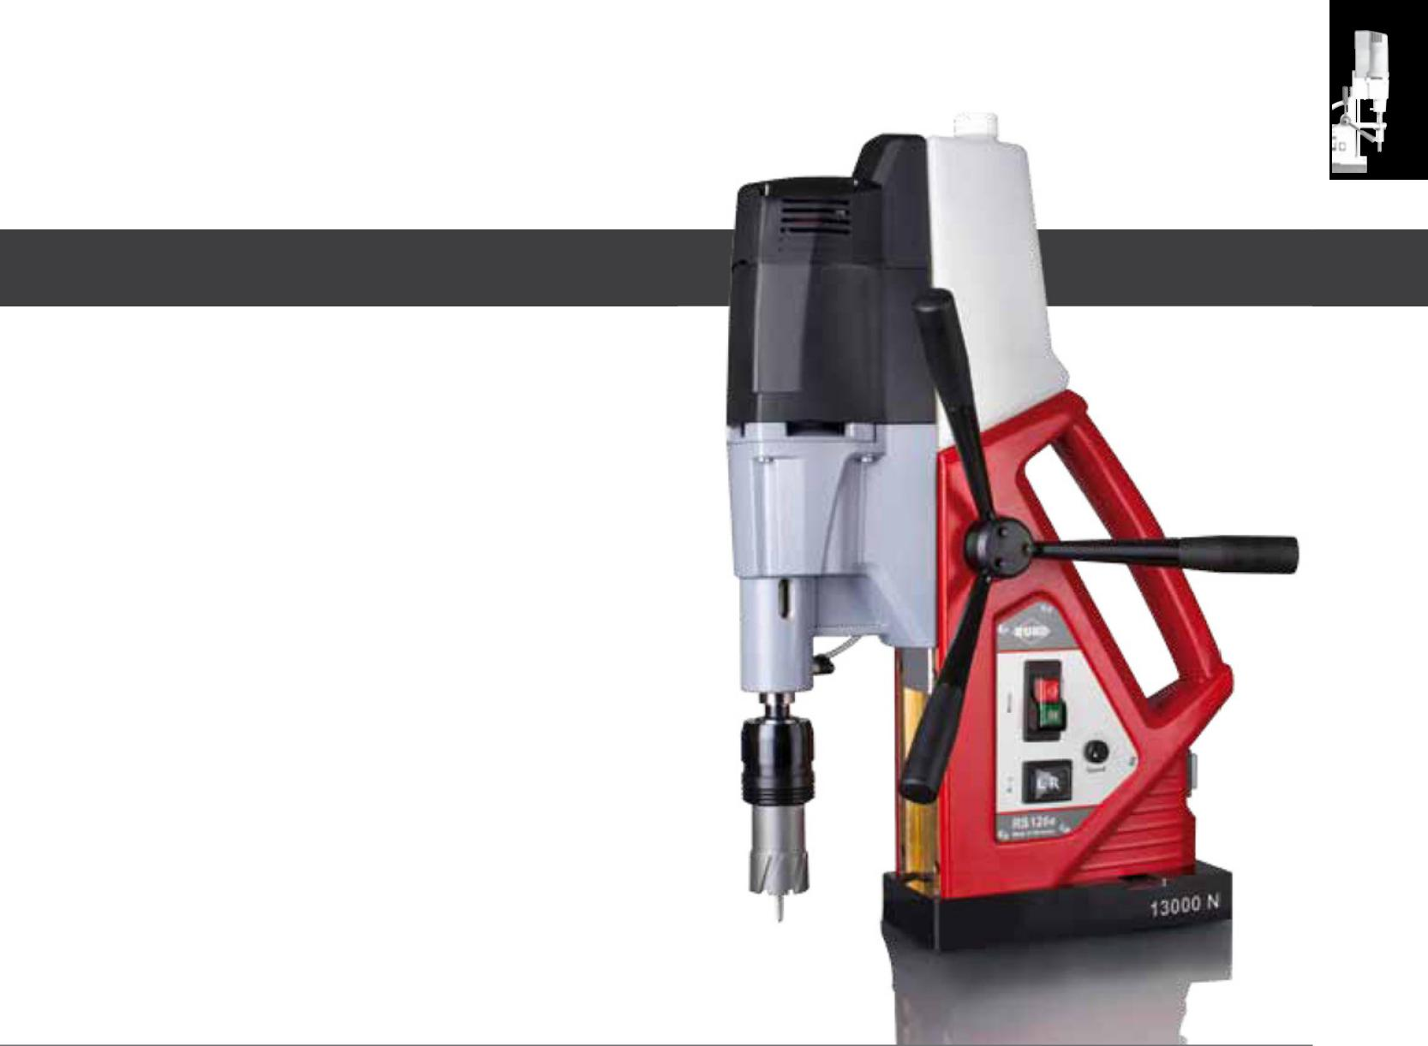
RS126e

PreMiUMline

- Light and handy

- 13.000 N clamping force

- Right-/ left-handed rotation

- 2-speed gearbox

- Speed controller

- Automatic coolant supply

- High-performance motor

Art. no. 108 0126 RS

Price on request.

Technical data:

Magnetic clamping force: | kg | Weight: |  |  | thread cutting:
13.000 N |  | 19,0 kg |  |  | up to M 20
total Power consumption: |  | Adapter: |  |  | Cutting depth core drills:
 |  |  |  | mm
1.200 Watt |  | Morse taper Mt 2 |  |  | up to 110,0 mm
rotation speeds:
1st gear: 100 - 250 r.p.m. |  | drill chuck: |  |  | input voltage:
2nd gear: 180 - 450 r.p.m. |  | 3,0 - 16,0 mm |  |  | 220 - 240 Volt
height: |  | Core drills: |  |  | Conformity with:
580,0 - 655,0 mm |  | Ø 12,0 - 60,0 mm |  |  | VDE, CEE
 |  | Countersinkers:
lift: |  | Ø 4,3 - 40,0 mm
200,0 mm |  | Countersink with Mt 2 shank
length and width: |  | twist drills:
 |  | DIN 338: max. Ø 16,0 mm
230,0 x 108,0 mm |  | DIN 1897: max. Ø 16,0 mm
 |  | DIN 345: max. Ø 23,0 mm
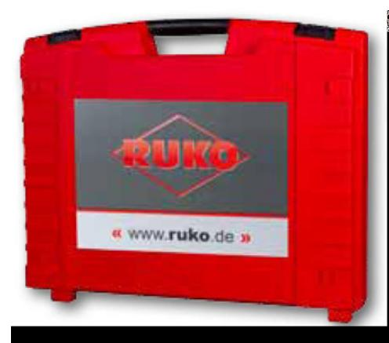
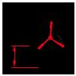
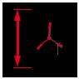
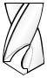

Accessories

1 | Plastic shipping case | 1 | Safety goggles
1 drill drift |  | 1 | Ear protectors
1 | Safety belt | 1 EasyLock article no. 108317
1 drill chuck Ø 3,0 - 16,0 mm, article no. 108 117 |  | 1 Cuttting paste 30 g article no.101 035
- Coolant bottle + sprayer

- Protective work gloves

PreCiSion toolS | 9

RS140e
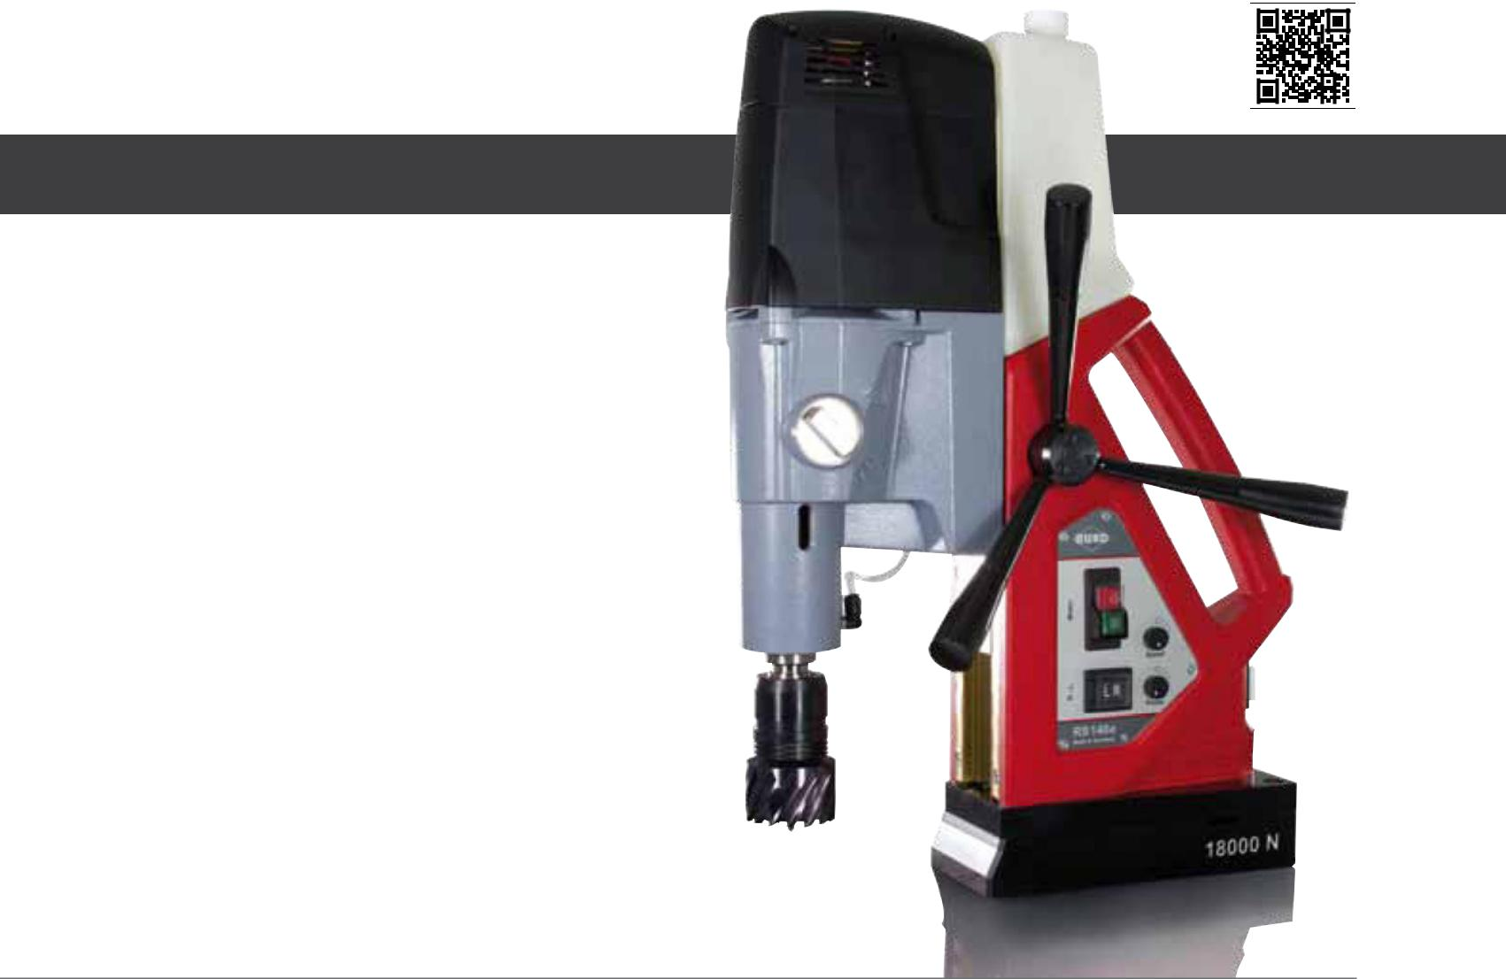

PreMiUMline

- 18.000 N clamping force

- Right-/ left-handed rotation

- 4-speed gearbox

- Speed controller

- Fine adjustment

- Automatic coolant supply

- High-performance motor

Art. no. 108 0140 RS

Price on request.

Technical data:

Magnetic clamping force: | kg | Weight: |  |  | thread cutting:
18.000 N |  | 26,0 kg |  |  | up to M 30
total Power consumption: |  | Adapter: |  |  | Cutting depth core drills:
 |  |  |  | mm
1.840 Watt |  | Morse taper MT 3 |  |  | up to 110,0 mm
rotation speeds: |  |  |  |  | input voltage:
1. gear 100 - 250 /2. gear 180 - 450 |  | drill chuck:
3. gear 160 - 450 / 4. gear 300 - 700 |  | 3,0 - 16,0 mm |  |  | 220 - 240 Volt
height: |  | Core drills: |  |  | Conformity with:
600,0 - 680,0 mm |  | Ø 12,0 - 100,0 mm |  |  | VDE, CEE
 |  | Countersinkers:
lift: |  | Ø 4,3 - 40,0 mm
200,0 mm |  | Countersink with MT 3 shank
length and width: |  | twist drills:
 |  | DIN 338: max. Ø 16,0 mm
240,0 x 108,0 mm |  | DIN 1897: max. Ø 16,0 mm
 |  | DIN 345: max. Ø 23,0 mm
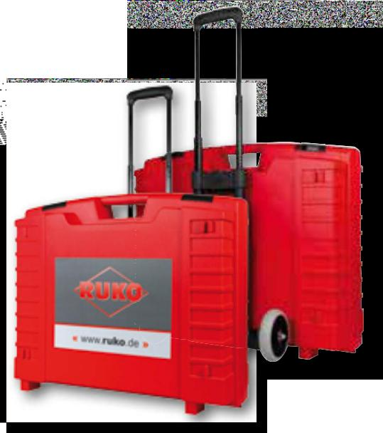

Accessories

1 | Plastic shipping case + trolley | 1 | Safety goggles
1 drill drift |  | 1 | Ear protectors
1 | Safety belt | 1 EasyLock article no. 108 318
1 drill chuck Ø 3,0 - 16,0 mm, article no. 108 117 |  | 1 Cuttting paste 30 g article no.101 035
- Coolant bottle + sprayer

- Protective work gloves

10 | PreCiSion toolS

the rUKo magnetic-stand drilling machines RS125e - RS140e
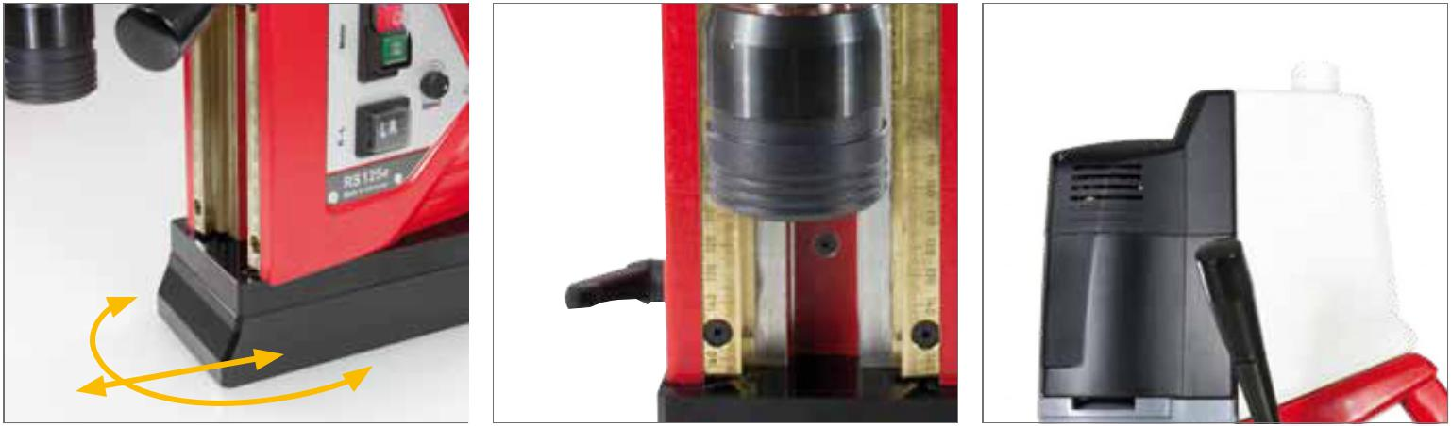

Standard fine adjustment stabilised (rS125e + RS140e)
- Displaceability: ± 5 mm
- Pivoting range: ± 5°
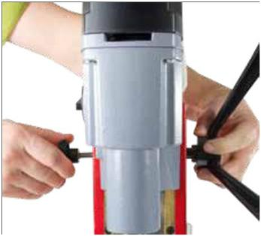

Fast and simple side change of the star grip.
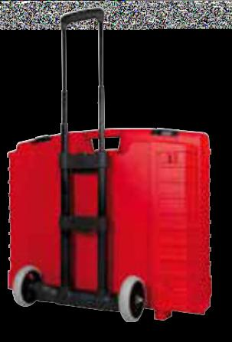

the new rUKo plastic case with trolley enables a safe and easy transport of RS125e + RS140e machines. the trolley can be easily latched to the case and removed again.

The RUKO fine adjustment enables repositio-ning with fixed magnets.
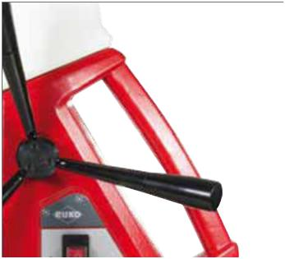

Better handling due to ergonomic carrying handle.

integrated coolant bottle with intelligent coolant supply (filling quantity 750 ml).
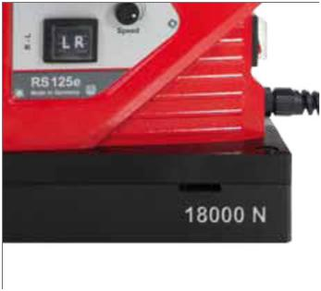

Magnet with 18.000 N clamping force and larger contact surface in models RS125e + RS140e.
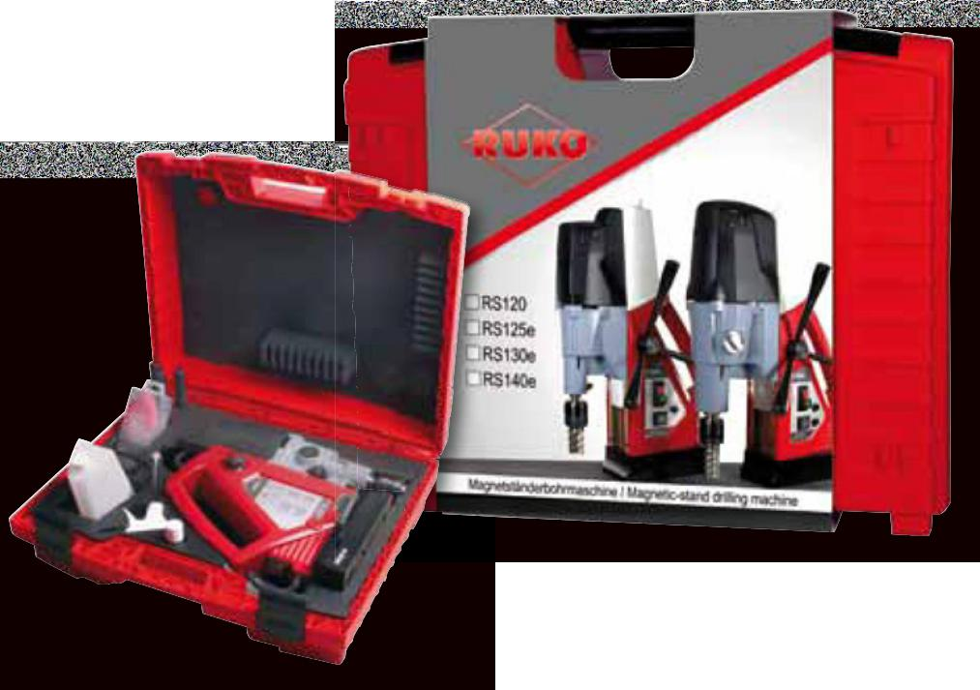

PreCiSion toolS | 11

RS10
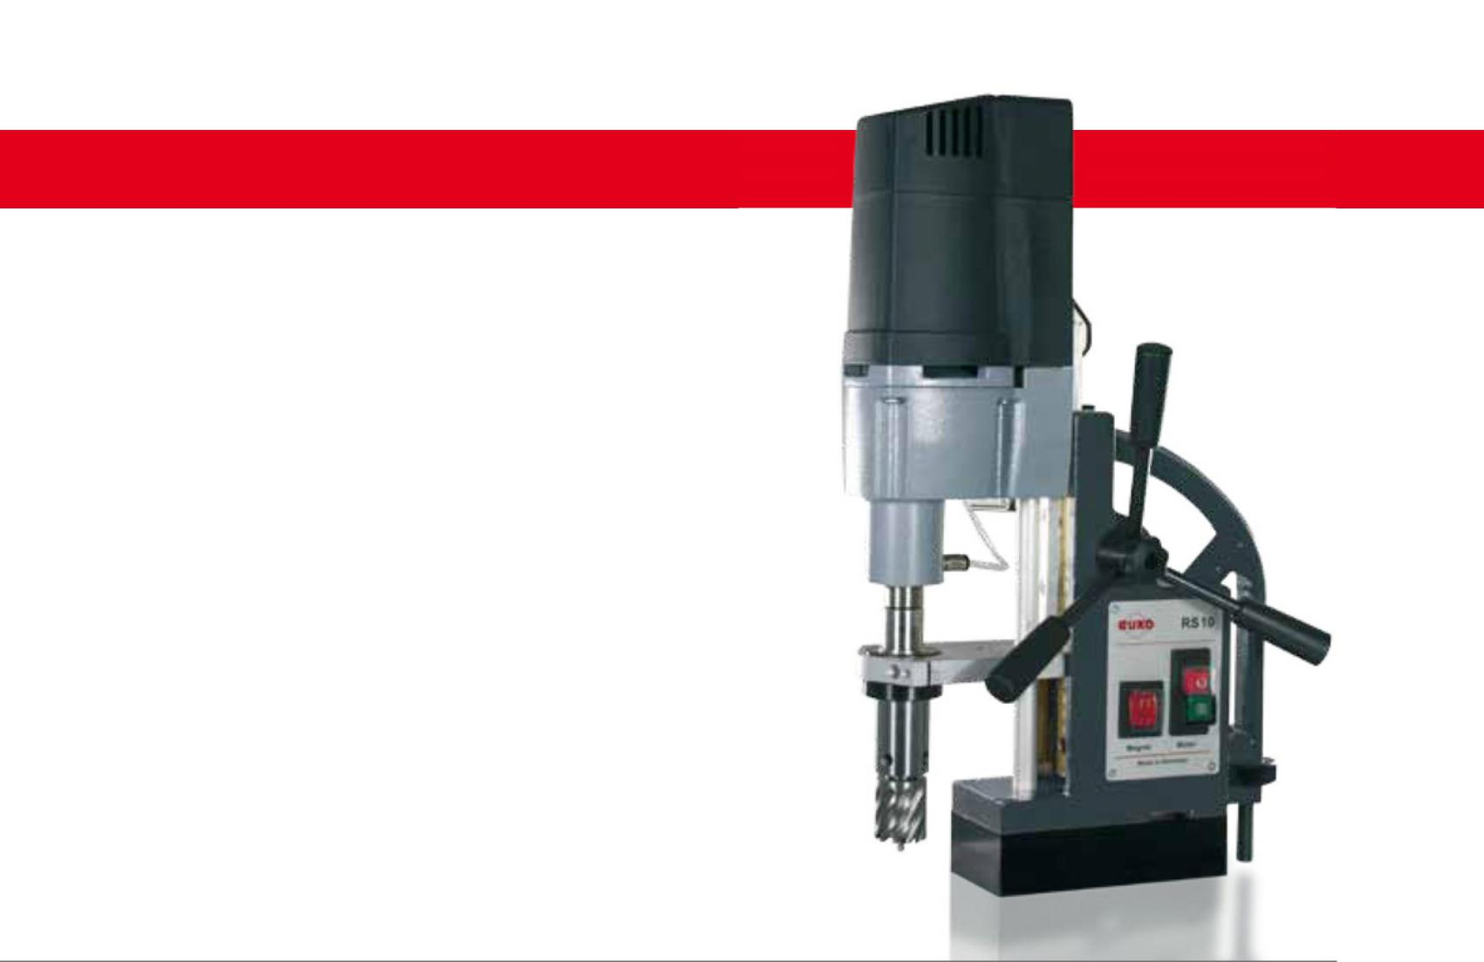

BASiCline

- Light and handy

- 10.000 N clamping force

Art. no. 108 001 RS

Price on request.

Technical data:

Magnetic clamping force: |  |  | Adapter: |  |  | length and width:
10.000 N |  |  | Weldon 19,0 mm (3/4“) |  |  | 160,0 x 80,0 mm
total Power consumption: |  |  | drill chuck: |  |  | Weight:
 |  |  |  | kg
1.120 Watt |  |  | 1,0 - 13,0 mm |  |  | 13,0 kg
rotation speeds: |  |  | Core drills: |  |  | input voltage:
450 r.p.m. |  |  | Ø 12,0 - 35,0 mm |  |  | 220 - 240 Volt
height: |  |  | twist drills:
 |  |  | DIN 338: max. Ø 10,0 mm |  |  | Conformity with:
413,0 - 548,0 mm |  |  | DIN 1897: max. Ø 13,0 mm |  |  | VDE, CEE
lift: |  |  | Cutting depth core drills:
 |  | mm
135,0 mm |  |  | up to 30,0 mm
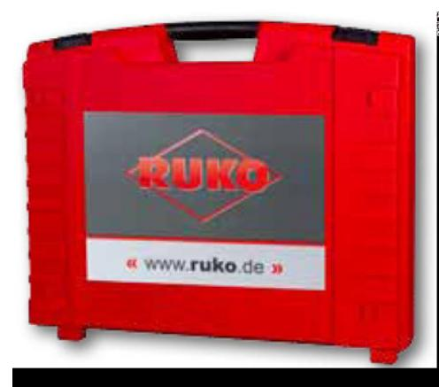
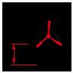
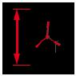
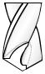

Accessories

- Plastic tool case

- Drill chuck 1,0 - 13,0 mm article no. 108 116

- Adapter for drill chuck article no. 108 115

- Cooling bottle including holding device article no. 108 101

- Allen key for Weldon shank

- Safety belt

- Operating instructions

- With arbor article no. 108 159 for core drills with Weldon shank

12 | PreCiSion toolS

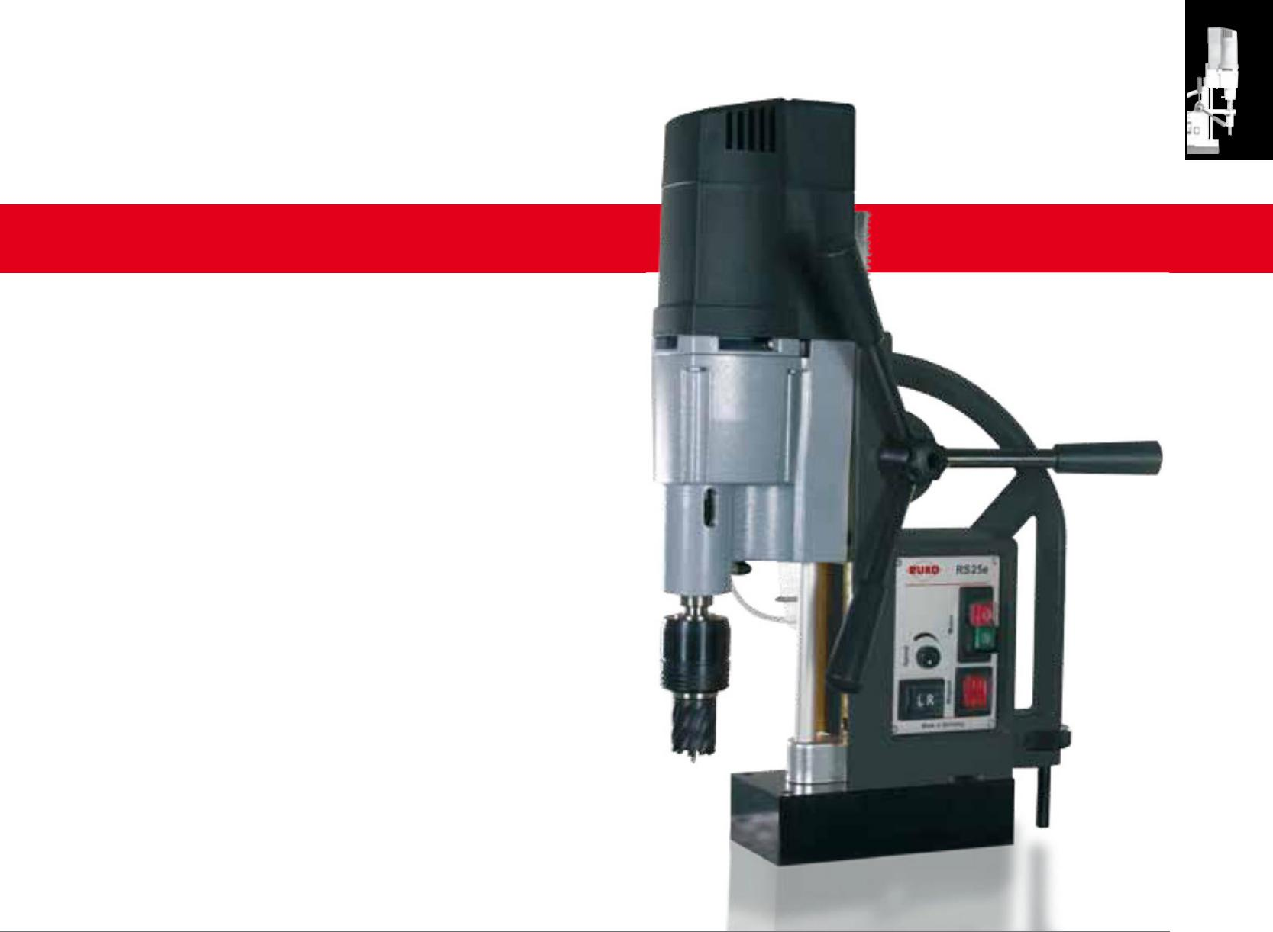
RS25e

BASiCline

- 13.000 N clamping force

- 2-speed gearbox

- Speed controller

- Right-/ left-handed rotation

Art. no. 108 005 RS

Price on request.

Technical data:

Magnetic clamping force: |  | kg | Weight: |  |  | thread cutting:
13.000 N |  |  | 18,0 kg |  |  | up to M 20
total Power consumption: |  |  | Adapter: |  |  | Cutting depth core drills:
 |  |  |  |  | mm
1.200 Watt |  |  | Morse taper Mt 2 |  |  | up to 55,0 mm
rotation speeds: |  |  |  |  |  | input voltage:
1. gear | 100 - 250 r.p.m |  | drill chuck:
2. gear | 180 - 450 r.p.m |  | 3,0 - 16,0 mm |  |  | 220 - 240 Volt
height: |  |  | Core drills: |  |  | Conformity with:
408,0 - 598,0 mm |  |  | Ø 12,0 - 60,0 mm |  |  | VDE, CEE
 |  |  | Countersinkers:
lift: |  |  | Ø 4,3 - 40,0 mm
190,0 mm |  |  | Countersink with Mt 2 shank
length and width: |  |  | twist drills:
 |  |  | DIN 338: max. Ø 13,0 mm
190,0 x 90,0 mm |  |  | DIN 1897: max. Ø 16,0 mm
 |  |  | DIN 345: max. Ø 20,0 mm
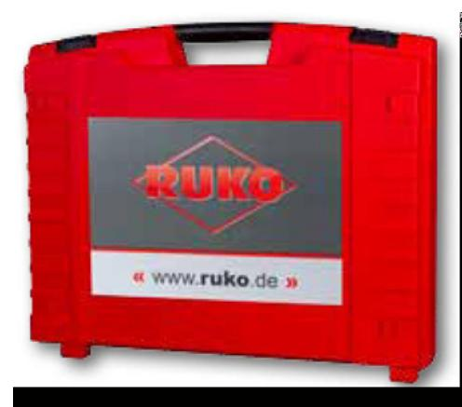
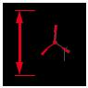
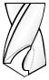

Accessories

1 | Plastic tool case | 1 | Drill drift
1 | Drill chuck 3,0 - 16,0 mm article no. 108 117 | 1 | Safety belt
1 | Spike cone MT 2 / B16 article no. 108 120 | 1 | Operating instructions
1 | Cooling bottle including holding device | 1 With arbor article no. 108 315
 | article no. 108 101 |  | for core drills with Weldon shank

PreCiSion toolS | 13

RS 40e
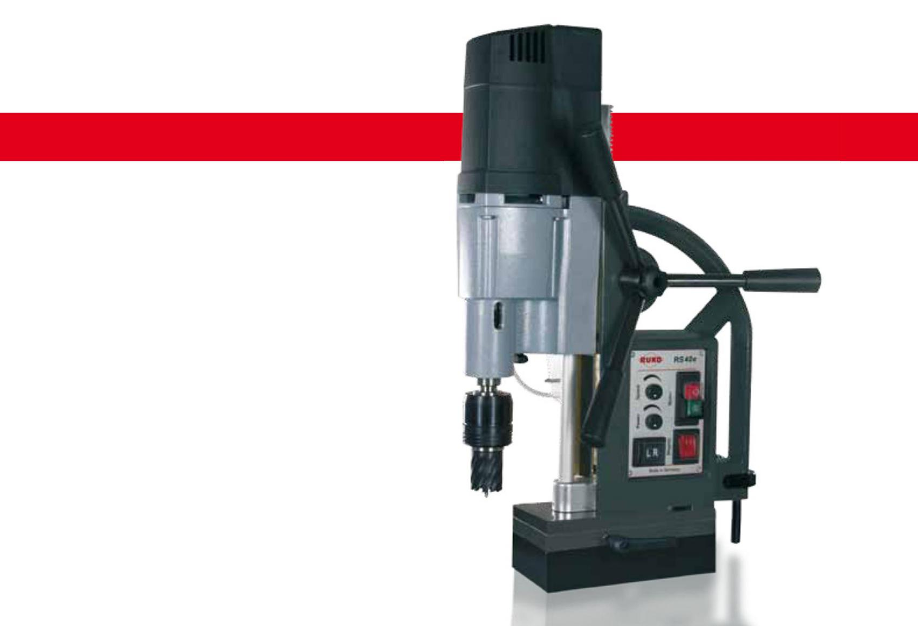

BASiCline

- 13.000 N clamping force

- Fine adjustment

- 2-speed gearbox

- Speed controller

- Right-/ left-handed rotation

Art. no. 108 004 RS

Price on request.

Technical data:

Magnetic clamping force: |  | kg | Weight: |  |  | thread cutting:
13.000 N |  |  | 24,0 kg |  |  | up to M 30
total Power consumption: |  |  | Adapter: |  |  | Cutting depth core drills:
 |  |  |  |  | mm
1.840 Watt |  |  | Morse taper MT 3 |  |  | up to 55,0 mm
rotation speeds:
1. gear | 60 - 140 r.p.m |  | drill chuck: |  |  | input voltage:
2. gear | 200 - 470 r.p.m |  | 3,0 - 16,0 mm |  |  | 220 - 240 Volt
height: |  |  | Core drills: |  |  | Conformity with:
450,0 - 640,0 mm |  |  | Ø 12,0 - 100,0 mm |  |  | VDE, CEE
 |  |  | Countersinkers:
lift: |  |  | Ø 4,3 - 40,0 mm
190,0 mm |  |  | Countersink with MT 3 shank
length and width: |  |  | twist drills:
 |  |  | DIN 338: max. Ø 16,0 mm
190,0 x 90,0 mm |  |  | DIN 345: max. Ø 23,0 mm
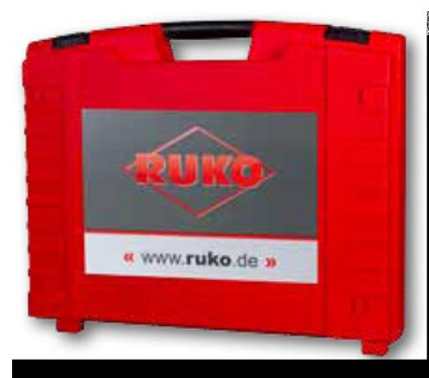

Accessories

- Plastic tool case

- Drill chuck 3,0 - 16,0 mm article no. 108 117

- Spike cone MT 3 / B16 article no. 108 121

- Cooling bottle including holding device article no. 108 101

- Drill drift

- Safety belt

- Operating instructions

- with arbor article no. 108 316 for core drills with Weldon shank

14 | PreCiSion toolS

RS 5e

BASiCline

- 10.000 N clamping force

- Speed controller

- left or right hand operation

- 11,0 kg
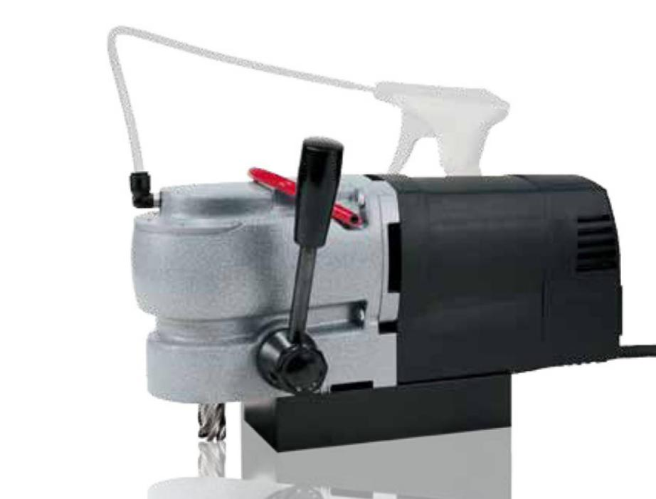

Art. no. 108 006 RS

Price on request.

Technical data:
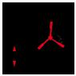

Magnetic clamping force: |  |  |  |  | lift: |  |  |  | Core drills:
10.000 N |  |  |  |  | 38,0 mm |  |  |  | Ø 12,0 - 35,0 mm
total Power consumption: |  |  |  |  | length and width: |  |  |  | Cutting depth core drills:
 |  |  |  |  |  |  |  | mm
1.200 Watt |  |  |  |  | 160,0 x 80,0 mm |  |  |  | up to 30,0 mm
rotation speeds: |  |  |  |  | Weight: |  |  |  | input voltage:
 |  | kg
140 - 350 r.p.m |  |  |  |  | 11,0 kg |  |  |  | 220 - 240 Volt
height: |  |  |  |  | Adapter: |  |  |  | Conformity with:
182,0 mm |  |  |  |  | Weldon 19,0 mm (3/4“) |  |  |  | VDE, CEE
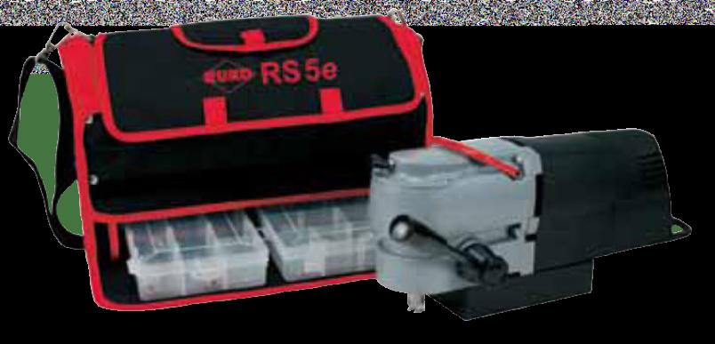
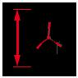

Accessories

1 Carrying bag incl. 2 plastic boxes

- Ejector pin Ø 6,35 x 70,0 mm article no. 108 344

- Cooling bottle article no. 108 101

- Safety belt

- Operating instructions

PreCiSion toolS | 15

a10
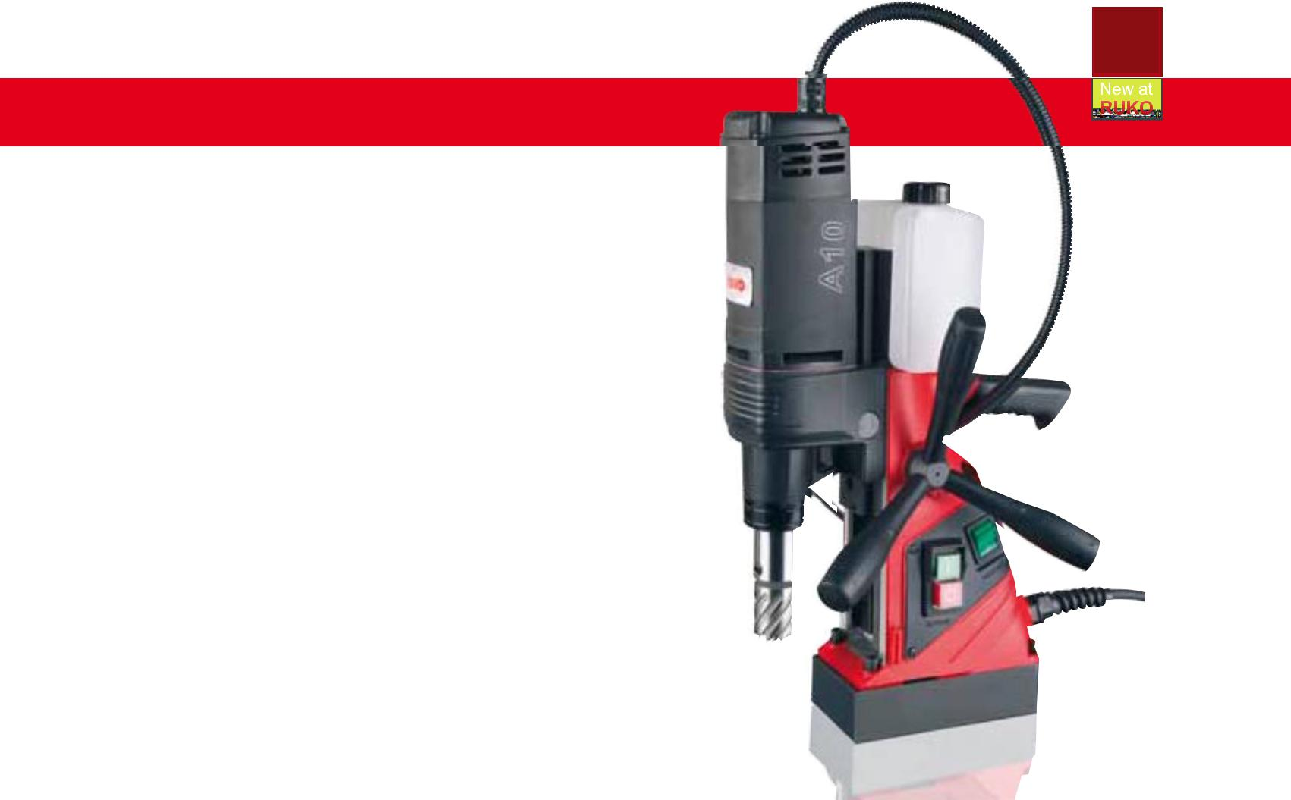

BASiCline

- Easy readjustment thanks to 50% reduction in magnetic power when the motor is switched off

- Height-adjustable power unit thanks to double dovetail guide

- Very light / easy to use

- 10.000 N clamping force

- Automatic coolant supply

Art. no. 108 010 A

Price on request.

Technical data:

Magnetic clamping force: |  | length and width: |  |  | Core drills:
10.000 N |  | 160,0 x 80,0 mm |  |  | Ø 12,0 - 35,0 mm
total Power consumption: |  | Weight: |  |  | Cutting depth core drills:
 | kg |  |  | mm
1.100 Watt |  | 10,5 kg |  |  | up to 110,0 mm
rotation speeds: |  | Adapter: |  |  | input voltage:
700 r.p.m |  | Weldon: 19,0 mm (3/4“) |  |  | 220 - 240 Volt
height: |  | twist drills: |  |  | Conformity with:
400,0 - 580,0 mm |  | DIN 338: max. Ø 13,0 mm |  |  | VDE, CEE
lift:
120,0 / 195,0 mm
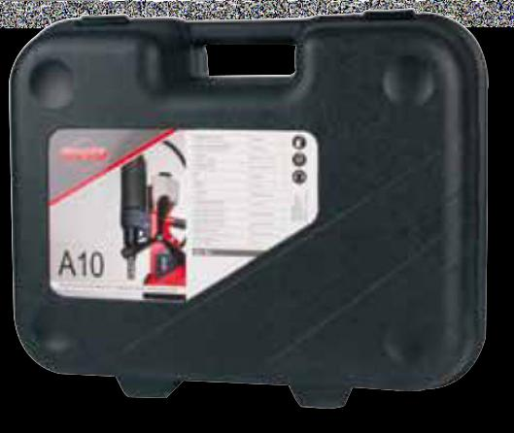
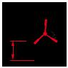
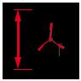
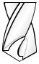

Accessories

1 Plastic tool case

1 Safety belt

3 Allen key 2,5 / 4 / 6

1 Cooling bottle

1 Operating instructions

16 | PreCiSion toolS

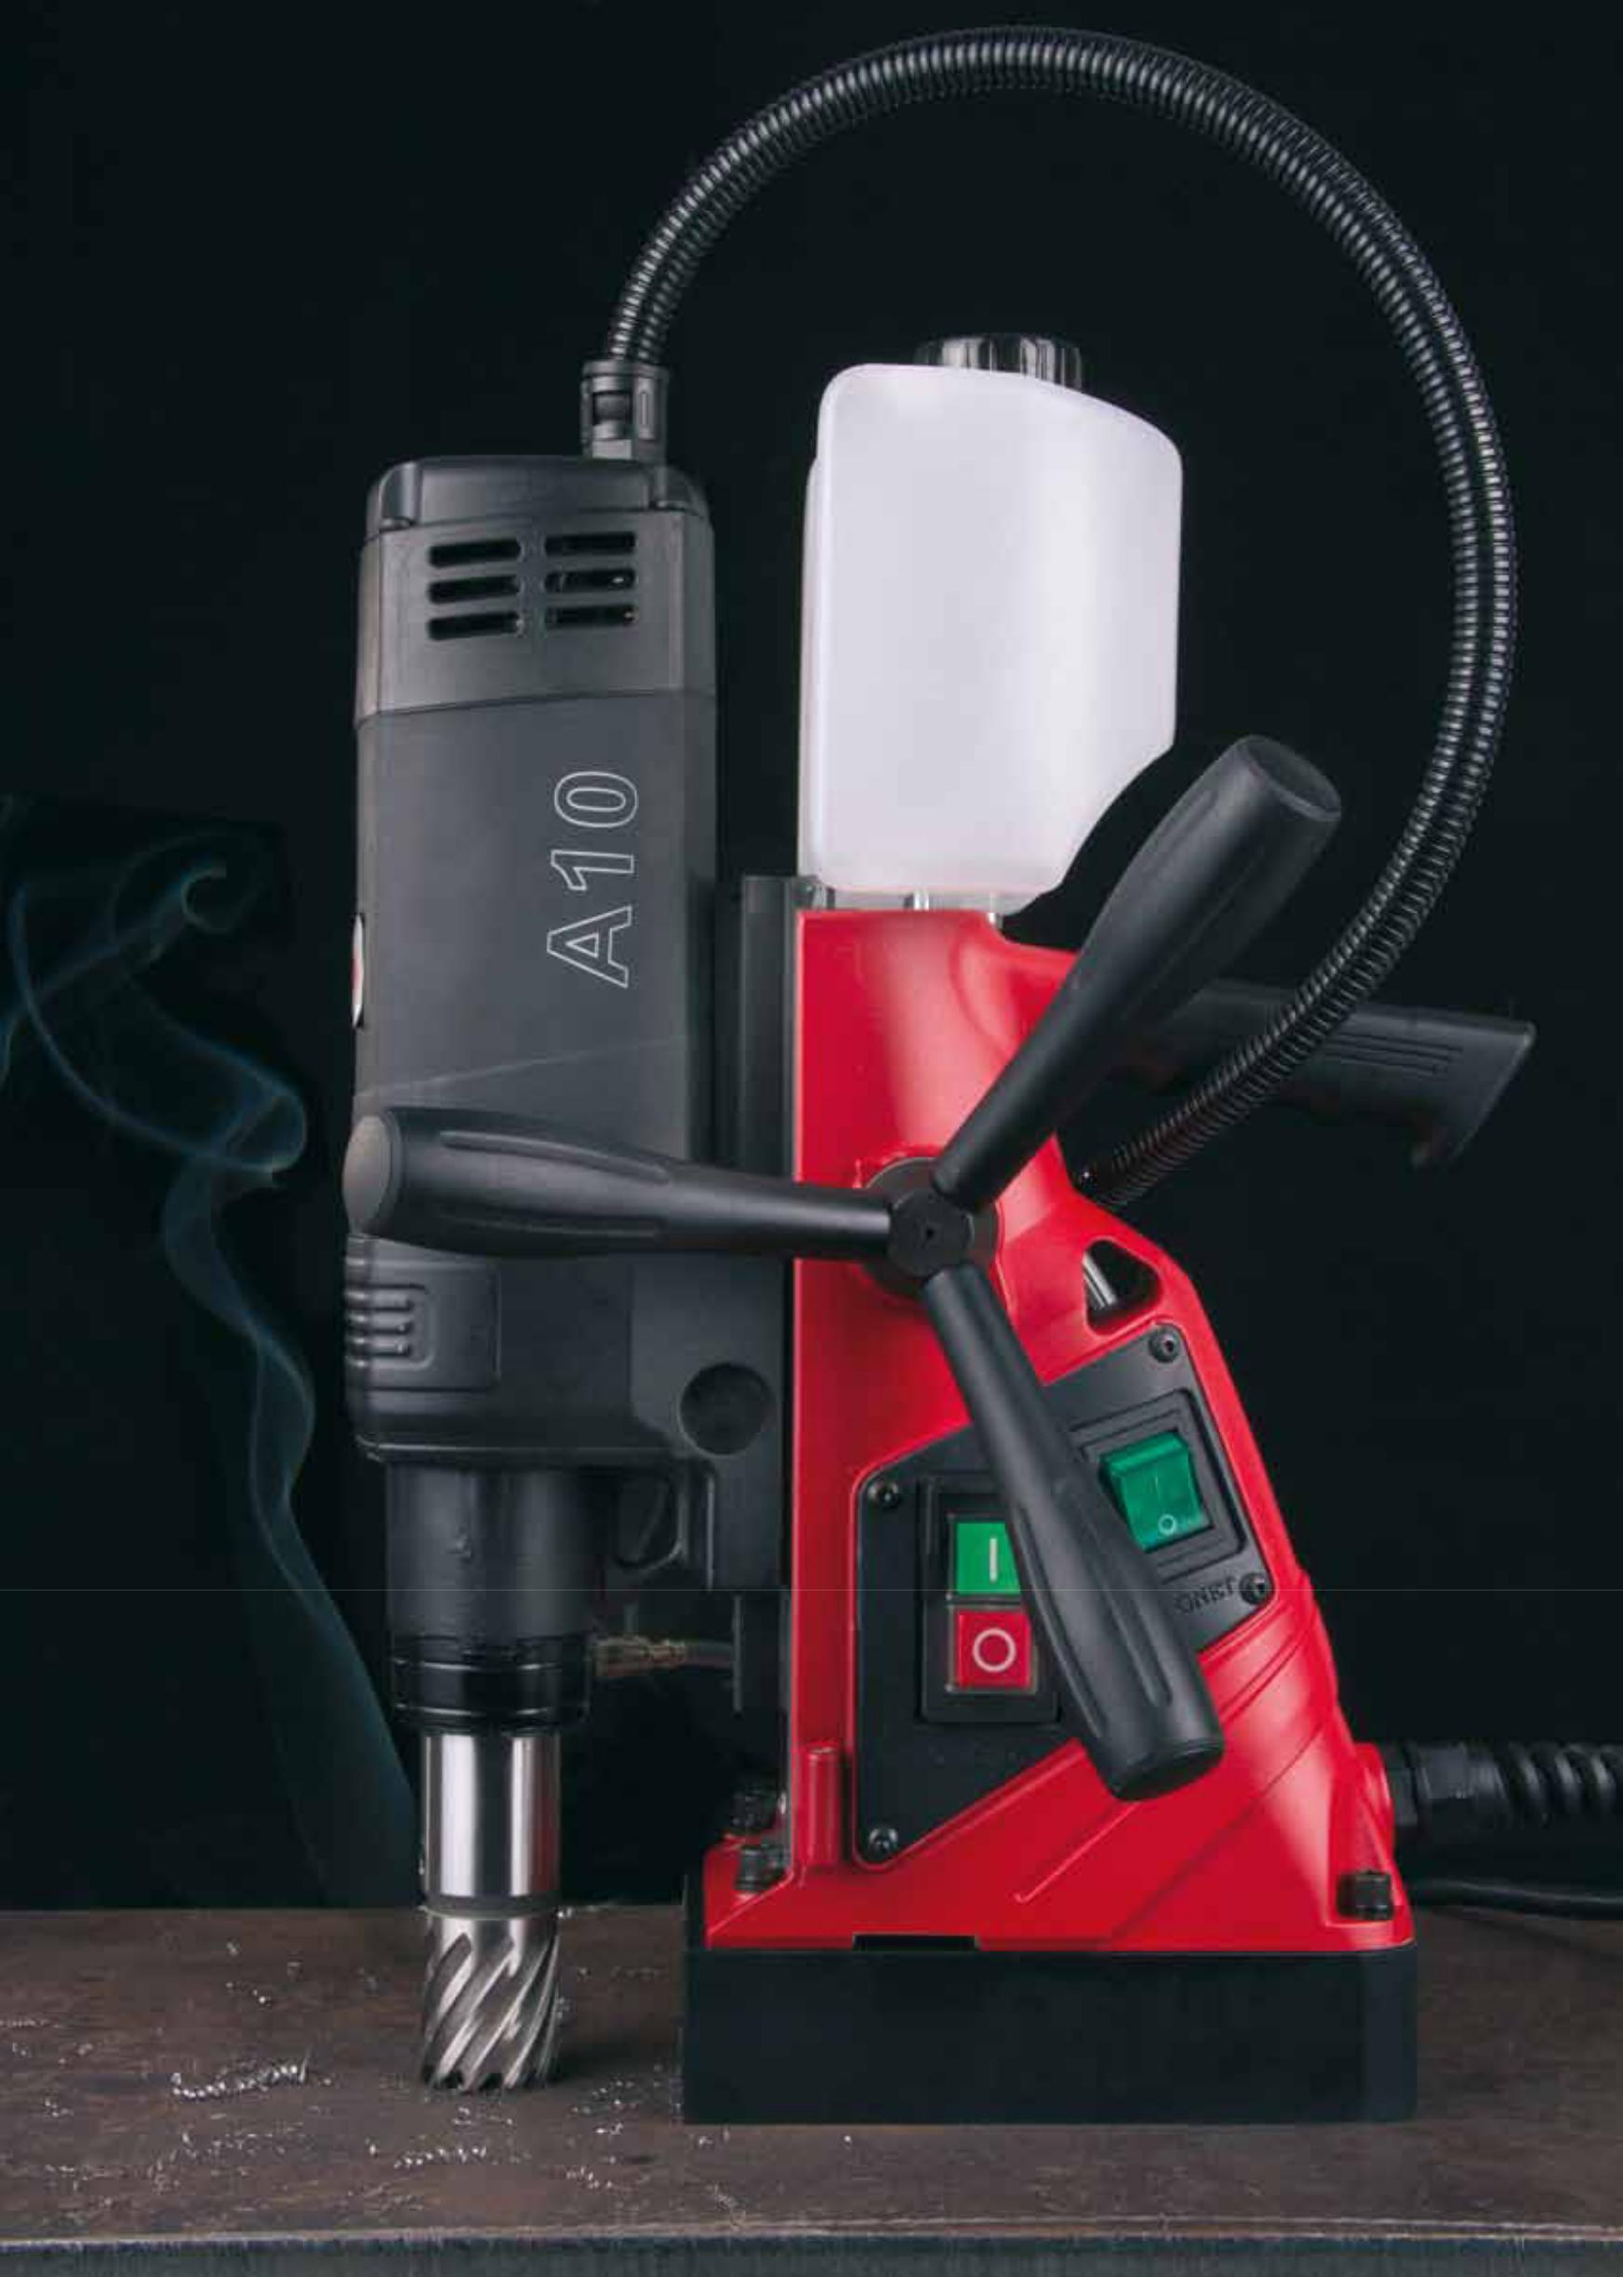

PreCiSion toolS | 17

RSH 1300
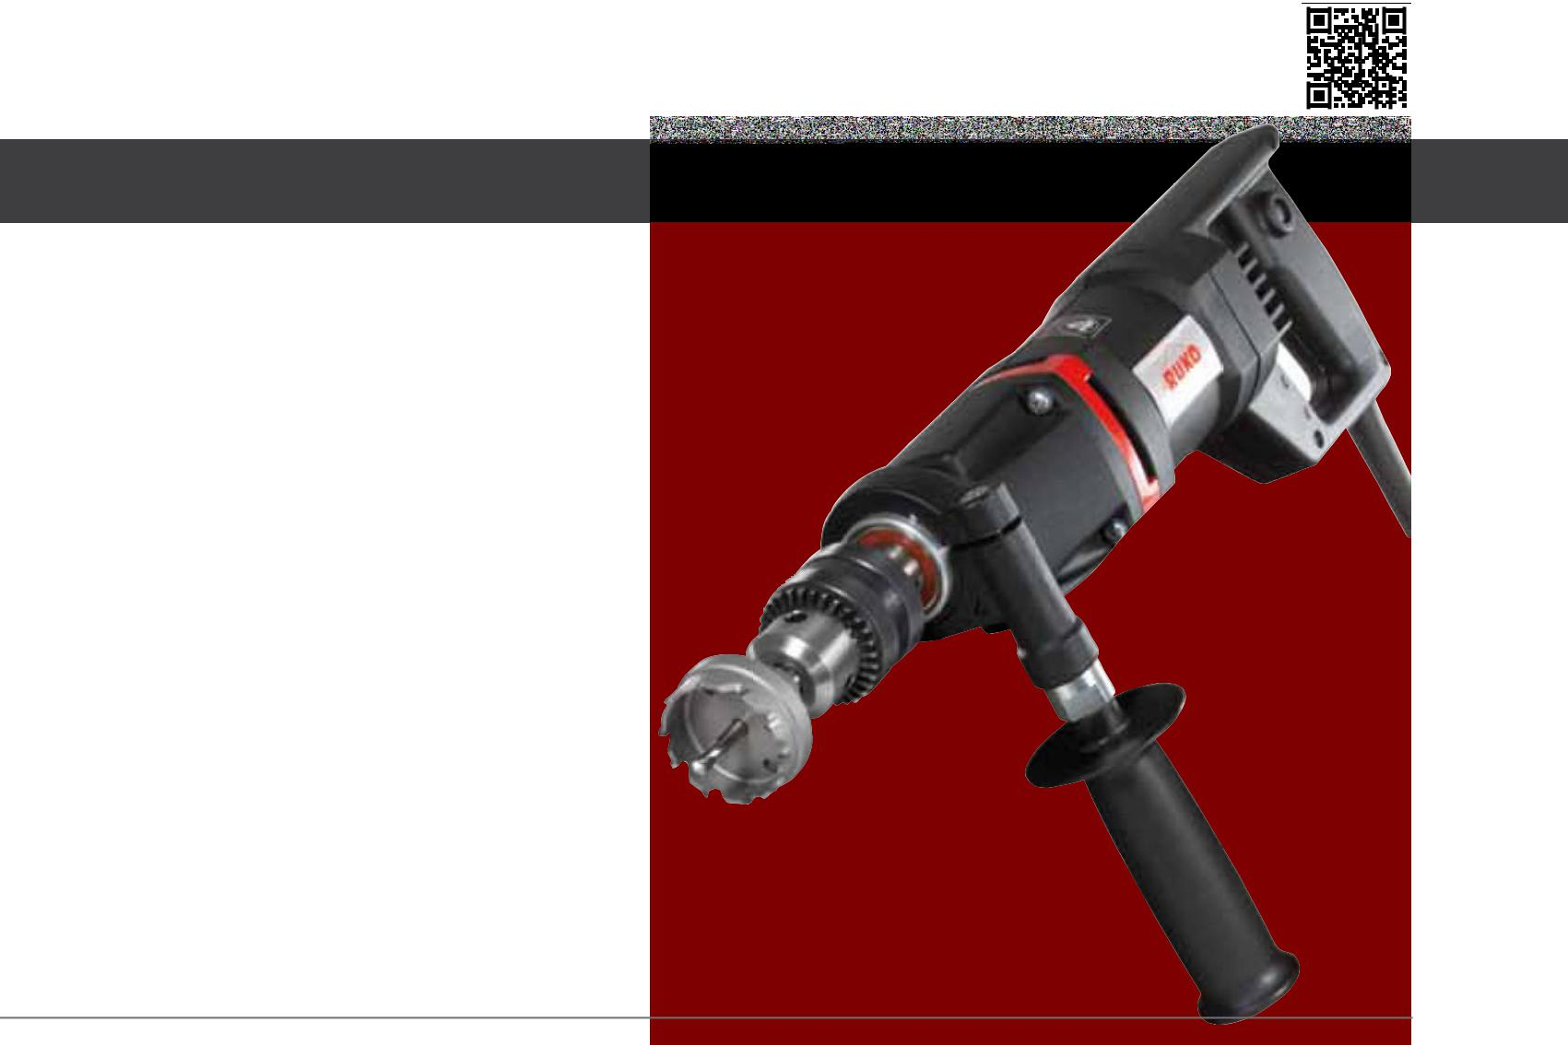

PreMiUMline

- Infinitely variable speed control

- right-/left-handed rotation

- Torque slipping clutch

- electronic overload protection

- restart inhibit

Art. no. 108 1300 RSH

Price on request.

Technical data:

 |  | total Power consumption: |  |  |  | Adapter: |  |  | thread forming:
 |  | 1.300 Watt |  |  |  | flexible 5/8“ x 16 |  |  | up to M8
 |  | Power output: |  |  |  | Multigrade hole saws MhS: |  |  | thread cutting:
 |  | 800 Watt |  |  |  | Ø 15,0 - 30,0 mm /20,0 mm |  |  | up to M12
 |  | rotation speeds: |  |  |  | TC hole saws, shallow cut: |  |  | input voltage:
 |  | 0 - 2000 r.p.m. |  |  |  | Ø 16,0 - 60,0 mm /4,0 mm |  |  | 220 - 240 Volt
 |  |  |  |  |  |  |  |  | Conformity with:
 |  | idling speed: |  |  |  | hSS-g hole saws:
 |  | 3400 r.p.m. |  |  |  | Ø 12,0 - 60,0 mm /2,5 mm |  |  | VDE, CEE
 |  | Weight: |  |  |  | Flow drilling:
kg
 |  | 3,4 kg |  |  |  | M4 - M8
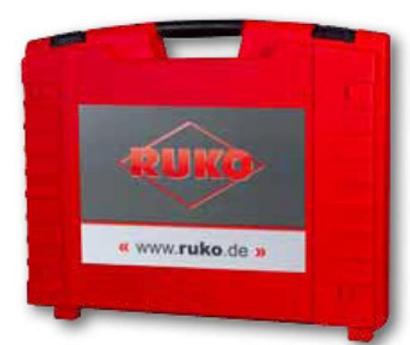

Accessories

- Flexible mounting 5/8“ x 16, article no. 108 323

- Cutting spray 200 ml, article no. 101 025

- Plastic tool case

18 | PreCiSion toolS

Application fields of the RSH 1300
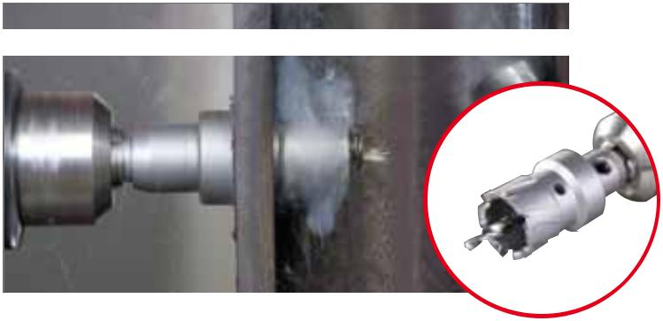

Core drilling MhS
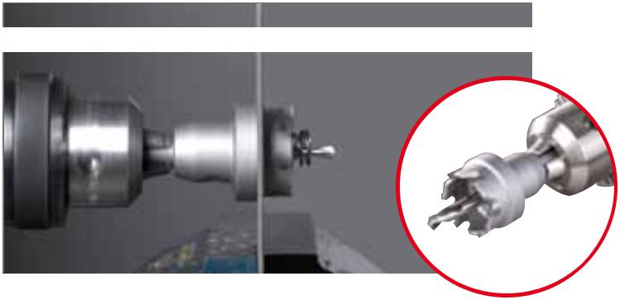

the rUKo tungsten-carbide-multigrade hole saws MhS can be used in hand drills up to 6.0 mm in steel. Suitable for high-alloyed steels such as stainless and acid-resistant steel, steel and cast steel (up to 20,0 mm), non-ferrous and light metals, plastics (up to 28,0 mm).

Tungsten carbide multigrade hole saws MHS Ø 15,0 - 30,0 mm Cutting depth up to 28,0 mm

Core drilling tC- shallow cut
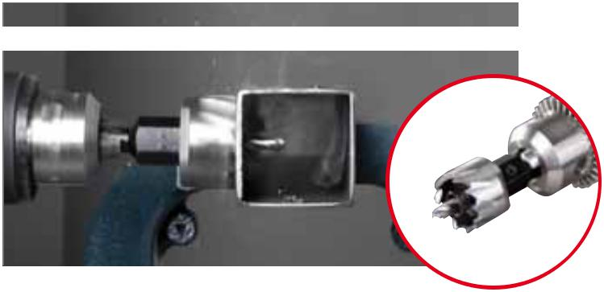

Core drilling hSS-g
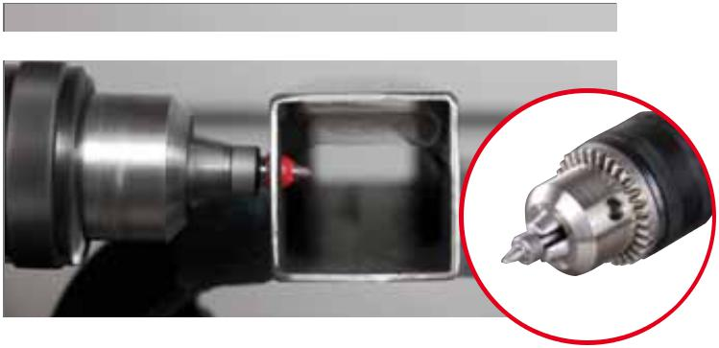

the rUKo tungsten-carbide-tipped hole saws can be used in hand and pillar drills. Suitable for high-alloyed steels such as stainless and acid-resistant steel (up to 2,0 mm), steel and cast steel, non-ferrous and light metals, plastics, reinforced fabrics, plasterboard and light building boards, wood.

Tungsten carbide hole saws, shallow cut: Ø 16,0 - 60,0 mm Cutting depth up to 4,0 mm

the rUKo hSS-g hole saws can be used in hand and pillar drills. Suitable for steel (up to 800 N/mm² strength) and cast steel, non-ferrous and light metals, plastics, reinforced fabrics, plasterboard and light buil-ding boards.

HSS-G hole saws: Ø 12,0 - 60,0 mm

Cutting depth up to 2,5 mm

Flow drilling
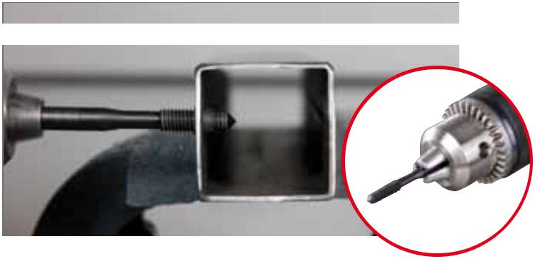

thread forming

Accessories for hand core drilling machine RSH 1300 - Page 48

Heat is generated locally using rotational speed and friction heat, which plastifies the metallic materials of all kinds. thus closed eyelets can be made in several basic material thickness within a few seconds without chips.

Flow drilling from M4 up to M8

As shaping is done without cutting, no interruption of the course

of the fibre in the material. the deformation creates very rigid threads.

Consistent accuracy even with high productivity.

Thread forming up to M8

PreCiSion toolS | 19

Vacuum clamping plate with compressed air connection for magnetic-stand drilling machine
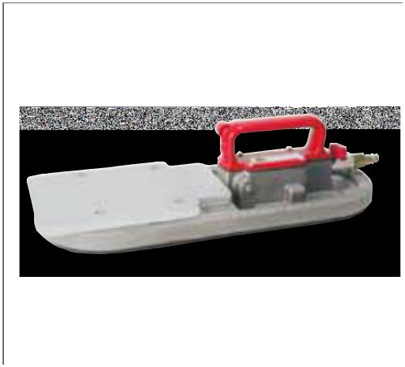

Length: | 410,0 mm |  | (16")
Width: | 153,0 mm |  | ( 6")
Height: | 100,0 mm |  | ( 4")
Weight: | 4,6 kg | (10.1 lbs)
Pressure at work min.: | 4,5 bar | (65 |  | PSI)
Pressure at work max.: | 8 bar | (120 |  | PSI)
Air consumption: | 0,06 m³
 | 2 CFM at 6 bar (85 PSI)

the vacuum clamping plate enables the use of magnetic stand drills on non-magnetic surfaces. In order to achieve the highest possible adhesive force, the application surface should be as free as possible of dust, scale, loose rust and filler. For safety reasons, the vacuum plate should only be used horizontally.
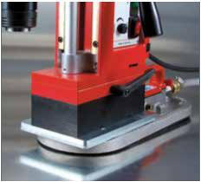

Packing unit:

individual carton

Article no.

Vacuum clamping plate with compressed | 108 113 | 1
air connection for magnetic-stand drilling machine

Pipe clamping device 500
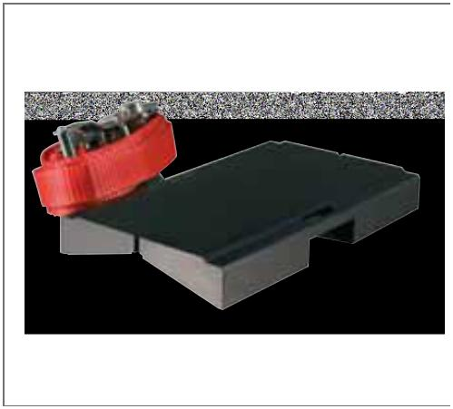
for magnetic-stand drilling machine

Length: | 220,0 mm (8.7”)
Width: | 130,0 mm (5.1”)
Height: | 28,0 mm (1.1”)
Safety belt: | 2,0 m (78.7”)
Weight: | 4,4 kg (9.7 lbs)
Clamping agent: | ratchet

The pipe clamping device enables the use of magnetic stand drills on pipes 50,0 to 500,0 mm in diameter. For saftey reasons, the pipe clamping device should only be used horizontally.
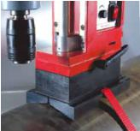

Packing unit:

individual carton

Article no.

Pipe clamping device 500 | 108 114 | 1
for magnetic-stand drilling machine

20 | PreCiSion toolS

Arbor holders for core drills with Weldon shank (3/4“)
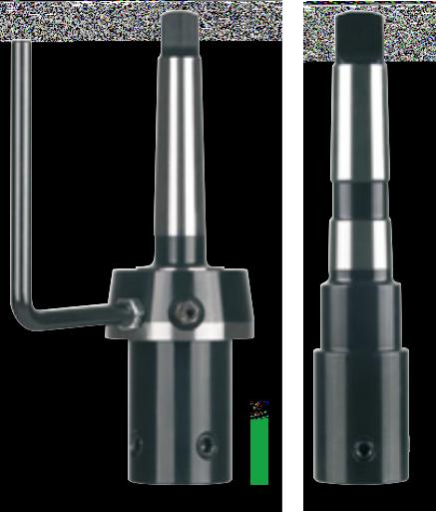

Packing unit: individual carton

 |  | 108 159 |  | 108 110 |  |  |  | 108 302 |  |  | 108 315 | 108 108
 |  |  | Magnetic-stand |  | Ø Core drills |  | Core drills |  | Article no.
 |  |  | drilling machine |  | mm |  | cutting depth mm
 | Arbor holder |  | rS10 |  | 10,0 - 35,0 |  | 30,0 |  | 108 159 |  | 1
 | with thread M 14
 | Arbor holder with morse taper no. 2 shank |  | rS25e |  | 10,0 - 60,0 |  | 30,0 / 50,0 |  | 108 302 |  | 1
 | and cooling bottle article no. 108 101
 | Arbor holder with morse taper no. 2 shank |  | rS25e |  | 10,0 - 60,0 |  | 30,0 / 50,0 |  | 108 315 |  | 1
 | and interior cooling |  | rS125e / RS126e
 | Arbor holder with morse taper no. 3 shank |  | rS40e |  | 10,0 - 60,0 |  | 30,0 / 50,0 |  | 108 303 |  | 1
 | and cooling bottle article no. 108 101
 | Arbor holder with morse taper no. 3 shank |  | rS40e / rS140e |  | 10,0 - 60,0 |  | 30,0 / 50,0 |  | 108 316 |  | 1
 | and interior cooling

Arbor holders for core drills with threaded retainer M18 x 6 P1,5

Packing unit: individual carton

 |  |  | Magnetic-stand |  | Ø Core drills |  | Core drills |  | Article no.
 |  |  | drilling machine |  | mm |  | cutting depth mm
 | Arbor holder with morse taper no. 2 shank including |  | rS25e |  | 12,0 - 80,0 |  | 50,0 |  | 108 102 |  | 1
 | cooling bottle article no. 108 101, adapter art. no.
 | 108 108 and ejector pin article no. 108 110
 | Arbor holder with morse taper no. 2 shank |  | rS25e |  | 12,0 - 80,0 |  | 50,0 |  | 108 104 |  | 1
 | and interior cooling including adapter article no. 108 |  | rS125e / RS126e
 | 108 and ejector pin article no. 108 110
 | Arbor holder with morse taper no. 3 shank including |  | rS40e |  | 12,0 - 80,0 |  | 50,0 |  | 108 103 |  | 1
 | cooling bottle article no. 108 101, adapter art. no.
 | 108 108 and ejector pin article no. 108 110
 | Arbor holder with morse taper no. 3 shank |  | rS40e / rS140e |  | 12,0 - 80,0 |  | 50,0 |  | 108 105 |  | 1
 | and interior cooling including adapter article no. 108
 | 108 and ejector pin article no. 108 110

PreCiSion toolS 21

Automatic easylock Quick-in arbor for core drills with Weldon shank (3/4“)
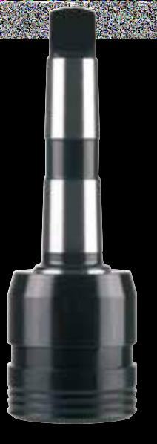

The EasyLock quick-in arbor enables a very quick tool change without additional tools.

Can be operated with one hand.
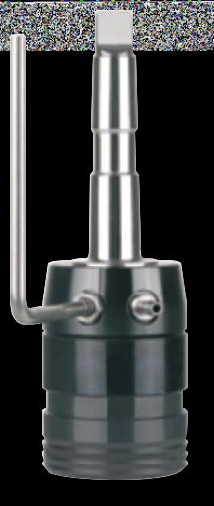

Packing unit: individual carton
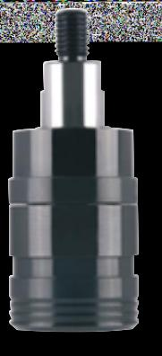

108 314 | 108 312 / 108 313 | 108 317 / 108 318

 | Magnetic-stand | Ø Core drills | Core drills | Article no.
 | drilling machine | mm | cutting depth mm

EasyLock with thread M 14

and interior cooling

easylock with morse taper no. 2 shank and cooling bottle article no. 108 101

easylock with morse taper no. 2 shank and interior cooling

EasyLock with morse taper no. 3 shank and cooling bottle article no. 108 101

EasyLock with morse taper no. 3 shank and interior cooling
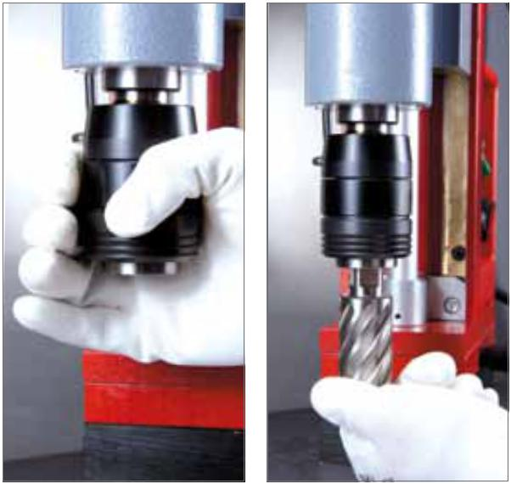

rS10 | 10,0 - 35,0 | 30,0 | 108 314 | 1
rS25e | 10,0 - 60,0 | 30,0 / 50,0 | 108 312 | 1
rS25e | 10,0 - 60,0 | 30,0 / 50,0 | 108 317 | 1
rS125e / RS126e
rS40e | 10,0 - 60,0 | 30,0 / 50,0 | 108 313 | 1
rS40e / rS140e | 10,0 - 60,0 | 30,0 / 50,0 | 108 318 | 1
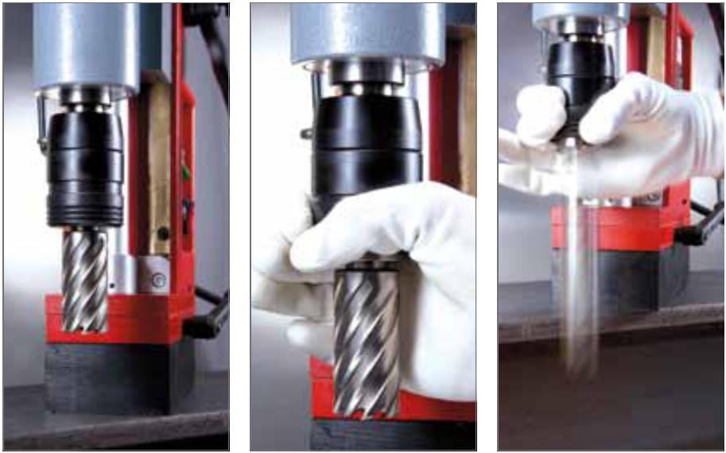

1 |  | 2 |  | 3 |  | 4 |  | 5

22 PreCiSion toolS

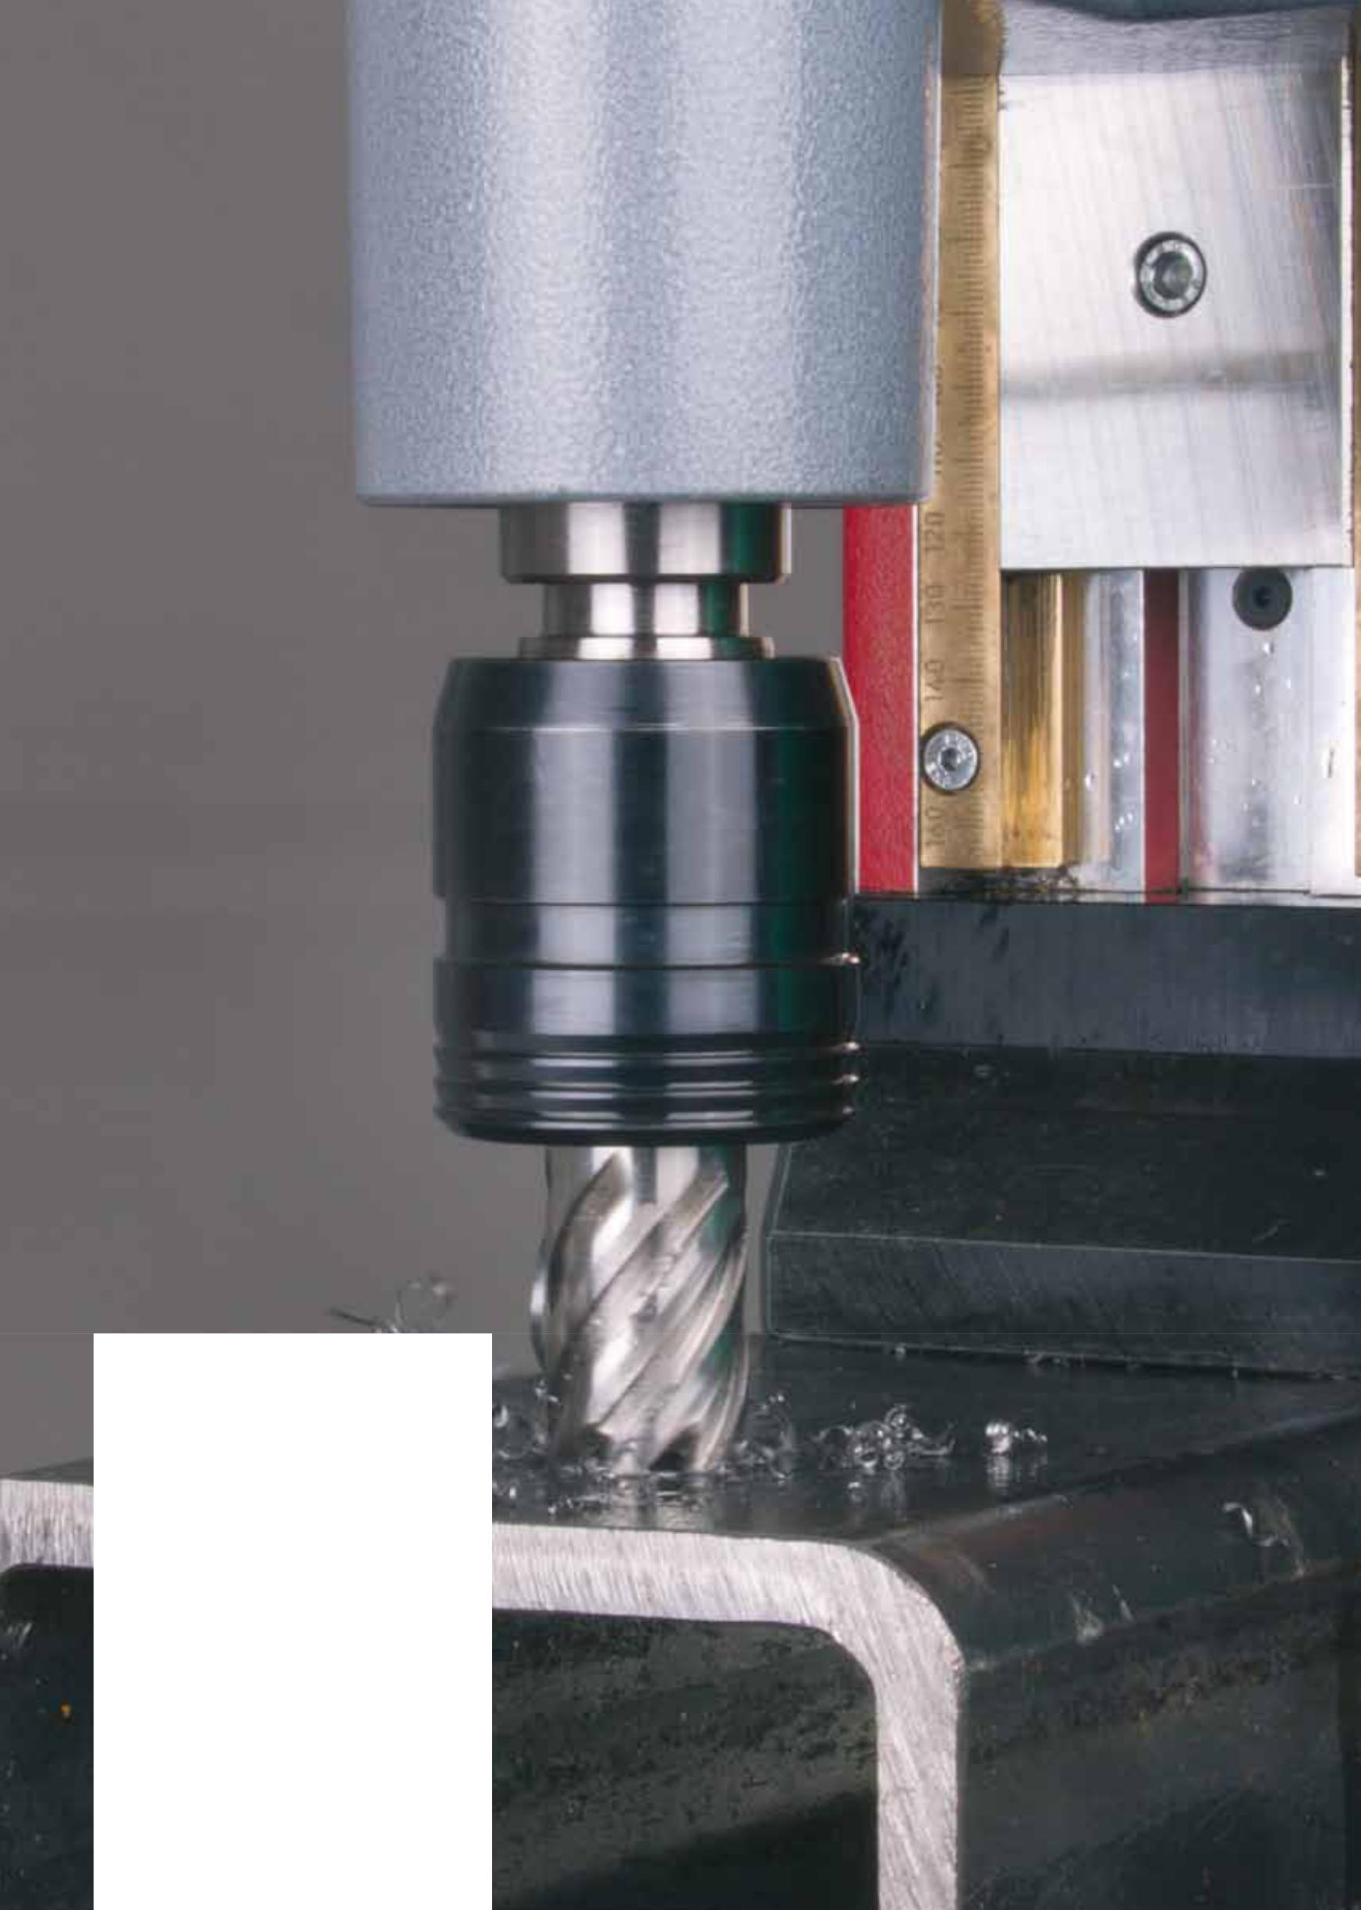

1. Push the ring spanner up until it sits tight.

- insert the core drill in the easylock.

This locks in with a loud “click.” the ring spanner snaps down.

3. The core drill is fixed securely in the

easylock. the machine is now ready for

operation.

4. To release the core drill, push the ring

spanner up.

5. Caution!

the core drill will fall out of the easylock.

PreCiSion toolS | 23

Arbor holders and quick-change inserts

for magnetic-stand drilling machine

Packing unit: individual plastic pack
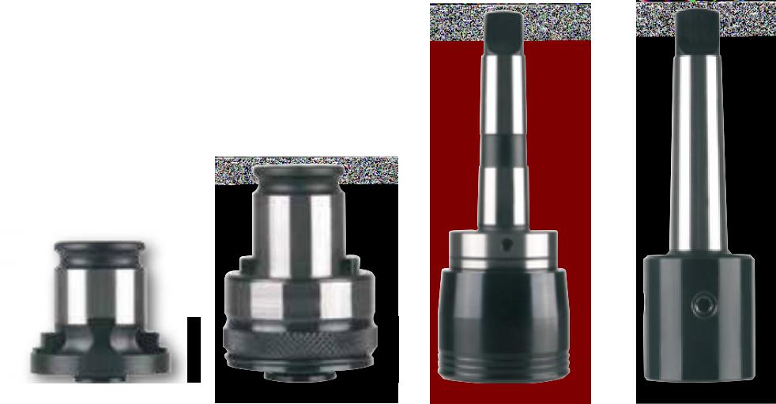

108 180 | 108 166 | 108 163 | 108 161

 |  |  | Magnetic-stand |  | Article no.
 |  |  | drilling machine
 | Quick-acting holder with morse taper no. 2 shank |  | rS25e |  | 108 163 |  | 1
 | and - 5,0 / +10,0 mm length compensation for thread taps |  | rS125e / RS126e
 | Quick-acting holder with morse taper no. 3 shank |  | rS40e |  | 108 160 |  | 1
 | and + / - 10,0 mm length compensation for thread taps |  | rS140e
 | MT 3 arbor holder for |  | rS40e |  | 108 161 |  | 1
 | M 27 thread taps |  | rS140e
 | MT 3 arbor holder for |  | rS40e |  | 108 162 |  | 1
 | M 30 thread taps |  | rS140e

Quick-change insert „with“ safety coupling

 | For thread tap |  | Article no.
 | Ø-shank mm |  | „with“ safety coupling
 | 6,0 |  | 108 166 |  |  | 1
 | 7,0 |  | 108 167 |  |  | 1
 | 8,0 |  | 108 168 |  |  | 1
 | 9,0 |  | 108 169 |  |  | 1
 | 10,0 |  | 108 170 |  |  | 1

Quick-change insert „without“ safety coupling

 | For thread tap |  | Article no.
 | Ø-shank mm |  | „without“ safety coupling
 | 6,0 |  | 108 180 |  |  | 1
 | 7,0 |  | 108 181 |  |  | 1
 | 8,0 |  | 108 182 |  |  | 1
 | 9,0 |  | 108 183 |  |  | 1
 | 10,0 |  | 108 184 |  |  | 1
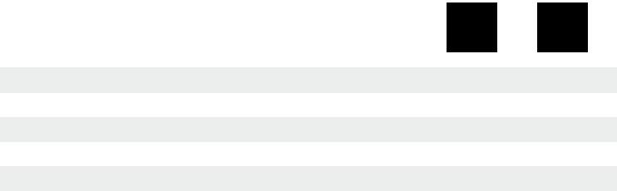

 | For thread tap |  | Article no.
 | Ø-shank mm |  | „with“ safety coupling
 | 11,0 |  | 108 171 |  |  | 1
 | 12,0 |  | 108 172 |  |  | 1
 | 14,0 |  | 108 173 |  |  | 1
 | 16,0 |  | 108 174 |  |  | 1
 | 18,0 |  | 108 175 |  |  | 1

 | For thread tap |  | Article no.
 | Ø-shank mm |  | „without“ safety coupling
 | 11,0 |  | 108 185 |  |  | 1
 | 12,0 |  | 108 186 |  |  | 1
 | 14,0 |  | 108 187 |  |  | 1
 | 16,0 |  | 108 188 |  |  | 1
 | 18,0 |  | 108 189 |  |  | 1

24 PreCiSion toolS

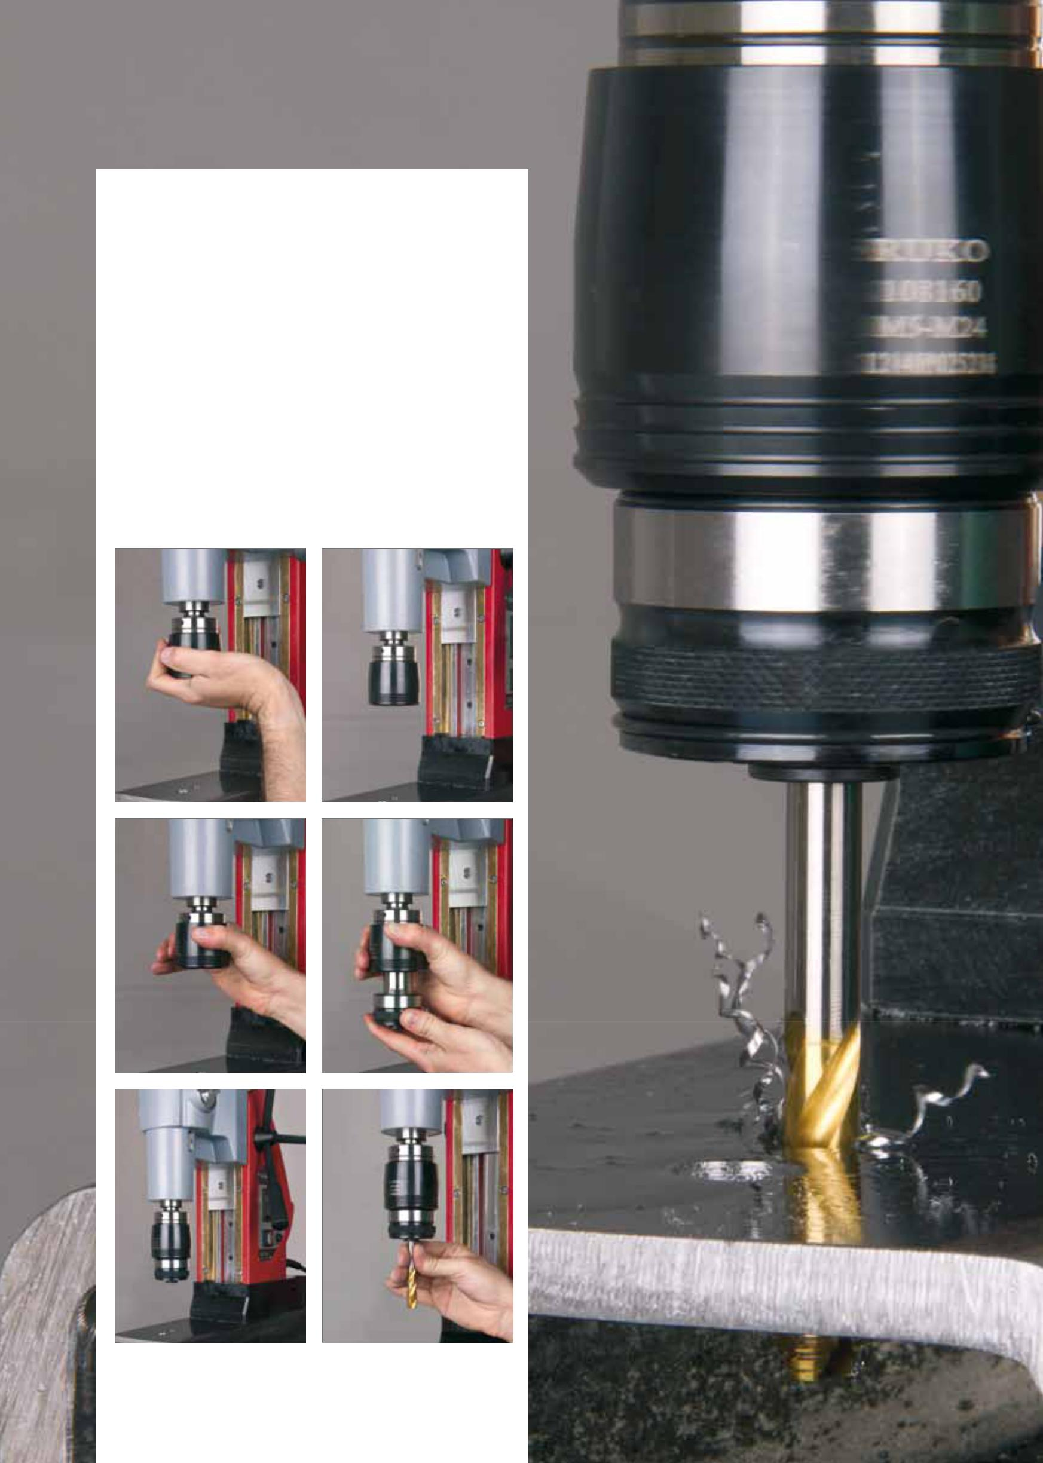

general information:

- Push the quick-release slot holder from below upwards into the slot until it is seated firmly.

- open the slot holder by pushing the locking ring upwards.

- Insert the quick change unit into the quick-release slot holder. This is locked in with a loud „click“. The lock ring snaps down.

- The machine threaded drill can be inserted easily into the quick-change unit.

- The machine is now ready for use.

PreCiSion toolS | 25

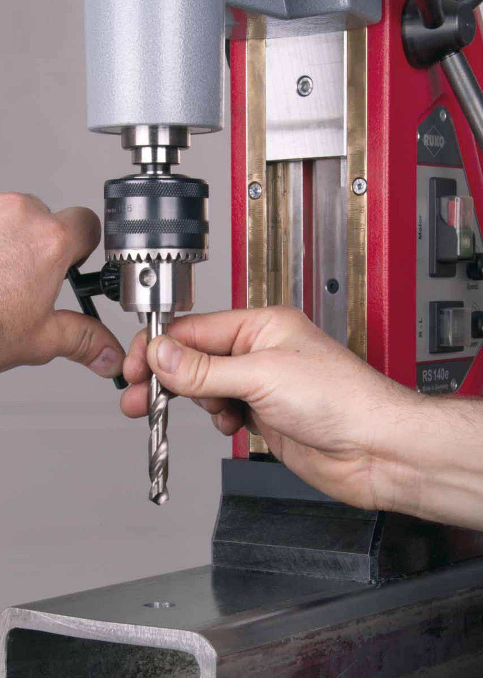

- PreCiSion toolS

Adapter, drill chuck and accessories for magnetic-stand drilling machine

Packing unit: individual plastic pack
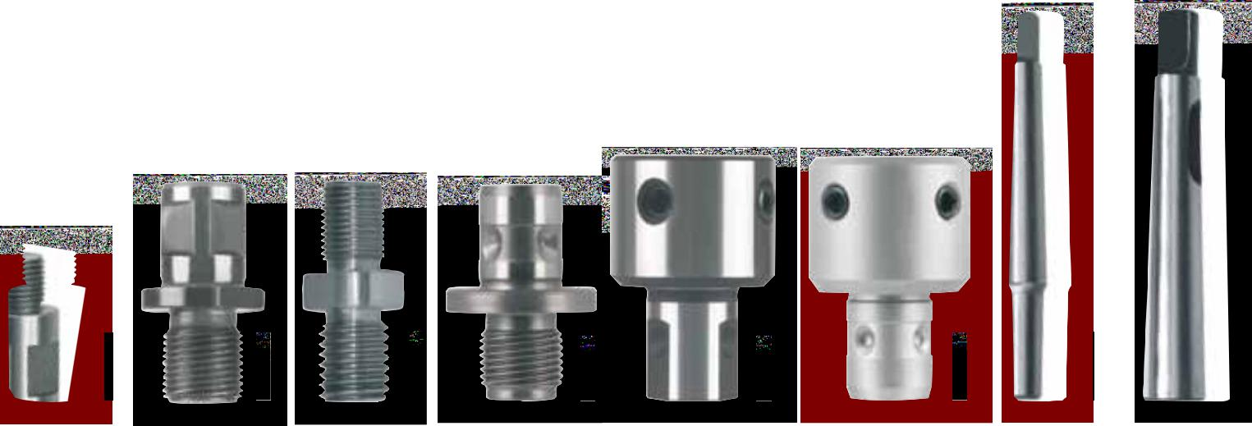

108 109 | 108 108 | 108 115 | 108 111 | 108 191 | 108 118 | 108 120 | 108 125

 |  |  | Magnetic-stand |  |  | Article no.
 |  |  | drilling machine
 | Adapter with thread retainer M18 x 6 P1,5 |  | rS10 / RS25e / RS40e |  |  | 108 107 |  | 1
 | for core drills with Weldon shank 3/4" |  | rS125e / RS126e / RS140e
 | Adapter with Weldon shank 3/4" |  | rS10 / RS25e / RS40e |  |  | 108 108 |  | 1
 | for core drills with thread retainer M18 x 6 P1,5 |  | rS125e / RS126e / RS140e
 | Adapter with Weldon shank 3/4" |  | rS10 | / RS25e / RS40e |  | 108 126 |  | 1
 | for core drills with Quick in-shank |  | rS125e | / RS126e / RS140e
 | Adapter with Quick in-shank |  | mit Quick in- |  |  | 108 111 |  | 1
 | for core drills with thread retainer M18 x 6 P1,5 |  |  | Aufnahme
 | Adapter with Quick in-shank |  | mit Quick in- |  |  | 108 118 |  | 1
 | for core drills with Weldon shank 3/4" |  |  | Aufnahme
 | Adapter with nitto shank |  |  | mit nitto- |  | 108 190 |  | 1
 | for core drills with Weldon shank 3/4" |  |  | Aufnahme
 | Adapter with Weldon shank 3/4" |  | rS10 | / RS25e / RS40e |  | 108 191 |  | 1
 | for core drills with nitto shank |  | rS125e | / RS126e / RS140e

Drill chuck with thread retainer 1/2" UNF | rS10 / A10 | 108 116 | 1
for clamp field Ø 1,0 - 13,0 mm
Drill chuck with B16 cone for clamp field | RS10 / RS25e / RS40e | 108 117 | 1
Ø 3,0 - 16,0 mm | RS125e / RS126e / RS140e
Adapter with Weldon shank 1/2" for drill chuck art. no. 108 116 | rS10 / A10 | 108 109 | 1
Adapter with thread M14 for drill chuck article no. 108 116 | rS10 | 108 115 | 1
Spike cone with morse taper no. 2 shank for drill chuck | rS25e | 108 120 | 1
article no. 108 117 | rS125e / RS126e
Spike cone with morse taper no. 3 shank for drill chuck | rS40e / RS140e | 108 121 | 1
article no. 108 117
Sleeve to reduce morse taper 3 down to morse taper 2 | rS40e / RS140e | 108 125 | 1
Sleeve to reduce morse taper 3 down to morse taper 1 | rS40e / RS140e | 108 124 | 1

PreCiSion toolS 27

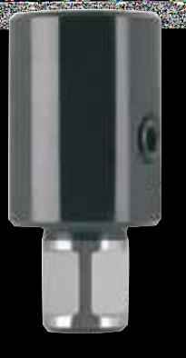
Adapter for thread taps with Weldon shank (3/4“)

in magnetic-stand drilling machines RS25e and RS40e

Packing unit: individual plastic pack

 | thread tap |  | For thread tap | Square | Article no.
 |  |  | Ø-shank mm | mm
 | M 8 |  | 6,0 |  | 108 192 |  |  | 1
 | M 10 |  | 7,0 | 5,5 | 108 193 |  |  | 1
 | M 12 |  | 9,0 | 7,0 | 108 194 |  |  | 1
 | M 14 |  | 11,0 | 9,0 | 108 195 |  |  | 1
 | M 16 |  | 12,0 | 9,0 | 108 196 |  |  | 1

 | thread tap |  | For thread tap |  | Square |  | Article no.
 |  |  | Ø-shank mm |  | mm
 | M 18 |  | 14,0 |  | 11,0 |  | 108 197 |  |  | 1
 | M 20 |  | 16,0 |  | 12,0 |  | 108 198 |  |  | 1
 | M 22 / 24 |  | 18,0 |  | 14,5 |  | 108 199 |  |  | 1
 | M 27 |  | 20,0 |  | 16,0 |  | 108 200 |  |  | 1
 | M 30 |  | 22,0 |  | 18,0 |  | 108 201 |  |  | 1

Adapter for magnetic-stand drilling machines as an addition to using a ratchet
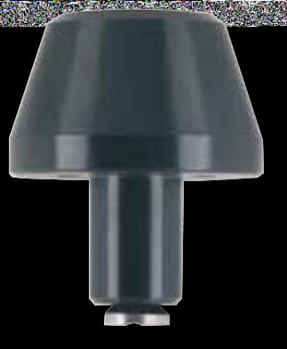

Packing unit: individual plastic pack

 | Article no. |  |  |  |  |  |  |  |  | Article no.

Adapter small, fits magnetic-stand | 108 164 | 1 |  |  | Adapter large, fits magnetic-stand | 108 165 | 1
drilling machines |  |  |  |  | drilling machines
RS5e / 10 |  |  |  |  | rS25e / 40e / 125e / 126e / 140e

Ratchet for RS5e
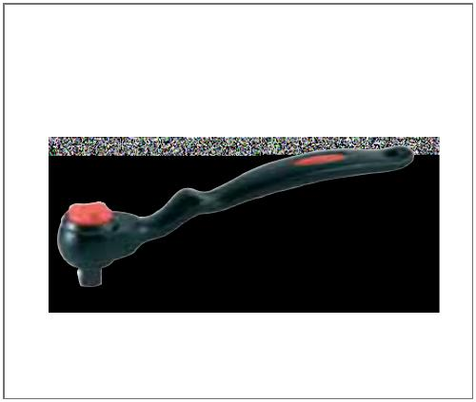

Bei beengten Platzverhältnissen anstatt griffstern verwendbar.

Packing unit: individual plastic pack

Article no.

Ratchet for RS5e | 108 205 | 1
3/8“ square

108 205

28 PreCiSion toolS

Magnetic chip lifter

the rUKo magnetic chip lifter attracts metal chips thanks to its strong magnet.

Pulling back the magnet into its housing simply allows the chips to drop off again.

ideal for removing the chips on magnetic-stand drilling machines and difficult to reach areas.

Packing unit: individual plastic pack

Article no.

Magnetic chip lifter, | 108 202 | 1
400,0 mm

Splash guard for magnetic-stand drilling machines

Packing unit: individual plastic pack

Article no.

Splash guard large, fits magnetic-stand drilling | 108 203 | 1
machines rS40e / 140e
Splash guard small, fits magnetic-stand drilling | 108 204 | 1
machines rS5e / 10 / 25e / 125e / 126e

108 202
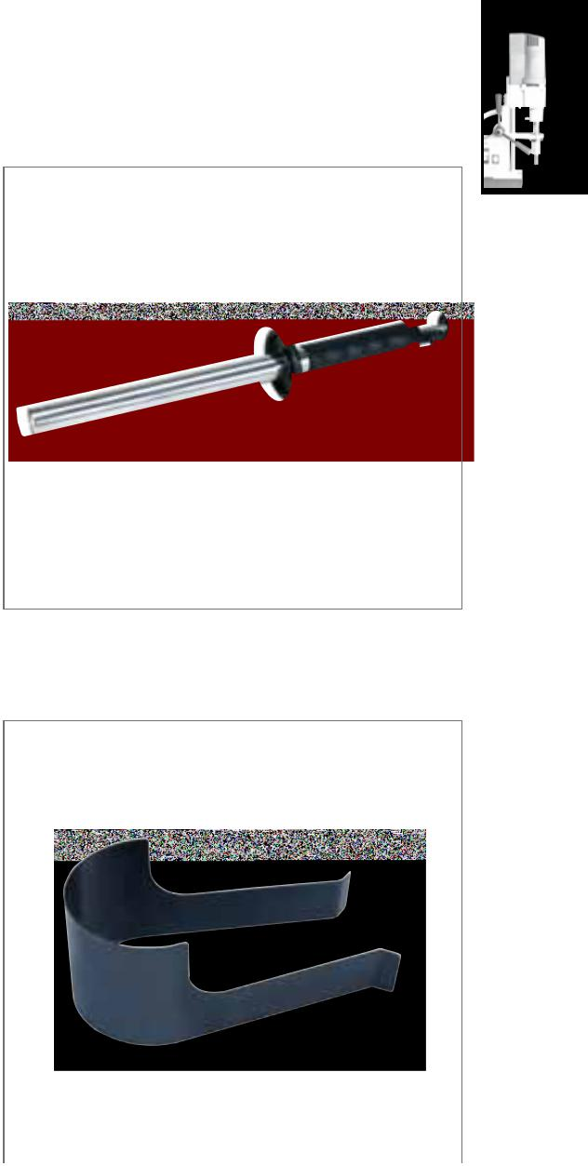

108 204

Cooling bottles (RS5e / 10 / 25e / 40e)

Packing unit: individual carton

Article no.

Cooling-spray bottle, 500 ml | 108 101 | 1
Cooling bottle with regulating tap, 500 ml | 108 122 | 1

108 101
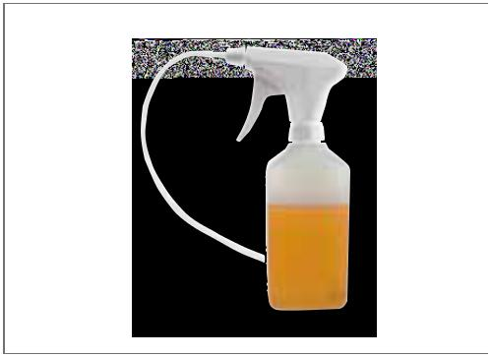

overview of thread tap shaft diameters

 | Ø-shank |  | DIN 352 |  | DIN 357 / |  | DIN 371 |  |  | UNC / UNF ≈ DIN |  | DIN 374 | UNC / UNF ≈ | DIN 5156 |  | DIN 40433
 | mm |  |  |  | DIN 376 |  |  |  |  | 371 |  |  | DIN 376
 | 6,0 |  | M 4,5 - M 8 |  | M 8 |  | M 5 / M 6 |  |  | Nr. 10/12 / 1/4" |  | MF 8 |  | G 1/8" |  | PG 7
 | 7,0 |  | M 9 / M 10 |  | M 9 / M 10 |  | M | 7 |  |  |  | MF 10
 | 8,0 |  | M 11 |  | M 11 |  | M | 8 |  | 5/16" |  |  | 7/16"
 | 9,0 |  | M 12 |  | M 12 |  | M | 9 |  |  |  | MF 12 | 1/2" |  |  | PG 9
 | 10,0 |  |  |  |  |  | M 10 |  |  | 3/8"
 | 11,0 |  | M 14 |  | M 14 |  |  |  |  |  |  | MF 14 | 9/16" | G 1/4" |  | PG 11
 | 12,0 |  | M 16 |  | M 16 |  |  |  |  |  |  | MF 16 | 5/8" | G 3/8" |  | PG 13,5
 | 14,0 |  | M 18 |  | M 18 |  |  |  |  |  |  | MF 18 | 3/4"
 | 16,0 |  | M 20 |  | M 20 |  |  |  |  |  |  | MF 20 |  | G 1/2"
 | 18,0 |  | M 22 / M 24 |  | M 22 / M 24 |  |  |  |  |  |  | MF 22 / MF 24 | 7/8" / 1" |  |  | PG 21
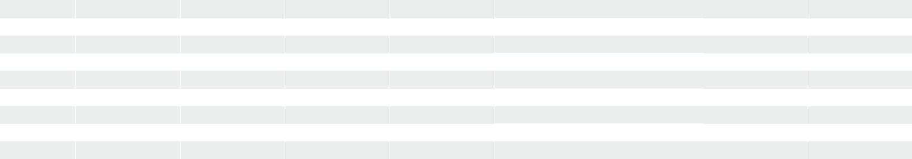

PreCiSion toolS 29

Solid drills with Weldon shank (3/4")
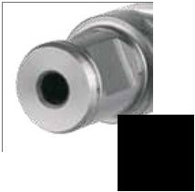

For use in magnetic-stand and pillar drilling machines with morse taper retainer. in connection with rUKo arbor holders no. 108 302 / 108 303 / 108 315 / 108 316, with RUKO EasyLock no. 108 312 / 108 313 / 108 314 or a weldon direct shank such as the rUKo magnetic-stand rS5e / RS10 drill.

Handling

• Push Solid drill „Solid 3S“ into arbor and tighten hexagon socket screw firmly.

- Check proper seating of Solid drill „Solid 3S“ in arbor holder.

• With the EasyLock arbor, the Solid drill „Solid 3S“ gets automatically locked.

- Drill to full dimension straight away. No centring or pre-drilling required.

- the blade geometry of the Solid drill „Solid 3S“ permits rapid upward chip removal.

- observe table of cutting speeds and employ appropriate cooling agent.

Core drills with Weldon shank (3/4")
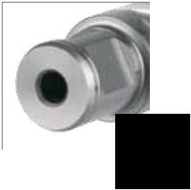

For use in magnetic-stand and pillar drilling machines with morse taper retainer. in connection with rUKo arbor holders no. 108 302 / 108 303 / 108 315 / 108 316, with RUKO EasyLock no. 108 312 / 108 313 / 108 314 or a weldon direct shank such as the rUKo magnetic-stand rS5e / RS10 drill.

Handling

- Insert Weldon shank ejector pin into core drill.

- Push core drill into arbor and tighten hexagon socket screw firmly.

• Check proper seating of core drill in arbor holder.

- With the EasyLock arbor, the core drill gets automatically locked.

- Drill to full dimension straight away. No centring or pre-drilling required.

- the blade geometry of the core drill permits rapid upward chip removal.

- The spring-loaded ejector pin facilitates removal of the cut-out.

- observe table of cutting speeds and employ appropriate cooling agent.

Core drills hSS with Quick in-shank
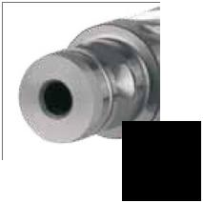

For use in magnetic-stand and column drilling machines in connection with Quick IN-adapter as the Fein KBM 32 Q.

Handling

• Insert ejector pin into core drill.

- Push core drill into Quick in-adapter.

- Drill to full dimension straight away. No centring or pre-drilling required.

• the blade geometry of the core drill permits rapid upward chip removal.

- The spring-loaded ejector pin facilitates removal of the cut-outs.

- observe table of cutting speeds and employ appropriate cooling agent.

Core drills with threaded retainer
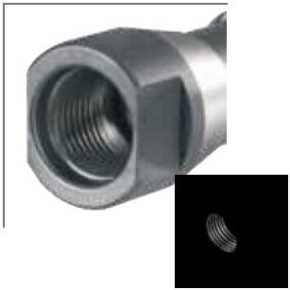

For use in magnetic-stand and pillar drilling machines with morse taper retainer. In connection with RUKO arbor holders no. 108 102 / 108 103 / 108 104 / 108 105 or a threaded retainer such as the Fein KBM 542 / KBM 65.

Handling

- Screw core drill into arbor holder.

• Drill to full dimension straight away. No centring or pre-drilling required.

- the blade geometry of the core drill permits rapid upward chip removal.

- The spring-loaded ejector pin facilitates removal of the cut-outs.

- observe table of cutting speeds and employ appropriate cooling agent.

30 | PreCiSion toolS

HSS |  |  |  |  |  |  | A10 / RS5e / RS10 / RS25e / RS40e
 |  |  |  |  |  |  | RS125e / RS126e / RS140e

Solid drills „Solid 3S“ with Weldon shank (3/4"),

CBN ground and 3 cutting edges, cutting depth 30,0 mm

The spiral-grooved geometry with 3 cutting edges ensures extremely high stability of the

"Solid 3S" solid drill, thus preventing the risk of breakage of the cutting edges by overloading or jam-ming of the chips. Thanks to the high stability, the service life of the "Solid 3S" is considerably increased. this reduces the costs of use. The "Solid 3S" enables drilling to full dimension without centring or pre-drilling. The "Solid 3S" can be ground more simply than core drills of the same diameter.
Ø1
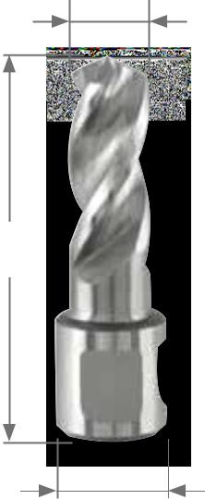

L1

Ø2

Packing unit: in plastic tubes of 1

reduces the risk of breakage compared to core drills up to
- 15.0 mm. Cooling required.

Steel (N/mm2) < 900

Steel (N/mm2) < 1100

Steel (N/mm2) < 1300

rust-resistant steel

Aluminium

Brass

Bronze

Plastics

Cast iron

titanium alloyed
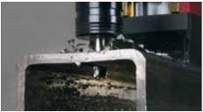

 | Ø1 |  | Ø2 |  | L1 |  | Cutting depth |  | HSS
 | mm |  | mm |  | mm |  | mm
 | 10,0 |  | 19,0 |  | 64,0 |  | 30,0 |  | 108 1210 |  |  | 1
 | 11,0 |  | 19,0 |  | 64,0 |  | 30,0 |  | 108 1211 |  |  | 1
 | 12,0 |  | 19,0 |  | 64,0 |  | 30,0 |  | 108 1212 |  |  | 1
 | 13,0 |  | 19,0 |  | 64,0 |  | 30,0 |  | 108 1213 |  |  | 1
 | 14,0 |  | 19,0 |  | 64,0 |  | 30,0 |  | 108 1214 |  |  | 1
 | 15,0 |  | 19,0 |  | 64,0 |  | 30,0 |  | 108 1215 |  |  | 1
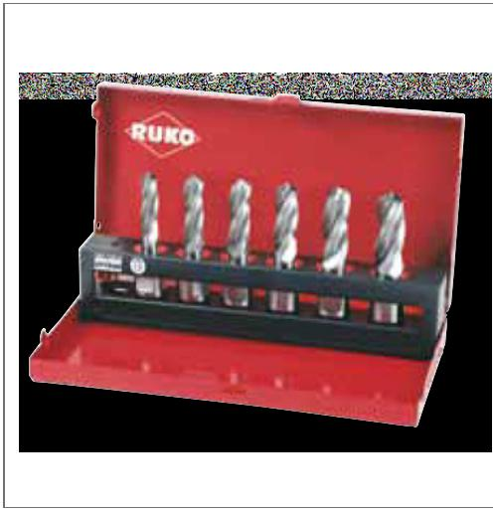
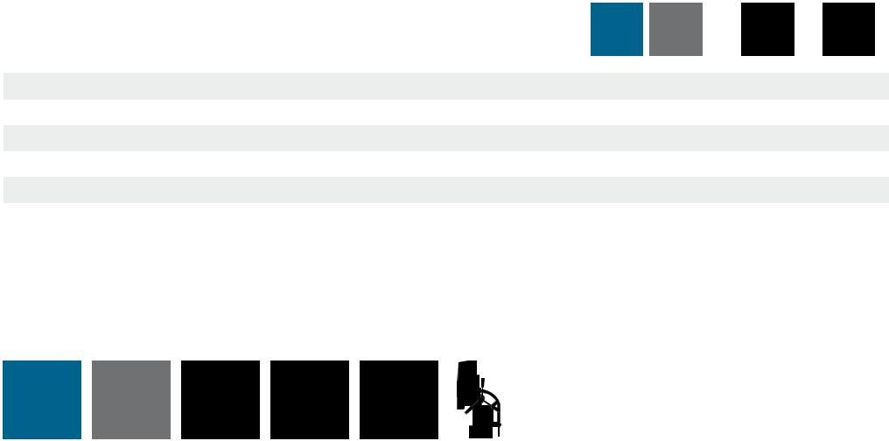

HSS |  |  |  |  |  |  | A10 / RS5e / RS10 / RS25e / RS40e
 |  |  |  |  |  |  | RS126e / RS140e

Solid drills „Solid 3S“ with Weldon shank (3/4")

and 3 cutting edges in steel case

HSS

6- piece set of solid drills „Solid 3S“ HSS | 108 830
- 10,0 mm - 11,0 mm - 12,0 mm - 13,0 mm - 14,0 mm - 15,0 mm

Main application other application

PreCiSion toolS | 31

HSS | HSSE |  |  |  |  |  |  | A10 / RS5e / RS10 / RS25e / RS40e
 | Co 5 |  |  |  |  |  |  | RS125e / RS126e / RS140e

Core drills HSS and HSSE-Co 5 with Weldon shank (3/4"), CBN ground, cutting depth 30,0 mm

Ejector pin: Article no. 108 304 (Ø 6,35 x 77,0 mm)

Packing unit: in plastic tubes of 1

 |  | Steel (N/mm2) < 900 |  |  |  |  |  |  |  |  |  |  |  |  |  |  |  |  | Brass
 |  | Steel (N/mm2) < 1100 |  |  |  |  |  |  |  |  |  |  |  |  |  |  |  |  | Bronze
 |  | Steel (N/mm2) < 1300 |  |  |  |  |  |  |  |  |  |  |  |  |  |  |  |  | Plastics
 |  | rust-resistant steel |  |  |  |  |  |  |  |  |  |  |  |  |  |  |  |  | Cast iron
 |  | Aluminium |  |  |  |  |  |  |  |  |  |  |  |  |  |  |  |  | titanium alloyed
 |  |  |  |  |  |  |  |  |  |  |  |  |  |  |  |  |  |  |  |  |  |  |  |  | HSSE
 |  | Ø1 |  |  | Ø2 |  |  |  |  |  | L1 |  |  |  |  |  |  |  | HSS
 |  | mm |  |  | mm |  |  |  |  | mm |  |  |  |  |  |  |  |  |  |  |  |  |  |  | Co 5
 |  | 12,0 |  |  | 19,0 |  |  |  |  | 63,0 |  |  |  |  |  |  |  | 108 212 |  |  |  |  |  |  | 108 212 E
 |  | 13,0 |  |  | 19,0 |  |  |  |  | 63,0 |  |  |  |  |  |  |  | 108 213 |  |  |  |  |  |  | 108 213 E
 |  | 14,0 |  |  | 19,0 |  |  |  |  | 63,0 |  |  |  |  |  |  |  | 108 214 |  |  |  |  |  |  | 108 214 E
 |  | 15,0 |  |  | 19,0 |  |  |  |  | 63,0 |  |  |  |  |  |  |  | 108 215 |  |  |  |  |  |  | 108 215 E
 |  | 16,0 |  |  | 19,0 |  |  |  |  | 63,0 |  |  |  |  |  |  |  | 108 216 |  |  |  |  |  |  | 108 216 E
 |  | 17,0 |  |  | 19,0 |  |  |  |  | 63,0 |  |  |  |  |  |  |  | 108 217 |  |  |  |  |  |  | 108 217 E
 |  | 18,0 |  |  | 19,0 |  |  |  |  | 63,0 |  |  |  |  |  |  |  | 108 218 |  |  |  |  |  |  | 108 218 E
 |  | 19,0 |  |  | 19,0 |  |  |  |  | 63,0 |  |  |  |  |  |  |  | 108 219 |  |  |  |  |  |  | 108 219 E
 |  | 20,0 |  |  | 19,0 |  |  |  |  | 63,0 |  |  |  |  |  |  |  | 108 220 |  |  |  |  |  |  | 108 220 E
 |  | 21,0 |  |  | 19,0 |  |  |  |  | 63,0 |  |  |  |  |  |  |  | 108 221 |  |  |  |  |  |  | 108 221 E
 |  | 22,0 |  |  | 19,0 |  |  |  |  | 63,0 |  |  |  |  |  |  |  | 108 222 |  |  |  |  |  |  | 108 222 E
 |  | 23,0 |  |  | 19,0 |  |  |  |  | 63,0 |  |  |  |  |  |  |  | 108 223 |  |  |  |  |  |  | 108 223 E
 |  | 24,0 |  |  | 19,0 |  |  |  |  | 63,0 |  |  |  |  |  |  |  | 108 224 |  |  |  |  |  |  | 108 224 E
 |  | 25,0 |  |  | 19,0 |  |  |  |  | 63,0 |  |  |  |  |  |  |  | 108 225 |  |  |  |  |  |  | 108 225 E
 |  | 26,0 |  |  | 19,0 |  |  |  |  | 63,0 |  |  |  |  |  |  |  | 108 226 |  |  |  |  |  |  | 108 226 E
 |  | 27,0 |  |  | 19,0 |  |  |  |  | 63,0 |  |  |  |  |  |  |  | 108 227 |  |  |  |  |  |  | 108 227 E
 |  | 28,0 |  |  | 19,0 |  |  |  |  | 63,0 |  |  |  |  |  |  |  | 108 228 |  |  |  |  |  |  | 108 228 E
 |  | 29,0 |  |  | 19,0 |  |  |  |  | 63,0 |  |  |  |  |  |  |  | 108 229 |  |  |  |  |  |  | 108 229 E
 |  | 30,0 |  |  | 19,0 |  |  |  |  | 63,0 |  |  |  |  |  |  |  | 108 230 |  |  |  |  |  |  | 108 230 E
 |  | 31,0 |  |  | 19,0 |  |  |  |  | 63,0 |  |  |  |  |  |  |  | 108 231 |  |  |  |  |  |  | 108 231 E
 |  | 32,0 |  |  | 19,0 |  |  |  |  | 63,0 |  |  |  |  |  |  |  | 108 232 |  |  |  |  |  |  | 108 232 E
 |  | 33,0 |  |  | 19,0 |  |  |  |  | 63,0 |  |  |  |  |  |  |  | 108 233 |  |  |  |  |  |  | 108 233 E
 |  | 34,0 |  |  | 19,0 |  |  |  |  | 63,0 |  |  |  |  |  |  |  | 108 234 |  |  |  |  |  |  | 108 234 E
 |  | 35,0 |  |  | 19,0 |  |  |  |  | 63,0 |  |  |  |  |  |  |  | 108 235 |  |  |  |  |  |  | 108 235 E
 |  | 36,0 |  |  | 19,0 |  |  |  |  | 63,0 |  |  |  |  |  |  |  | 108 236 |  |  |  |  |  |  | 108 236 E
 |  | 37,0 |  |  | 19,0 |  |  |  |  | 63,0 |  |  |  |  |  |  |  | 108 237 |  |  |  |  |  |  | 108 237 E
 |  | 38,0 |  |  | 19,0 |  |  |  |  | 63,0 |  |  |  |  |  |  |  | 108 238 |  |  |  |  |  |  | 108 238 E
 |  | 39,0 |  |  | 19,0 |  |  |  |  | 63,0 |  |  |  |  |  |  |  | 108 239 |  |  |  |  |  |  | 108 239 E
 |  | 40,0 |  |  | 19,0 |  |  |  |  | 63,0 |  |  |  |  |  |  |  | 108 240 |  |  |  |  |  |  | 108 240 E
 |  | 41,0 |  |  | 19,0 |  |  |  |  | 63,0 |  |  |  |  |  |  |  | 108 241 |  |  |  |  |  |  | 108 241 E
 |  | 42,0 |  |  | 19,0 |  |  |  |  | 63,0 |  |  |  |  |  |  |  | 108 242 |  |  |  |  |  |  | 108 242 E
 |  | 43,0 |  |  | 19,0 |  |  |  |  | 63,0 |  |  |  |  |  |  |  | 108 243 |  |  |  |  |  |  | 108 243 E
 |  | 44,0 |  |  | 19,0 |  |  |  |  | 63,0 |  |  |  |  |  |  |  | 108 244 |  |  |  |  |  |  | 108 244 E
 |  | 45,0 |  |  | 19,0 |  |  |  |  | 63,0 |  |  |  |  |  |  |  | 108 245 |  |  |  |  |  |  | 108 245 E
 |  | 46,0 |  |  | 19,0 |  |  |  |  | 63,0 |  |  |  |  |  |  |  | 108 246 |  |  |  |  |  |  | 108 246 E
 |  | 47,0 |  |  | 19,0 |  |  |  |  | 63,0 |  |  |  |  |  |  |  | 108 247 |  |  |  |  |  |  | 108 247 E
 |  | 48,0 |  |  | 19,0 |  |  |  |  | 63,0 |  |  |  |  |  |  |  | 108 248 |  |  |  |  |  |  | 108 248 E
 |  | 49,0 |  |  | 19,0 |  |  |  |  | 63,0 |  |  |  |  |  |  |  | 108 249 |  |  |  |  |  |  | 108 249 E
 |  | 50,0 |  |  | 19,0 |  |  |  |  | 63,0 |  |  |  |  |  |  |  | 108 250 |  |  |  |  |  |  | 108 250 E
 |  | 51,0 |  |  | 19,0 |  |  |  |  | 63,0 |  |  |  |  |  |  |  | 108 251 |  |  |  |  |  |  | 108 251 E
 |  | 52,0 |  |  | 19,0 |  |  |  |  | 63,0 |  |  |  |  |  |  |  | 108 252 |  |  |  |  |  |  | 108 252 E
 |  | 53,0 |  |  | 19,0 |  |  |  |  | 63,0 |  |  |  |  |  |  |  | 108 253 |  |  |  |  |  |  | 108 253 E
 |  | 54,0 |  |  | 19,0 |  |  |  |  | 63,0 |  |  |  |  |  |  |  | 108 254 |  |  |  |  |  |  | 108 254 E
 |  | 55,0 |  |  | 19,0 |  |  |  |  | 63,0 |  |  |  |  |  |  |  | 108 255 |  |  |  |  |  |  | 108 255 E
 |  | 56,0 |  |  | 19,0 |  |  |  |  | 63,0 |  |  |  |  |  |  |  | 108 256 |  |  |  |  |  |  | 108 256 E
 |  | 57,0 |  |  | 19,0 |  |  |  |  | 63,0 |  |  |  |  |  |  |  | 108 257 |  |  |  |  |  |  | 108 257 E
 |  | 58,0 |  |  | 19,0 |  |  |  |  | 63,0 |  |  |  |  |  |  |  | 108 258 |  |  |  |  |  |  | 108 258 E
 |  | 59,0 |  |  | 19,0 |  |  |  |  | 63,0 |  |  |  |  |  |  |  | 108 259 |  |  |  |  |  |  | 108 259 E
 |  | 60,0 |  |  | 19,0 |  |  |  |  | 63,0 |  |  |  |  |  |  |  | 108 260 |  |  |  |  |  |  | 108 260 E
32 |  |  |  |  | PreCiSion toolS
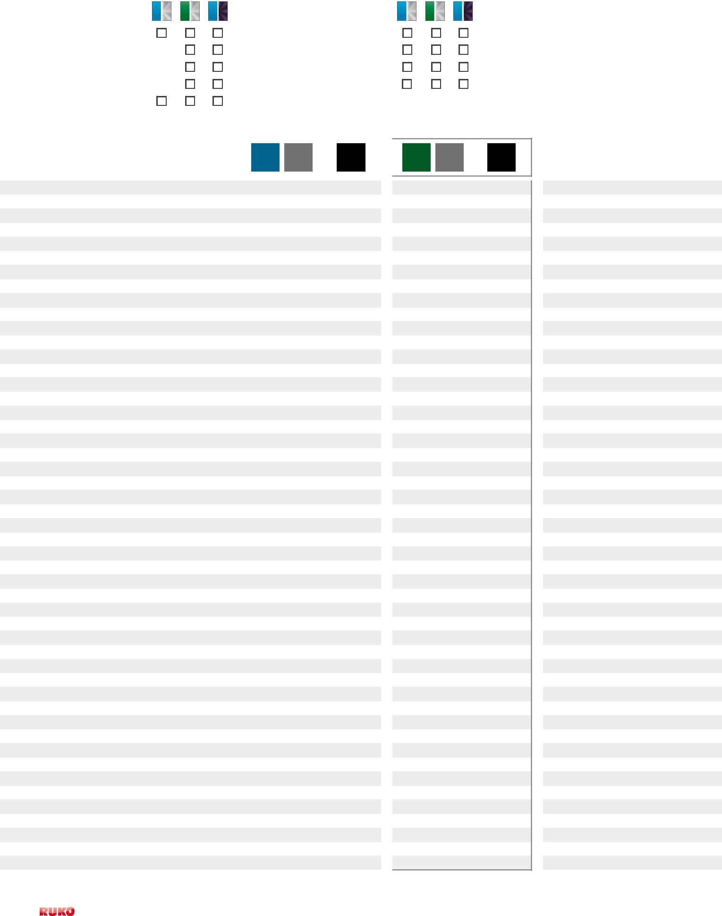
Ø1
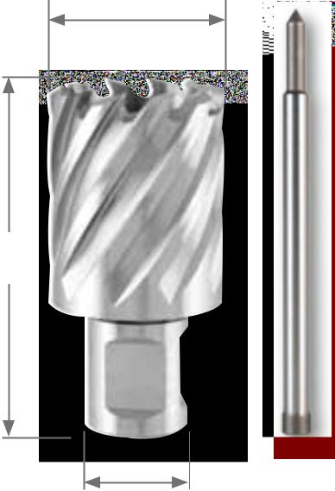

L1

108 304

Ø2

HSS

108 212 F |  | 1
108 213 F |  | 1
108 214 F |  | 1
108 215 F |  | 1
108 216 F |  | 1
108 217 F |  | 1
108 218 F |  | 1
108 219 F |  | 1
108 220 F |  | 1
108 221 F |  | 1
108 222 F |  | 1
108 223 F |  | 1
108 224 F |  | 1
108 225 F |  | 1
108 226 F |  | 1
108 227 F |  | 1
108 228 F |  | 1
108 229 F |  | 1
108 230 F |  | 1
108 231 F |  | 1
108 232 F |  | 1
108 233 F |  | 1
108 234 F |  | 1
108 235 F |  | 1
108 236 F |  | 1
108 237 F |  | 1
108 238 F |  | 1
108 239 F |  | 1
108 240 F |  | 1
108 241 F |  | 1
108 242 F |  | 1
108 243 F |  | 1
108 244 F |  | 1
108 245 F |  | 1
108 246 F |  | 1
108 247 F |  | 1
108 248 F |  | 1
108 249 F |  | 1
108 250 F |  | 1
108 251 F |  | 1
108 252 F |  | 1
108 253 F |  | 1
108 254 F |  | 1
108 255 F |  | 1
108 256 F |  | 1
108 257 F |  | 1
108 258 F |  | 1
108 259 F |  | 1
108 260 F |  | 1

HSS | HSSE |  |  |  |  |  |  | A10 / RS5e / RS10 / RS25e / RS40e
 | Co 5 |  |  |  |  |  |  | RS125e / RS126e / RS140e

Set of core drills HSS and HSSE-Co 5 with Weldon shank (3/4"), CBN ground, cutting depth 30,0 mm in plastic case

 | HSS
10-piece set of core drills with Weldon shank (3/4") | 108 810
8 core drills with weldon shank (3/4")
- 12,0 mm - 14,0 mm - 16,0 mm - 18,0 mm - 20,0 mm - 22,0 mm - 24,0 mm - 26,0 mm + 1 cutting spray 50 ml article-no. 101 010
+ 1 ejector pin Ø 6,35 mm x 77,0 mm for cutting depth 30,0 mm article-no. 108 304

10-piece set of core drills with Weldon shank (3/4") | 108 813
8 core drills with weldon shank (3/4")
- 2 x 14,0 mm - 2 x 16,0 mm - 2 x 18,0 mm - 1 x 20,0 mm - 1 x 22,0 mm + 1 cutting spray 50 ml article-no. 101 010
+ 1 ejector pin Ø 6,35 mm x 77,0 mm for cutting depth 30,0 mm article-no. 108 304
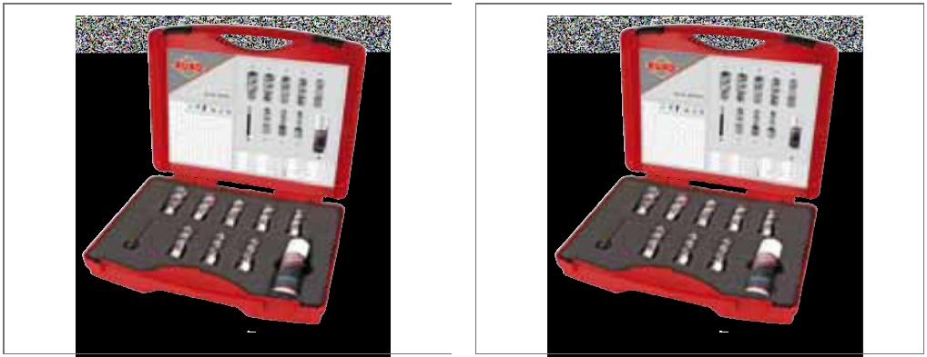

HSSE
Co 5

108 810 E

—
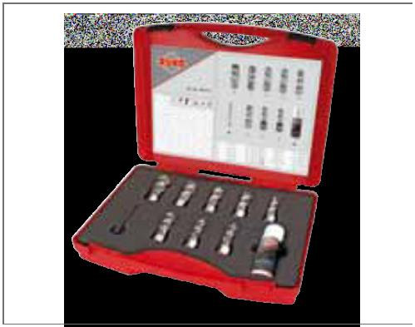

108 810 | 108 810 E | 108 813

Set of core drills HSS and HSSE-Co 5 with Weldon shank (3/4"), CBN ground, cutting depth 30,0 mm in steel case

 | HSS |  |  |  |  | HSSE
 |  |  |  |  |  | Co 5

7-piece set of core drills with weldon shank (3/4") | 108 820 |  |  | —
6 core drills with Weldon shank (3/4")
Ø 12,0 - 14,0 - 16,0 - 18,0 - 20,0 - 22,0 mm
+ 1 ejector pin Ø 6,35 mm x 77,0 mm
for cutting depth 30,0 mm article-no. 108 304
7-piece set of core drills with weldon shank (3/4") | 108 840 |  |  | 108 840 E
6 core drills with Weldon shank (3/4")
Ø 2 x 14,0 mm - 2 x 18,0 mm - 2 x 22,0 mm
+ 1 ejector pin Ø 6,35 mm x 77,0 mm
for cutting depth 30,0 mm article-no. 108 304
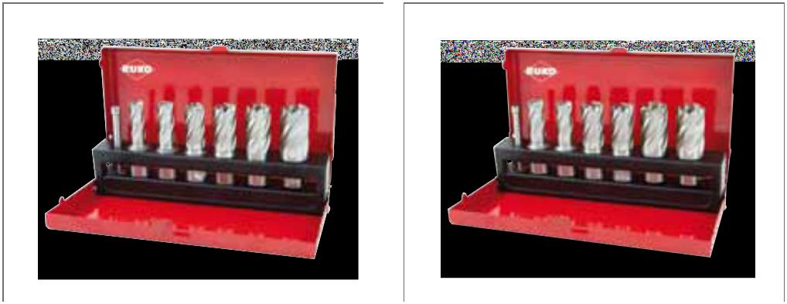

HSS

108 820 F

108 840 F
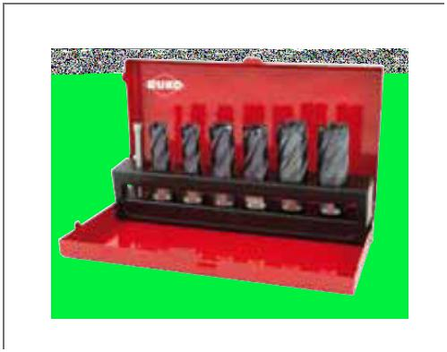

108 820 | 108 840 E | 108 840 F

Main application other application

PreCiSion toolS | 33

HSS | HSSE |  |  |  |  |  |  | RS10 / RS25e / RS40e |  |  | Ø1
 | Co 5 |  | 55,0 mm
 |  |  |  |  |  |  |  | RS125e / RS126e / RS140e
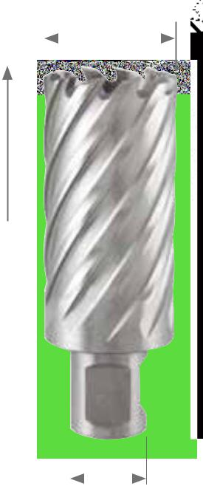

Core drills HSS and HSSE-Co 5 with Weldon shank (3/4"), CBN ground, cutting depth 55,0 mm

Ejector pin: Article no. 108 305 (Ø 6,35 x 102,0 mm)

 |  |  |  |  |  |  |  |  |  |  |  |  |  |  |  |  |  |  |  |  |  |  | L1
Packing unit: in plastic tubes of 1
Steel (N/mm2) < 900 |  |  |  |  |  |  |  |  |  |  |  | Brass
Steel (N/mm2) < 1100 |  |  |  |  |  |  |  |  |  |  |  | Bronze
Steel (N/mm2) < 1300 |  |  |  |  |  |  |  |  |  |  |  | Plastics
rust-resistant steel |  |  |  |  |  |  |  |  |  |  |  | Cast iron |  |  |  |  |  |  |  |  |  |  |  |  |  |  | Ø2
Aluminium |  |  |  |  |  |  |  |  |  |  |  | titanium alloyed

108 305
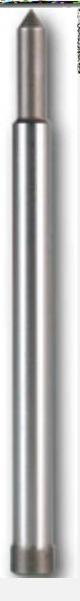

 | Ø1 |  | Ø2 |  | L1 |  | HSS
 | mm |  | mm |  | mm
 | 12,0 |  | 19,0 |  | 88,0 |  | 108 512
 | 13,0 |  | 19,0 |  | 88,0 |  | 108 513
 | 14,0 |  | 19,0 |  | 88,0 |  | 108 514
 | 15,0 |  | 19,0 |  | 88,0 |  | 108 515
 | 16,0 |  | 19,0 |  | 88,0 |  | 108 516
 | 17,0 |  | 19,0 |  | 88,0 |  | 108 517
 | 18,0 |  | 19,0 |  | 88,0 |  | 108 518
 | 19,0 |  | 19,0 |  | 88,0 |  | 108 519
 | 20,0 |  | 19,0 |  | 88,0 |  | 108 520
 | 21,0 |  | 19,0 |  | 88,0 |  | 108 521
 | 22,0 |  | 19,0 |  | 88,0 |  | 108 522
 | 23,0 |  | 19,0 |  | 88,0 |  | 108 523
 | 24,0 |  | 19,0 |  | 88,0 |  | 108 524
 | 25,0 |  | 19,0 |  | 88,0 |  | 108 525
 | 26,0 |  | 19,0 |  | 88,0 |  | 108 526
 | 27,0 |  | 19,0 |  | 88,0 |  | 108 527
 | 28,0 |  | 19,0 |  | 88,0 |  | 108 528
 | 29,0 |  | 19,0 |  | 88,0 |  | 108 529
 | 30,0 |  | 19,0 |  | 88,0 |  | 108 530
 | 31,0 |  | 19,0 |  | 88,0 |  | 108 531
 | 32,0 |  | 19,0 |  | 88,0 |  | 108 532
 | 33,0 |  | 19,0 |  | 88,0 |  | 108 533
 | 34,0 |  | 19,0 |  | 88,0 |  | 108 534
 | 35,0 |  | 19,0 |  | 88,0 |  | 108 535
 | 36,0 |  | 19,0 |  | 88,0 |  | 108 536
 | 37,0 |  | 19,0 |  | 88,0 |  | 108 537
 | 38,0 |  | 19,0 |  | 88,0 |  | 108 538
 | 39,0 |  | 19,0 |  | 88,0 |  | 108 539
 | 40,0 |  | 19,0 |  | 88,0 |  | 108 540
 | 41,0 |  | 19,0 |  | 88,0 |  | 108 541
 | 42,0 |  | 19,0 |  | 88,0 |  | 108 542
 | 43,0 |  | 19,0 |  | 88,0 |  | 108 543
 | 44,0 |  | 19,0 |  | 88,0 |  | 108 544
 | 45,0 |  | 19,0 |  | 88,0 |  | 108 545
 | 46,0 |  | 19,0 |  | 88,0 |  | 108 546
 | 47,0 |  | 19,0 |  | 88,0 |  | 108 547
 | 48,0 |  | 19,0 |  | 88,0 |  | 108 548
 | 49,0 |  | 19,0 |  | 88,0 |  | 108 549
 | 50,0 |  | 19,0 |  | 88,0 |  | 108 550
 | 51,0 |  | 19,0 |  | 88,0 |  | 108 551
 | 52,0 |  | 19,0 |  | 88,0 |  | 108 552
 | 53,0 |  | 19,0 |  | 88,0 |  | 108 553
 | 54,0 |  | 19,0 |  | 88,0 |  | 108 554
 | 55,0 |  | 19,0 |  | 88,0 |  | 108 555
 | 56,0 |  | 19,0 |  | 88,0 |  | 108 556
 | 57,0 |  | 19,0 |  | 88,0 |  | 108 557
 | 58,0 |  | 19,0 |  | 88,0 |  | 108 558
 | 59,0 |  | 19,0 |  | 88,0 |  | 108 559
 | 60,0 |  | 19,0 |  | 88,0 |  | 108 560
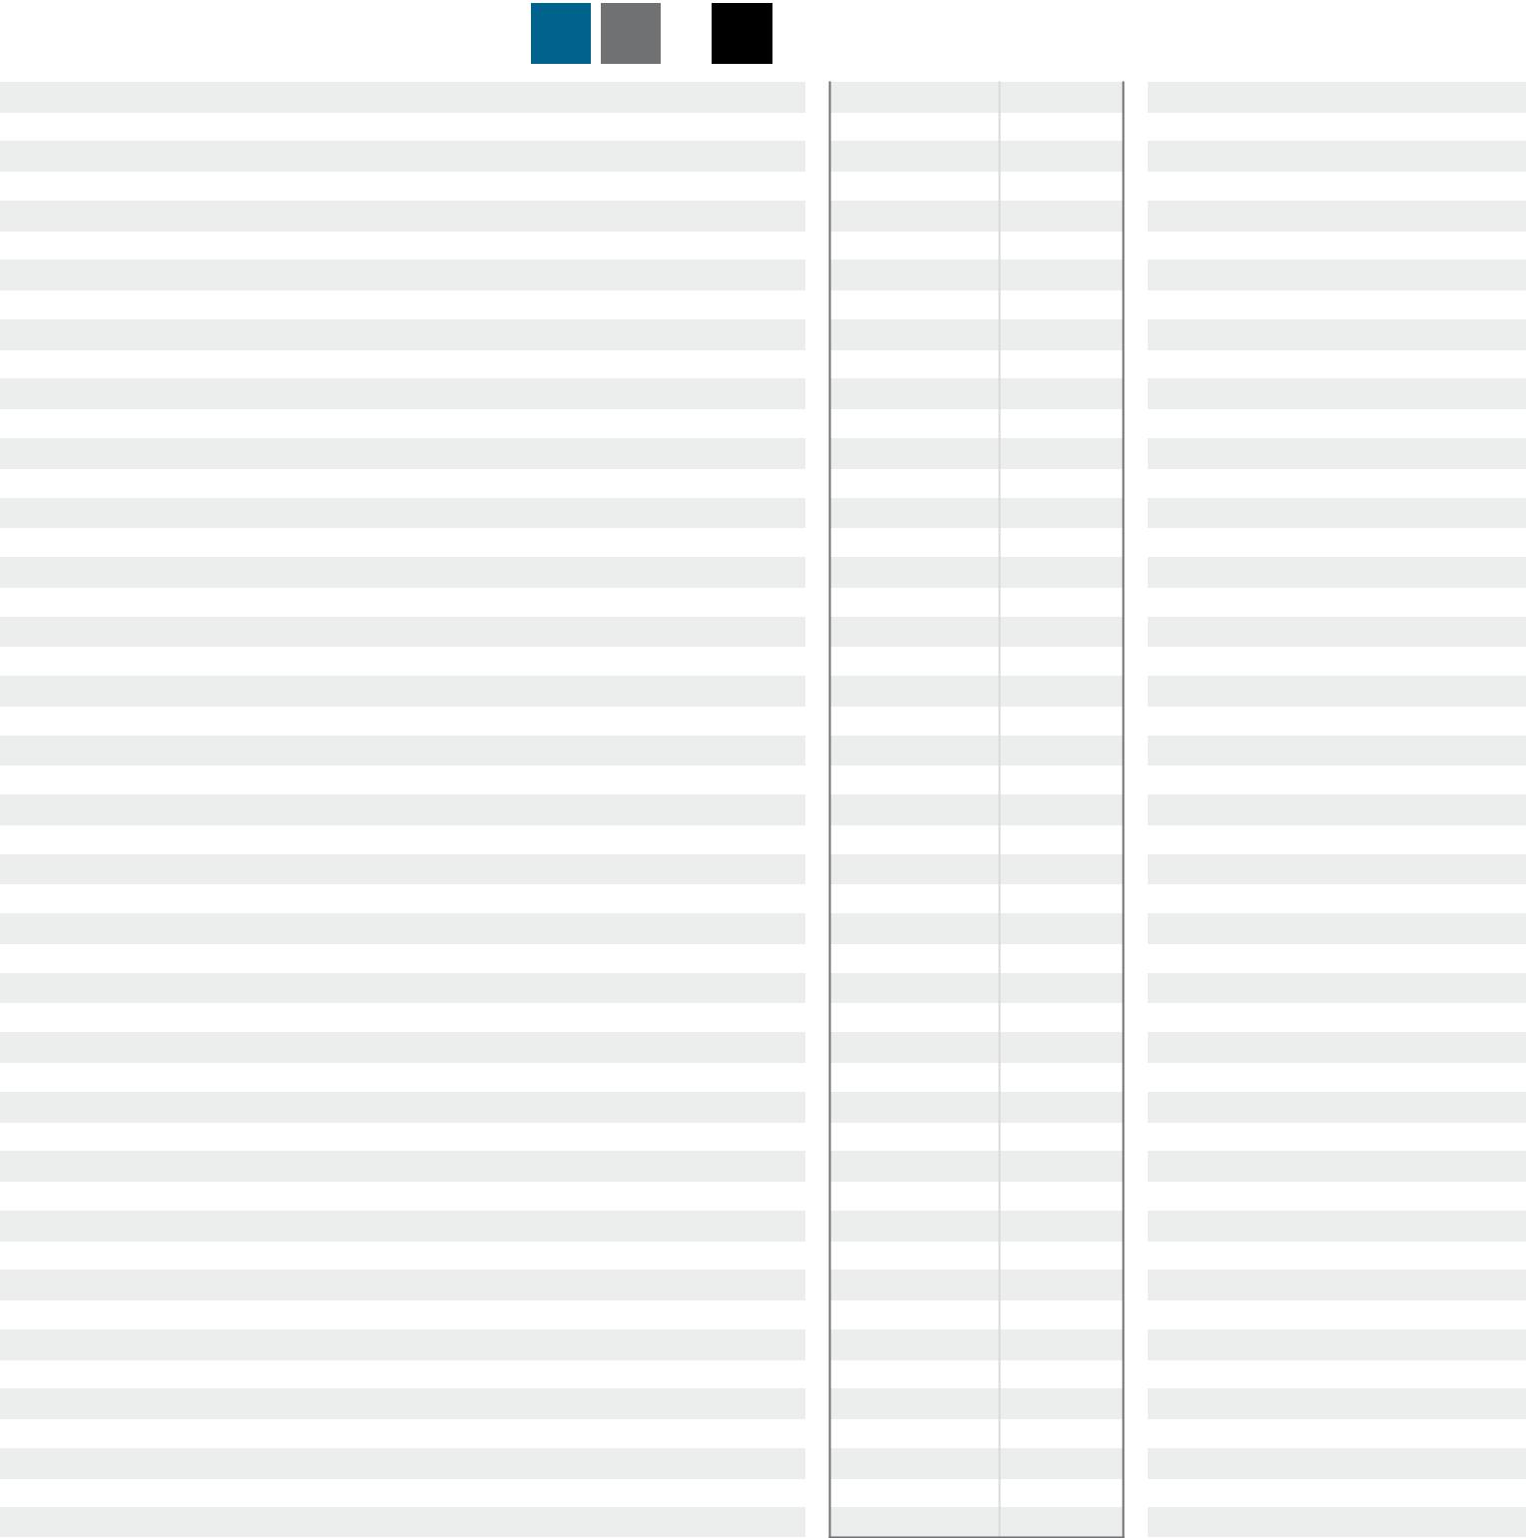

HSSE
Co 5

108 512 E

108 513 E

108 514 E

108 515 E

108 516 E

108 517 E

108 518 E

108 519 E

108 520 E

108 521 E

108 522 E

108 523 E

108 524 E

108 525 E

108 526 E

108 527 E

108 528 E

108 529 E

108 530 E

108 531 E

108 532 E

108 533 E

108 534 E

108 535 E

108 536 E

108 537 E

108 538 E

108 539 E

108 540 E

108 541 E

108 542 E

108 543 E

108 544 E

108 545 E

108 546 E

108 547 E

108 548 E

108 549 E

108 550 E

108 551 E

108 552 E

108 553 E

108 554 E

108 555 E

108 556 E

108 557 E

108 558 E

108 559 E

108 560 E

HSS

108 512 F |  | 1
108 513 F |  | 1
108 514 F |  | 1
108 515 F |  | 1
108 516 F |  | 1
108 517 F |  | 1
108 518 F |  | 1
108 519 F |  | 1
108 520 F |  | 1
108 521 F |  | 1
108 522 F |  | 1
108 523 F |  | 1
108 524 F |  | 1
108 525 F |  | 1
108 526 F |  | 1
108 527 F |  | 1
108 528 F |  | 1
108 529 F |  | 1
108 530 F |  | 1
108 531 F |  | 1
108 532 F |  | 1
108 533 F |  | 1
108 534 F |  | 1
108 535 F |  | 1
108 536 F |  | 1
108 537 F |  | 1
108 538 F |  | 1
108 539 F |  | 1
108 540 F |  | 1
108 541 F |  | 1
108 542 F |  | 1
108 543 F |  | 1
108 544 F |  | 1
108 545 F |  | 1
108 546 F |  | 1
108 547 F |  | 1
108 548 F |  | 1
108 549 F |  | 1
108 550 F |  | 1
108 551 F |  | 1
108 552 F |  | 1
108 553 F |  | 1
108 554 F |  | 1
108 555 F |  | 1
108 556 F |  | 1
108 557 F |  | 1
108 558 F |  | 1
108 559 F |  | 1
108 560 F |  | 1

34 | PreCiSion toolS

HSS |  | RS125e / RS126e
 | 110,0 mm |  | RS140e

Core drills HSS with Weldon shank (3/4"), CBN ground, cutting depth 110,0 mm

Ejector pin: Article no. 108 2000 (Ø 8,0 x 155,0 mm)

Packing unit: in plastic tubes of 1

Ø1
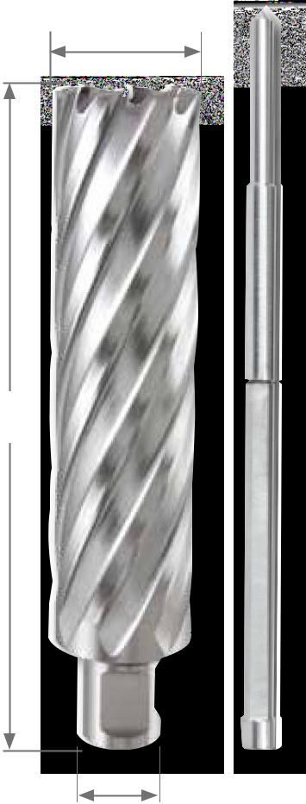

L1

Move core drill out of the hole, remove the chips in the borehole. repeat this procedure several times.

reduces the risk of breakage and increases the service life of the core drill.

Steel (N/mm2) < 900
Steel (N/mm2) < 1100
Steel (N/mm2) < 1300
rust-resistant steel
Aluminium
Brass
Bronze
Plastics
Cast iron
titanium alloyed | Ø2

108 2000

 | Ø1 |  | Ø2 |  | L1 |  | Cutting |  | HSS
 | mm |  | mm |  | mm |  | depth mm
 | 20,0 |  | 19,0 |  | 145,0 |  | 110,0 |  | 108 2020
 | 21,0 |  | 19,0 |  | 145,0 |  | 110,0 |  | 108 2021
 | 22,0 |  | 19,0 |  | 145,0 |  | 110,0 |  | 108 2022
 | 24,0 |  | 19,0 |  | 145,0 |  | 110,0 |  | 108 2024
 | 25,0 |  | 19,0 |  | 145,0 |  | 110,0 |  | 108 2025
 | 26,0 |  | 19,0 |  | 145,0 |  | 110,0 |  | 108 2026
 | 28,0 |  | 19,0 |  | 145,0 |  | 110,0 |  | 108 2028
 | 30,0 |  | 19,0 |  | 145,0 |  | 110,0 |  | 108 2030
 | 32,0 |  | 19,0 |  | 145,0 |  | 110,0 |  | 108 2032
 | 33,0 |  | 19,0 |  | 145,0 |  | 110,0 |  | 108 2033
 | 34,0 |  | 19,0 |  | 145,0 |  | 110,0 |  | 108 2034
 | 35,0 |  | 19,0 |  | 145,0 |  | 110,0 |  | 108 2035
 | 36,0 |  | 19,0 |  | 145,0 |  | 110,0 |  | 108 2036
 | 38,0 |  | 19,0 |  | 145,0 |  | 110,0 |  | 108 2038
 | 40,0 |  | 19,0 |  | 145,0 |  | 110,0 |  | 108 2040
 | 41,0 |  | 19,0 |  | 145,0 |  | 110,0 |  | 108 2041
 | 42,0 |  | 19,0 |  | 145,0 |  | 110,0 |  | 108 2042
 | 45,0 |  | 19,0 |  | 145,0 |  | 110,0 |  | 108 2045
 | 50,0 |  | 19,0 |  | 145,0 |  | 110,0 |  | 108 2050
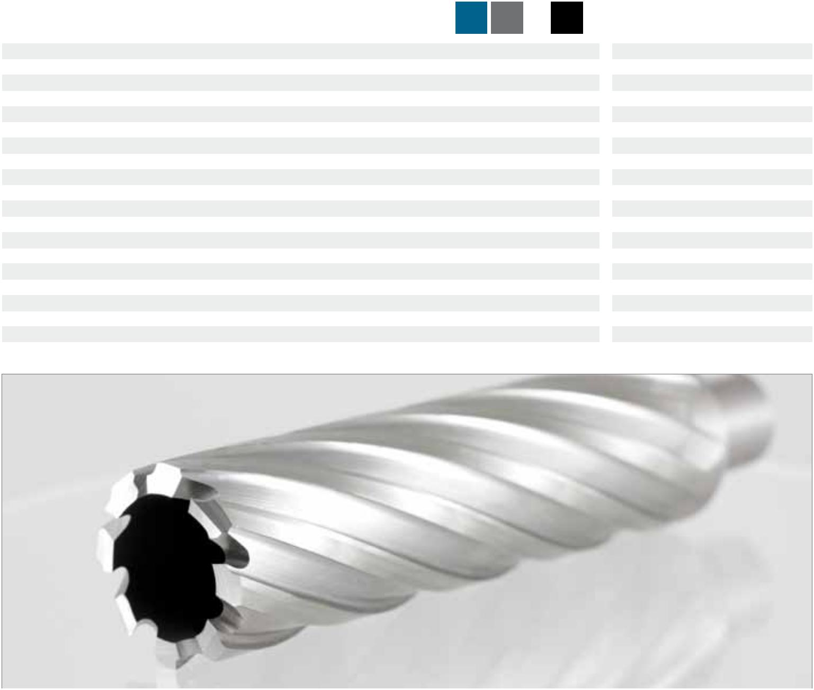

HSS

108 2020 F |  | 1
108 2021 F |  | 1
108 2022 F |  | 1
108 2024 F |  | 1
108 2025 F |  | 1
108 2026 F |  | 1
108 2028 F |  | 1
108 2030 F |  | 1
108 2032 F |  | 1
108 2033 F |  | 1
108 2034 F |  | 1
108 2035 F |  | 1
108 2036 F |  | 1
108 2038 F |  | 1
108 2040 F |  | 1
108 2041 F |  | 1
108 2042 F |  | 1
108 2045 F |  | 1
108 2050 F |  | 1

Main application other application

PreCiSion toolS | 35

HSSE
Co 5 |  | 35,0 mm |  |  |  |  | RS5e / RS10 / RS25e / RS40e
 |  |  |  |  |  |  | RS125e / RS126e / RS140e

Core drills HSSE-Co 5 with Quick IN-shank, CBN ground, cutting depth 35,0 mm

Ejector pin: Article no. 108 306 (Ø 6,35 x 87,0 mm)

Machine no.: with Quick in-adapter

Packing unit: in plastic tubes of 1

Steel (N/mm2) < 900 |  |  |  |  |  |  |  | Brass
Steel (N/mm2) < 1100 |  |  |  |  |  |  |  | Bronze
Steel (N/mm2) < 1300 |  |  |  |  |  |  |  | Plastics
rust-resistant steel |  |  |  |  |  |  |  | Cast iron
Aluminium |  |  |  |  |  |  |  | titanium alloyed
Ø1 |  |  |  |  |  |  |  |  | L1 |  | Cutting
 |  | Ø2
mm |  | mm |  |  |  |  |  |  | mm |  | depth mm
12,0 |  | 18,0 |  |  |  |  |  |  | 77,0 |  | 35,0
13,0 |  | 18,0 |  |  |  |  |  |  | 77,0 |  | 35,0
14,0 |  | 18,0 |  |  |  |  |  |  | 77,0 |  | 35,0
15,0 |  | 18,0 |  |  |  |  |  |  | 77,0 |  | 35,0
16,0 |  | 18,0 |  |  |  |  |  |  | 77,0 |  | 35,0
17,0 |  | 18,0 |  |  |  |  |  |  | 77,0 |  | 35,0
18,0 |  | 18,0 |  |  |  |  |  |  | 77,0 |  | 35,0
19,0 |  | 18,0 |  |  |  |  |  |  | 77,0 |  | 35,0
20,0 |  | 18,0 |  |  |  |  |  |  | 77,0 |  | 35,0
21,0 |  | 18,0 |  |  |  |  |  |  | 77,0 |  | 35,0
22,0 |  | 18,0 |  |  |  |  |  |  | 77,0 |  | 35,0
23,0 |  | 18,0 |  |  |  |  |  |  | 77,0 |  | 35,0
24,0 |  | 18,0 |  |  |  |  |  |  | 77,0 |  | 35,0
25,0 |  | 18,0 |  |  |  |  |  |  | 77,0 |  | 35,0
26,0 |  | 18,0 |  |  |  |  |  |  | 77,0 |  | 35,0
27,0 |  | 18,0 |  |  |  |  |  |  | 77,0 |  | 35,0
28,0 |  | 18,0 |  |  |  |  |  |  | 77,0 |  | 35,0
29,0 |  | 18,0 |  |  |  |  |  |  | 77,0 |  | 35,0
30,0 |  | 18,0 |  |  |  |  |  |  | 77,0 |  | 35,0
32,0 |  | 18,0 |  |  |  |  |  |  | 77,0 |  | 35,0
35,0 |  | 18,0 |  |  |  |  |  |  | 77,0 |  | 35,0
36,0 |  | 18,0 |  |  |  |  |  |  | 77,0 |  | 35,0
40,0 |  | 18,0 |  |  |  |  |  |  | 77,0 |  | 35,0
45,0 |  | 18,0 |  |  |  |  |  |  | 77,0 |  | 35,0
50,0 |  | 18,0 |  |  |  |  |  |  | 77,0 |  | 35,0
55,0 |  | 18,0 |  |  |  |  |  |  | 77,0 |  | 35,0
60,0 |  | 18,0 |  |  |  |  |  |  | 77,0 |  | 35,0
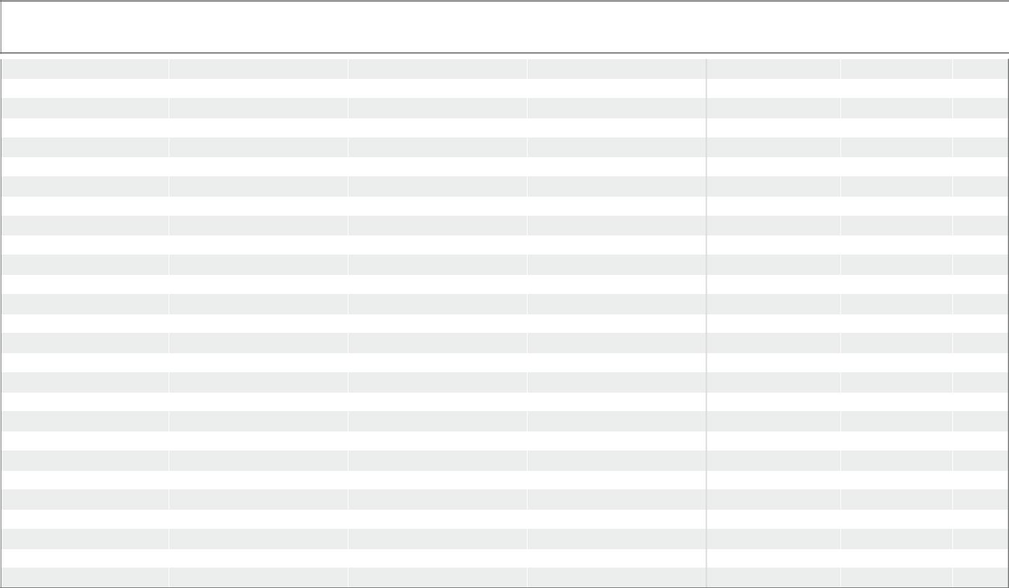

Set of core drills HSSE-Co 5 with Quick IN-shank, CBn ground in plastic case

 |  |  | HSSE
 |  |  | Co 5
 | 10-piece set of core drills HSSE-Co 5 with Quick in-shank |  | 108 811 E
 | 8 core drills HSSE-Co 5
 | Ø 12,0 mm - 14,0 mm - 16,0 mm - 18,0 mm
 | 20,0 mm - 22,0 mm - 24,0 mm - 26,0 mm
 | + 1 cutting spray 50 ml article no. 101 010
 | + 1 ejector pin Ø 6,35 x 87,0 mm
 | for cutting depth 35,0 mm article no. 108 306
Ø1
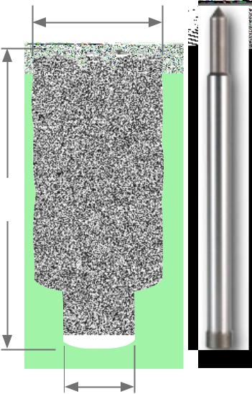

L1

108 306

Ø2

HSSE
Co 5

108 912 E |  | 1
108 913 E |  | 1
108 914 E |  | 1
108 915 E |  | 1
108 916 E |  | 1
108 917 E |  | 1
108 918 E |  | 1
108 919 E |  | 1
108 920 E |  | 1
108 921 E |  | 1
108 922 E |  | 1
108 923 E |  | 1
108 924 E |  | 1
108 925 E |  | 1
108 926 E |  | 1
108 927 E |  | 1
108 928 E |  | 1
108 929 E |  | 1
108 930 E |  | 1
108 932 E |  | 1
108 935 E |  | 1
108 936 E |  | 1
108 940 E |  | 1
108 945 E |  | 1
108 950 E |  | 1
108 955 E |  | 1
108 960 E |  | 1
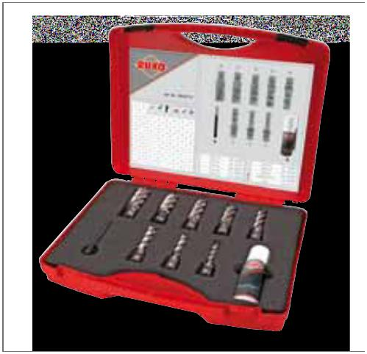

36 PreCiSion toolS

the cutting edge is the important thing ...
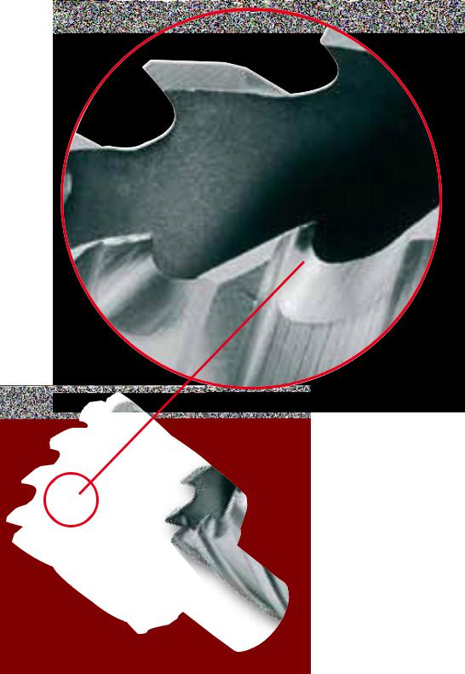

Considerably improved cutting behaviour was attained by research into the cutting geometry, which has a beneficial effect on cutting performance and drill life.

- optimised cutting edge geometry for increased cutting performances and reduced cutting forces.

- the effective cutting angles are designed for universal use in various sorts of steel.

- Improved removal of chips thanks to U-shaped recesses. The specific geometry of the recess reduces the thermal load on the hSS core drill as the heat created in cutting is removed with the chips to a very great extent.

- Reduction of the friction between the HSS core drill and the workpiece thanks to optimised spiral-shaped guide chamfers.

Comparison of cutting times core drills HSS vs. twist drills HSS DIN 345

Work piece: steel girder

Material: construction steel S235JR-according to DIN EN 10025

Cutting depth: 12,0 mm

Machine: rUKo Magnetic-stand drilling machine rS140e

Cutting with twist drills has been made without pilot drilling

directly into the material. no cooling or lubrication has been used.

RUKO core drills will save costs and time. As core drills only cut the width of the teeth and as twist drills cut the entire diameter of the hole, core drills are many times faster (see diagram). Centering and pilot drilling are not necessary anymore.

Core drills cut up to ten times faster than twist drills. Core drills only cut the width of the teeth. The core is ejected.

Lower energy requirements and less wear result in a longer working life. Twist drills have to machine the entire diameter of the hole.

this calls for considerable downward pressure and high driving power.
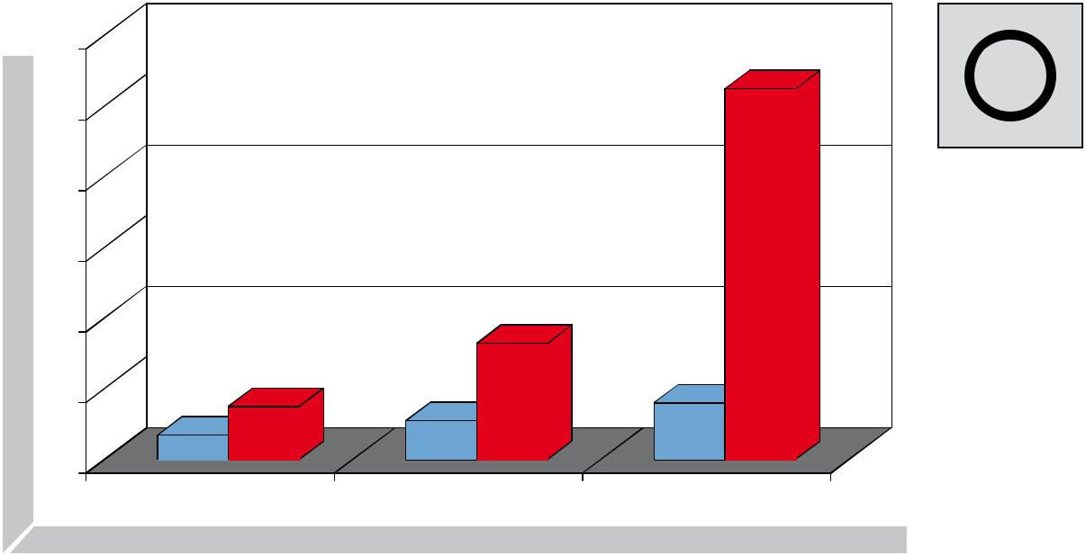

 | 120
inseconds | 100
 | 60
 | 80
time
drilling | 40
 | 20
15
7

0

Ø 12,0 mm

Core drills hSS

105

33

11 ¹⁴

Ø 20,0 mm Ø 30,0 mm

Twist drills HSS DIN 345

Cutting volume with:

Core drills

Cutting volume with:

twist drills

Main application other application

PreCiSion toolS | 37

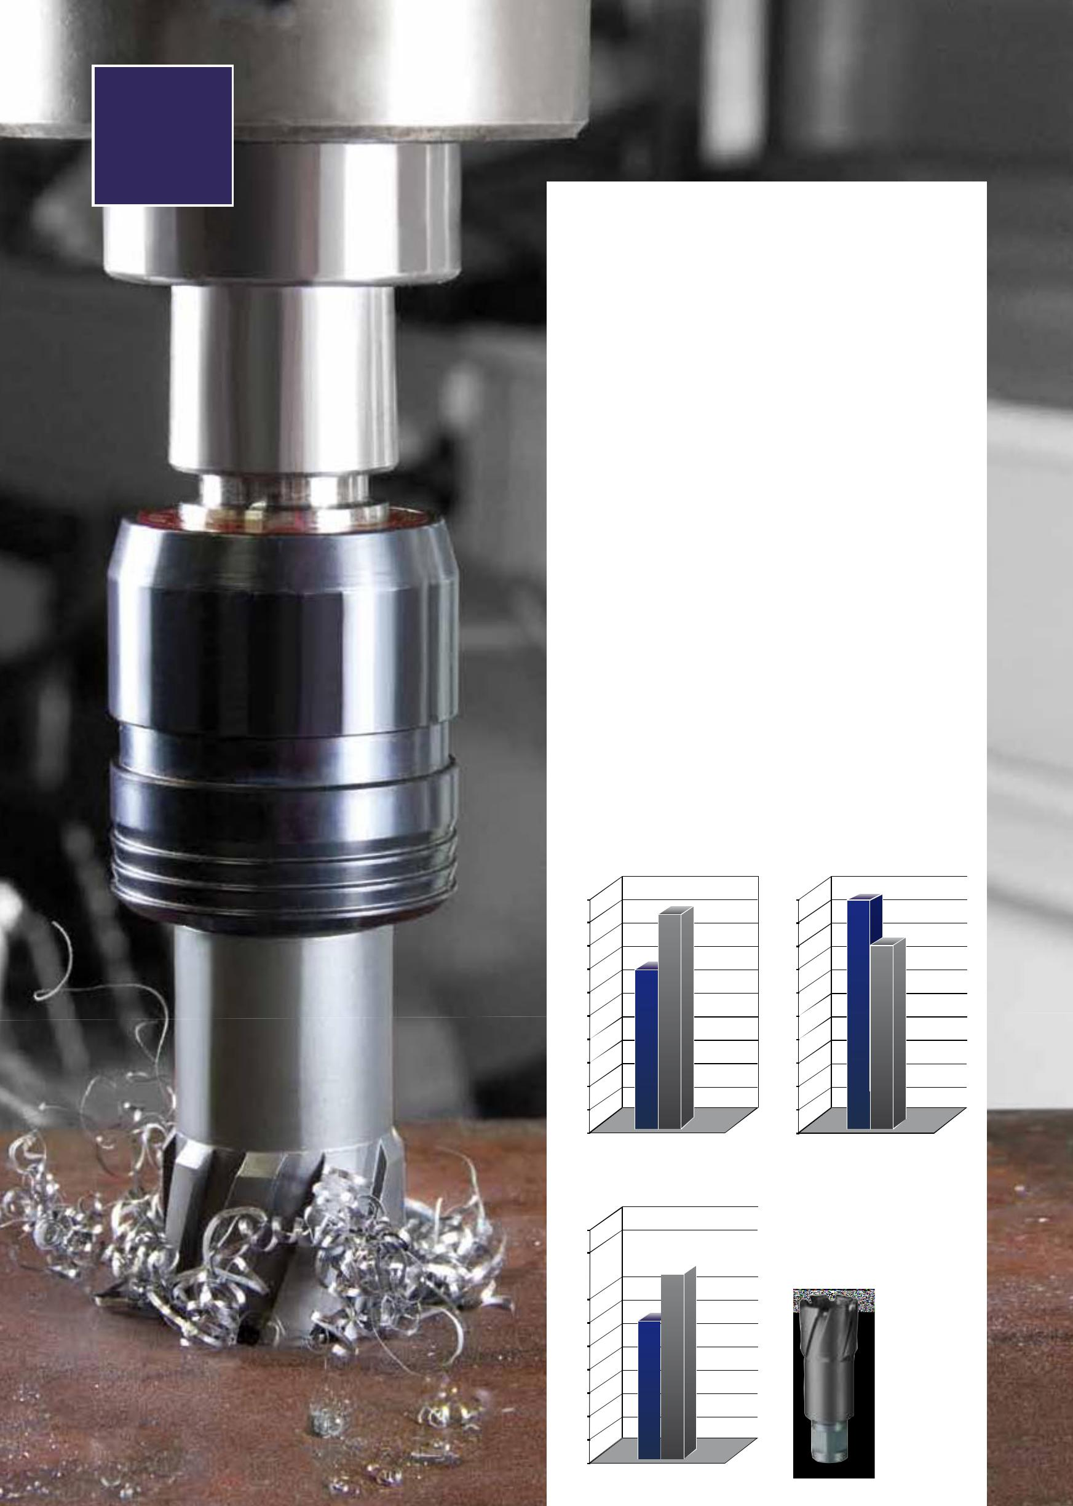

Product information

the rUKo core drills with tecrona coating and tungsten - carbide -

cutting edges can be universally used in non - hardened steels and

super alloys (materials with very high alloy percentages of Al,Ti, ni -

ckel like inconel, hastelloy, Inox, etc.) .

technical data:

Surface: blue - grey

Hardness: 4200 HV

Thickness: 1µm - 7µm

Coefficient of friction: 0. 35

Advantages of the tecrona coating

the tecrona coating is the ideal coating for all drilling works that

stress the tool extremely. It adheres very well to the tool, where

by the wear - resistant coating increases the surface hardness to

approximately 4200 HV. The coefficient of friction is extremely low

in this coating, thereby increasing the service life with low wear.

Applications:

Particularly for rail tracks, Hardox / Weldox steel, steel, cast iron, high -

alloyed chromium steel such as stainless and acid - resistant steel.

Comparison of | Comparison of
hardness | coefficients of friction
5000 | 0,5
4500 | 0,45
4000 | 0,4
3500 | 0,35
3000 | 0,3
2500 | 0,25
2000 | 0,2
1500 | 0,15
1000 | 0,1
500 | 0,05
0 | 0

temperature resistance

1500

1350

TiAlN

Tecrona

38 | PreCiSion toolS

1200

1050

900

750

600

450

300

150

0

TC |  | A10 / RS10 / RS25e / RS40e
 |  | 50,0 mm | RS125e / RS126e / RS140e

Core drills with tungsten-carbide cutting edges and Weldon shank (3/4"), cutting depth 50,0 mm

Suitable for Hardox / Weldox 400 steel

Ejector pin:

- 12,0 mm up to Ø 17,0, Article no. 108 305 (Ø 6,35 x 102,0 mm)

- 18,0 mm up to Ø 50,0, Article no. 108 701 (Ø 8,0 x 112,0 mm)

Packing unit: individual plastic pack

Steel (N/mm2) < 900 |  |  |  |  |  |  |  |  |  |  |  |  |  |  |  |  | Brass
Steel (N/mm2) < 1100 |  |  |  |  |  |  |  |  |  |  |  |  |  |  |  |  | Bronze
Steel (N/mm2) < 1300 |  |  |  |  |  |  |  |  |  |  |  |  |  |  |  |  | Plastics
rust-resistant steel |  |  |  |  |  |  |  |  |  |  |  |  |  |  |  |  | Cast iron
Aluminium |  |  |  |  |  |  |  |  |  |  |  |  |  |  |  |  | titanium alloyed
Ø1 |  |  | Ø2 |  |  | L1 |  |  |  | Cutting |  |  |  |  |  |  |  |  | TC
 | mm |  | mm |  |  | mm |  |  | depth mm
12,0 |  |  | 19,0 |  |  | 84,0 |  |  | 50,0 |  |  |  |  |  |  |  |  |  | 108 712
13,0 |  |  | 19,0 |  |  | 84,0 |  |  | 50,0 |  |  |  |  |  |  |  |  |  | 108 713
14,0 |  |  | 19,0 |  |  | 84,0 |  |  | 50,0 |  |  |  |  |  |  |  |  |  | 108 714
15,0 |  |  | 19,0 |  |  | 84,0 |  |  | 50,0 |  |  |  |  |  |  |  |  |  | 108 715
16,0 |  |  | 19,0 |  |  | 84,0 |  |  | 50,0 |  |  |  |  |  |  |  |  |  | 108 716
17,0 |  |  | 19,0 |  |  | 84,0 |  |  | 50,0 |  |  |  |  |  |  |  |  |  | 108 717
18,0 |  |  | 19,0 |  |  | 84,0 |  |  | 50,0 |  |  |  |  |  |  |  |  |  | 108 718
19,0 |  |  | 19,0 |  |  | 84,0 |  |  | 50,0 |  |  |  |  |  |  |  |  |  | 108 719
20,0 |  |  | 19,0 |  |  | 84,0 |  |  | 50,0 |  |  |  |  |  |  |  |  |  | 108 720
21,0 |  |  | 19,0 |  |  | 84,0 |  |  | 50,0 |  |  |  |  |  |  |  |  |  | 108 721
22,0 |  |  | 19,0 |  |  | 84,0 |  |  | 50,0 |  |  |  |  |  |  |  |  |  | 108 722
23,0 |  |  | 19,0 |  |  | 84,0 |  |  | 50,0 |  |  |  |  |  |  |  |  |  | 108 723
24,0 |  |  | 19,0 |  |  | 84,0 |  |  | 50,0 |  |  |  |  |  |  |  |  |  | 108 724
25,0 |  |  | 19,0 |  |  | 84,0 |  |  | 50,0 |  |  |  |  |  |  |  |  |  | 108 725
26,0 |  |  | 19,0 |  |  | 84,0 |  |  | 50,0 |  |  |  |  |  |  |  |  |  | 108 726
27,0 |  |  | 19,0 |  |  | 84,0 |  |  | 50,0 |  |  |  |  |  |  |  |  |  | 108 727
28,0 |  |  | 19,0 |  |  | 84,0 |  |  | 50,0 |  |  |  |  |  |  |  |  |  | 108 728
29,0 |  |  | 19,0 |  |  | 84,0 |  |  | 50,0 |  |  |  |  |  |  |  |  |  | 108 729
30,0 |  |  | 19,0 |  |  | 84,0 |  |  | 50,0 |  |  |  |  |  |  |  |  |  | 108 730
31,0 |  |  | 19,0 |  |  | 84,0 |  |  | 50,0 |  |  |  |  |  |  |  |  |  | 108 731
32,0 |  |  | 19,0 |  |  | 84,0 |  |  | 50,0 |  |  |  |  |  |  |  |  |  | 108 732
33,0 |  |  | 19,0 |  |  | 84,0 |  |  | 50,0 |  |  |  |  |  |  |  |  |  | 108 733
34,0 |  |  | 19,0 |  |  | 84,0 |  |  | 50,0 |  |  |  |  |  |  |  |  |  | 108 734
35,0 |  |  | 19,0 |  |  | 84,0 |  |  | 50,0 |  |  |  |  |  |  |  |  |  | 108 735
36,0 |  |  | 19,0 |  |  | 84,0 |  |  | 50,0 |  |  |  |  |  |  |  |  |  | 108 736
37,0 |  |  | 19,0 |  |  | 84,0 |  |  | 50,0 |  |  |  |  |  |  |  |  |  | 108 737
38,0 |  |  | 19,0 |  |  | 84,0 |  |  | 50,0 |  |  |  |  |  |  |  |  |  | 108 738
39,0 |  |  | 19,0 |  |  | 84,0 |  |  | 50,0 |  |  |  |  |  |  |  |  |  | 108 739
40,0 |  |  | 19,0 |  |  | 84,0 |  |  | 50,0 |  |  |  |  |  |  |  |  |  | 108 740
41,0 |  |  | 19,0 |  |  | 84,0 |  |  | 50,0 |  |  |  |  |  |  |  |  |  | 108 741
42,0 |  |  | 19,0 |  |  | 84,0 |  |  | 50,0 |  |  |  |  |  |  |  |  |  | 108 742
43,0 |  |  | 19,0 |  |  | 84,0 |  |  | 50,0 |  |  |  |  |  |  |  |  |  | 108 743
44,0 |  |  | 19,0 |  |  | 84,0 |  |  | 50,0 |  |  |  |  |  |  |  |  |  | 108 744
45,0 |  |  | 19,0 |  |  | 84,0 |  |  | 50,0 |  |  |  |  |  |  |  |  |  | 108 745
46,0 |  |  | 19,0 |  |  | 84,0 |  |  | 50,0 |  |  |  |  |  |  |  |  |  | 108 746
47,0 |  |  | 19,0 |  |  | 84,0 |  |  | 50,0 |  |  |  |  |  |  |  |  |  | 108 747
48,0 |  |  | 19,0 |  |  | 84,0 |  |  | 50,0 |  |  |  |  |  |  |  |  |  | 108 748
49,0 |  |  | 19,0 |  |  | 84,0 |  |  | 50,0 |  |  |  |  |  |  |  |  |  | 108 749
50,0 |  |  | 19,0 |  |  | 84,0 |  |  | 50,0 |  |  |  |  |  |  |  |  |  | 108 750
 | Main application |  |  | other application
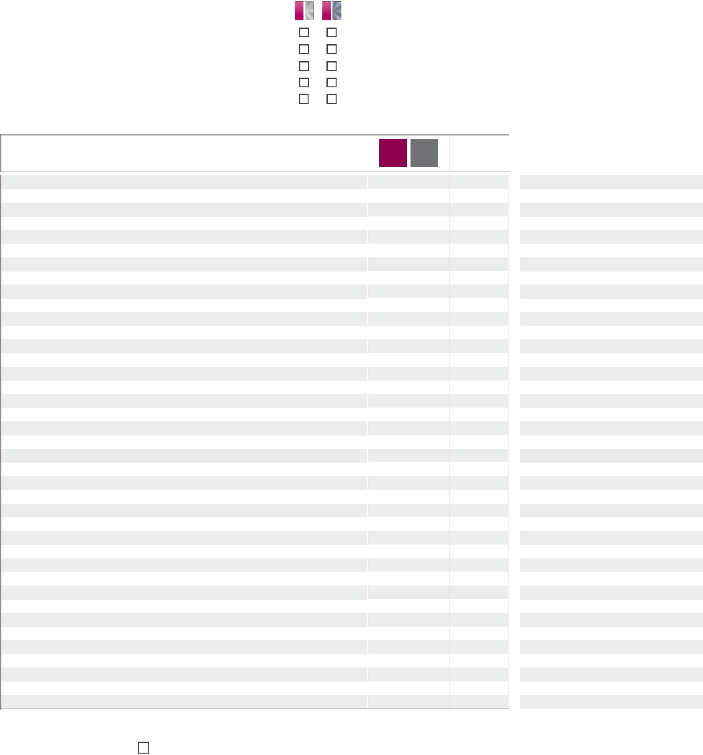

Ø1
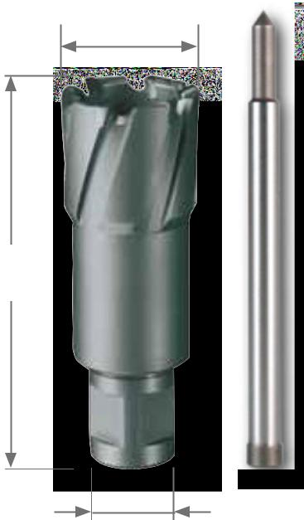

L1

108 305

Ø2
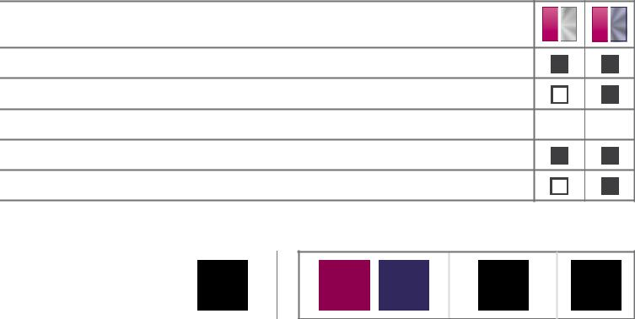

TC

108 712 C |  |  |  | 1
108 713 C |  |  |  | 1
108 714 C |  |  |  | 1
108 715 C |  |  |  | 1
108 716 C |  |  |  | 1
108 717 C |  |  |  | 1
108 718 C |  |  |  | 1
108 719 C |  |  |  | 1
108 720 C |  |  |  | 1
108 721 C |  |  |  | 1
108 722 C |  |  |  | 1
108 723 C |  |  |  | 1
108 724 C |  |  |  | 1
108 725 C |  |  |  | 1
108 726 C |  |  |  | 1
108 727 C |  |  |  | 1
108 728 C |  |  |  | 1
108 729 C |  |  |  | 1
108 730 C |  |  |  | 1
108 731 C |  |  |  | 1
108 732 C |  |  |  | 1
108 733 C |  |  |  | 1
108 734 C |  |  |  | 1
108 735 C |  |  |  | 1
108 736 C |  |  |  | 1
108 737 C |  |  |  | 1
108 738 C |  |  |  | 1
108 739 C |  |  |  | 1
108 740 C |  |  |  | 1
108 741 C |  |  |  | 1
108 742 C |  |  |  | 1
108 743 C |  |  |  | 1
108 744 C |  |  |  | 1
108 745 C |  |  |  | 1
108 746 C |  |  |  | 1
108 747 C |  |  |  | 1
108 748 C |  |  |  | 1
108 749 C |  |  |  | 1
108 750 C |  |  |  | 1
PreCiSion toolS |  |  | 39

TC |  | RS10 / RS25e / RS40e
 | 50,0 mm |  | RS125e / RS126e / RS140e

Core drills with tungsten-carbide and Quick IN-shank, CBN ground, cutting depth 50,0 mm

- 12,0 mm up to Ø 32,0 mm with fixed shank.

- 33,0 mm up to Ø 80,0 mm including Quick IN-adapter No. 108 111.

Machine no.: with Quick in-adapter

Ejector pin: Ø 12,0 mm up to Ø 32,0 mm, article no. 108 305 (Ø 6,35 x 102,0 mm)

Ø 33,0 mm up to Ø 80,0 mm, article no. 108 110 (Ø 6,35 x 123,0 mm)

Packing unit: individual plastic pack

 |  | Steel (N/mm2) < 900 |  |  |  |  |  |  |  |  |  |  |  |  |  |  |  | Brass
 |  | Steel (N/mm2) < 1100 |  |  |  |  |  |  |  |  |  |  |  |  |  |  |  | Bronze
 |  | Steel (N/mm2) < 1300 |  |  |  |  |  |  |  |  |  |  |  |  |  |  |  | Plastics
 |  | rust-resistant steel |  |  |  |  |  |  |  |  |  |  |  |  |  |  |  | Cast iron
 |  | Aluminium |  |  |  |  |  |  |  |  |  |  |  |  |  |  |  | titanium alloyed
 |  | Ø1 |  |  |  | Ø2 |  | L1 |  | Cutting depth |  |  |  |  |  |  |  |  |  | TC
 |  | mm |  |  |  | mm |  | mm |  |  |  | mm
 |  | 12,0 |  |  |  | 18,0 |  | 83,0 |  | 50,0 |  |  |  |  |  |  |  |  |  | 108 1112
 |  | 13,0 |  |  |  | 18,0 |  | 83,0 |  | 50,0 |  |  |  |  |  |  |  |  |  | 108 1113
 |  | 14,0 |  |  |  | 18,0 |  | 83,0 |  | 50,0 |  |  |  |  |  |  |  |  |  | 108 1114
 |  | 15,0 |  |  |  | 18,0 |  | 83,0 |  | 50,0 |  |  |  |  |  |  |  |  |  | 108 1115
 |  | 16,0 |  |  |  | 18,0 |  | 83,0 |  | 50,0 |  |  |  |  |  |  |  |  |  | 108 1116
 |  | 17,0 |  |  |  | 18,0 |  | 83,0 |  | 50,0 |  |  |  |  |  |  |  |  |  | 108 1117
 |  | 18,0 |  |  |  | 18,0 |  | 83,0 |  | 50,0 |  |  |  |  |  |  |  |  |  | 108 1118
 |  | 19,0 |  |  |  | 18,0 |  | 83,0 |  | 50,0 |  |  |  |  |  |  |  |  |  | 108 1119
 |  | 20,0 |  |  |  | 18,0 |  | 83,0 |  | 50,0 |  |  |  |  |  |  |  |  |  | 108 1120
 |  | 21,0 |  |  |  | 18,0 |  | 83,0 |  | 50,0 |  |  |  |  |  |  |  |  |  | 108 1121
 |  | 22,0 |  |  |  | 18,0 |  | 83,0 |  | 50,0 |  |  |  |  |  |  |  |  |  | 108 1122
 |  | 23,0 |  |  |  | 18,0 |  | 83,0 |  | 50,0 |  |  |  |  |  |  |  |  |  | 108 1123
 |  | 24,0 |  |  |  | 18,0 |  | 83,0 |  | 50,0 |  |  |  |  |  |  |  |  |  | 108 1124
 |  | 25,0 |  |  |  | 18,0 |  | 83,0 |  | 50,0 |  |  |  |  |  |  |  |  |  | 108 1125
 |  | 26,0 |  |  |  | 18,0 |  | 83,0 |  | 50,0 |  |  |  |  |  |  |  |  |  | 108 1126
 |  | 27,0 |  |  |  | 18,0 |  | 83,0 |  | 50,0 |  |  |  |  |  |  |  |  |  | 108 1127
 |  | 28,0 |  |  |  | 18,0 |  | 83,0 |  | 50,0 |  |  |  |  |  |  |  |  |  | 108 1128
 |  | 29,0 |  |  |  | 18,0 |  | 83,0 |  | 50,0 |  |  |  |  |  |  |  |  |  | 108 1129
 |  | 30,0 |  |  |  | 18,0 |  | 83,0 |  | 50,0 |  |  |  |  |  |  |  |  |  | 108 1130
 |  | 31,0 |  |  |  | 18,0 |  | 83,0 |  | 50,0 |  |  |  |  |  |  |  |  |  | 108 1131
 |  | 32,0 |  |  |  | 18,0 |  | 83,0 |  | 50,0 |  |  |  |  |  |  |  |  |  | 108 1132
 |  | 33,0 |  |  |  | 18,0 |  | 112,0 |  | 50,0 |  |  |  |  |  |  |  |  |  | 108 1133
 |  | 34,0 |  |  |  | 18,0 |  | 112,0 |  | 50,0 |  |  |  |  |  |  |  |  |  | 108 1134
 |  | 35,0 |  |  |  | 18,0 |  | 112,0 |  | 50,0 |  |  |  |  |  |  |  |  |  | 108 1135
 |  | 36,0 |  |  |  | 18,0 |  | 112,0 |  | 50,0 |  |  |  |  |  |  |  |  |  | 108 1136
 |  | 37,0 |  |  |  | 18,0 |  | 112,0 |  | 50,0 |  |  |  |  |  |  |  |  |  | 108 1137
 |  | 38,0 |  |  |  | 18,0 |  | 112,0 |  | 50,0 |  |  |  |  |  |  |  |  |  | 108 1138
 |  | 39,0 |  |  |  | 18,0 |  | 112,0 |  | 50,0 |  |  |  |  |  |  |  |  |  | 108 1139
 |  | 40,0 |  |  |  | 18,0 |  | 112,0 |  | 50,0 |  |  |  |  |  |  |  |  |  | 108 1140
 |  | 41,0 |  |  |  | 18,0 |  | 112,0 |  | 50,0 |  |  |  |  |  |  |  |  |  | 108 1141
 |  | 42,0 |  |  |  | 18,0 |  | 112,0 |  | 50,0 |  |  |  |  |  |  |  |  |  | 108 1142
 |  | 43,0 |  |  |  | 18,0 |  | 112,0 |  | 50,0 |  |  |  |  |  |  |  |  |  | 108 1143
 |  | 44,0 |  |  |  | 18,0 |  | 112,0 |  | 50,0 |  |  |  |  |  |  |  |  |  | 108 1144
 |  | 45,0 |  |  |  | 18,0 |  | 112,0 |  | 50,0 |  |  |  |  |  |  |  |  |  | 108 1145
 |  | 46,0 |  |  |  | 18,0 |  | 112,0 |  | 50,0 |  |  |  |  |  |  |  |  |  | 108 1146
 |  | 47,0 |  |  |  | 18,0 |  | 112,0 |  | 50,0 |  |  |  |  |  |  |  |  |  | 108 1147
 |  | 48,0 |  |  |  | 18,0 |  | 112,0 |  | 50,0 |  |  |  |  |  |  |  |  |  | 108 1148
 |  | 49,0 |  |  |  | 18,0 |  | 112,0 |  | 50,0 |  |  |  |  |  |  |  |  |  | 108 1149
 |  | 50,0 |  |  |  | 18,0 |  | 112,0 |  | 50,0 |  |  |  |  |  |  |  |  |  | 108 1150
40 |  |  |  | PreCiSion toolS
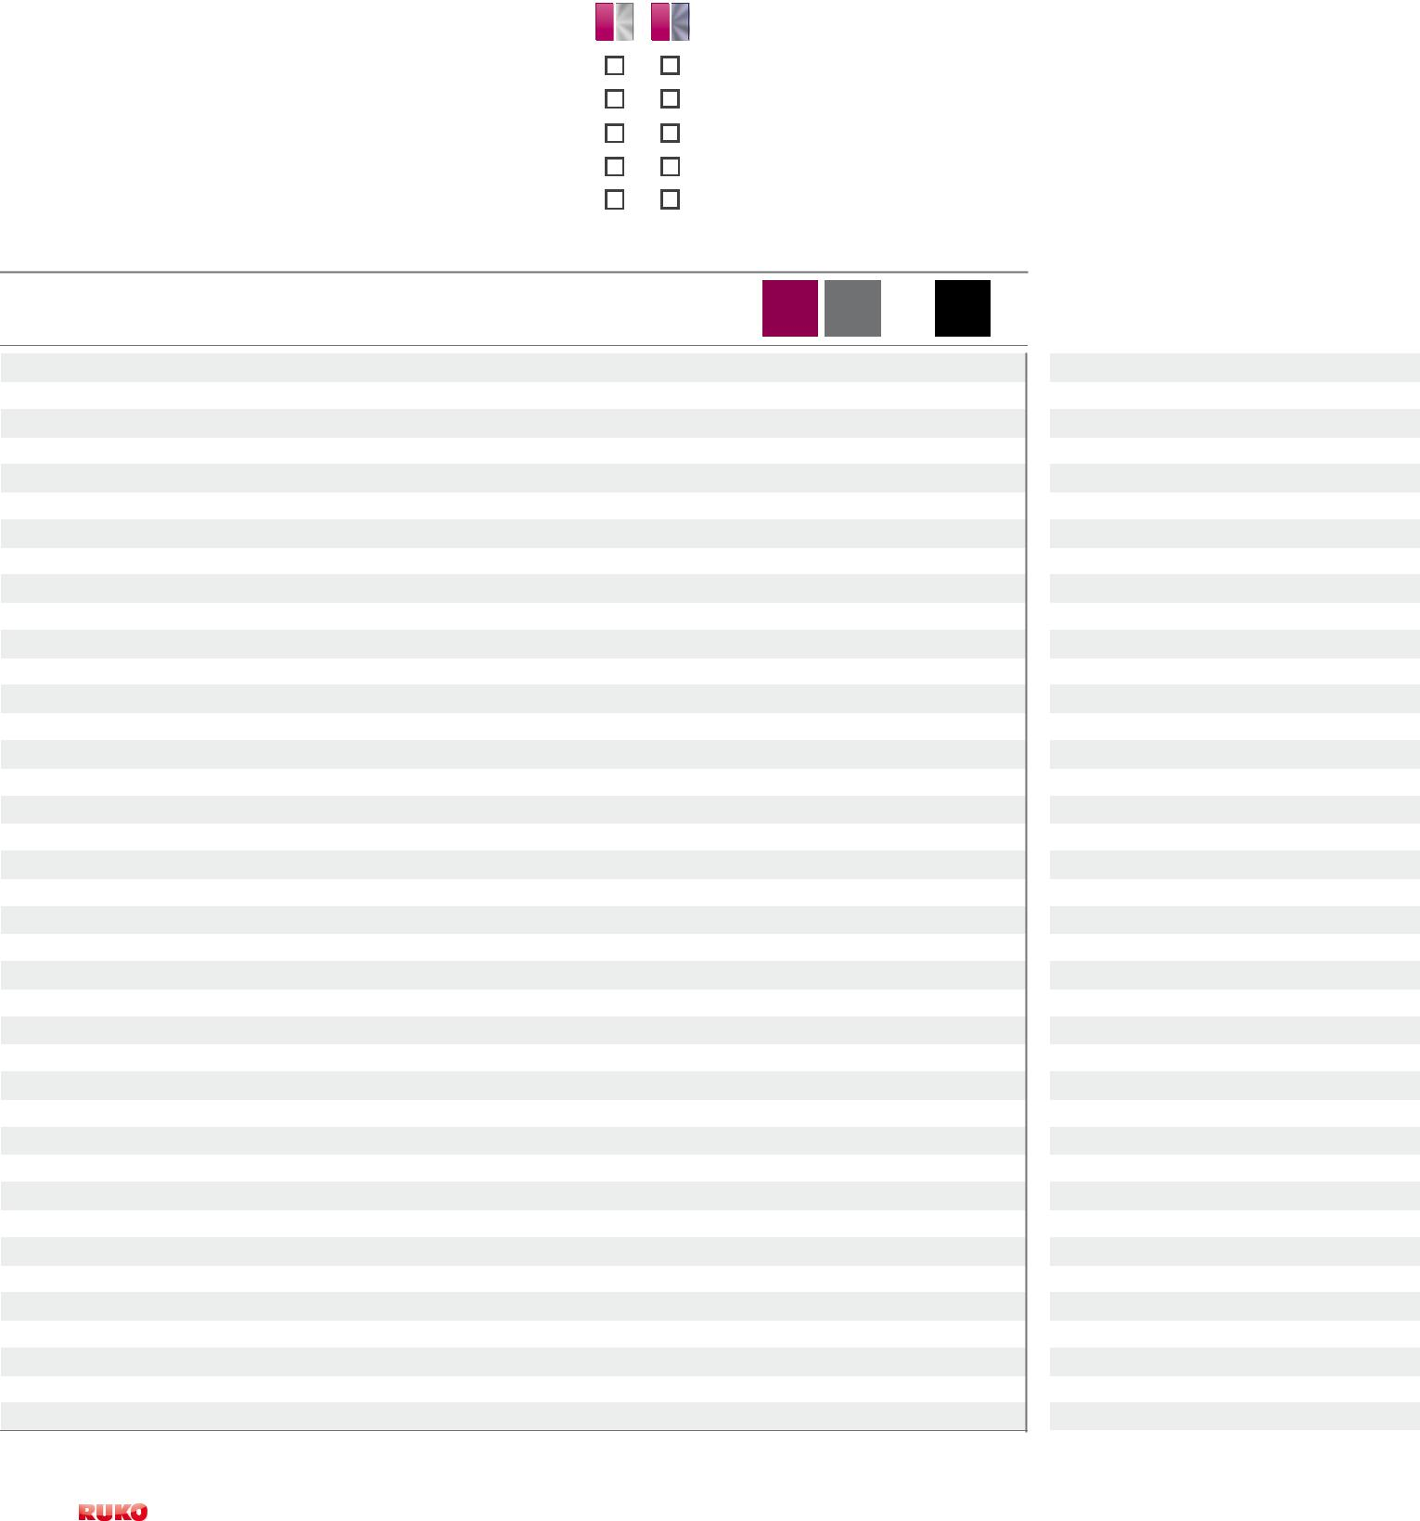

Ø1
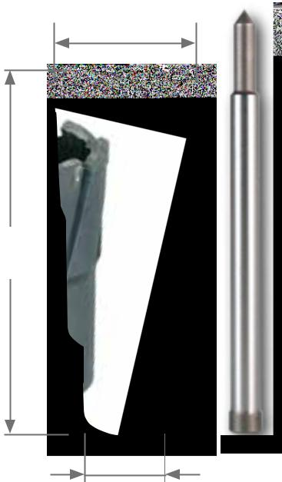

L1

108 305

Ø2

TC

108 1112 C |  | 1
108 1113 C |  | 1
108 1114 C |  | 1
108 1115 C |  | 1
108 1116 C |  | 1
108 1117 C |  | 1
108 1118 C |  | 1
108 1119 C |  | 1
108 1120 C |  | 1
108 1121 C |  | 1
108 1122 C |  | 1
108 1123 C |  | 1
108 1124 C |  | 1
108 1125 C |  | 1
108 1126 C |  | 1
108 1127 C |  | 1
108 1128 C |  | 1
108 1129 C |  | 1
108 1130 C |  | 1
108 1131 C |  | 1
108 1132 C |  | 1
108 1133 C |  | 1
108 1134 C |  | 1
108 1135 C |  | 1
108 1136 C |  | 1
108 1137 C |  | 1
108 1138 C |  | 1
108 1139 C |  | 1
108 1140 C |  | 1
108 1141 C |  | 1
108 1142 C |  | 1
108 1143 C |  | 1
108 1144 C |  | 1
108 1145 C |  | 1
108 1146 C |  | 1
108 1147 C |  | 1
108 1148 C |  | 1
108 1149 C |  | 1
108 1150 C |  | 1

 | Ø1 |  | Ø2 |  | L1 |  | Cutting depth |  | TC |  |  |  |  |  |  | TC
 | mm |  | mm |  | mm |  | mm
 | 51,0 |  | 18,0 |  | 112,0 |  | 50,0 |  | 108 1151 |  |  |  |  |  |  | 108 1151 C |  |  |  |  |  |  |  |  | 1
 | 52,0 |  | 18,0 |  | 112,0 |  | 50,0 |  | 108 1152 |  |  |  |  |  |  | 108 1152 C |  |  |  |  |  |  |  |  | 1
 | 53,0 |  | 18,0 |  | 112,0 |  | 50,0 |  | 108 1153 |  |  |  |  |  |  | 108 1153 C |  |  |  |  |  |  |  |  | 1
 | 54,0 |  | 18,0 |  | 112,0 |  | 50,0 |  | 108 1154 |  |  |  |  |  |  | 108 1154 C |  |  |  |  |  |  |  |  | 1
 | 55,0 |  | 18,0 |  | 112,0 |  | 50,0 |  | 108 1155 |  |  |  |  |  |  | 108 1155 C |  |  |  |  |  |  |  |  | 1
 | 60,0 |  | 18,0 |  | 112,0 |  | 50,0 |  | 108 1160 |  |  |  |  |  |  | 108 1160 C |  |  |  |  |  |  |  |  | 1
 | 61,0 |  | 18,0 |  | 112,0 |  | 50,0 |  | 108 1161 |  |  |  |  |  |  | 108 1161 C |  |  |  |  |  |  |  |  | 1
 | 63,0 |  | 18,0 |  | 112,0 |  | 50,0 |  | 108 1163 |  |  |  |  |  |  | 108 1163 C |  |  |  |  |  |  |  |  | 1
 | 65,0 |  | 18,0 |  | 112,0 |  | 50,0 |  | 108 1165 |  |  |  |  |  |  | 108 1165 C |  |  |  |  |  |  |  |  | 1
 | 68,0 |  | 18,0 |  | 112,0 |  | 50,0 |  | 108 1168 |  |  |  |  |  |  | 108 1168 C |  |  |  |  |  |  |  |  | 1
 | 70,0 |  | 18,0 |  | 112,0 |  | 50,0 |  | 108 1170 |  |  |  |  |  |  | 108 1170 C |  |  |  |  |  |  |  |  | 1
 | 71,0 |  | 18,0 |  | 112,0 |  | 50,0 |  | 108 1171 |  |  |  |  |  |  | 108 1171 C |  |  |  |  |  |  |  |  | 1
 | 75,0 |  | 18,0 |  | 112,0 |  | 50,0 |  | 108 1175 |  |  |  |  |  |  | 108 1175 C |  |  |  |  |  |  |  |  | 1
 | 80,0 |  | 18,0 |  | 112,0 |  | 50,0 |  | 108 1180 |  |  |  |  |  |  | 108 1180 C |  |  |  |  |  |  |  |  | 1

TC |  | RS10 / RS25e / RS40e
 |  | 50,0 mm | RS125e / RS126e / RS140e

Set of core drills with tungsten-carbide cutting edges and Quick IN-shank, CBN ground in plastic case
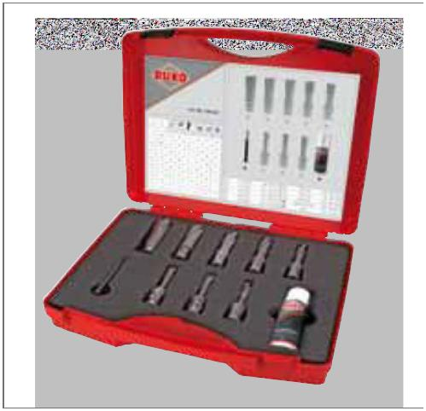

 | TC
10-piece set of core drills with tungsten-carbide cutting edges | 108 822
8 core drills with tungsten-carbide cutting edges and Quick in-shank
- 12,0 mm - 14,0 mm - 16,0 mm - 18,0 mm 20,0 mm - 22,0 mm - 24,0 mm - 26,0 mm
- 1 cutting spray 50 ml article no. 101 010

- 1 ejector pin Ø 6,35 x 102,0 mm

for cutting depth 50,0 mm article no. 108 305

Coolants and lubricants

the rUKo coolants and lubricants provide an outstanding separation and cooling effect. They generate a high surface quality and increase the service life of the tools, even with hard and brittle materials.

Suitably aligned to our product range, you will find the coolants and lubricants in our main catalogue from page 319.

Main application other application

PreCiSion toolS | 41

TC |  | A10 / RS10 / RS25e / RS40e
 | 50,0 mm |  | RS125e / RS126e / RS140e

Core drills with tungsten-carbide cutting edges and threaded retainer, cutting depth 50,0 mm

Ejector pin: article no. 108 110 (Ø 6,35 x 123,0 mm)

Adapter: thread M18 x 6 P1,5

Ø1
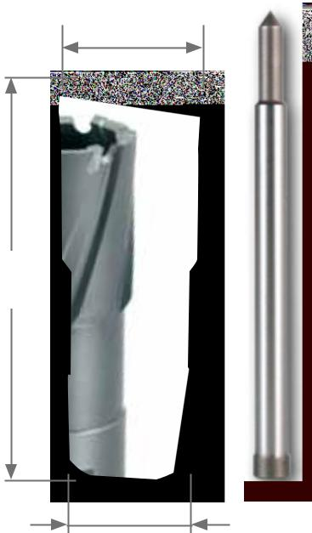

L1

108 110

Ø2

Steel (N/mm2) < 900

Steel (N/mm2) < 1100

Steel (N/mm2) < 1300

rust-resistant steel

Aluminium

Brass

Bronze

Plastics

Cast iron

titanium alloyed

 | Ø1 |  | Ø2 |  | L1 |  | Cutting depth |  | TC
 | mm |  | mm |  | mm |  | mm
 | 12,0 |  | MT 2 / 3 |  | 84,0 |  | 50,0 |  | 108 012
 | 13,0 |  | MT 2 / 3 |  | 84,0 |  | 50,0 |  | 108 013
 | 14,0 |  | MT 2 / 3 |  | 84,0 |  | 50,0 |  | 108 014
 | 15,0 |  | MT 2 / 3 |  | 84,0 |  | 50,0 |  | 108 015
 | 16,0 |  | MT 2 / 3 |  | 84,0 |  | 50,0 |  | 108 016
 | 17,0 |  | MT 2 / 3 |  | 84,0 |  | 50,0 |  | 108 017
 | 18,0 |  | MT 2 / 3 |  | 84,0 |  | 50,0 |  | 108 018
 | 19,0 |  | MT 2 / 3 |  | 84,0 |  | 50,0 |  | 108 019
 | 20,0 |  | MT 2 / 3 |  | 84,0 |  | 50,0 |  | 108 020
 | 21,0 |  | MT 2 / 3 |  | 84,0 |  | 50,0 |  | 108 021
 | 22,0 |  | MT 2 / 3 |  | 84,0 |  | 50,0 |  | 108 022
 | 23,0 |  | MT 2 / 3 |  | 84,0 |  | 50,0 |  | 108 023
 | 24,0 |  | MT 2 / 3 |  | 84,0 |  | 50,0 |  | 108 024
 | 25,0 |  | MT 2 / 3 |  | 84,0 |  | 50,0 |  | 108 025
 | 26,0 |  | MT 2 / 3 |  | 84,0 |  | 50,0 |  | 108 026
 | 27,0 |  | MT 2 / 3 |  | 84,0 |  | 50,0 |  | 108 027
 | 28,0 |  | MT 2 / 3 |  | 84,0 |  | 50,0 |  | 108 028
 | 29,0 |  | MT 2 / 3 |  | 84,0 |  | 50,0 |  | 108 029
 | 30,0 |  | MT 2 / 3 |  | 84,0 |  | 50,0 |  | 108 030
 | 31,0 |  | MT 2 / 3 |  | 84,0 |  | 50,0 |  | 108 031
 | 32,0 |  | MT 2 / 3 |  | 84,0 |  | 50,0 |  | 108 032
 | 33,0 |  | MT 2 / 3 |  | 84,0 |  | 50,0 |  | 108 033
 | 34,0 |  | MT 2 / 3 |  | 84,0 |  | 50,0 |  | 108 034
 | 35,0 |  | MT 2 / 3 |  | 84,0 |  | 50,0 |  | 108 035
 | 36,0 |  | MT 2 / 3 |  | 84,0 |  | 50,0 |  | 108 036
 | 37,0 |  | MT 2 / 3 |  | 84,0 |  | 50,0 |  | 108 037
 | 38,0 |  | MT 2 / 3 |  | 84,0 |  | 50,0 |  | 108 038
 | 39,0 |  | MT 2 / 3 |  | 84,0 |  | 50,0 |  | 108 039
 | 40,0 |  | MT 2 / 3 |  | 84,0 |  | 50,0 |  | 108 040
 | 41,0 |  | MT 2 / 3 |  | 84,0 |  | 50,0 |  | 108 041
 | 42,0 |  | MT 2 / 3 |  | 84,0 |  | 50,0 |  | 108 042
 | 43,0 |  | MT 2 / 3 |  | 84,0 |  | 50,0 |  | 108 043
 | 44,0 |  | MT 2 / 3 |  | 84,0 |  | 50,0 |  | 108 044
 | 45,0 |  | MT 2 / 3 |  | 84,0 |  | 50,0 |  | 108 045
 | 46,0 |  | MT 2 / 3 |  | 84,0 |  | 50,0 |  | 108 046
 | 47,0 |  | MT 2 / 3 |  | 84,0 |  | 50,0 |  | 108 047
 | 48,0 |  | MT 2 / 3 |  | 84,0 |  | 50,0 |  | 108 048
 | 49,0 |  | MT 2 / 3 |  | 84,0 |  | 50,0 |  | 108 049
 | 50,0 |  | MT 2 / 3 |  | 84,0 |  | 50,0 |  | 108 050
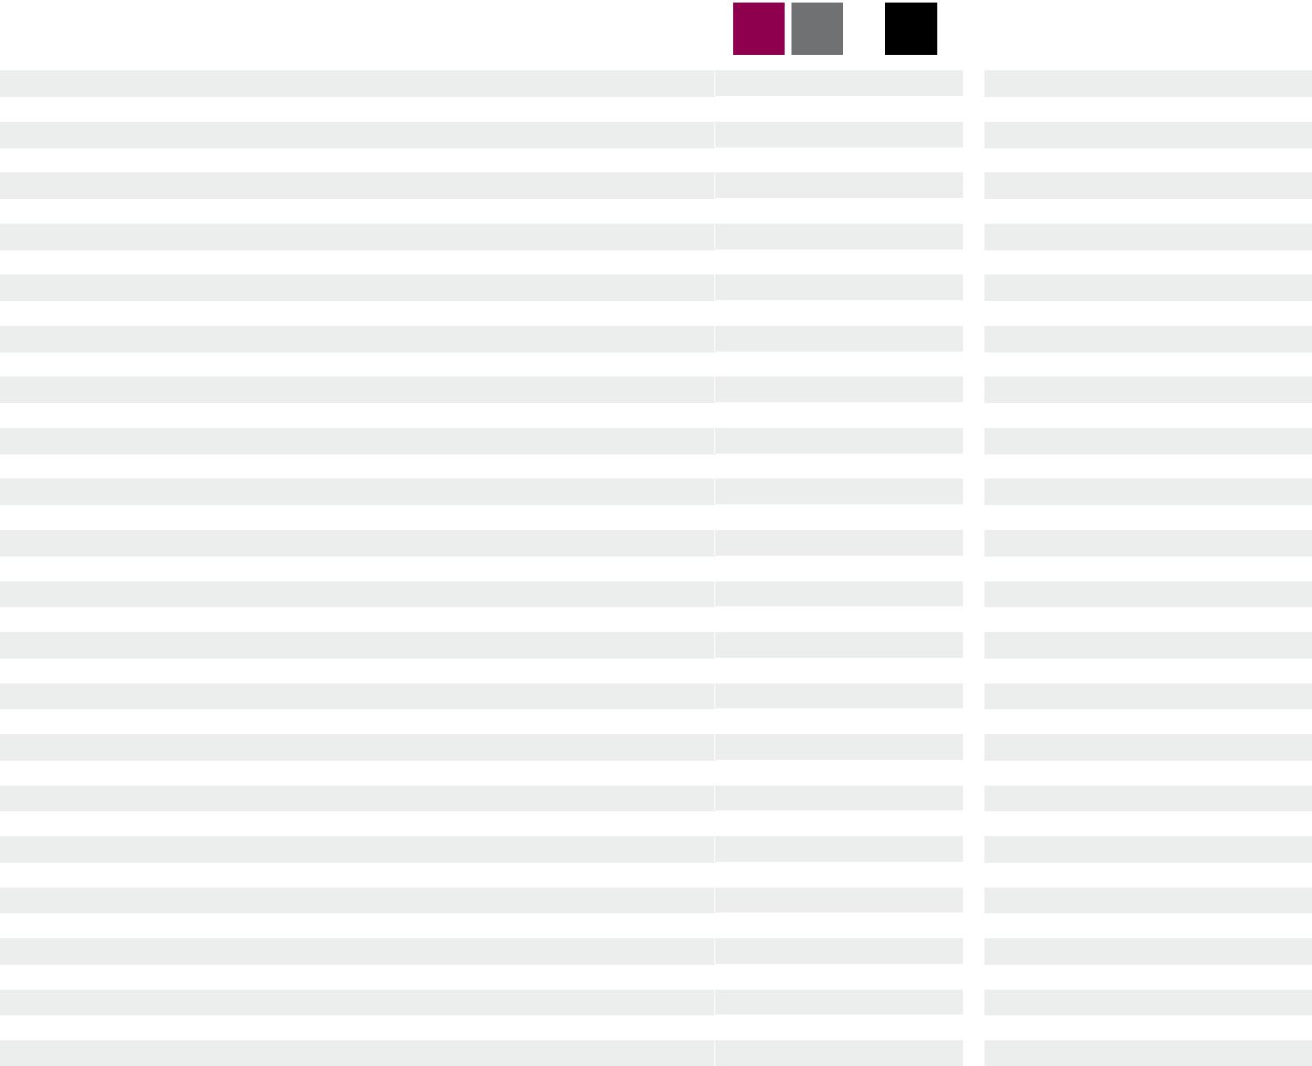

TC

108 012 C |  | 1
108 013 C |  | 1
108 014 C |  | 1
108 015 C |  | 1
108 016 C |  | 1
108 017 C |  | 1
108 018 C |  | 1
108 019 C |  | 1
108 020 C |  | 1
108 021 C |  | 1
108 022 C |  | 1
108 023 C |  | 1
108 024 C |  | 1
108 025 C |  | 1
108 026 C |  | 1
108 027 C |  | 1
108 028 C |  | 1
108 029 C |  | 1
108 030 C |  | 1
108 031 C |  | 1
108 032 C |  | 1
108 033 C |  | 1
108 034 C |  | 1
108 035 C |  | 1
108 036 C |  | 1
108 037 C |  | 1
108 038 C |  | 1
108 039 C |  | 1
108 040 C |  | 1
108 041 C |  | 1
108 042 C |  | 1
108 043 C |  | 1
108 044 C |  | 1
108 045 C |  | 1
108 046 C |  | 1
108 047 C |  | 1
108 048 C |  | 1
108 049 C |  | 1
108 050 C |  | 1

42 | PreCiSion toolS

 | Ø1 |  | Ø2 |  | L1 |  | Cutting depth |  | TC |  |  |  |  |  |  | TC
 | mm |  | mm |  | mm |  | mm
 | 51,0 |  | Mt 2 / 3 |  | 84,0 |  | 50,0 |  | 108 051 |  |  |  |  |  |  | 108 051 C |  |  |  |  |  |  |  |  | 1
 | 52,0 |  | Mt 2 / 3 |  | 84,0 |  | 50,0 |  | 108 052 |  |  |  |  |  |  | 108 052 C |  |  |  |  |  |  |  |  | 1
 | 53,0 |  | Mt 2 / 3 |  | 84,0 |  | 50,0 |  | 108 053 |  |  |  |  |  |  | 108 053 C |  |  |  |  |  |  |  |  | 1
 | 54,0 |  | Mt 2 / 3 |  | 84,0 |  | 50,0 |  | 108 054 |  |  |  |  |  |  | 108 054 C |  |  |  |  |  |  |  |  | 1
 | 55,0 |  | Mt 2 / 3 |  | 84,0 |  | 50,0 |  | 108 055 |  |  |  |  |  |  | 108 055 C |  |  |  |  |  |  |  |  | 1
 | 60,0 |  | Mt 2 / 3 |  | 84,0 |  | 50,0 |  | 108 060 |  |  |  |  |  |  | 108 060 C |  |  |  |  |  |  |  |  | 1
 | 61,0 |  | Mt 2 / 3 |  | 84,0 |  | 50,0 |  | 108 061 |  |  |  |  |  |  | 108 061 C |  |  |  |  |  |  |  |  | 1
 | 63,0 |  | Mt 2 / 3 |  | 84,0 |  | 50,0 |  | 108 063 |  |  |  |  |  |  | 108 063 C |  |  |  |  |  |  |  |  | 1
 | 65,0 |  | Mt 2 / 3 |  | 84,0 |  | 50,0 |  | 108 065 |  |  |  |  |  |  | 108 065 C |  |  |  |  |  |  |  |  | 1
 | 68,0 |  | Mt 2 / 3 |  | 84,0 |  | 50,0 |  | 108 068 |  |  |  |  |  |  | 108 068 C |  |  |  |  |  |  |  |  | 1
 | 70,0 |  | Mt 2 / 3 |  | 84,0 |  | 50,0 |  | 108 070 |  |  |  |  |  |  | 108 070 C |  |  |  |  |  |  |  |  | 1
 | 71,0 |  | Mt 2 / 3 |  | 84,0 |  | 50,0 |  | 108 071 |  |  |  |  |  |  | 108 071 C |  |  |  |  |  |  |  |  | 1
 | 75,0 |  | Mt 2 / 3 |  | 84,0 |  | 50,0 |  | 108 075 |  |  |  |  |  |  | 108 075 C |  |  |  |  |  |  |  |  | 1
 | 80,0 |  | Mt 2 / 3 |  | 84,0 |  | 50,0 |  | 108 080 |  |  |  |  |  |  | 108 080 C |  |  |  |  |  |  |  |  | 1
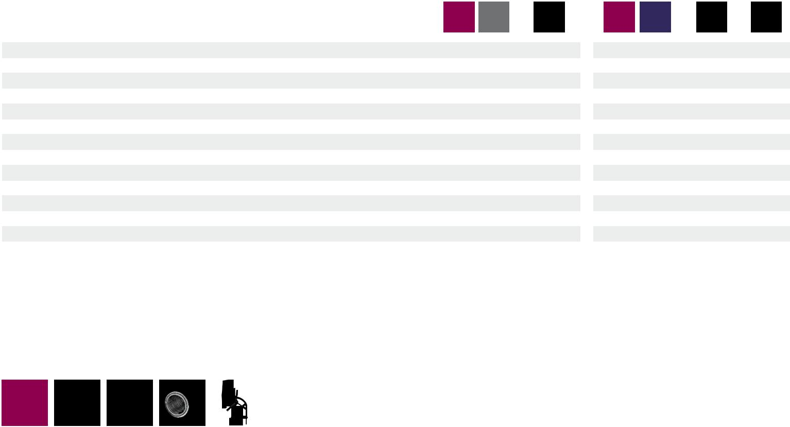

TC |  | A10 / RS10 / RS25e / RS40e
 |  | 50,0 mm | RS125e / RS126e / RS140e

Set of core drills with tungsten-carbide cutting edges and threaded retainer in plastic case
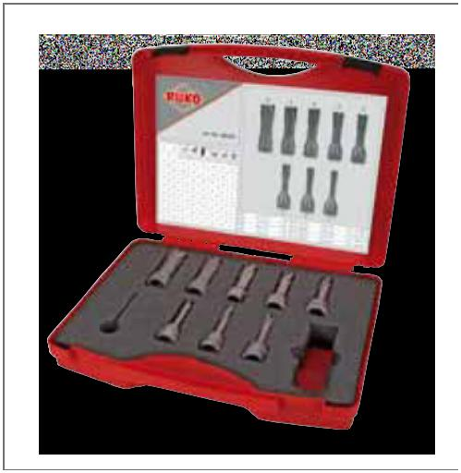

 |  |  | TC
 | 8-piece set of core drills with tungsten-carbide cutting edges |  | 108 823
 | 8 core drills with tungsten-carbide and threaded retainer
 | Ø 12,0 mm - 14,0 mm - 16,0 mm - 18,0 mm
 | 20,0 mm - 22,0 mm - 24,0 mm - 26,0 mm

Main application other application

PreCiSion toolS | 43

TC |  |  |  |  |  |  | A10 / RS5e / RS10 / RS25e / RS40e
 |  |  |  |  |  |  | RS125e / RS126e / RS140e

Core drills with tungsten-carbide cutting edges and Weldon shank for railway tracks, cutting depth 30,0 mm

Can be used on all track drilling machines. the cutting geometry has been specially optimized for heavy duty chip removal from railway tracks, thus makes efficient use possible.

Ejector pin: Article no. 108 1510 (Ø 8,0 x 81,0 mm)

Packing unit: individual plastic pack

Steel (N/mm2) < 900 |  |  |  |  |  |  |  |  |  |  |  |  |  | Brass
Steel (N/mm2) < 1100 |  |  |  |  |  |  |  |  |  |  |  |  |  | Bronze
Steel (N/mm2) < 1300 |  |  |  |  |  |  |  |  |  |  |  |  |  | Plastics
rust-resistant steel |  |  |  |  |  |  |  |  |  |  |  |  |  | Cast iron
Aluminium |  |  |  |  |  |  |  |  |  |  |  |  |  | titanium alloyed
Ø1 |  | Ø2 |  | L1 |  | Cutting depth |  |  |  |  |  |  |  |  |  | TC
mm |  | mm |  | mm |  |  |  | mm
19,0 |  | 19,0 |  | 63,0 |  | 30,0 |  |  |  |  |  |  |  |  |  | 108 1519
20,0 |  | 19,0 |  | 63,0 |  | 30,0 |  |  |  |  |  |  |  |  |  | 108 1520
21,0 |  | 19,0 |  | 63,0 |  | 30,0 |  |  |  |  |  |  |  |  |  | 108 1521
22,0 |  | 19,0 |  | 63,0 |  | 30,0 |  |  |  |  |  |  |  |  |  | 108 1522
23,0 |  | 19,0 |  | 63,0 |  | 30,0 |  |  |  |  |  |  |  |  |  | 108 1523
24,0 |  | 19,0 |  | 63,0 |  | 30,0 |  |  |  |  |  |  |  |  |  | 108 1524
25,0 |  | 19,0 |  | 63,0 |  | 30,0 |  |  |  |  |  |  |  |  |  | 108 1525
26,0 |  | 19,0 |  | 63,0 |  | 30,0 |  |  |  |  |  |  |  |  |  | 108 1526
26,5 |  | 19,0 |  | 63,0 |  | 30,0 |  |  |  |  |  |  |  |  |  | 108 15265
27,0 |  | 19,0 |  | 63,0 |  | 30,0 |  |  |  |  |  |  |  |  |  | 108 1527
27,5 |  | 19,0 |  | 63,0 |  | 30,0 |  |  |  |  |  |  |  |  |  | 108 15275
28,0 |  | 19,0 |  | 63,0 |  | 30,0 |  |  |  |  |  |  |  |  |  | 108 1528
29,0 |  | 19,0 |  | 63,0 |  | 30,0 |  |  |  |  |  |  |  |  |  | 108 1529
30,0 |  | 19,0 |  | 63,0 |  | 30,0 |  |  |  |  |  |  |  |  |  | 108 1530
31,0 |  | 19,0 |  | 63,0 |  | 30,0 |  |  |  |  |  |  |  |  |  | 108 1531
32,0 |  | 19,0 |  | 63,0 |  | 30,0 |  |  |  |  |  |  |  |  |  | 108 1532
33,0 |  | 19,0 |  | 63,0 |  | 30,0 |  |  |  |  |  |  |  |  |  | 108 1533
34,0 |  | 19,0 |  | 63,0 |  | 30,0 |  |  |  |  |  |  |  |  |  | 108 1534
36,0 |  | 19,0 |  | 63,0 |  | 30,0 |  |  |  |  |  |  |  |  |  | 108 1536
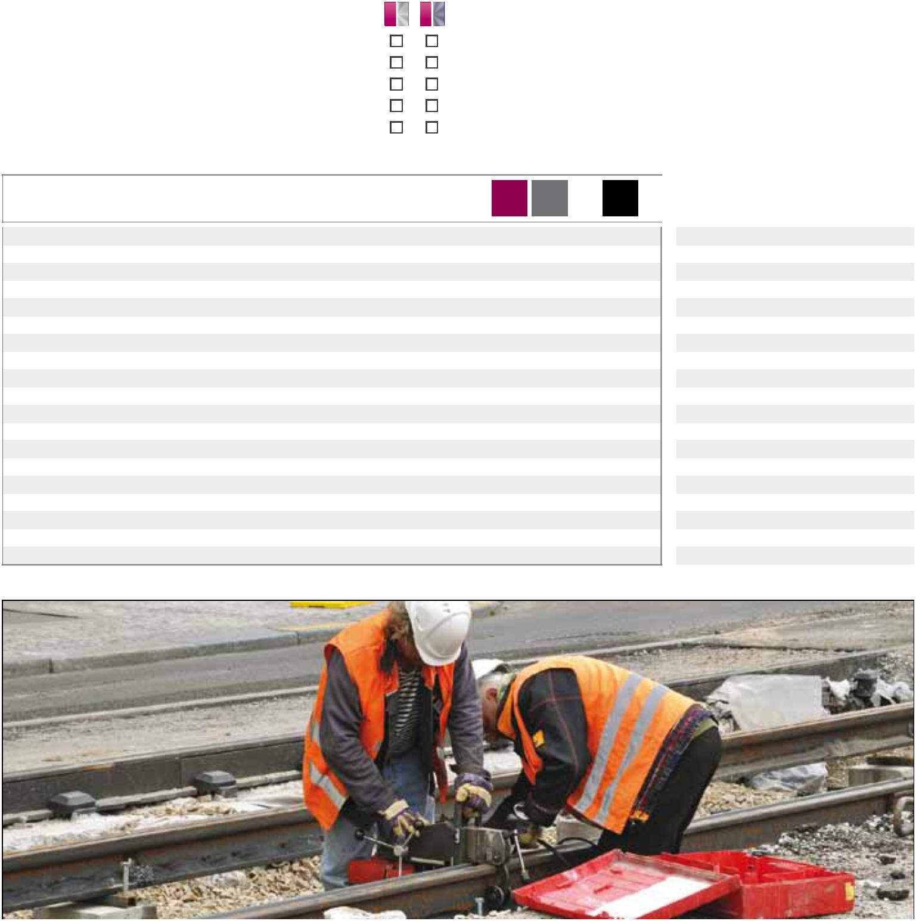

Ø1
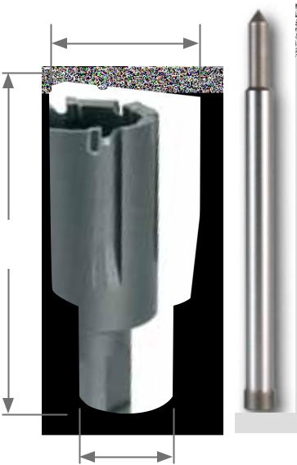

L1

108 1510

Ø2

TC

108 1519 C |  | 1
108 1520 C |  | 1
108 1521 C |  | 1
108 1522 C |  | 1
108 1523 C |  | 1
108 1524 C |  | 1
108 1525 C |  | 1
108 1526 C |  | 1
108 15265 C |  | 1
108 1527 C |  | 1
108 15275 C |  | 1
108 1528 C |  | 1
108 1529 C |  | 1
108 1530 C |  | 1
108 1531 C |  | 1
108 1532 C |  | 1
108 1533 C |  | 1
108 1534 C |  | 1
108 1536 C |  | 1

44 | PreCiSion toolS

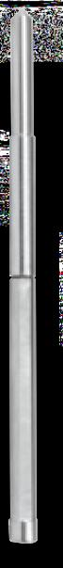
Ejector pins for core drills
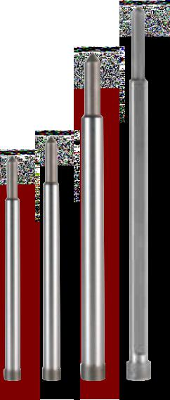

Packing unit: individual plastic pack

- Centring:
Position the ejector pin centrally on the centre punch.
now the machine is in the correct drilling position. Please turn on magnet now.

- Coolant supply:
The cutting oil is supplied through the ejector pin by the automatic internal lubrication and is issued optimally to the cutting edges.
- Ejecting:
In the final phase, the drill core is pushed from the borehole by the spring pretensioned ejector pin.
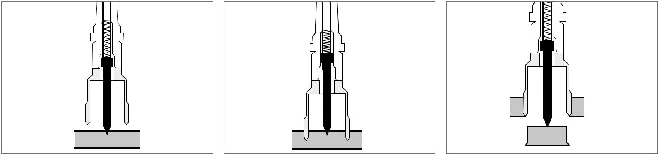

1 |  | 2 |  | 3

Ejector pins for core drills HSS

 |  |  | Core drills
 |  |  | cutting depth mm
 | Ejector pin Ø 6,35 x 77,0 mm for |  | 30,0 |  |  |  |  |  | 1
 |  |  |  | 108 304
 | core drills HSS with Weldon shank (¾")
 | Ejector pin Ø 6,35 x 87,0 mm for |  | 35,0 / 50,0 | 108 306 |  |  |  |  | 1
 | core drills hSS / tC with Quick in-shank
 | Ejector pin Ø 6,35 x 102,0 mm for |  | 55,0 | 108 305 |  |  |  |  | 1
 | core drills HSS / TC with Weldon shank (¾")
 | Ejector pin Ø 8,0 x 155,0 mm for |  | 110,0 | 108 2000 |  |  |  |  | 1
 | core drills HSS with Weldon shank (¾")
 | Ejector pin Ø 6,35 x 70,0 mm for |  | 30,0 | 108 344 |  |  |  |  | 1
 | core drills HSS with Weldon shank (¾") for RS5e

Ejector pins for core drills TC

Core drills

cutting depth mm

Ejector pin Ø 8,0 x 81,0 mm for
core drills TC with Weldon shank (¾") for railway tracks

Ejector pin Ø 6,35 x 87,0 mm for

core drills hSS / tC with Quick in-shank

Ejector pin Ø 8,0 x 112,0 mm for

core drills TC with Weldon shank (¾")

Ejector pin Ø 6,35 x 123,0 mm for

core drills TC with Weldon- (¾") and Quick IN-shank

Ejector pin Ø 6,35 x 102,0 mm for

core drills HSS / TC with Weldon shank (¾")

30,0 | 108 1510 |  | 1
35,0 / 50,0 | 108 306 |  | 1
50,0 | 108 701 |  | 1
50,0 | 108 110 |  | 1
+ Adapter
55,0 | 108 305 |  | 1

Main application other application

PreCiSion toolS | 45

recommended cutting speeds for
hSS core drills

 | Material: |  |  |  | high carbon |  | Alloyed |  | Cast |  | CuZn- |  | CuZn- |  | Aluminium |  | thermo- |  | duro-
 |  |  |  |  | struc. steel |  | steel |  | iron |  | alloy |  | alloy |  | alloy |  | plastics |  | plastics
 |  |  |  |  | up to |  | up to |  | over |  |  |  |  |  | up to
 |  |  |  |  | 700 N/mm² |  | 1000 N/mm² |  | 250 N/mm² |  | brittle |  | tough |  | 11% Si
 | Vc = m/min |  |  |  | 30 |  | 20 |  | 10 |  | 60 |  | 35 |  | 30 |  | 20 | 15
 | Coolant: |  |  |  | Cutting spray |  | Cutting spray |  | Compressed air |  | Compressed air |  | Compressed air |  | Cutting spray |  | Water |  | Compressed air
 | Ø mm |  | Ø inch |  | r.p.m. |  | r.p.m. |  | r.p.m. |  | r.p.m. |  | r.p.m. |  | r.p.m. |  | r.p.m. |  | r.p.m.
 | 12,0 |  | 15/32 |  | 796 |  | 531 |  | 265 |  | 1592 |  | 929 |  | 796 |  | 531 |  | 398
 | 13,0 |  | 33/64 |  | 735 |  | 490 |  | 245 |  | 1470 |  | 857 |  | 735 |  | 490 |  | 367
 | 14,0 |  | 35/64 |  | 682 |  | 455 |  | 227 |  | 1365 |  | 796 |  | 682 |  | 455 |  | 341
 | 15,0 |  | 19/32 |  | 637 |  | 425 |  | 212 |  | 1274 |  | 743 |  | 637 |  | 425 |  | 318
 | 16,0 |  | 5/8 |  | 597 |  | 398 |  | 199 |  | 1194 |  | 697 |  | 597 |  | 398 |  | 299
 | 17,0 |  | 43/64 |  | 562 |  | 375 |  | 187 |  | 1124 |  | 656 |  | 562 |  | 375 |  | 281
 | 18,0 |  | 45/64 |  | 531 |  | 354 |  | 177 |  | 1062 |  | 619 |  | 531 |  | 354 |  | 265
 | 19,0 |  | 3/4 |  | 503 |  | 335 |  | 168 |  | 1006 |  | 587 |  | 503 |  | 335 |  | 251
 | 20,0 |  | 25/32 |  | 478 |  | 318 |  | 159 |  | 955 |  | 557 |  | 478 |  | 318 |  | 239
 | 21,0 |  | 53/64 |  | 455 |  | 303 |  | 152 |  | 910 |  | 531 |  | 455 |  | 303 |  | 227
 | 22,0 |  | 7/8 |  | 434 |  | 290 |  | 145 |  | 869 |  | 507 |  | 434 |  | 290 |  | 217
 | 23,0 |  | 29/32 |  | 415 |  | 277 |  | 138 |  | 831 |  | 485 |  | 415 |  | 277 |  | 208
 | 24,0 |  | 15/16 |  | 398 |  | 265 |  | 133 |  | 796 |  | 464 |  | 398 |  | 265 |  | 199
 | 25,0 |  | 63/64 |  | 382 |  | 255 |  | 127 |  | 764 |  | 446 |  | 382 |  | 255 |  | 191
 | 26,0 |  | 1 1/32 |  | 367 |  | 245 |  | 122 |  | 735 |  | 429 |  | 367 |  | 245 |  | 184
 | 27,0 |  | 1 1/16 |  | 354 |  | 236 |  | 118 |  | 708 |  | 413 |  | 354 |  | 236 |  | 177
 | 28,0 |  | 1 3/32 |  | 341 |  | 227 |  | 114 |  | 682 |  | 398 |  | 341 |  | 227 |  | 171
 | 29,0 |  | 1 9/64 |  | 329 |  | 220 |  | 110 |  | 659 |  | 384 |  | 329 |  | 220 |  | 165
 | 30,0 |  | 1 3/16 |  | 318 |  | 212 |  | 106 |  | 637 |  | 372 |  | 318 |  | 212 |  | 159
 | 31,0 |  | 1 7/32 |  | 308 |  | 205 |  | 103 |  | 616 |  | 360 |  | 308 |  | 205 |  | 154
 | 32,0 |  | 1 17/64 |  | 299 |  | 199 |  | 100 |  | 597 |  | 348 |  | 299 |  | 199 |  | 149
 | 33,0 |  | 1 19/64 |  | 290 |  | 193 |  | 97 |  | 579 |  | 338 |  | 290 |  | 193 |  | 145
 | 34,0 |  | 1 11/32 |  | 281 |  | 187 |  | 94 |  | 562 |  | 328 |  | 281 |  | 187 |  | 141
 | 35,0 |  | 1 3/8 |  | 273 |  | 182 |  | 91 |  | 546 |  | 318 |  | 273 |  | 182 |  | 136
 | 36,0 |  | 1 27/64 |  | 265 |  | 177 |  | 88 |  | 531 |  | 310 |  | 265 |  | 177 |  | 133
 | 37,0 |  | 1 29/64 |  | 258 |  | 172 |  | 86 |  | 516 |  | 301 |  | 258 |  | 172 |  | 129
 | 38,0 |  | 1 1/2 |  | 251 |  | 168 |  | 84 |  | 503 |  | 293 |  | 251 |  | 168 |  | 126
 | 39,0 |  | 1 17/32 |  | 245 |  | 163 |  | 82 |  | 490 |  | 286 |  | 245 |  | 163 |  | 122
 | 40,0 |  | 1 37/64 |  | 239 |  | 159 |  | 80 |  | 478 |  | 279 |  | 239 |  | 159 |  | 119
 | 41,0 |  | 1 39/64 |  | 233 |  | 155 |  | 78 |  | 466 |  | 272 |  | 233 |  | 155 |  | 117
 | 42,0 |  | 1 21/32 |  | 227 |  | 152 |  | 76 |  | 455 |  | 265 |  | 227 |  | 152 |  | 114
 | 43,0 |  | 1 11/16 |  | 222 |  | 148 |  | 74 |  | 444 |  | 259 |  | 222 |  | 148 |  | 111
 | 44,0 |  | 1 47/64 |  | 217 |  | 145 |  | 72 |  | 434 |  | 253 |  | 217 |  | 145 |  | 109
 | 45,0 |  | 1 25/32 |  | 212 |  | 142 |  | 71 |  | 425 |  | 248 |  | 212 |  | 142 |  | 106
 | 46,0 |  | 1 13/16 |  | 208 |  | 138 |  | 69 |  | 415 |  | 242 |  | 208 |  | 138 |  | 104
 | 47,0 |  | 1 55/64 |  | 203 |  | 136 |  | 68 |  | 407 |  | 237 |  | 203 |  | 136 |  | 102
 | 48,0 |  | 1 57/64 |  | 199 |  | 133 |  | 66 |  | 398 |  | 232 |  | 199 |  | 133 |  | 100
 | 49,0 |  | 1 15/16 |  | 195 |  | 130 |  | 65 |  | 390 |  | 227 |  | 195 |  | 130 |  | 97
 | 50,0 |  | 1 31/32 |  | 191 |  | 127 |  | 64 |  | 382 |  | 223 |  | 191 |  | 127 |  | 96
 | 51,0 |  | 2 |  | 187 |  | 125 |  | 62 |  | 375 |  | 219 |  | 187 |  | 125 |  | 94
 | 52,0 |  | 2 3/64 |  | 184 |  | 122 |  | 61 |  | 367 |  | 214 |  | 184 |  | 122 |  | 92
 | 53,0 |  | 2 3/32 |  | 180 |  | 120 |  | 60 |  | 361 |  | 210 |  | 180 |  | 120 |  | 90
 | 54,0 |  | 2 1/8 |  | 177 |  | 118 |  | 59 |  | 354 |  | 206 |  | 177 |  | 118 |  | 88
 | 55,0 |  | 2 5/32 |  | 174 |  | 116 |  | 58 |  | 347 |  | 203 |  | 174 |  | 116 |  | 87
 | 60,0 |  | 2 3/8 |  | 159 |  | 106 |  | 53 |  | 318 |  | 186 |  | 159 |  | 106 |  | 80

46 | PreCiSion toolS

recommended cutting speeds for
tungsten-carbide core drills

 | Material: |  |  |  | high carbon |  | Alloyed |  | Cast |  | CuZn- |  | CuZn- |  | Aluminium |  | thermo- |  | duro-
 |  |  |  |  | struc. steel |  | steel |  | iron |  | alloy |  | alloy |  | alloy |  | plastics |  | plastics
 |  |  |  |  | up to |  | up to |  | over |  |  |  |  |  | up to
 |  |  |  |  | 700 N/mm² |  | 1000 N/mm² |  | 250 N/mm² |  | brittle |  | tough |  | 11% Si
 | Vc = m/min |  |  |  | 50 | 35 |  |  | 40 | 60 |  |  | 40 |  | 60 |  | 45 |  | 40
 | Coolant: |  |  |  | Cutting spray |  | Cutting spray |  | Compressed air |  | Compressed air |  | Compressed air |  | Cutting spray |  | Water |  | Compressed air
 | Ø mm |  | Ø inch |  | r.p.m. |  | r.p.m. |  | r.p.m. |  | r.p.m. |  | r.p.m. |  | r.p.m. |  | r.p.m. |  | r.p.m.
 | 12,0 |  | 15/32 |  | 1327 |  | 929 |  | 1062 |  | 1592 |  | 265 |  | 1592 |  | 1194 |  | 1062
 | 13,0 |  | 33/64 |  | 1225 |  | 857 |  | 980 |  | 1470 |  | 245 |  | 1470 |  | 1102 |  | 980
 | 14,0 |  | 35/64 |  | 1137 |  | 796 |  | 910 |  | 1365 |  | 227 |  | 1365 |  | 1024 |  | 910
 | 15,0 |  | 19/32 |  | 1062 |  | 743 |  | 849 |  | 1274 |  | 212 |  | 1274 |  | 955 |  | 849
 | 16,0 |  | 5/8 |  | 995 |  | 697 |  | 796 |  | 1194 |  | 199 |  | 1194 |  | 896 |  | 796
 | 17,0 |  | 34/64 |  | 937 |  | 656 |  | 749 |  | 1124 |  | 187 |  | 1124 |  | 843 |  | 749
 | 18,0 |  | 45/64 |  | 885 |  | 619 |  | 708 |  | 1062 |  | 177 |  | 1062 |  | 796 |  | 708
 | 19,0 |  | 3/4 |  | 838 |  | 587 |  | 670 |  | 1006 |  | 168 |  | 1006 |  | 754 |  | 670
 | 20,0 |  | 25/32 |  | 796 |  | 557 |  | 637 |  | 955 |  | 159 |  | 955 |  | 717 |  | 637
 | 21,0 |  | 3/4 |  | 758 |  | 531 |  | 607 |  | 910 |  | 152 |  | 910 |  | 682 |  | 607
 | 22,0 |  | 7/8 |  | 724 |  | 507 |  | 579 |  | 869 |  | 145 |  | 869 |  | 651 |  | 579
 | 23,0 |  | 13/16 |  | 692 |  | 485 |  | 554 |  | 831 |  | 138 |  | 831 |  | 623 |  | 554
 | 24,0 |  | 15/16 |  | 663 |  | 464 |  | 531 |  | 796 |  | 133 |  | 796 |  | 597 |  | 531
 | 25,0 |  | 63/64 |  | 637 |  | 446 |  | 510 |  | 764 |  | 127 |  | 764 |  | 573 |  | 510
 | 26,0 |  | 1 1/32 |  | 612 |  | 429 |  | 490 |  | 735 |  | 122 |  | 735 |  | 551 |  | 490
 | 27,0 |  | 1 1/16 |  | 590 |  | 413 |  | 472 |  | 708 |  | 118 |  | 708 |  | 531 |  | 472
 | 28,0 |  | 1 3/32 |  | 569 |  | 398 |  | 455 |  | 682 |  | 114 |  | 682 |  | 512 |  | 455
 | 29,0 |  | 1 9/64 |  | 549 |  | 384 |  | 439 |  | 659 |  | 110 |  | 659 |  | 494 |  | 439
 | 30,0 |  | 1 3/16 |  | 531 |  | 372 |  | 425 |  | 637 |  | 106 |  | 637 |  | 478 |  | 425
 | 31,0 |  | 1 7/32 |  | 514 |  | 360 |  | 411 |  | 616 |  | 103 |  | 616 |  | 462 |  | 411
 | 32,0 |  | 1 17/64 |  | 498 |  | 348 |  | 398 |  | 597 |  | 100 |  | 597 |  | 448 |  | 398
 | 33,0 |  | 1 19/64 |  | 483 |  | 338 |  | 386 |  | 579 |  | 97 |  | 579 |  | 434 |  | 386
 | 34,0 |  | 1 11/32 |  | 468 |  | 328 |  | 375 |  | 562 |  | 94 |  | 562 |  | 422 |  | 375
 | 35,0 |  | 1 3/8 |  | 455 |  | 318 |  | 364 |  | 546 |  | 91 |  | 546 |  | 409 |  | 364
 | 36,0 |  | 1 27/64 |  | 442 |  | 310 |  | 354 |  | 531 |  | 88 |  | 531 |  | 398 |  | 354
 | 37,0 |  | 1 29/64 |  | 430 |  | 301 |  | 344 |  | 516 |  | 86 |  | 516 |  | 387 |  | 344
 | 38,0 |  | 1 1/2 |  | 419 |  | 293 |  | 335 |  | 503 |  | 84 |  | 503 |  | 377 |  | 335
 | 39,0 |  | 1 17/32 |  | 408 |  | 286 |  | 327 |  | 490 |  | 82 |  | 490 |  | 367 |  | 327
 | 40,0 |  | 1 37/64 |  | 398 |  | 279 |  | 318 |  | 478 |  | 80 |  | 478 |  | 358 |  | 318
 | 41,0 |  | 1 39/64 |  | 388 |  | 272 |  | 311 |  | 466 |  | 78 |  | 466 |  | 350 |  | 311
 | 42,0 |  | 1 21/32 |  | 379 |  | 265 |  | 303 |  | 455 |  | 76 |  | 455 |  | 341 |  | 303
 | 43,0 |  | 1 11/16 |  | 370 |  | 259 |  | 296 |  | 444 |  | 74 |  | 444 |  | 333 |  | 296
 | 44,0 |  | 1 47/64 |  | 362 |  | 253 |  | 290 |  | 434 |  | 72 |  | 434 |  | 326 |  | 290
 | 45,0 |  | 1 25/32 |  | 354 |  | 248 |  | 283 |  | 425 |  | 71 |  | 425 |  | 318 |  | 283
 | 46,0 |  | 1 13/16 |  | 346 |  | 242 |  | 277 |  | 415 |  | 69 |  | 415 |  | 312 |  | 277
 | 47,0 |  | 1 55/64 |  | 339 |  | 237 |  | 271 |  | 407 |  | 68 |  | 407 |  | 305 |  | 271
 | 48,0 |  | 1 57/64 |  | 332 |  | 232 |  | 265 |  | 398 |  | 66 |  | 398 |  | 299 |  | 265
 | 49,0 |  | 1 15/16 |  | 325 |  | 227 |  | 260 |  | 390 |  | 65 |  | 390 |  | 292 |  | 260
 | 50,0 |  | 1 31/32 |  | 318 |  | 223 |  | 255 |  | 382 |  | 64 |  | 382 |  | 287 |  | 255
 | 51,0 |  | 2 |  | 312 |  | 219 |  | 250 |  | 375 |  | 62 |  | 375 |  | 281 |  | 250
 | 52,0 |  | 2 3/64 |  | 306 |  | 214 |  | 245 |  | 367 |  | 61 |  | 367 |  | 276 |  | 245
 | 53,0 |  | 2 3/32 |  | 300 |  | 210 |  | 240 |  | 361 |  | 60 |  | 361 |  | 270 |  | 240
 | 54,0 |  | 2 1/8 |  | 295 |  | 206 |  | 236 |  | 354 |  | 59 |  | 354 |  | 265 |  | 236
 | 55,0 |  | 2 5/32 |  | 290 |  | 203 |  | 232 |  | 347 |  | 58 |  | 347 |  | 261 |  | 232
 | 60,0 |  | 2 3/8 |  | 265 |  | 186 |  | 212 |  | 318 |  | 53 |  | 318 |  | 239 |  | 212
 | 61,0 |  | 2 13/32 |  | 261 |  | 183 |  | 209 |  | 313 |  | 52 |  | 313 |  | 235 |  | 209
 | 65,0 |  | 2 9/16 |  | 245 |  | 171 |  | 196 |  | 294 |  | 49 |  | 294 |  | 220 |  | 196
 | 68,0 |  | 2 43/64 |  | 234 |  | 164 |  | 187 |  | 281 |  | 47 |  | 281 |  | 211 |  | 187
 | 70,0 |  | 2 3/4 |  | 227 |  | 159 |  | 182 |  | 273 |  | 45 |  | 273 |  | 205 |  | 182
 | 71,0 |  | 2 51/64 |  | 224 |  | 157 |  | 179 |  | 269 |  | 45 |  | 269 |  | 202 |  | 179
 | 75,0 |  | 2 61/64 |  | 212 |  | 149 |  | 170 |  | 255 |  | 42 |  | 255 |  | 191 |  | 170
 | 80,0 |  | 3 5/32 |  | 199 |  | 139 |  | 159 |  | 239 |  | 40 |  | 239 |  | 179 |  | 159
 | 85,0 |  | 3 11/32 |  | 187 |  | 131 |  | 150 |  | 225 |  | 37 |  | 225 |  | 169 |  | 150
 | 90,0 |  | 3 35/64 |  | 177 |  | 124 |  | 142 |  | 212 |  | 35 |  | 212 |  | 159 |  | 142
 | 95,0 |  | 3 47/64 |  | 168 |  | 117 |  | 134 |  | 201 |  | 34 |  | 201 |  | 151 |  | 134
 | 100,0 |  | 3 15/16 |  | 159 |  | 111 |  | 127 |  | 191 |  | 32 |  | 191 |  | 143 |  | 127

PreCiSion toolS | 47

Ø1
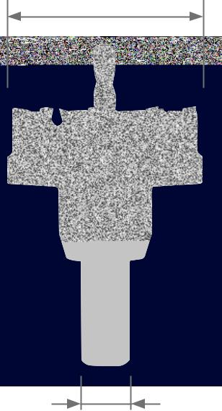
TC

4,0 mm | 10,0 mm | TC

accessories for RSH 1300

Tungsten carbide hole saws, shallow cut

Shank Ø2: Ø 16,0 - 50,5 mm = Ø 10,0 mm

Shank Ø2: Ø 51,0 - 60,0 mm = Ø 13,0 mm

Packing unit: individual carton | Ø2

Steel (N/mm2) < 900 |  |  |  |  | Brass
Steel (N/mm2) < 1100 |  |  |  |  | Bronze
Steel (N/mm2) < 1300 |  |  |  |  | Plastics
rust-resistant steel |  |  |  |  | Cast iron
Aluminium |  |  |  |  | titanium alloyed

 | Ø1 |  | Ø |  | through dimen- |  | tube dimen- |  | TC
 | mm |  | inch |  | sions M + PG |  | sions inch
 | 16,0 |  | 5/8 |  | ~ PG 9 |  |  |  | 105 016 -1 |  | 1
 | 16,5 |  |  |  | M 16 |  |  |  | 105 165 -1 |  | 1
 | 17,0 |  |  |  |  |  |  |  | 105 017 -1 |  | 1
 | 18,0 |  |  |  |  |  |  |  | 105 018 -1 |  | 1
 | 18,6 |  |  |  | PG 11 |  |  |  | 105 186 -1 |  | 1
 | 19,0 |  | 3/4 |  |  |  | 3/8 |  | 105 019 -1 |  | 1
 | 20,0 |  |  |  |  |  |  |  | 105 020 -1 |  | 1
 | 20,4 |  | 13/16 |  | M20 / PG13,5 |  |  |  | 105 204 -1 |  | 1
 | 21,0 |  |  |  |  |  |  |  | 105 021 -1 |  | 1
 | 22,0 |  |  |  |  |  | 1/2 |  | 105 022 -1 |  | 1
 | 22,5 |  | 7/8 |  | PG 16 |  |  |  | 105 225 -1 |  | 1
 | 23,0 |  |  |  |  |  |  |  | 105 023 -1 |  | 1
 | 24,0 |  | 15/16 |  |  |  |  |  | 105 024 -1 |  | 1
 | 25,0 |  |  |  |  |  |  |  | 105 025 -1 |  | 1
 | 25,5 |  | 1 |  | M 25 |  |  |  | 105 255 -1 |  | 1
 | 26,0 |  |  |  |  |  |  |  | 105 026 -1 |  | 1
 | 27,0 |  | 1 1/16 |  |  |  |  |  | 105 027 -1 |  | 1
 | 28,0 |  | 1 3/32 |  |  |  |  |  | 105 028 -1 |  | 1
 | 28,3 |  | 1 1/8 |  | PG 21 |  |  |  | 105 283 -1 |  | 1
 | 29,0 |  |  |  |  |  | 3/4 |  | 105 029 -1 |  | 1
 | 30,0 |  | 1 3/16 |  |  |  |  |  | 105 030 -1 |  | 1
 | 32,0 |  | 1 1/4 |  |  |  |  |  | 105 032 -1 |  | 1

 | Ø1 | Ø | through dimen- |  | tube dimen- |  | TC
 | mm | inch | sions M + PG |  | sions inch
 | 32,5 |  | M 32 |  |  |  | 105 325 -1 |  | 1
 | 34,0 |  |  |  |  |  | 105 034 -1 |  | 1
 | 35,0 | 1 3/8 |  |  | 1 |  | 105 035 -1 |  | 1
 | 36,0 |  |  |  |  |  | 105 036 -1 |  | 1
 | 37,0 | 1 7/16 | PG 29 |  |  |  | 105 037 -1 |  | 1
 | 38,0 | 1 1/2 |  |  |  |  | 105 038 -1 |  | 1
 | 40,0 | 1 9/16 |  |  |  |  | 105 040 -1 |  | 1
 | 40,5 |  | M 40 |  |  |  | 105 405 -1 |  | 1
 | 41,0 | 1 5/8 |  |  |  |  | 105 041 -1 |  | 1
 | 42,0 |  |  |  |  |  | 105 042 -1 |  | 1
 | 43,0 | 1 11/16 |  |  |  |  | 105 043 -1 |  | 1
 | 44,0 | 1 3/4 |  |  | 1 1/4 |  | 105 044 -1 |  | 1
 | 45,0 |  |  |  |  |  | 105 045 -1 |  | 1
 | 48,0 |  |  |  |  |  | 105 048 -1 |  | 1
 | 50,0 | 1 31/32 |  |  |  |  | 105 050 -1 |  | 1
 | 50,5 |  | M 50 |  |  |  | 105 505 -1 |  | 1
 | 51,0 | 2 |  |  | 1 1/2 |  | 105 051 -1 |  | 1
 | 52,0 |  |  |  |  |  | 105 052 -1 |  | 1
 | 54,0 | 2 1/8 | PG 42 |  |  |  | 105 054 -1 |  | 1
 | 55,0 |  |  |  |  |  | 105 055 -1 |  | 1
 | 57,0 | 2 1/4 |  |  |  |  | 105 057 -1 |  | 1
 | 60,0 | 2 3/8 | ~ PG 48 |  |  |  | 105 060 -1 |  | 1
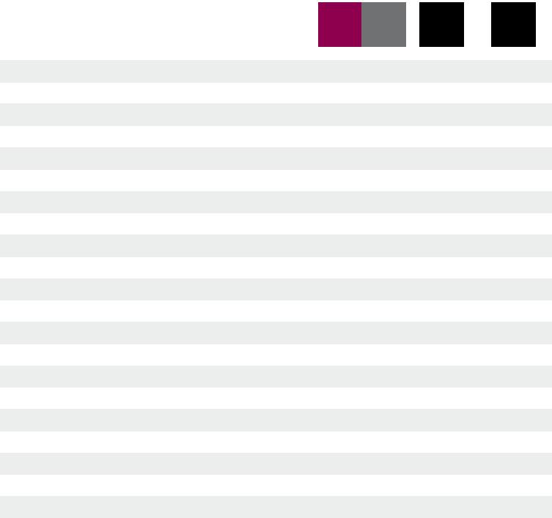

HSSE
Co 5

Accessories - Tungsten-carbide hole saws, shallow cut

Packing unit: individual plastic pack

105 174 | 113 001
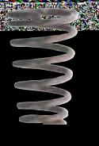

 | Ø |  | length |  | For hole saws |  | For hole saws |  | HSSE
 | mm |  | mm |  | Ø mm |  | cutting depth |  | Co 5
 | 6,0 |  | 47,0 |  | 16,0 - 70,0 |  | shallow |  | 113 001 |  |  | 1
 | Ejector spring |  |  |  |  |  |  |  | 105 174 |  |  | 1

48 PreCiSion toolS

Ø1
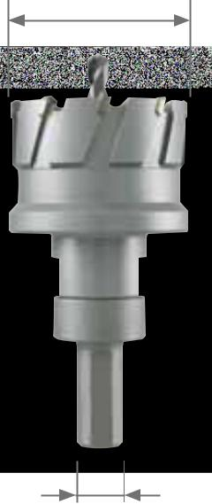
TC

28,0 mm | 28,0 mm | TC

accessories for RSH 1300

tungsten carbide multigrade hole saws MhS

Packing unit: individual plastic pack | Ø2

 | Steel (N/mm2) < 900 |  |  |  |  |  |  | Brass
 | Steel (N/mm2) < 1100 |  |  |  |  |  |  | Bronze
 | Steel (N/mm2) < 1300 |  |  |  |  |  |  | Plastics
 | rust-resistant steel |  |  |  |  |  |  | Cast iron
 | Aluminium |  |  |  |  |  |  | titanium alloyed
 | Ø1 | Ø |  |  |  |  |  | tube dimensions | Ø2 |  |  |  |  |  | TC
 | mm | inch |  |  |  |  |  | inch | mm
 | 15,0 |  |  |  |  |  |  |  | 13,0 mm |  |  |  |  |  | 113 015 -1 |  | 1
 | 16,0 | 5/8 |  |  |  |  |  |  | 13,0 mm |  |  |  |  |  | 113 016 -1 |  | 1
 | 17,0 |  |  |  |  |  |  |  | 13,0 mm |  |  |  |  |  | 113 017 -1 |  | 1
 | 18,0 |  |  |  |  |  |  |  | 13,0 mm |  |  |  |  |  | 113 018 -1 |  | 1
 | 19,0 | 3/4 |  |  |  |  | 3/8 |  | 13,0 mm |  |  |  |  |  | 113 019 -1 |  | 1
 | 20,0 |  |  |  |  |  |  |  | 13,0 mm |  |  |  |  |  | 113 020 -1 |  | 1
 | 21,0 |  |  |  |  |  |  |  | 13,0 mm |  |  |  |  |  | 113 021 -1 |  | 1
 | 22,0 | 7/8 |  |  |  |  | 1/2 |  | 13,0 mm |  |  |  |  |  | 113 022 -1 |  | 1
 | 23,0 |  |  |  |  |  |  |  | 13,0 mm |  |  |  |  |  | 113 023 -1 |  | 1
 | 24,0 | 15/16 |  |  |  |  |  |  | 13,0 mm |  |  |  |  |  | 113 024 -1 |  | 1
 | 25,0 | 1 |  |  |  |  |  |  | 13,0 mm |  |  |  |  |  | 113 025 -1 |  | 1
 | 26,0 |  |  |  |  |  |  |  | 13,0 mm |  |  |  |  |  | 113 026 -1 |  | 1
 | 27,0 | 1 1/16 |  |  |  |  |  |  | 13,0 mm |  |  |  |  |  | 113 027 -1 |  | 1
 | 28,0 | 1 3/32 |  |  |  |  |  |  | 13,0 mm |  |  |  |  |  | 113 028 -1 |  | 1
 | 29,0 | 1 1/8 |  |  |  |  | 3/4 |  | 13,0 mm |  |  |  |  |  | 113 029 -1 |  | 1
 | 30,0 | 1 3/16 |  |  |  |  |  |  | 13,0 mm |  |  |  |  |  | 113 030 -1 |  | 1
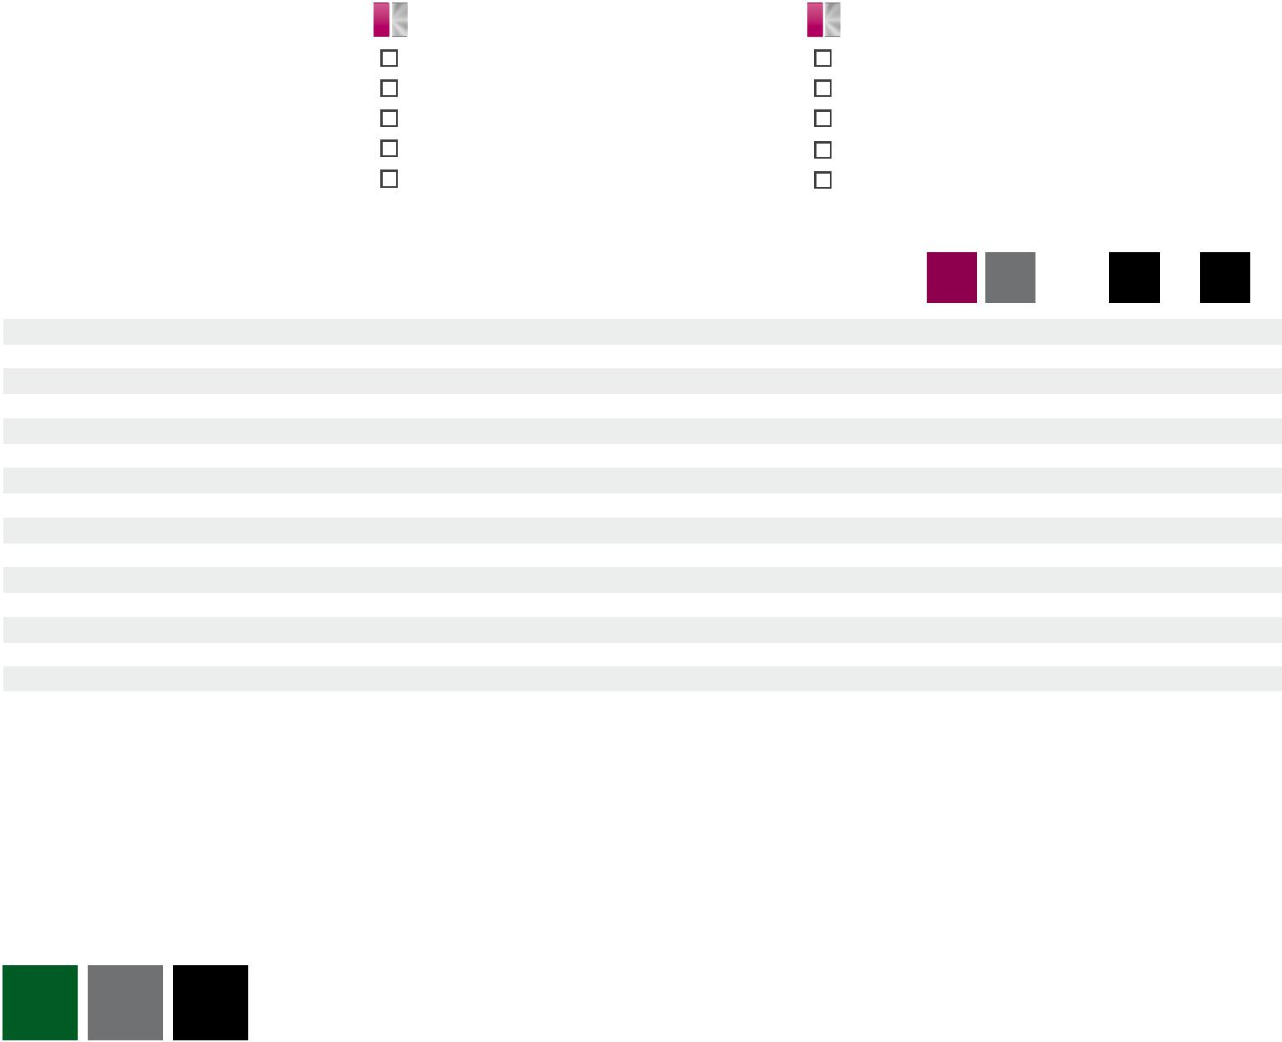

HSSE
Co 5

Accessories - tungsten-carbide multigrade hole saws MhS

Packing unit: individual plastic pack

113 218 | 113 002
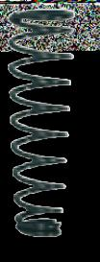

 | Ø |  | length |  | For hole saws |  | HSSE
 | mm |  | mm |  | Ø mm |  | Co 5
 | 6,0 |  | 65,0 |  | 15,0 - 30,0 |  | 113 002 |  |  | 1
 | Ejector spring |  |  |  |  |  | 113 218 |  |  | 1

Main application other application

PreCiSion toolS | 49

HSS
Ø1
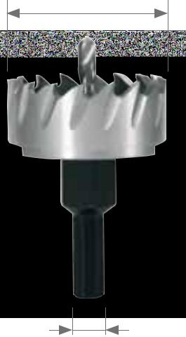

2,5 - 5,0 mm 5,0 mm

accessories for hand core drilling machine RSH 1300 hSS-g hole saws

Shank Ø2: Ø 12,0 - 14,0 mm = 8,0 mm

Shank Ø2: Ø 15,0 - 50,0 mm = 10,0 mm

Shank Ø2: Ø 55,0 - 60,0 mm = 12,0 mm

Ø2

Packing unit: individual plastic pack
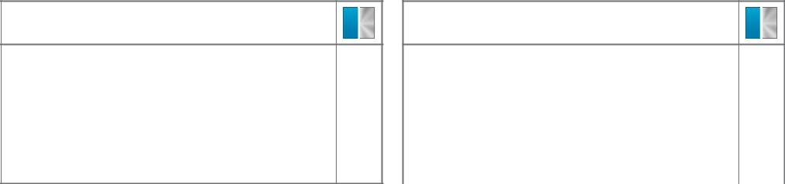

Steel (N/mm2) < 900

Steel (N/mm2) < 1100

Steel (N/mm2) < 1300

rust-resistant steel

Aluminium

Brass

Bronze

Plastics

Cast iron

titanium alloyed

 | Ø1 |  | Ø | Pg | tube dim. | HSS
 | mm |  | inch |  | inch
 | 12,0 |  | 15/32 |  |  | 128 012 |  | 1
 | 13,0 |  |  |  |  | 128 013 |  | 1
 | 14,0 |  | 9/16 |  |  | 128 014 |  | 1
 | 15,0 |  |  |  |  | 128 015 |  | 1
 | 16,0 |  | 5/8 | PG 9 |  | 128 016 |  | 1
 | 17,0 |  |  |  |  | 128 017 |  | 1
 | 18,0 |  |  |  |  | 128 018 |  | 1
 | 19,0 |  | 3/4 |  | 3/8 | 128 019 |  | 1
 | 20,0 |  |  |  |  | 128 020 |  | 1
 | 21,0 |  |  |  |  | 128 021 |  | 1
 | 22,0 |  |  |  | 1/2 | 128 022 |  | 1
 | 23,0 |  |  |  |  | 128 023 |  | 1
 | 24,0 |  | 15/16 |  |  | 128 024 |  | 1
 | 25,0 |  |  |  |  | 128 025 |  | 1
 | 26,0 |  |  |  |  | 128 026 |  | 1
 | 27,0 |  | 1 1/16 |  |  | 128 027 |  | 1
 | 28,0 |  | 1 3/32 |  |  | 128 028 |  | 1
 | 29,0 |  |  |  | 3/4 | 128 029 |  | 1
 | 30,0 |  | 1 3/16 |  |  | 128 030 |  | 1
 | 31,0 |  | 1 7/32 |  |  | 128 031 |  | 1
 | 32,0 |  | 1 1/4 |  |  | 128 032 |  | 1

 | Ø1 | Ø | Pg | tube dim. | HSS
 | mm | inch |  | inch
 | 33,0 |  |  |  | 128 033 |  | 1
 | 34,0 |  |  |  | 128 034 |  | 1
 | 35,0 | 1 3/8 |  | 1 | 128 035 |  | 1
 | 36,0 |  |  |  | 128 036 |  | 1
 | 37,0 | 1 7/16 | PG 29 |  | 128 037 |  | 1
 | 38,0 | 1 1/2 |  |  | 128 038 |  | 1
 | 39,0 |  |  |  | 128 039 |  | 1
 | 40,0 | 1 9/16 |  |  | 128 040 |  | 1
 | 41,0 | 1 5/8 |  |  | 128 041 |  | 1
 | 42,0 |  |  |  | 128 042 |  | 1
 | 43,0 | 1 11/16 |  |  | 128 043 |  | 1
 | 44,0 | 1 3/4 |  | 1 1/4 | 128 044 |  | 1
 | 45,0 |  |  |  | 128 045 |  | 1
 | 46,0 |  |  |  | 128 046 |  | 1
 | 47,0 | 1 7/8 | PG 36 |  | 128 047 |  | 1
 | 48,0 |  |  |  | 128 048 |  | 1
 | 49,0 |  |  |  | 128 049 |  | 1
 | 50,0 | 1 31/32 |  |  | 128 050 |  | 1
 | 55,0 |  |  |  | 128 055 |  | 1
 | 60,0 | 2 3/8 | PG 48 |  | 128 060 |  | 1
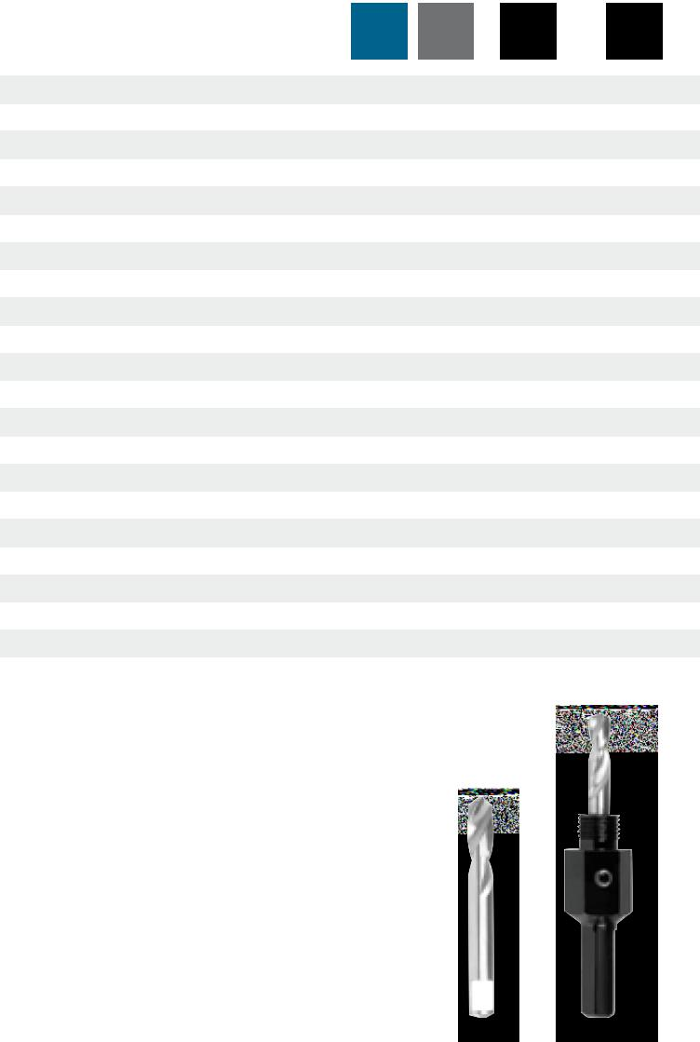

HSS

Accessories - hSS-g hole saws

Packing unit: individual plastic pack

128 216 | 128 215 | 128 212
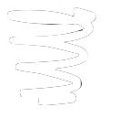
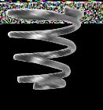

 |  |  | For hole saws |  | Shank |  | HSS
 |  |  | Ø mm |  | Ø mm
 | Arbor holder including pilot drill M 10 x 1,25 mm |  | 12,0 - 14,0 |  | 8,0 |  | 128 211 |  |  | 1
 | Arbor holder including pilot drill M 12 x 1,25 mm |  | 15,0 - 34,0 |  | 10,0 |  | 128 212 |  |  | 1
 | Arbor holder including pilot drill M 14 x 1,50 mm |  | 35,0 - 50,0 |  | 10,0 |  | 128 213 |  |  | 1
 | Arbor holder including pilot drill M 16 x 1,50 mm |  | 51,0 - 100,0 |  | 12,0 |  | 128 214 |  |  | 1
 | Pilot pin Ø 6,0 x 52,0 mm |  | 12,0 - 100,0 |  | - |  | 128 215 |  |  | 1
 | Ejector spring |  | Ø > 20,0 |  | - |  | 128 216 |  |  | 1

50 PreCiSion toolS

HSSE |  |  | D |  | DIN |  |  |  |  |  | 6H
Co 5 |  |  |  |  | 2174 |  | 60° |  | 4 |  | ISO 2

accessories for hand core drilling machine RSH 1300

Forming taps DIN 2174 HSS Co 5-nitrated-VAP, ground

Forming taps with reinforced shank for through threads and bottoming.

M
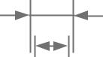

Ø1
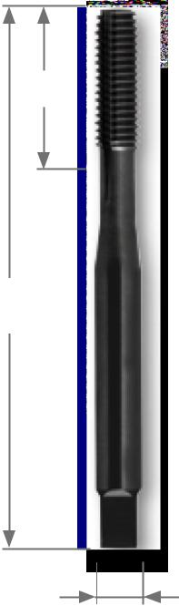

l2

Thread: metric, DIN ISO 13

Flanks: relief-ground

Packing unit: individual plastic pack

Steel (N/mm2) < 800

Steel (N/mm2) < 1000

Steel (N/mm2) < 1200

rust-resistant steel

Aluminium

Brass

Bronze

Plastics

Cast iron

titanium alloyed

L1

Ø2

nominal |  |  | Pitch |  | thread core hole |  | L1 |  | l2 |  | Ø2
thread size M |  |  | mm |  | Ø1 mm |  | mm |  | mm |  | mm
M | 4 |  | 0,70 |  | 3,70 |  | 63,0 |  | 13,0 |  | 4,5
M | 5 |  | 0,80 |  | 4,65 |  | 70,0 |  | 16,0 |  | 6,0
M | 6 |  | 1,00 |  | 5,55 |  | 80,0 |  | 19,0 |  | 6,0
M | 8 |  | 1,25 |  | 7,45 |  | 90,0 |  | 22,0 |  | 8,0

TC

tC flow drill with self centre tip

Heat is generated locally using rotational speed and friction heat, which plastifies the metallic materials of all kinds. thus closed eyelets can be made in several basic material thickness within a few seconds without chips.

Packing unit: individual plastic pack

nominal |  |  | thread core hole |  | Material thickness
thread size M |  |  | Ø mm |  | mm
M | 4 |  | 3,7 |  | 1,3
M | 5 |  | 4,5 |  | 1,3
M | 6 |  | 5,4 |  | 2,0
M | 8 |  | 7,4 |  | 2,0
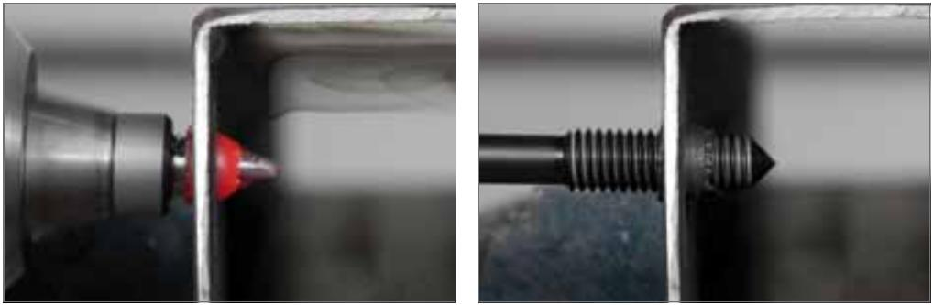

HSSE
Co 5

271 004 N | 1
271 005 N | 1
271 006 N | 1
271 008 N | 1

M
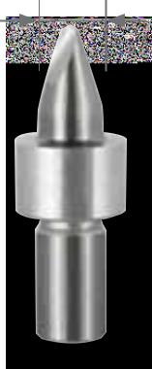

TC

274 004 | 1
274 005 | 1
274 006 | 1
274 008 | 1
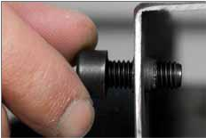

Main application other application

PreCiSion toolS | 51

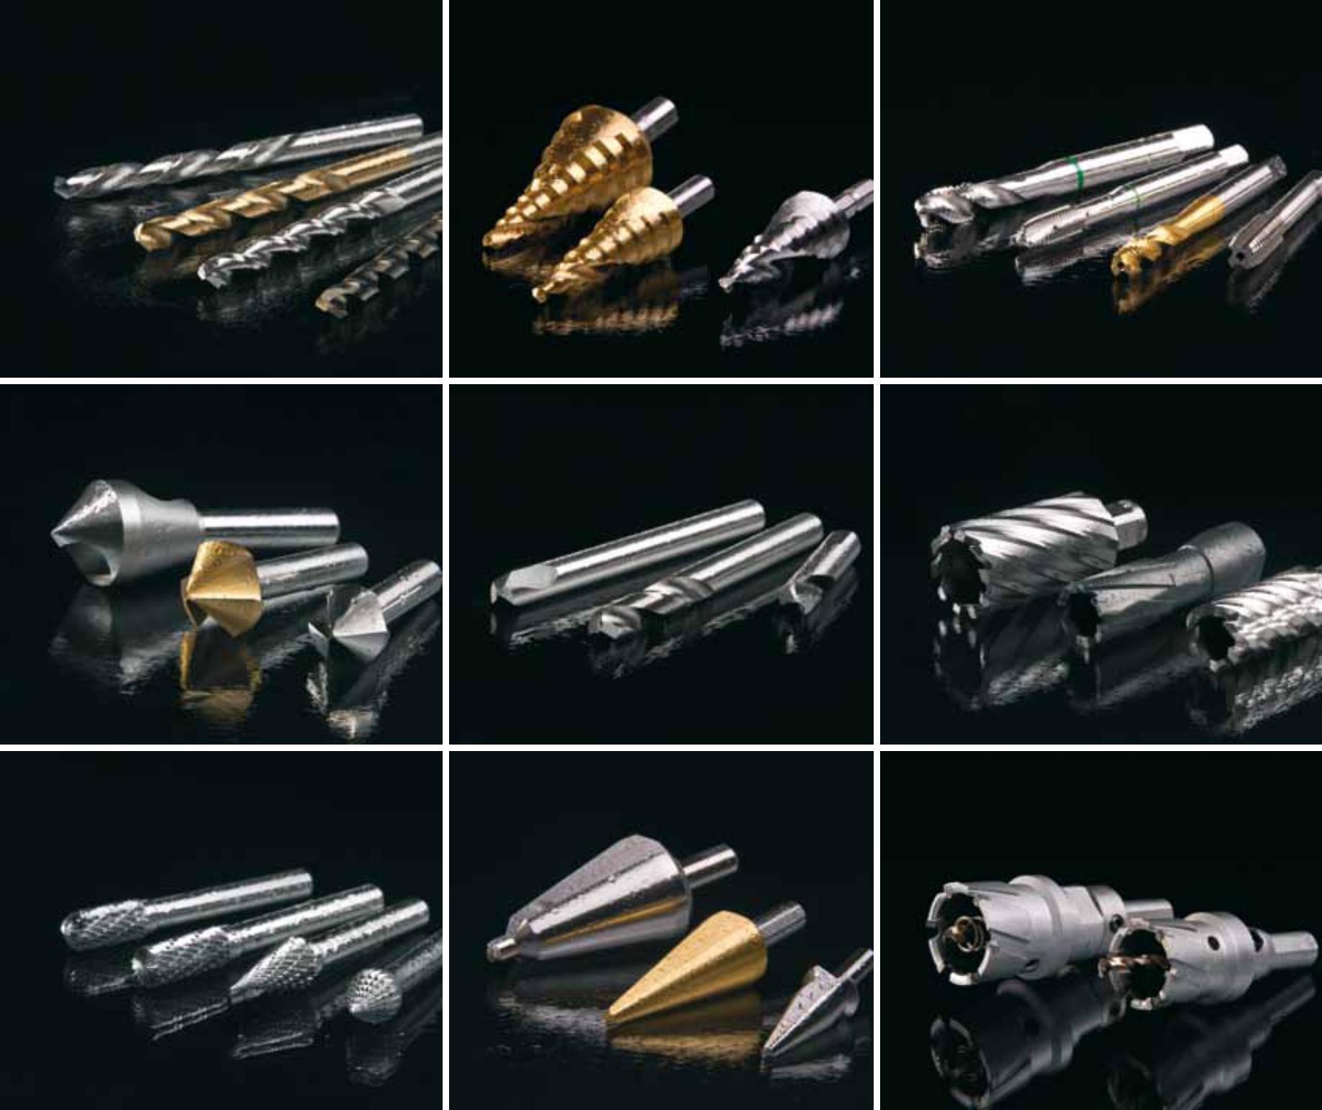

RUKO GmbH Precision tools

Robert-Bosch-Straße 7– 11

71088 Holzgerlingen

Germany

Tel.: | +49(0)7031 / 6800-0 | Export sales
Internet: www.ruko.de |  | Tel.: +49(0)7031 | / 6800-54 | / 84 / 85 / 790
E-Mail: | info@ruko.de | Fax. +49(0)7031 | / 6800-21 | / 66

© All rights reserved.

This catalogue is protected by copyright law and remains solely our property.

We reserve the right to make changes to technical data. Images are non-binding.

Liability for printing errors is excluded. This catalogue invalidates any previous editions.

RUKO dealer cross prices in € exc. VAT.

No. 810 969 / 1. Edition March 2016

