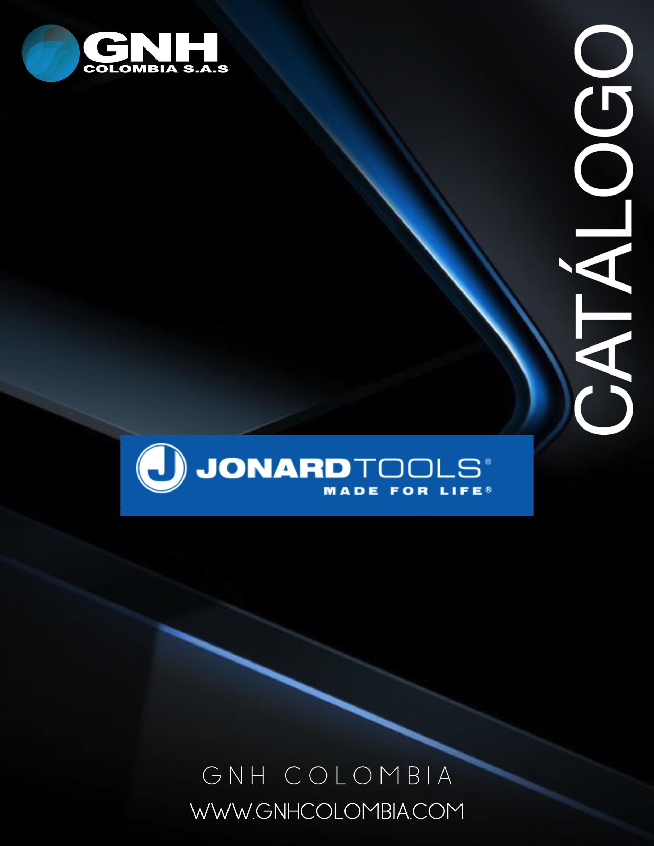

Catalog No. 120

1

FOUNDED IN 1958

Jonard Tools® manufactures tools for the Telecom, CATV, Fiber Optic, Home Automation, Security

- Alarm, and Electrical markets. Jonard Tools designs and engineers patented products by utilizing customer partnerships to create innovative solutions for industry needs. New tools are released each month and are all Made For Life® with lifetime warranties. Through quality and innovation Jonard Tools aims to move the industry forward and connect the world.

Warranty

We stand by our brand with a Lifetime Warranty - see details on our website www.jonard.com.

Contact Us

Customer Service Email: sales@jonard.com Website: www.jonard.com

Phone: 914.793.0700 Fax: 914.793.4527

1

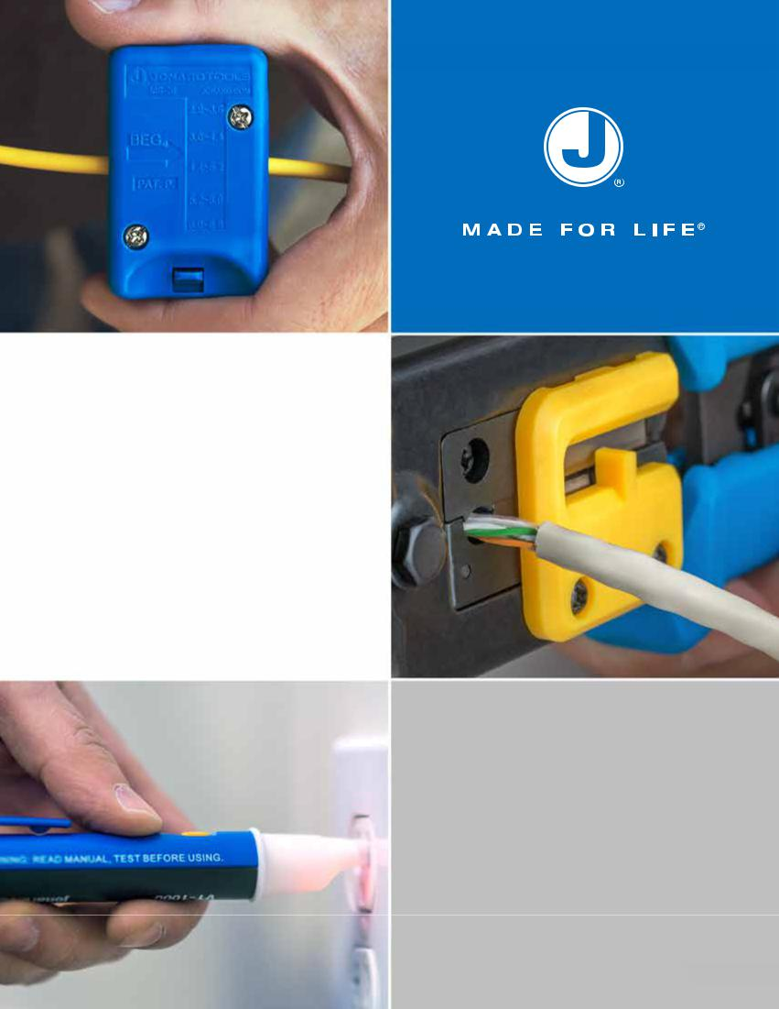

TABLE OF CONTENTS

Fiber Optic Tools | 3
CATV/COAX Tools | 14
Cable Installation | 28
Hand Tools | 34
Network & Telecommunication Tools | 48
Wire Strippers & Slitters | 56
Insertion & Extraction Tools | 58
Soldering & Desoldering Tools | 60
Kynar Wire | 61
Wire Wrap Tools | 63
Force Gauges | 73
Alignment & Adjustment Tools | 75
Index | 77

Stay Connected With

All Things Jonard!

www.youtube.com/JonardTools

www.facebook.com/JonardTools

@JonardTools

@JonardTools

2

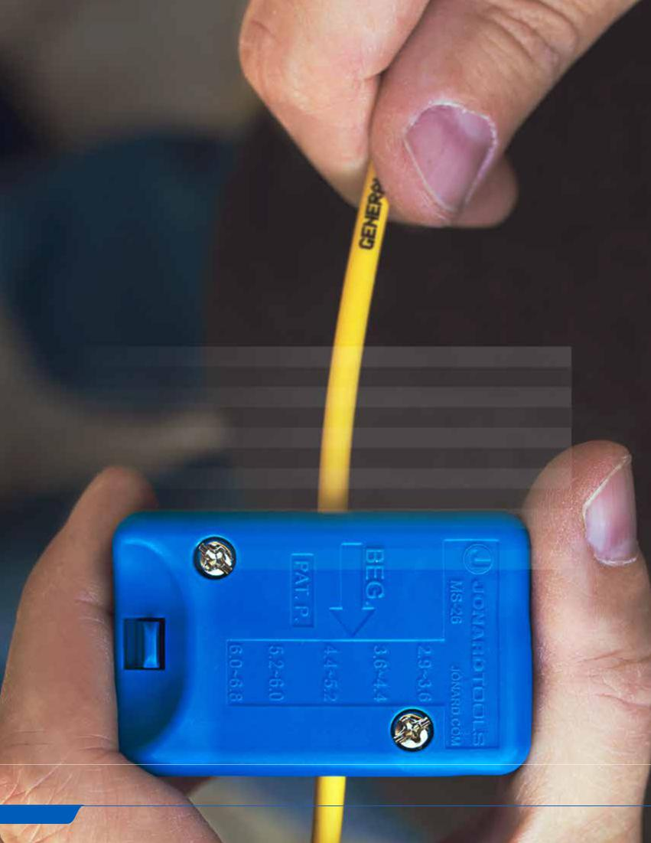

FIBER OPTIC TOOLS

Fiber optics uses flexible fibers of glass to transmit light signals that allow for higher bandwidths and longer distances than traditional wires. Optical fibers are as thin as a human hair and carry large amounts of data for telecommunication, television, and computer networking. Fiber optic cables usually consist of a core surrounded by cladding, buffer tubes, and an outer jacket. For simplex fiber cables, drop cables for FTTH, distribution, and blown fiber cables, our tools aid in stripping, prepping, connecting, cleaning, and terminating these fiber cables.

CONTENTS

Strippers | 4
Slitters | 5
Cutters | 7
Crimpers | 8
Inspection Tools | 8
Fiber Cleaners | 9
Fiber Scribes | 10
Fiber Cleavers | 10
Fiber Connectors | 10
Fiber Optic Tool Kits | 11
Thermal Strippers & Ultrasonic Cleaners | 13

3

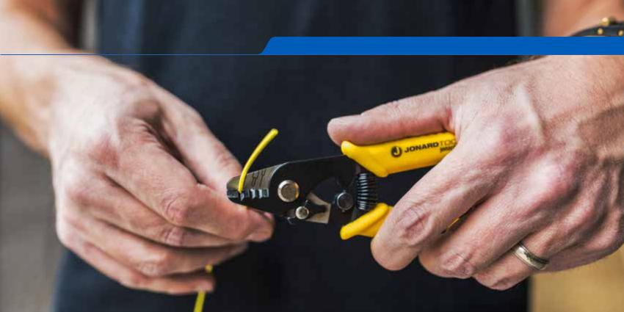
jonard.com | Fiber Optic Tools

Fiber Optic Stripper - JIC-125
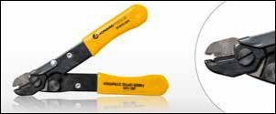

The Fiber Optic Stripper is used for stripping 250 micron buffer coating from 125 micron optical fiber. Preset at the factory so no adjustments are necessary. Unique design prevents nicks or scratches on the optical fiber plus blades are ground and hardened for long life. Yellow plastic dipped handles

Ergonomic Fiber Optic Stripper - JIC-175
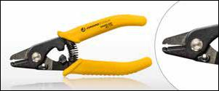

Used for stripping the 250 micron coating from the 125 micron optical fiber. Preset at the factory so no adjustments are necessary, this unique Ergonomic design prevents nicks or scratches on the optical fiber. The stripping blades are ground and hardened for durability and long life. Handle is made of TPR (Thermoplastic Rubber).

Ergonomic Fiber Optic Stripper, 200 micron - JIC-200
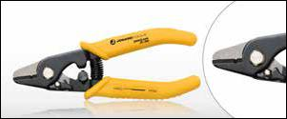

Used for stripping the 200 micron coating from the 125 micron optical fiber. Preset at the factory so no adjustments are necessary, this unique Ergonomic design prevents nicks or scratches on the optical fiber. The stripping blades are ground and hardened for durability and long life. Handle is made of TPR (Thermoplastic Rubber).

Fiber Optic Stripper Three Hole - JIC-375
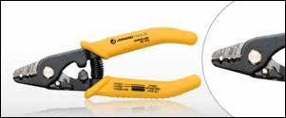

Three hole Fiber Optic Stripper model performs all common fiber stripping functions. The first hole of this Fiber Optic Stripper strips the 1.6-3 mm fiber jacket down to the 600-900 micron buffer coating. The second hole strips the 600-900 micron buffer coating down to the 250 micron coating and the third hole is used to strip the 250 micron cable down to the 125 micron glass fiber without nicks or scratches. Handle is made of TPR (Thermoplastic Rubber).

4

Cable Slit & Ring Tool - CSR-1575
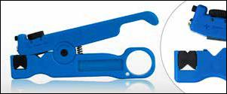

The CSR-1575 is designed to slit and ring cables, buffer tubes and jackets on fiber optic cables up to 7.5mm (0.3”) in diameter. The tool features an easily adjustable slit blade and ring blade as well as a removable and reversible V block that improves slitting performance and accommodates smaller to larger diameter cables.

Replacement Blade Set: CSR-2

Ratcheting Cable Slitter - RCS-25
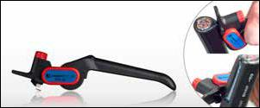

Slits and rings PVC, PE, rubber, and other cable jacket materials. Will work on small cables as well as cables larger than 25mm. Designed with reversible double-ended replaceable blade with adjustable cutting depth 0-5mm for each unique cable application. 10/20/30mm scaled on tool for slitting length reference. For midspan or end cable slit and ring applications.

Replacement Blade: RCS-25RB

Fiber Optic Drop Cable Slitter - FOD-2000
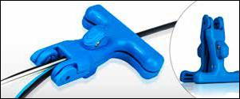

The PATENTED FOD-2000 Fiber Optic Drop Cable Slitter is a tool that simplifies the slitting of drop cable jackets at the end of the cable or mid-span and was developed specifically for FTTH technicians working with flat fiber drop cables. The FOD-2000 puts a slit on both sides of the jacket allowing easy access to the fiber and strength members. The ease of use makes this tool truly unique!

Replacement Blades: FOD-RB25

Riser Slitting Tool - RST-8514
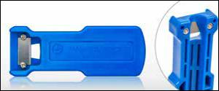

The RST-8514 is a mid-span slitting tool used to create an access window in round FTTH riser cables as well as microducts. It works with 8.5mm to 14mm round cables. RST-RB25 Replacement Blades (Pkg of 25 blades).

Easy to use:

- Press the tool against the cable to be accessed.

- Grip the tool and the cable firmly in one hand and pull.

5

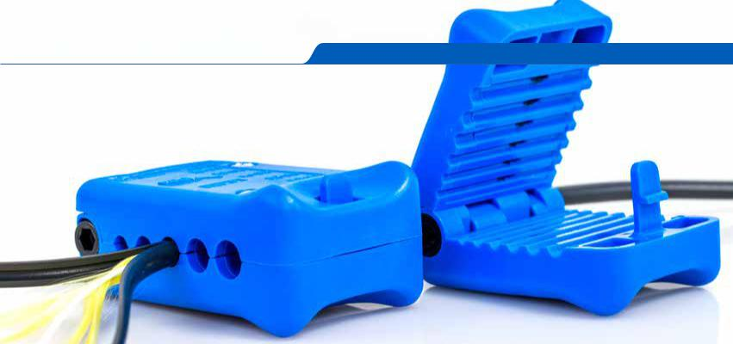
jonard.com | Fiber Optic Tools

 |  |  |  | Mid Span Slitters
 |  |  |  | These PATENTED tools are designed to open fiber jackets and loose buffer tubes
 |  |  |  | to provide easy fiber access. The buffer tube slitting is done without damage to the
 |  |  |  | fiber. Blades are replaceable. Note: MS-326 is designed for cables used in ducts
 |  |  |  | and microducts.
 |  |  |  | Simple to use:
 |  |  |  | • | Select the correct groove. Grooves marked with the recommended fiber size
 |  |  |  | • | Place the fiber in the groove to be used
 |  |  |  | • | Note: The arrow on the top of the tool indicates the pulling direction and the
 |  |  |  | • | line indicates the blade location
 |  |  |  |  | Close the tool making sure lock is engaged and pull to slit the fiber
 |  |  |  | • | For ring operation repeat steps above and, instead of pulling, rotate the tool
 |  |  |  |  | 3-6 times to ring the cable
SPECIFICATIONS | MS-6 | MS-26 |  |  |  | MS-306 |  | MS-316 | MS-326
DESCRIPTION | Mid Span Slitter | Mid Span Slitter |  |  |  | Mid Span Slit & Ring Tool |  | Mid Span Slit & Ring Tool | Mid Span Slit & Ring Tool
 | (1.2mm-3.3mm) | (2.9mm-6.8mm) |  |  |  | (1.2mm-3.3mm) |  | (2.9mm-6.8mm) | (5mm-10mm)
NO. OF PRECISION | 6 | 5 |  |  |  | 12 (6 Slitting, 6 Ringing) |  | 10 (5 Slitting, 5 Ringing) | 10 (5 Slitting, 5 Ringing)
GROOVES
GROOVE SIZES | 1.2-1.5, 1.5-1.8, 1.8- | 2.9-3.6, 3.6-4.4, 4.4- |  |  |  | 1.2-1.5, 1.5-1.8, 1.8- |  | 2.9-3.6, 3.6-4.4, 4.4- | 5.0-5.6, 6.0-6.6, 7.2-
(MM) | 2.1, 2.1-2.5, 2.5-2.9, | 5.2, 5.2-6.0, 6.0-6.8 |  |  |  | 2.1, 2.1-2.5, 2.5-2.9, |  | 5.2, 5.2-6.0, 6.0-6.8 | 7.8, 7.8-8.4, 9.4-10
 | 2.9-3.3 |  |  |  |  | 2.9-3.3
REPLACEMENT | MSB-1533 | MSB-2968 |  |  |  | MS-306RB |  | MS-316RB | MSB-5010
CARTRIDGE
 |  |  |  | Mid Span Slitter Replacement Cartridges
 |  |  |  | JONARD P/N |  |  | DESCRIPTION
 |  |  |  | MSB-1533 |  |  | Replacement Blades for MS-6
 |  |  |  | MSB-2968 |  |  | Replacement Blades for MS-26
 |  |  |  | MS-306RB |  |  | Replacement Blades for MS-306
 |  |  |  | MS-316RB |  |  | Replacement Blades for MS-316
 |  |  |  | MSB-5010 |  |  | Replacement Blades for MS-326
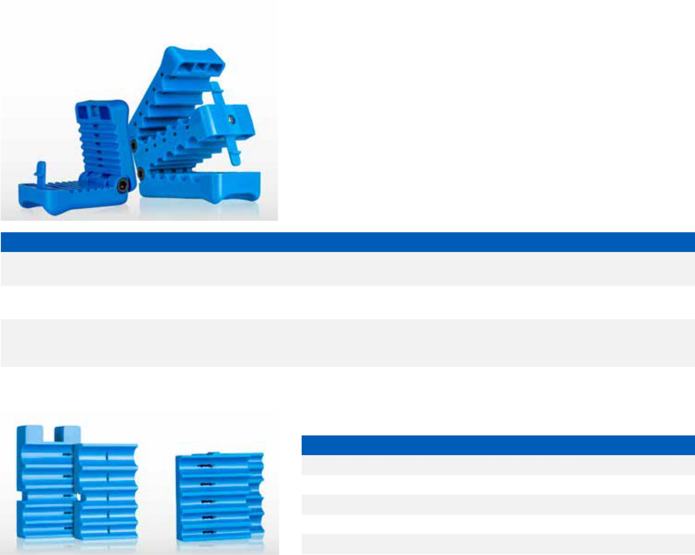

6

Slit & Ring Tools
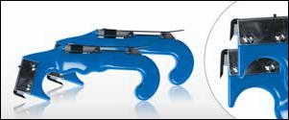

The JIC-4366 Cable Slit & Ring Tool and the JIC-4377 Fiber Jacket Slit & Ring Tool are used as cable sheath and jacket slitters. They can slit and ring-cut many types of buffer tubes, breakout cables, and jacketed fiber cables. The built in slitting blade opens the cable sheath and the ring cut blade works on diameters from 1/8” to 3/8”. The JIC-4377 has a shorter tapered slitting blade specifically for easier use with the OFS Minicord EZ Bend and other similar cables.

Both come with a set of spare blades:

RB-2060/6 Replacement blades for ring cut on JIC-4366, JIC-4377, and JIC-2060

RB-2878/6 Replacement blades (package of 6) for stripping feature of the JIC-4366

and JIC-4377.

Wire & Kevlar Cutting Shears - JIC-186
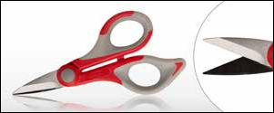

High carbon stainless steel blades (heat treated to HRC 58-60) designed to cut Kevlar®, cabling insulation, tape, cable ties and other material. Ergonomic handles for user comfort and durability. Adjustable joint screw under protective cap, a serrated blade for gripping, sharp and durable. 6” long. Handle material is dual component Nylon and Santoprene.

Micro Duct Tube Cutter - MDC-14
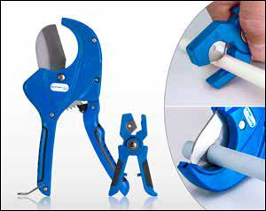

Cuts micro ducts and other types of tubing made from PVC, Nylon, Polyethylene and other materials quickly and with less effort so cuts are clean and straight. Maximum duct diameter 14mm (9/16”). Tool is made from Polypropylene with TPR (Thermoplastic Rubber) grips for comfort. Blade is made from heat treated stainless steel for longer life. Overall Length: 4.5” (114.3mm)

Large Fiber Duct Cutter - MDC-64

The MDC-64 Is a large Fiber Duct tube cutter designed to cut Fiber Ducts (up to 64mm/2.52” in diameter), PVC, CPVC, PE, HDPE, PEX and other nonmetallic tubing. This ratcheting cutter provides high leverage to facilitate cutting with minimal effort. Comfortable one hand operation and easy open release. Provides square and straight cuts with no mess when compared to other saw type pipe cutters. The Triangular blade shape helps to hold the tubing as well as to reduce cutting force. Tool body is Die Cast Aluminum alloy and cutting blade is made from Stainless Steel for long life. Overall Length: 9.5” (241.3 mm)
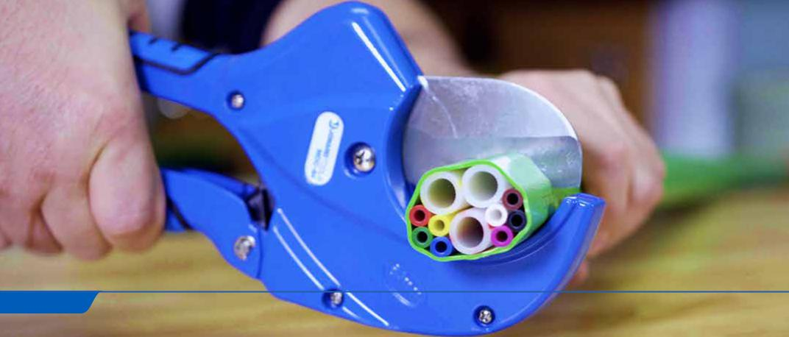

7

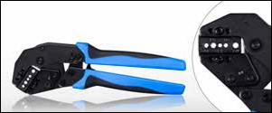

Fiber Optic Crimping Die UCD-2685
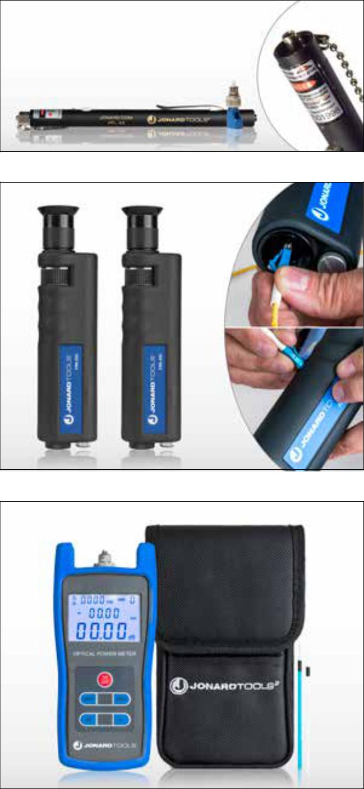

 | F4
 | .178 |  | .139
F4 | .151 | .134 | .190
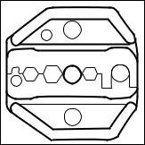
jonard.com | Fiber Optic Tools

Crimper With Fiber Die - UC-8039

The UC-8039 Universal Crimper with Fiber Optic Die (UCD-2685) offers exceptional performance. Designed for minimal closing force (higher crimp force produced with lower hand force), plus there is no break-over hand force making the last click easily achievable. The head is angled to lessen the need to bend the wrist awkwardly, die changes are made quickly and easily, ergonomic handles are dual component with a soft rubber insert plus the tool includes a built in safety release mechanism. Very durable steel housing accommodates both Fiber Optic and Coax dies.

Kit includes:

UC-8000 Universal Crimper Without Die

UCD-2685 Fiber Optic Crimping Die

Visual Fault Locator Kit - VFL-150

Visual Fault Locator Kit - Includes: VFL-25, 2 AAA Batteries, VFL-25125 FC/LC Adapter. This pen style VFL is specially designed for field personnel who need a portable light source tool for fiber tracing, fiber routing, continuity testing, to locate breakpoints (bending or cracking in fiber optic cables), and poor connections. VFL-150 works on FC, SC, ST connectors and will work on LC connectors when used with the included VFL-25125 adapter. Distance: Up to 5km (3.10 miles).

Fiber Inspection Microscopes

Fiber inspection microscopes have a focus wheel and features 2.5mm and 1.25mm adapters for use on most fiber connectors. The achromatic lens offers excellent imaging and integrated laser filters for safety (not intended for use with illuminated fibers). Coaxial illumination provides clear view of connector face and fiber.

The FIM-200 has 200x magnification

The FIM-400 has 400x magnification
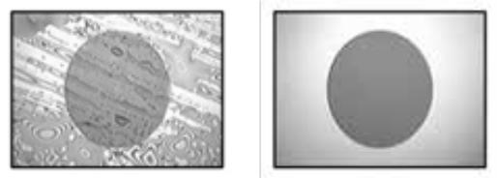

Before Cleaning After Cleaning

Fiber Optic Power Meter - FPM-50

An intelligent fiber optic power meter designed to measure wavelengths with high precision. Used for absolute and relative power measurements. Wavelengths Measured (mm): 850, 980, 1300, 1310, 1490, 1550, 1625, 1650.

Features:
- Measures a wide range of wavelengths

- Auto-off feature

- Special function allows manual calibration of the unit

- LCD back-lite for viewing in low light locations

Includes: |  | •
• | Power Meter |  | Cotton Swabs
• | Protective Cover | • | (1) FC and (1) SC Adapter
• | 3 AA Batteries | • | Nylon Carry Case

8

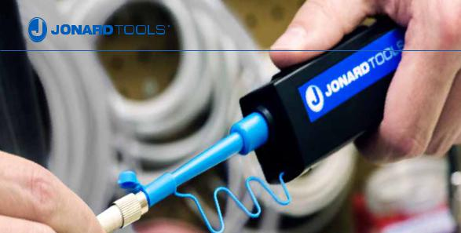

Fiber Connector Cleaners
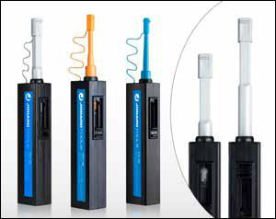

Designed to provide exceptional cleaning performance by cleaning connectors beyond the critical fiber core area and cleaning deep into the contact area of a bulkhead adapter or connectors on fiber optic cables. The tethered dust cap provides protection for the micro fiber cleaning fabric and is an adapter for connector end face cleaning.

Features a PATENTED 360 degree Rotational Tip for extra wide cleaning, easy one push operation and extendable nozzle, providing an additional 1.5 inches for a nozzle length of 4 inches to aid in accessing deep ports or crowded access panels. Additionally the Fiber Connector Cleaners use a non-woven micro fiber that is lint free. The FCC-120 provides 500+ cleanings and both the FCC-125 and FCC-250 provide 800+.

The outer bodies are made from static dissipative material for ESD safe work.

SPECIFICATIONS | FCC-120 | FCC-125 | FCC-250
DESCRIPTION | Fiber Connector Cleaner MPO | Fiber Connector Cleaner 1.25mm | Fiber Connector Cleaner 2.5mm
FIBER CONNECTORS | MPO | LC | FC, SC, ST

Universal Fiber Connector Cleaner - FCC-300
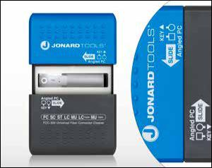

The new, FCC-300 Universal Fiber Connector Cleaner incorporates a new non-woven, synthetic cleaning cloth offering greater durability, usability and improved reliability. And this cloth can handle wet or dry cleanings and there is never a fiber residue on the end face.

The FCC-300 is a handheld connector cleaner that is strong enough for aggressive cleaning of a wider range of contaminates, soils and end-face debris. Stable, consistent, cleaning performance regardless of operator skill thanks to its PATENT PENDING Slide-Guide™ connector holder.

Key Features:

- Extra durable, compact and highly reliable cleaner for connector end-face cleaning in the field and factory.
- Automatic “Clean and Advance” tape technology provides a fresh cleaning

surface after each swipe eliminating waste and guaranteeing long tool life. Cleaning
and tape advance occurs in either direction, only one swipe needed to clean connector end face.
- Packaged in a handy palm sized unit, for over 500 cleanings.

- Works with both Simplex or Duplex applications.

- ESD Anti-static materials. Supports both PC and APC end face designs.

9

jonard.com | Fiber Optic Tools

Fiber Wipes, Pack of 50 - FW-50

Alcohol Wipes. Pure 91% Isopropyl Alcohol.

•
•
•
•

•

Excellent Cleaner for optical surfaces, glass fibers, and connector end faces

Fast evaporating, residue-free solvent

Mild, non-abrasive solvent

Compatible with most plastics, glass and metals Convenient, safe package

Fiber Scribe - FS-616
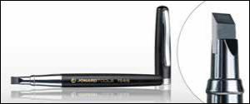

Housed in a protective metal housing with pocket clip, the FS-616 has a 6mm wide blade with a 35-degree beveled edge. It features a wide carbide blade, allowing the cleaving of standard as well as larger diameter fibers and miniature rod shaped lenses. Ideal for scratch and pull scribing of fiber optic cables.

Fiber Cleaver - FC-220
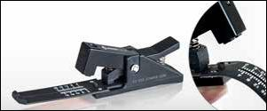

The FC-220 is a single fiber cleaver designed to accommodate either 900µm buffered or 250µm coated fiber. The quick and easy three-step operation is well suited for mechanical splice and quick termination field connector applications. The leaf spring base is ruled to allow for cleave lengths of 2 to 20mm. The standard carbide blade will perform up to 6000 cleaves.

Replacement Carbide Steel Blade: FC-4, Replacement Leaf Spring: FC-65

Fiber Connector Tools
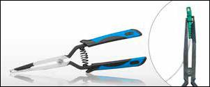

The perfect tools for inserting and extracting fiber connectors in high density patch panels. Both include a spring-loaded comfortable grip to allow for easy operation.

FCT-100 is designed to work with LC, SC simplex and duplex connectors as well as with MU, MT-RJ and other similar type connectors.

FCT-200 is designed to work with current LC connectors and next version LC connectors.
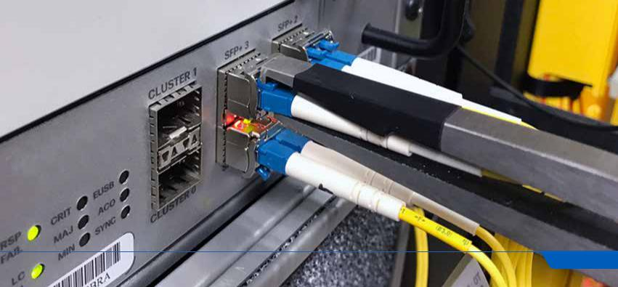

10

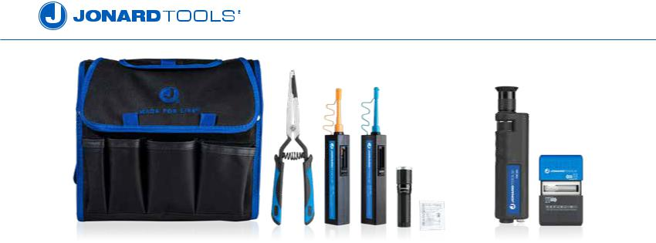

Fiber Connector Cleaning/Inspection Kits

Provides you with all the tools needed for cleaning and inspecting fiber connector end faces.

•
•
•

TK-186 Fiber Connector Cleaning Kit

TK-188 Fiber Connector Cleaning and Inspection Kit 200x Magnification

TK-189 Fiber Connector Cleaning and Inspection Kit 400x Magnification

JONARD P/N | DESCRIPTION |  | TK-186 |  | TK-188 |  | TK-189
FCC-125 | Fiber Connector Cleaner 1.25mm |  |  | X |  | X | X
FCC-250 | Fiber Connector Cleaner 2.5mm |  |  | X |  | X | X
FCC-300 | Universal Fiber Connector Cleaner |  |  |  |  | X | X
FCT-100 | Fiber Connector Insertion and Removal Tool |  |  | X |  | X | X
FIM-200 | Fiber Inspection Microscope 200x Magnification |  |  |  |  | X
FIM-400 | Fiber Inspection Microscope 400x Magnification |  |  |  |  |  | X
FL-2000 | LED Flashlight with Zoom Lens |  |  | X |  | X | X
FW-50 | Fiber Wipes (Pkg. of 50) |  |  | X |  | X | X
H-90 | Rugged 21 Pocket Tool Case |  |  | X |  | X | X
 |  | Fiber Optic Tool Kits
 |  | The TK-325 Scissor & Pouch Kit consists of the JIC-186 Wire & Kevlar Cutting
 |  | Shears and the H-25 Pouch with belt clip.
 |  | The TK-350 Fiber Kit with Kevlar Cutter includes the JIC-375 Fiber Optic Stripper
 |  | Three Hole, JIC-186 Ergonomic Fiber Optic Kevlar Cutter, and the convenient H-60
 |  | Molded Two Pouch with a convenient metal clip.
 |  | The TK-375 Fiber Stripper & Scissor Kit includes the JIC-375 Fiber Optic Stripper,
 |  | ES-1964 Electrician’s Scissor, and convenient molded two tool plastic pouch (with
 |  | metal clip).
JONARD P/N | DESCRIPTION |  | TK-325 |  | TK-350 |  | TK-375
ES-1964 | Electrician Scissor |  |  |  |  |  | X
H-25 | Plastic Molded Pouch For JIC-186 & JIC-195 |  |  | X
H-36 | Molded Pouch |  |  |  |  |  | X
H-60 | Molded Two Tool Pouch |  |  |  |  | X
JIC-186 | Ergonomic Fiber Optic Kevlar Cutter |  |  | X |  | X
JIC-375 | Fiber Optic Stripper- 3 Hole |  |  |  |  | X | X
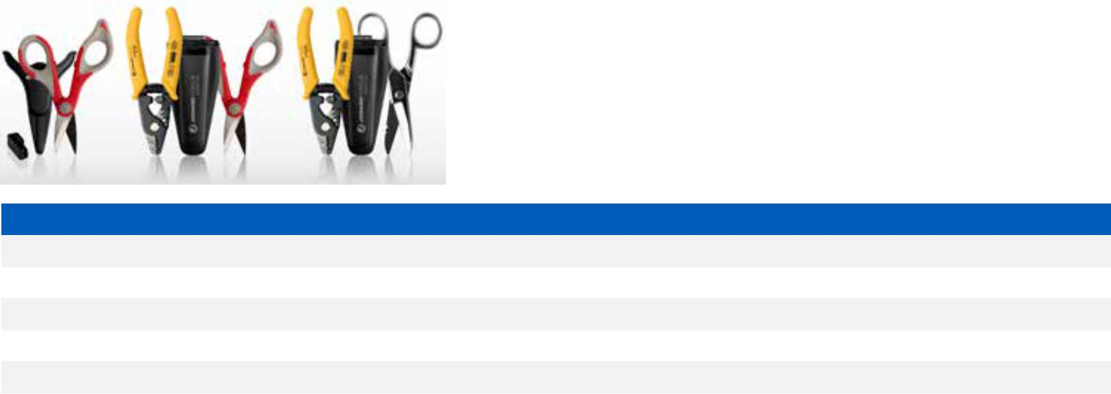

11

jonard.com | Fiber Optic Tools
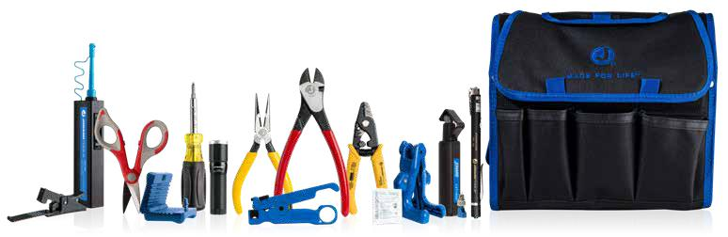

Fiber Prep Kits

Provides you with all the tools needed to access and prepare a fiber optic cable for termination.

•
•
•

•

TK-120 Fiber Prep Kit

TK-150 Fiber Prep Kit, W/ Connector Cleaner, Fiber Cleaver & Visual Fault Locater

TK-160 Fiber Prep Kit W/ Connector Cleaners, Visual Fault Locater

TK-170 Fiber Prep Kit with Small & Large Mid Span Slitters

JONARD P/N | DESCRIPTION | TK-120 | TK-150 | TK-160 | TK-170
CSR-1575 | Cable Slit & Ring Tool | X | X | X | X
CST-1900 | Round Cable Stripper | X | X | X | X
FC-220 | Fiber Cleaver |  | X
FCC-125 | Fiber Connector Cleaner 1.25mm |  |  | X
FCC-250 | Fiber Connector Cleaner 2.5mm |  | X | X
FL-2000 | LED Flashlight with Zoom Lens | X | X | X
FOD-2000 | Fiber Optic Drop Cable Slitter | X | X | X
FW-5 | Fiber Wipes (Pkg. of 5) | X | X | X
H-90 | Rugged 21 Pocket Tool Case | X | X | X | X
JIC-1022 | Fiber Jacket Stripper |  |  |  | X
JIC-186 | Ergonomic Kevlar Cutter | X | X | X | X
JIC-22035 | Probe Pick - Spudger |  |  |  | X
JIC-2288 | High Leverage Diagonal Cutter | X | X | X | X
JIC-375 | Fiber Optic Stripper | X | X | X | X
JIC-842 | Telecom Long Nose D Pliers | X | X | X | X
KN-7 | Cable Splicing Knife |  |  |  | X
MS-26 | Mid Span Slitter (2.9mm-6.8mm) |  |  |  | X
MS-6 | Mid Span Slitter (1.2mm-3.3mm) | X | X | X | X
SD-61 | Screwdriver Multi-Bit 6-In-1 | X | X | X | X
UST-500 | Universal Cable Stripping Tool |  |  |  | X
VFL-150 | Visual Fault Locator |  | X | X

12

Thermal Strippers Adjustable & Fixed Blade
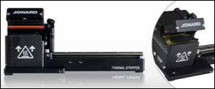

The Jonard Thermal Strippers are compact, easy-to-use fiber stripping units designed to thermo-mechanically remove coatings from optical fibers. The heater is adjustable up to 200ºC; far hotter than any competing product. This feature facilitates stripping extremely difficult and baked-on coatings and in some cases can even remove fluoroacrylate undercoatings.

Our TSAB-40 Adjustable Blade Thermal Stripper supports optical fibers with

cladding diameters from 30µm to 1000µm, with buffer diameters up to 1200µm. This includes standard 250µm, 400µm, and 900µm coated fibers.

Adjustable temperature and time settings allow it to adapt to stripping a variety of different acrylate coatings and cladding sizes.

Our TSFB-125 Fixed Blade Thermal Stripper supports standard 125µm optical fibers, including 250µm, 400µm, and 900µm coated fibers. Adjustable temperature and time settings allow it to adapt to stripping a variety of different coatings. The precision, self-centering blade design produces high strength stripping performance unmatched by previous flat blade strippers.

Features:
- Compact, low-maintenance bench top design

- Adjustable temperature and time settings to accommodate different fiber coatings

Includes: Power Supply, Power Cord, Cleaning Brush

Thermal Stripper Platforms & Universal Clamp
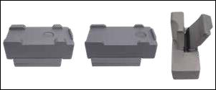

For Fitel, Fujikura and Ericsson fiber holders use the corresponding platforms. For LDF and all others without fiber holders use the Jonard Tools Universal Clamp.

 | JONARD PART # | DESCRIPTION
 | TSPE-125 | Ericsson Style Platform
 | TSPF-125 | Fitel/Fujikura Style Platform
 | TSUC-40 | Universal Clamp

Ultrasonic Cleaner - TSUC-5000
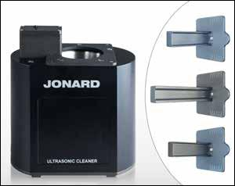

The Jonard Tools TSUC-5000, compact, low maintenance Ultrasonic Cleaner is a purpose-built ultrasonic fiber cleaner that has been designed specifically for fiber splicing applications.

Easy to use, an audible and visual indicator will signify when the fiber should be removed. Versatile settings allow user to adjust for cycle duration and intensity levels for maximum results. Options include a solid lid to reduce evaporation, and custom rails that can be adapted to the most popular fiber holders such as Fitel, Fujikura and Ericsson. Reservoir holds 70ml of alcohol.

Ultrasonic Cleaner Rails & Cover

JONARD PART # | DESCRIPTION
TSUC-516 | Ultrasonic Cleaner 16mm Fitel Fujikura Rail
TSUC-512 | Ultrasonic Cleaner 12mm Ericsson Rail
TSUC-518 | Ultrasonic Cleaner 18mm Fitel Rail
TSUC-510 | Ultrasonic Cleaner Cover
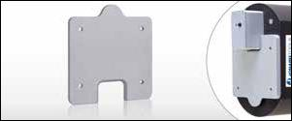

13

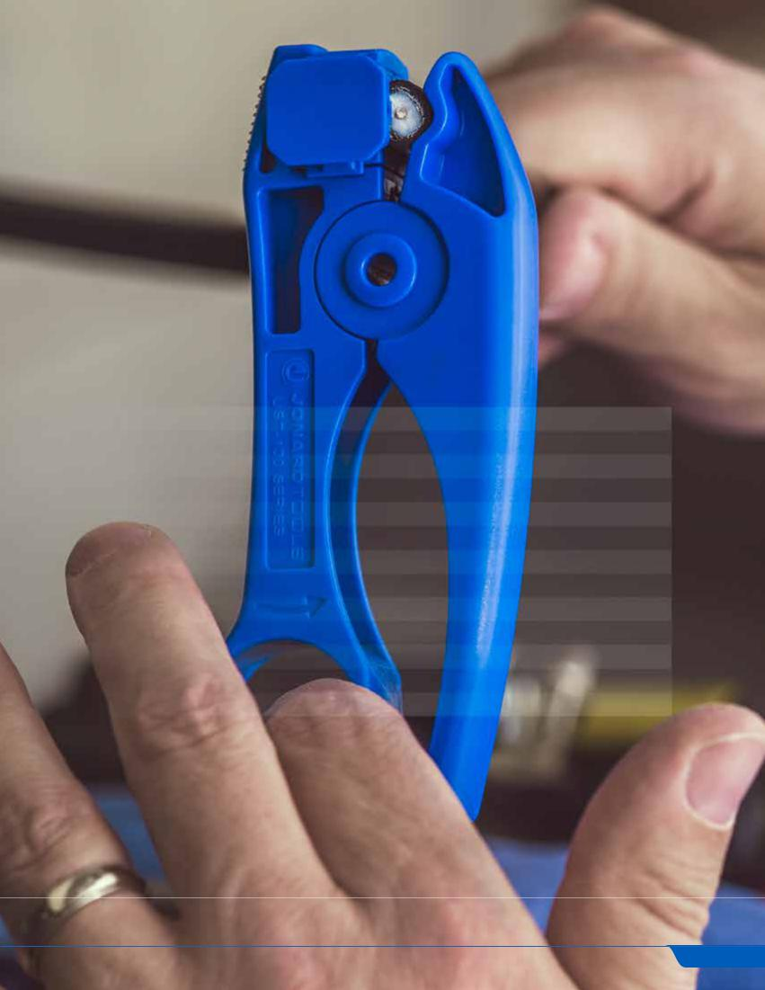

CATV/COAX TOOLS

CATV is short for Community Antenna Television, now known as Cable TV, which is transmitted via coaxial cables (COAX). COAX cables transmit radio frequency signals using an electromagnetic field carried through the tubular cable. These cables consist of an inner conductor, insulation, conducting shield, and outer sheath jacket. The spacing within the cables must be consistent in order to transmit the signals, and our tools ensure proper methods that will not damage these cables in any way.

CONTENTS

Strippers | 15
Compression Tools | 16
Crimpers | 17
Tool Kits | 18
Coring Tools | 20
Torque Wrenches | 20
Speed & Combination Wrenches | 21
Terminate / Lock / Unlock | 22
Pedestal Opening Tools | 24
Mapping / Testing / Probing | 25
Cutters | 26
Connector Tools | 27
Flaring Tools | 27

14

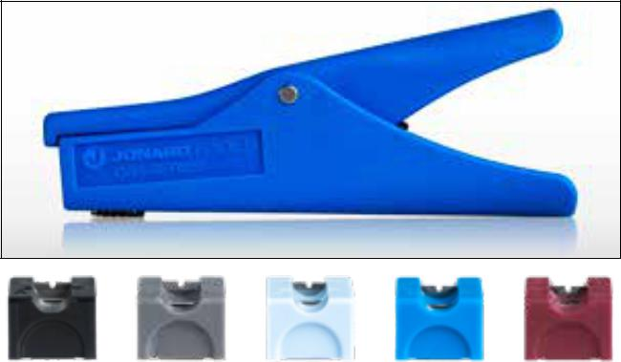

CSS-105 CSS-110 CSS-115 CSS-120 CSS-125
Coax Stub End Strippers

The CSS Series tools are coaxial cable strippers specifically designed to strip a stub end of a coax cable in a wall outlet box, which eliminates the need to run new cable, saving time and money. Each CSS tool provides a two step strip of an RG59/6 cable to a specific braid length and center conductor length (shown in the chart below). The built-in strip stop insures the strip lengths are consistent.

Easy to use:

Squeeze handles to open jaws and insert cable, release to close jaws, rotate like a screwdriver and remove. Tool will not cut the braid or score the center conductor.

Blades cartridges are easily changed and replaced.

SPECIFICATIONS | CSS-596 | CSS-5097 | CSS-5110 | CSS-5127 | CSS-5610
DESCRIPTION | Coax Stub End | Coax Stub | Coax Stub | Coax Stub | Coax Stub
 | Stripper | End Stripper | End Stripper | End Stripper | End Stripper
 | (RG59/RG6) | (9mm/7mm) | (10mm/10mm) | (12mm/7mm) | (6mm/10mm)
BLADE | CSS-105 | CSS-115 | CSS-120 | CSS-110 | CSS-125
BLADE CARTRIDGE COLOR | Black | Grey | Light Blue | Blue | Burgandy
BRAIDED STRIP LENGTH | 1/4” | 9mm | 10mm | 12mm | 6mm
CENTER CONDUCTOR STRIP LENGTH | 5/16” | 7mm | 10mm | 7mm | 10mm
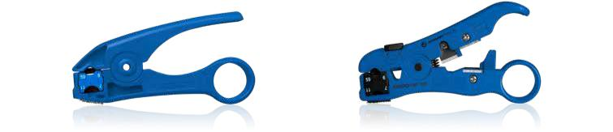

UST-100 SERIES UST-500 SERIES

Coax Stripping Tools

The UST Series creates a two step strip on a multitude of cables (and the UST-175 provides a three step strip). These tools includes a Velcro strip for folding back the braided shield of the cable. Cartridge blades are interchangeable and capable of making over 5,000 cuts.

SPECIFICATIONS | UST-100 | UST-125 | UST-150 | UST-175 | UST-185 | UST-1596 | UST-500 | UST-525 | UST-596
DESCRIPTION | RG59/6 & | Coax | CAT/TP & | Mini-Coax | Mini Coax | Coax | Universal | Universal | Universal
 | 7/11 COAX | Stripping Tool | RG59/6 Cable | Cable Stripper | Cable Stripper | Stripping Tool | Cable | Cable Strip | Cable
 | Stripping Tool | For RG59/6 | Stripping Tool |  |  | With Twin | Stripping Tool | Tool With | Stripping Tool
 |  | & 7/11 With |  |  |  | RG59/6 Blade |  | UST-225 | RG59/6
 |  | Cable Stop |  |  |  |  |  | Blade
CABLE TYPE | Coax | Coax | Coax | Coax | Coax | Coax | Coax, RG5, | Coax, RG5, | Coax, RG5,
 |  |  |  |  |  |  | CAT6, Flat | CAT6, Flat | CAT6, Flat
 |  |  |  |  |  |  | 4P/6P | 4P/6P | 4P/6P
CABLE SIZE | RG59/6, 7/11 | RG59/6, 7/11 | RG59/6, UTP | Mini Coax | Mini Coax | RG59/6 | RG59/6, UTP, | 7/11, | RG59/6,
 |  |  |  |  |  |  | 7/11, Flat | RG59/6, | UTP, Flat
 |  |  |  |  |  |  | Telephone | UTP, Flat | Telephone
 |  |  |  |  |  |  | UST-205 | Telephone
CARTRIDGE | UST-205 | UST-225 | UST-215 | UST-220 | UST-230 | UST-210 | UST-205 | UST-225 | UST-210
 | Blade for | Blade for | Blade for | Blade | Blade | RG59/6 Twin | Blade for | Blade | RG59/6 Twin
 | RG59/6 & | RG59/6 & | RG59/6 | Three Level | Two Level | Blades with | RG59/6 & | RG59/6, | Blades with
 | 7/11 | 7/11 With | 711 With | Mini-Coax | 1/4” x 1/4” | Cable Stop | 7/11 | 7/11” with | Cable Stop
 |  | Cable Stop | Cable Stop & |  | Mini-Coax |  |  | Cable Stop
 |  |  | Unshielded
 |  |  | Twisted Pair

15

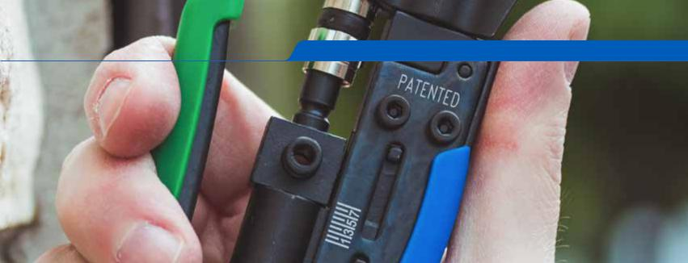
jonard.com | CATV / Coax Tools
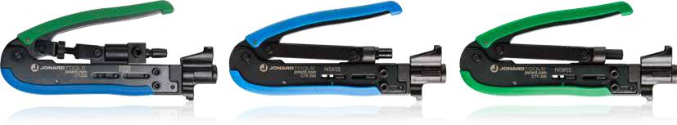

Compression Tools

COAX cables RG6 and RG59 utilize many different fittings to terminate cables. Jonard offers compression tools to work with all types of connectors (BNC, PPC, Belden, and more).

CT-200 - Universal Compression Tool designed for use on most F connectors (RG59, RG6, & RG11), BNC connectors (RG59 & RG6) and RCA connectors (RG59 & RG6).
CTF-200 - Compression tool with a fixed design for use on the longer style F connectors (such as PPC® EXXLWS Aquatight connector, EX-XL and other similar length connectors)
CTF-200CG - Compression tool with a fixed design for use on Corning Gilbert connectors. Tool also works with brands such as PPC & Thomas Betts. CTF-230 - This dual compression tool is two tools in one, combing the features of the CTF-200 and the CTF-300. It is designed for use on either short or long F connectors (such as PPC EX6 and PPC EX6XL), and also works on most RG 11 connectors. The Green ring side of the plunger is for the “short” PPC EX6 style
CTF-300 - Compression tool with a fixed design for use on the shorter style F connectors (such as PPC Aquatight Connector EX or shorter connectors and other similar length connectors).

SPECIFICATIONS | CT-200 | CTF-200 | CTF-200CG | CTF-230 | CTF-300
DESCRIPTION | Universal Compression | Compression Tool | Compression Tool | Dual Compression Tool | Compression Tool
 | Tool | Fixed - Long | Fixed - Long CG | - Short and Long | Fixed - Short
CONNECTOR TYPE | Adjustable | Fixed | Fixed | Fixed | Fixed
CONNECTOR LENGTH | Short & Long | Long | Long | Short & Long | Short
HANDLE COLOR | Green/Blue | Blue | Blue | Green/Blue | Green
REPLACEABLE PLUNGER P/N | 21881 | N/A | N/A | 21912 | N/A

360 Degree Compression Tool for RG59/6 - CTF-180
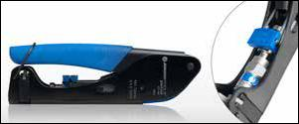

Fixed compression tool with reversible plunger and 360 degree F connector support for use with most short and long F connectors. This compression tool works on F connectors for RG6 and RG59 cables. The tool is solid steel construction, protected with a black oxide finish, spring loaded and fitted with blue cushioned grips making this tool rugged yet comfortable to use. Includes integrated handle lock for storage.

16

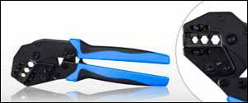

Coax Crimping Die
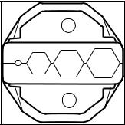

UCD-2045

.058.252 | 324 | 350
Crimper With Coax Die - UC-8012

The UC-8012 Universal Crimper with COAX Die (UCD-2045) crimps CATV “F” connectors used on RG59 and RG6 cables. Hole sizes are 0.068”, 0.262”, 0.324”,

- 360” (1.73mm, 6.65mm, 8.23mm, 9.14mm). This fully ratcheted crimper offers exceptional performance. Designed for minimal closing force (higher crimp force produced with lower hand force), plus there is no break-over hand force making the last click easily achievable. The head is angled to lessen the need to bend the wrist awkwardly. Very durable steel housing accommodates both Fiber Optic and Coax dies.

Kit includes:

UC-8000 Universal Crimper Without Die

UCD-2045 Coax Crimping Die

Modular Crimping Tool 6 In 1 - UC-864
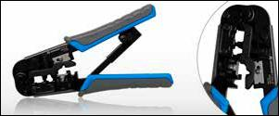

A rugged modular crimping and stripping tool for voice and data applications. The tool has 2 crimping slots; one slot used for 8 position modular plugs and the other slot is used for both 6 and 4 position modular plugs. The tool also has a round cable jacket stripper as well as a flat cable stripper and cutter. Tool works with the following modular plugs: RJ11, RJ12, RJ22 and RJ45.

Replacement Blade: UC-866

Regular and Feed-Thru Connector Crimper Tool - UC-4568
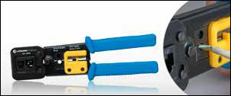

Durable all-steel construction crimp tool with built-in cutter and stripper.

Features:
  - Crimp and trim off excess conductors with a simple squeeze of the tool

  - Cleanly shears excess conductors leaving a smooth flat finish

  - Ratcheted, ultra-stable platform for consistent terminations with low hand force

  - Tool includes built in jacket stripper for round cables as well as flat cables plus a flat cable cutter
- Crimping dies are precision ground. Crimps 2,4,6 and 8 position RJ11 and RJ45 regular and feedthrough type modular connectors

- Heavy duty cutting blade good for 3,000 cuts

- Ergonomic handles for greater comfort
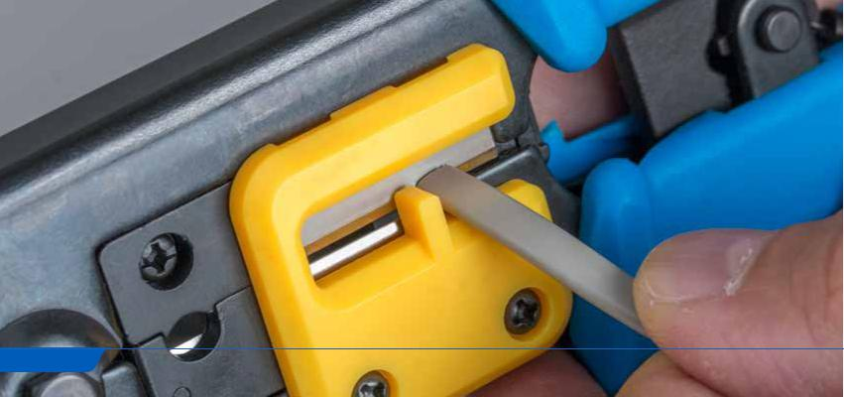

17

jonard.com | CATV / Coax Tools
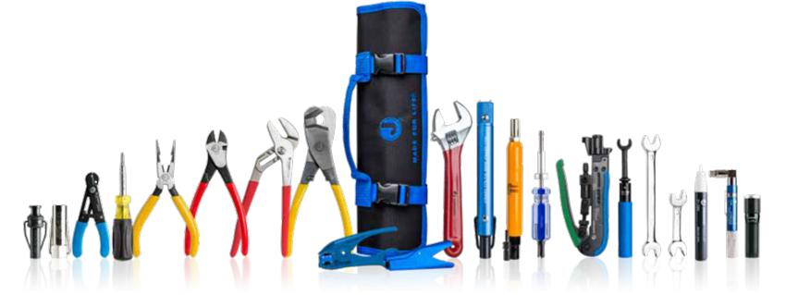

Professional CATV Communications Tool Kit - TK-822

All these tools are provided in a 25 Pocket Tool Roll Up Pouch (H-125) with extra pockets for extra tools, connectors and many other items, including an extra storage area at the end of the pouch.

Kit includes:
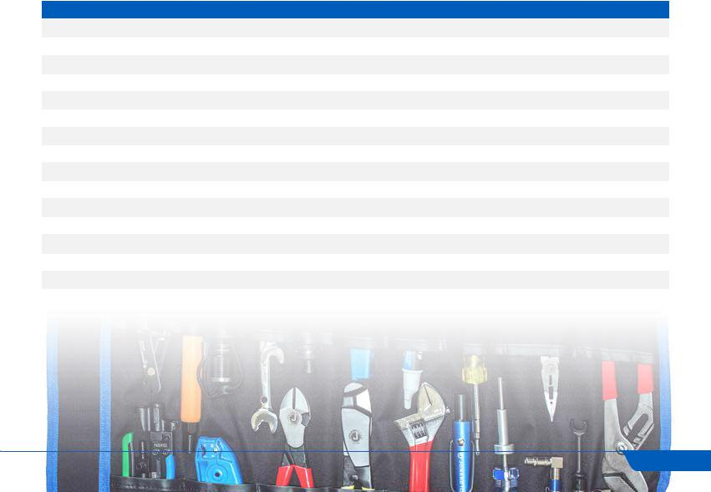

JONARD P/N | DESCRIPTION
JIC-750 | 3/4" COAX Cable Cutter
JIC-2288 | Plier, Diagonal, Cutter, 8"
JIC-22148 | Combo Crimper, Long Nose Pliers
JIC-50210 | Pump Plier 10"
M-216CS22 | Can Wrench, Ergo, W/ Wire Stripper
PT-300 | Pocket Continuity Tester & Toner
SD-61 | Screwdriver Multi-Bit 6 In 1
SST-716 | Security Shield Tool 7/16"
SST-916 | Security Shield Tool 9/16"
SK-51632 | Security Key Insert
TT-7V | Terminator Tool With Prongs
TTS-716 | Trap And Security Combo Tool
TWAF-71630 | Torque Wrench, Full Head 7/16", 30 in/lb
UST-125 | COAX Stripping Tool For RG59/6 & 7/11 With Cable Stop
VT-1000 | Voltage Detector
WS-5 | Adjustable Wire Stripper & Cutter

18

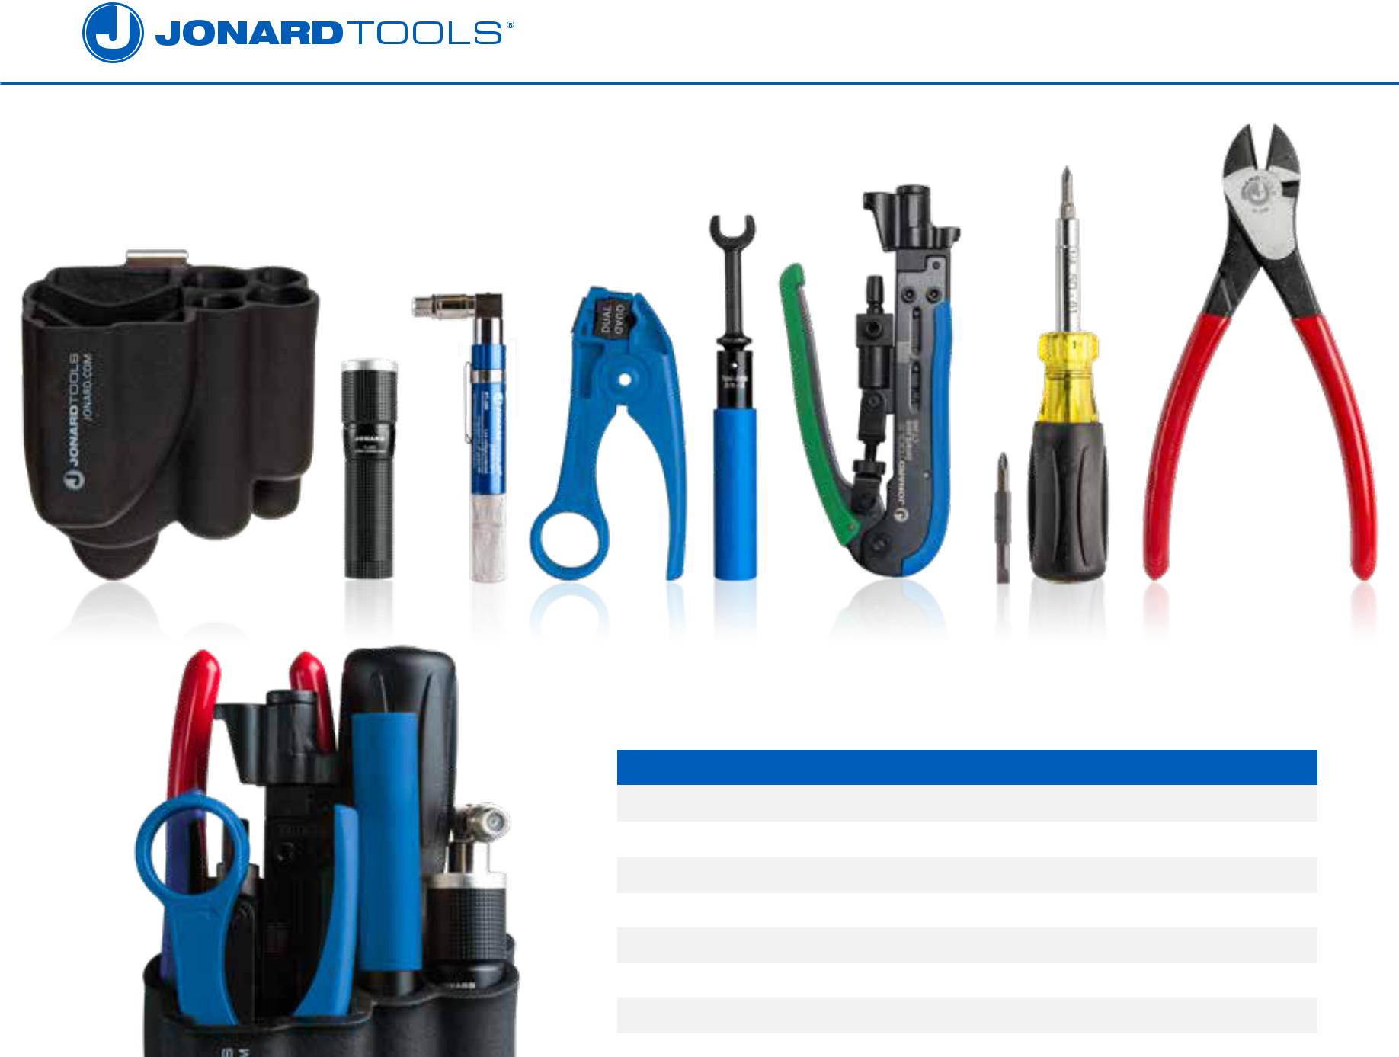

 |  |  | Coax Tool Kits
 |  |  | A CATV technician’s service kit designed for repair and maintenance of CATV cable
 |  |  | networks.
 |  |  |  | JONARD P/N |  |  | DESCRIPTION
 |  |  |  | TK-78 |  |  | Coax Tool Kit with 360 Degree Compression Tool
 |  |  |  | TK-78E |  |  | 360 Degree Compression Tool for RG59/6
 |  |  |  | TK-82 |  |  | Coax Tool Kit Long Connectors
 |  |  |  | TK-83 |  |  | Coax Tool Kit Short Connectors
 |  |  |  | TK-85 |  |  | Coax Tool Kit Universal
 |  |  |  | TK-87 |  |  | Coax Tool Kit Dual Connectors
 |  |  |  | TK-89 |  |  | Mini Coax Tool Kit
Kits Contains:
JONARD P/N | DESCRIPTION |  |  |  | TK-78 | TK-78E |  | TK-82 | TK-83 | TK-85 | TK-87 | TK-89
CT-200 | Universal Compression Tool |  |  |  |  |  |  |  |  | X |  | X
CTF-180 | 360 Degree Compression Tool for RG59/6 |  |  |  | X |  | X
CTF-200 | Compression Tool Fixed - Long |  |  |  |  |  |  | X
CTF-230 | Dual Compression Tool |  |  |  |  |  |  |  |  |  | X
CTF-300 | Compression Tool Fixed - Short |  |  |  |  |  |  |  | X |  | X
FL-2000 | LED Flashlight with Zoom Lens |  |  |  | X |  | X | X | X | X | X | X
H-85 | Molded 8 Tool Pouch |  |  |  | X |  | X | X | X | X | X | X
JIC-2288 | Plier, Diagonal, Cutter, 8" |  |  |  | X |  | X | X | X | X | X | X
PT-300 | Pocket Continuity Tester & Toner |  |  |  | X |  | X | X | X | X | X | X
SD-61 | Screwdriver Multi-Bit 6 In 1 |  |  |  | X |  | X | X | X | X | X | X
TWAF-1130 | Torque Wrench, Full Head 11mm, 30 in./lb. |  |  |  |  |  | X
TWAF-71630 | Torque Wrench, Full Head 7/16", 30 in./lb. |  |  |  | X |  |  | X | X | X | X | X
UST-125 | Cable Stripper RG59/6 & RG7/11 with Cable Stop |  |  |  | X |  | X | X | X | X | X
UST-185 | Mini Coax Cable Stripper |  |  |  |  |  |  |  |  |  |  | X

19

jonard.com | CATV / Coax Tools
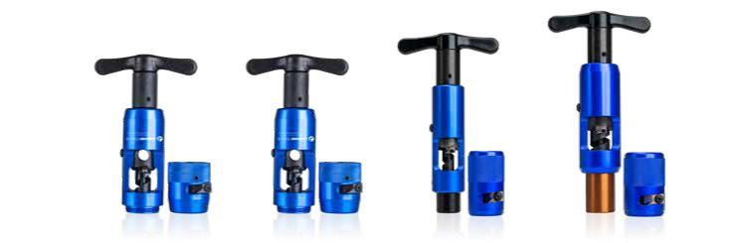

Hardline Strip & Core Tools

The Jonard all-in-one coring tools provide a complete coring solution for multiple types and sizes of hardline cables. These tools include a jacket stripper at the front of the tool, a coring tool with an adjustable center conductor beveler and a stop to insure consistent coring lengths with a comfortable ratcheting handle. The jacket stripper is removable so you can use it as a standalone jacket stripper or just use the coring portion. Remove the ratcheting handle and you can connect the coring tool to a drill for faster coring. The tool is rugged with an all-aluminum housing and rugged T shaped ratcheting handle. Blades are easily replaced as is the coring bit and beveler. Tools are designed to work on Commscope P3, QR and Times Fiber T10 cables.

All-In-One

SPECIFICATIONS | HSC-50 | HSC-75 | HSC-625 | HSC-540QR | HSC-860QR
DESCRIPTION | Hardline Strip & Core Tool 1/2” | Hardline Strip & Core Tool 3/4” | Hardline Strip & Core Tool 5/8” | Hardline Strip & Core Tool Kit 540QR | Hardline Strip & Core Tool Kit 860QR
SIZE OF CABLE | 1/2” (12.7mm) | 3/4” (19.05mm) | 5/8” (15.86mm) | QR540 (13.72mm) | QR860 (21.84mm)
REPLACEMENT PARTS | HS-RB, HC-RB, HCB-50 | HS-RB, HC-RB, HCB-75 | HS-RB, HC-RB, HCB-625 | HS-RBQR, HC-RBQR, HCB-540QR | HS-RBQR, HC-RBQR, HCB-860QR

Jacket Strippers

SPECIFICATIONS | HS-50
DESCRIPTION | Hardline jacket stripper 1/2”
SIZE OF CABLE | 1/2” (12.7mm)
REPLACEMENT PARTS | HS-RB

HS-75 | HS-625
Hardline jacket stripper 3/4” | Hardline jacket stripper 5/8”
3/4” (19.05mm) | 5/8” (15.86mm)
HS-RB | HS-RB

Coring

SPECIFICATIONS | HC-50
DESCRIPTION | Hardline coring tool 1/2”
SIZE OF CABLE | 1/2” (12.7mm)
REPLACEMENT PARTS | HC-RB, HCB-50

HC-75 | HC-625
Hardline coring tool 3/4” | Hardline coring tool 5/8”
3/4” (19.05mm) | 5/8” (15.86mm)
HC-RB, HCB-75 | HC-RB, HCB-625

Coax Center Conductor Cleaner - CC-120
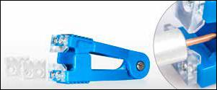

The CC-120 Coax Center Conductor Cleaner is designed to clean away excess dielectric from the center conductor of distribution or trunk cables without nicking or scratching the center conductors surface.

The CC-120 comes with a set of Flat blades installed and a pair of saw tooth blades to provide flexibility. Replacement set of 4 blades available Part number: CC-4

Torque Wrench, Swivel Head, 40 |  | 3/8” Socket For TWSW-40 - Pkg
in/lb - TWSW-40 |  | 10 - TWS-38/10
Used to properly torque cable shield bond |  | 3/8” Socket For TWSW-40 Torque Wrench
connectors and other ground connections. |  | - Pkg 10
Head swivels 90° and is factory set for 40
in./Lb. Can be used with any 3/8” drive
sockets. Audible click when proper torque is
achieved.
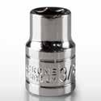
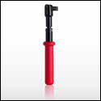

20

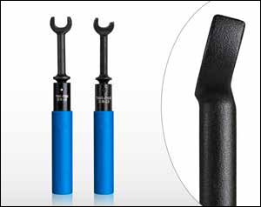
Speed Head 7/16 Full Head 7/16 Full Head 1/2 Full Head 9/16
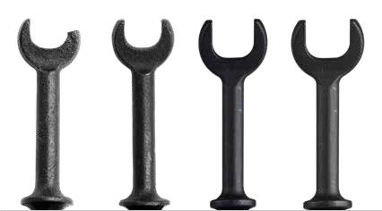

Close-Up of Angled Head

Torque Wrenches

The full head Torque Wrenches behave like traditional open end wrenches. Designed for “F” Connectors, these wrenches help prevent over tightening. An audible click tells you the F Connector has been torqued to the proper torque requirement. These wrenches all have angle heads, sized for 1/2”, 7/16”, 9/16” applications, and are designed with an ergonomic cushioned handle for user comfort and protection. These wrenches work in tightening mode only. Note: Speed Head wrenches are designed to act like a ratcheting wrench, skipping over corners of nuts/bolts (allowing for continuous turning).

TORQUE | WRENCH SIZE | HEAD TYPE | JONARD P/N
 | 7/16” (11.11mm) | Full | TWAF-71620
20-inch-lbs (2.26 NM) | 7/16” (11.11mm) | Speed | TWAS-71620
 | 1/2” (12.7mm) | Full | TWAF-1220
 | 9/16” (14.29mm) | Full | TWAF-91620
25-inch-lbs (2.82 NM) | 7/16” (11.11mm) | Full | TWAF-71625
 | 11mm | Full | TWAF-1130
30 inch-lbs (3.39 NM) | 7/16” (11.11mm) | Full | TWAF-71630
 | 7/16” (11.11mm) | Speed | TWAS-71630
 | 9/16” (14.29mm) | Full | TWAF-91630
40 inch-lbs (4.52 NM) | 7/16” (11.11mm) | Full | TWAF-71640
 | 9/16” (14.29mm) | Full | TWAF-91640

Torque Wrenches with Attached Security Shield Tool
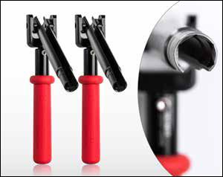

The security shield tool is permanently attached, 4 3/4” (120mm), and pivots in 90-degree increments.

These tools are ideal for hard to reach shielded F Connector fittings where a pre-set torque is required.

The TWAFST-71622 is set at 22 |  | in./lb (2.49 | NM)
The TWAFST-71630 is set at 30 |  | in./lb (3.39 | NM)
SPECIFICATIONS | TWAFST-71622 |  |  | TWAFST-71630
DESCRIPTION | Torque Wrench w/ SST 7/16”, |  |  | Torque Wrench w/ SST 7/16”,
 | 22 in/lb |  |  | 30 in/lb
TORQUE | 22 in-lbs (2.49 NM) |  |  | 30 inch-lbs (3.39 NM)

21

jonard.com | CATV / Coax Tools

Speed Wrenches

Our PATENTED speed wrenches are designed to get your job done more efficiently. This line of speed wrenches is made to work on splitters, F Connectors, and all 7/16” connections. These wrenches are made of chrome vanadium steel, chrome plated, and polished to a high gloss finish.

Speed heads make tightening and loosening quick and easy while the circular hole in the tool allows you to add this to your carabiner and/or tool belt.

SPECIFICATIONS | ASW-12 | ASW-716 | ASW-916 | ASW-R12 | ASW-R716 | ASW-7916 | ASWS-716 | ASWS-R716
DESCRIPTION | Angled Head | Angled Head | Angled Head | Speed Ratchet | Speed Ratchet | Speed Wrench | Angled Speed | Ratcheting
 | Speed Wrench | Speed Wrench | Speed Wrench | Wrench 1/2” | Wrench 7/16” | Double End | Wrench Stub- | Speed Wrench
 | 1/2” | 7/16” | 9/16” |  |  | 7/16 & 9/16 | by 7/16” | Stubby 7/16”
WRENCH TYPE | Speed | Speed | Speed | Combination, | Combination, | Speed | Speed | Combination,
 |  |  |  | Speed, Ratch- | Speed, Ratch- |  |  | Speed, Ratch-
 |  |  |  | eting | eting |  |  | eting

Combination Wrenches
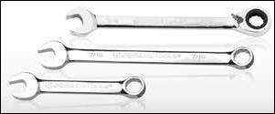

These combination wrenches measure 7/16” at both ends and have an angled offset (15°) to ease access in confined areas. Chrome plated, polished to a high gloss finish and made of chrome vanadium steel. The ratcheting end of the CWRR-716 allows you to toggle from tightening to loosening.

CWS-716 - Combination Wrench Stubby 7/16” CW-716 - Combination Wrench 7/16” CWRR-716 - Combo Wrench, Ratcheting, Reversible

Open End Wrench 3/8” & 7/16” - OW-38716
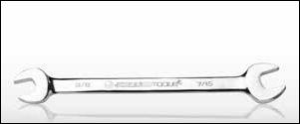

Wrench measures 3/8” on one end and 7/16“ at opposite end. Both ends are designed with an angled offset (15°) for work in confined areas. Polished to a high gloss finish and made of chrome vanadium steel. Tool is 6.25” (158.8mm) long. The wrench can be used on 7/16 “F” fittings and can be used to tighten the nuts and bolts on traps and taps. Can also be used on CATV hardware.

22

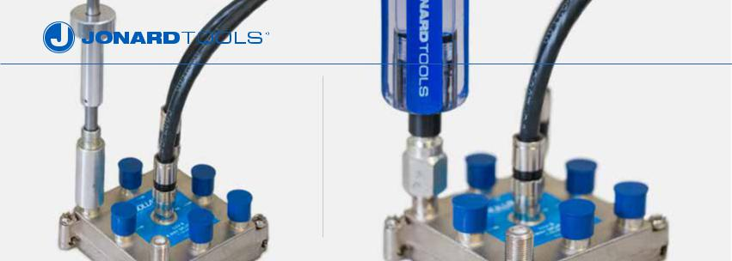

Terminator Tools
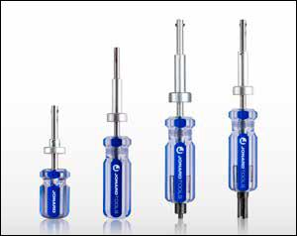

Jonard creates tools for all kinds of locking terminators. Termination is essential when running cable to ensure a quality service and prevent theft. Our tools provide ergonomic handles for greater leverage and superior grip.

Jonard termination tools are made of stainless steel and are available in several lengths and termination styles.
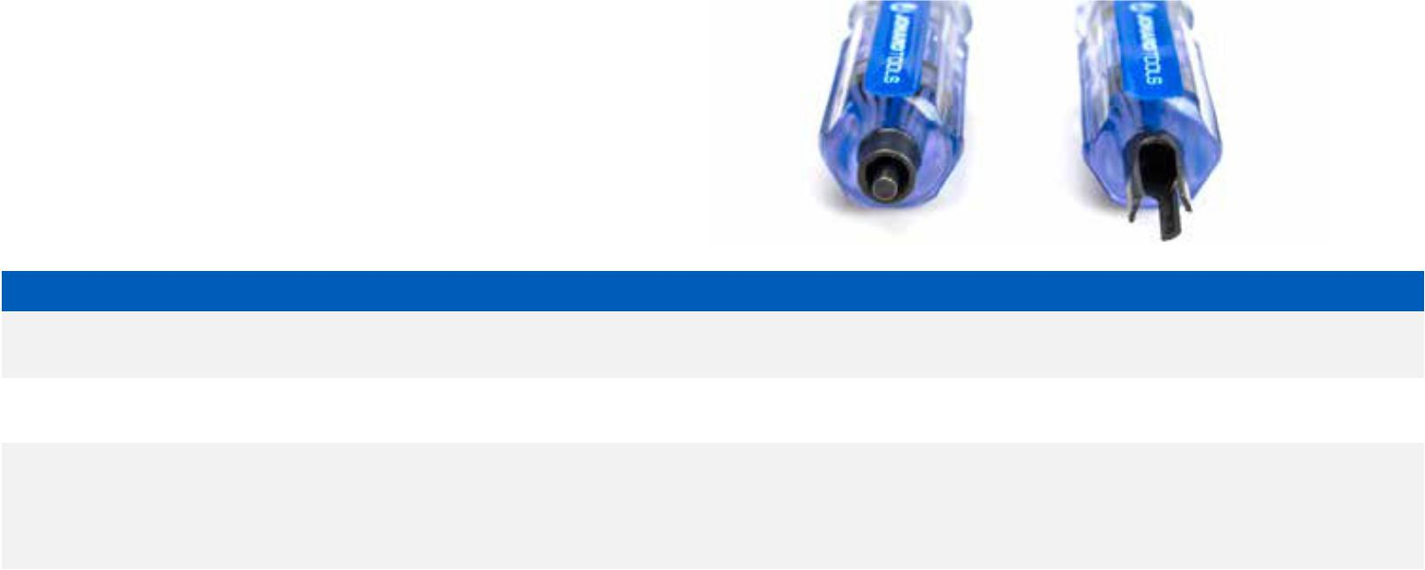

SPECIFICATIONS | TT-4 | TT-7 | TT-7V | TT-7PT
DESCRIPTION | Terminator Tool 4” | Terminator Tool 7” | Terminator Tool With Prongs | Terminator Tool For PPC & T&B
TERMINATION STYLE | Spring Ears | Spring Ears | Spring Ears, 2 Prong | Spring Ears
USED ON | Gilbert Morlock, PCT LT, PPC | Gilbert Morlock, PCT LT, PPC | Gilbert Morlock, PCT LT, PPC | Gilbert Morlock, PCT LT, PPC
 | PST, Signal Vision LT, Signal | PST, Signal Vision LT, Signal | PST, Signal Vision LT, Signal | PST, Signal Vision LT, Signal
 | Vision SV-LTA | Vision SV-LTA | Vision SV-LTA, Viewsonics 2 | Vision SV-LTA, PPC 502, T&B
 |  |  | Prong, Viewsonics 3 Prong | CLF, TRL

Cam Style Locking Terminator Tools
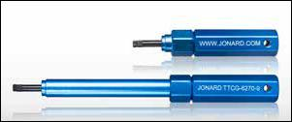

A Cam Style locking terminator tool for Corning Gilbert style terminators. Works on Gilbert NS-5762-3 (plus -9, -11, -13 & -15 terminators). High quality aluminum construction, blue color.

TTCG-6270-5 Locking Terminator Tool 5”

TTCG-6270-9 Locking Terminator Tool 9”

23

jonard.com | CATV / Coax Tools

P Key For Self Lock Pedestal Lock - TTK-225
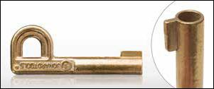

This P Key is designed to work with Channell Locks and other similar pedestal locks. This P key fits many popular pedestals and opens most heavy duty spring lock cabinets. Also referred to as a skeleton key, made of brass and fits easily on a key chain. For authorized personnel only.

Trap And Security Combo Tool - TTS-716
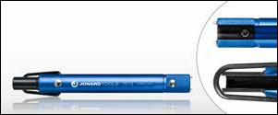

Two tools in one - a trap wrench with a security wrench. The perfect tool for all standard traps and equally adaptable for all sizes of metal security shields (The security wrench fits all metal 7/16” hex fittings). Made of lightweight aluminum with a security socket made of hardened steel for longer life.

2 Prong termination style.

Low Torque Termination Tool - TT-812
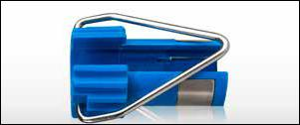

Tightens F-Connectors Right The First Time and Every Time. This indoor torque tool is great for connecting coax connectors to consumer electronic devices with the proper amount of torque 8-12 in/lbs, 1 3/8” long. PATENTED.

Terminator Tool For PPLT-75 & PPLT-LR - TT-PPLTT4
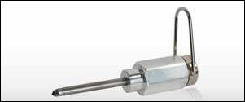

This terminator tool is designed for use with PPLT Series locking terminators, specifically the PPLT-75 and PPLT-LR. Specially designed to overcome problems of theft and tool breakage. Loop for clipping to belt. Plunger diameter .218”. Aluminum body.

Barrel Lock Plunger Key - TTB-6
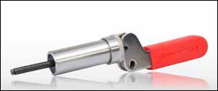

The TTB-6 Barrel Lock Plunger Key is compatible with barrel locks with inside diameters ranging from 0.176” to 0.196” made by Channell, Highfield and Innertite. Works on Channell LK03029817, Highfield 93180775-S and used in CATV Pedestal Applications.

This key may also fit other locks used in the electric, gas and water utilities. Know your lock size before purchasing.

The key is made of high carbon alloy steel, designed for heavy duty use and engineered for superior tamper resistance. Smooth plunger and heavy duty spring for strength and durability, and serialized for added security.

24

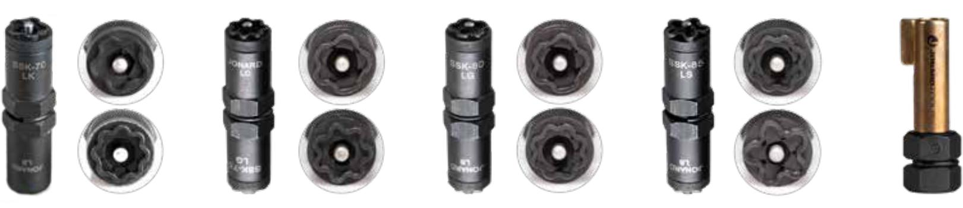

LK Flower | LG Flower | LG Flower |  | LB 8-Point
Pattern | Pattern | Pattern |  | Pattern
LB 8-Point | LC 7-Point | LB 8-Point |  | LB 5-Point
Pattern | Pattern | Pattern |  | Star
SSK-70 | SSK-75 | SSK-80 | SSK-85 | SSK-90
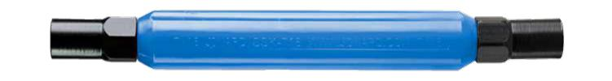

SSK-716
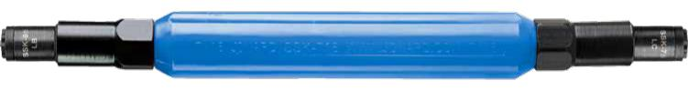

SSK-876

Star Keys & Star Key Slam Lock Sets

The SSK-716 can wrench is specifically designed to work with all of our SSK Series Keys. The SSK-716 can wrench has two 7/16” hex sockets 1 ½” deep on either end and can be used to open enclosures that require a 7/16” socket.

Star Key Kits:
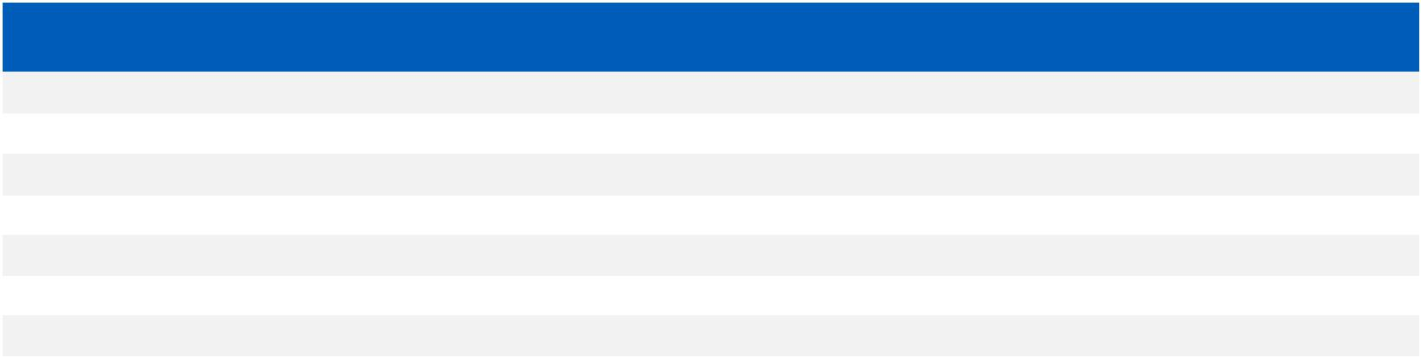

JONARD P/N | SSK-716 CAN | SSK-70 SLAM | SSK-75 SLAM | SSK-80 SLAM | SSK-85 SLAM | SSK-90 P-KEY
 | WRENCH | LOCK STAR KEY | LOCK STAR KEY | LOCK STAR KEY | LOCK STAR KEY
SSK-700 | X | X
SSK-750 | X |  | X
SSK-800 | X |  |  | X
SSK-850 | X |  |  |  | X
SSK-876 | X |  | X |  | X
SSK-900 | X |  |  |  |  | X
SSK-950 | X |  |  |  | X | X

The SSK-70 star key has a LK flower pattern on one side and a LB 8 point star pattern on the other. The SSK-75 star key has a LG flower pattern on one side and a LC 7 point star pattern on the other. The SSK-80 star key has a LG flower pattern on one side and a LB 8 point star pattern on the other. The SSK-85 Star Key has a LB 8 point star pattern on one end and a LS 5 point star pattern on the other. Keys are two-sided, just switch from one side to the other for each pattern (SSK-90 is single sided P Key).

For authorized personnel only.

Star Keys:

DESCRIPTION | SSK-70 SLAM | SSK-75 SLAM | SSK-80 SLAM | SSK-85 SLAM |  | SSK-90 P-KEY
 | LOCK STAR KEY | LOCK STAR KEY | LOCK STAR KEY | LOCK STAR KEY
KEY PATTERN | LB 8 point star | LC 7 point star | LB 8 point star | LB 8 | point star | P Key
 | LK flower | LG flower | LG flower | LS 5 | point star

25

jonard.com | CATV / Coax Tools

Pocket Continuity Tester & Toner - PT-300
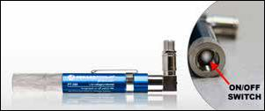

Locate cables in an MDU, home, business or anyplace where you need to identify a cable. This drop cable continuity tester can detect troublesome short circuits or other self-grounding devices and is accurate up to 5,000 feet (1,500 m).

The right angle connector helps work in confined areas and is voltage protected up to 52 volts. An LED light indicates splitters and a loud tone identifies line carrier signals, but when not in use the tool can be turned off to preserve the AAA batteries inside and avoid corrosion.

Replacement Pocket Toner Speaker Part No. PT-350

Voltage Detector - VT-1000
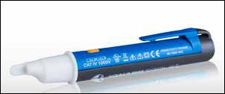

The VT-1000 is a Non Contact voltage detector and is useful in identifying the presence of AC voltage at outlets, switches, circuit breakers, fuses, wires and cables. Compact and lightweight with built in pocket clip. CAT IV rating provides expanded operation and protection.

Voltage detection between 90 to 1000 VAC.

Cable Mappers & Toners
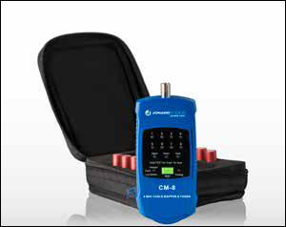

Find and identify multiple coax cables in main cable boxes. For use on Coax Cables for CATV, Satellite Installations, Audio Video Equipment, CCTV and Security & Alarm Installations. The CM-8 Coax Cable Mapper & Toner is designed to quickly find and identify multiple cables and easily map runs to and from a central cable bundle.
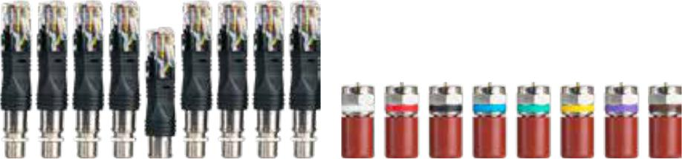

CMI-RJ45 CMI-SET8

CM-8 Kit contains:

Cable Mapper & Toner, 8 Cable Identifiers (numbered & color coded), 2 Alligator Clip Sets, Rugged Nylon Case & Instruction sheet

CM-17 Kit contains:

Contents of the CM-8 kit & 9 RJ45 connectors

Modular Cable Tester - MCT-468
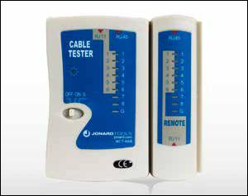

The MCT-468 is designed to check and troubleshoot the pin connections of RJ45, RJ12, and RJ11 connectorized cables. It is ideal for testing the continuity of a cable with RJ11 or RJ45 connectors prior to installation.

Features:
- Can test RJ45, RJ12, and RJ11 terminated cables

- Tests for opens, shorts and miswiring

- Full LED indication lights on both main and remote unit.

- Auto tests when switched on

- Move switch to S to slowdown auto test feature

- Small size and lightweight

- Carry case included

- Uses a 9V battery (included)

26

Multi-Function Cable Tester Tone & Probe Kit - TETP-900
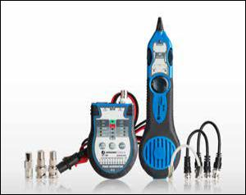

Ideal for VDV (Voice Data Video) professionals in telecommunications, this multi-function cable tester works on RJ45 LAN cable, BNC & F coaxial cable, 6P2C/4P2C jacks and provides tone generation.

Kit includes:

- TET-700 Multi-Function Cable Tester & Toner

- TEP-200 Tone Tracing Probe

- TET-6 Accessory Kit for TET-700

- Two 9V batteries

- Zippered case

Copper COAX & Network Cable Cutter - JIC-625
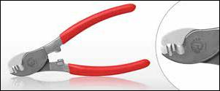

The JIC-625 is designed to cut all types of soft copper coax and network cables. Will cut solid, stranded and flexible cables to 6 AWG. Not for use on steel, aluminum alloys or hard drawn copper cables.

Made from heat treated chrome vanadium steel for longer life. The blades are precision ground for easier cutting.

Jaw Thickness: .4” (10.2mm), Overall Length: 6-1/2” (165mm)

COAX Cable Cutter Steel - JIC-725
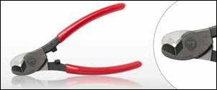

A plier designed specifically for coax cables with a steel center conductor. This plier has been tested (over 25,000 cuts) on cables with steel centers, and specifically CCSC (copper clad steel center) conductor cables without degradation to the cutting blades. Made from chrome vanadium steel. Plier will also cut many other cable types.

Jaw Thickness: .1/4” (6.35mm), Overall Length: 6-1/4” (158.75mm)

3/4” COAX Cable Cutter - JIC-750
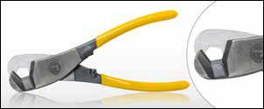

Also known as a Banana Cutter, this cutter is designed to cut up to 3/4” hard line coaxial cable as well as larger fiber cables. Made from chrome vanadium steel, pliers are heat treated for added strength and longer lasting cutting edges.Tool cuts cleanly without compressed or frayed ends. Functions like a tube cutter - eliminates cable distortion during cable prep. NOT designed to cut steel cable.

Cable Diameter: .3/4” (19.05mm), Overall Length: 8-3/4” (222mm)

1” COAX Cable Cutter - JIC-755
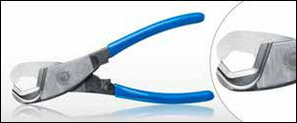

Designed to cut up to 1” coaxial cable. This tool works like a tube cutter to eliminate cable deformation during cable preparation.

Tool provides precision one-handed cutting action. Made from Chrome Vanadium steel with hardened cutting blades. Not designed for ACSR or other steel cables.

Cable Diameter: .1” (25.4mm), Overall Length: 8-1/4” (165mm)

27

jonard.com | CATV / Coax Tools

Connector Tools
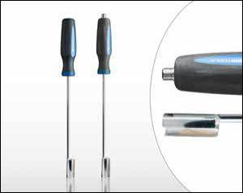

The Jonard connector tools are designed to provide easy access to cable connectors in high-density locations. The sockets provide a reach of either 12 or 18 inches and have a comfortable grip to avoid slipping.

The RF-18 and RF-12 options include an insertion device on the back of the handle to aid in making connections and work with F Connectors and BNC Connectors. The RBNC-12 connector tool works on BNC connector types.

RBNC-12 BNC Connector Tool 12” Total Length RF-12 F Connector Tool 12” Total Length RF-18 F Connector Tool 18” Total Length

Security Shield Tools
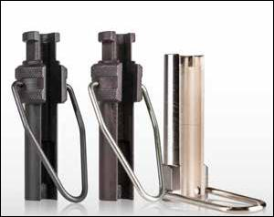

SST-716 Security Shield Tool 7/16” & SST-716AT Security Shield Tool Water Tight are used with 7/16” hex shielded F Connectors. Design includes extended 7/16” shank for ease of use with Torque Wrenches in security shield applications. Black oxide finish. Knurled handle for secure gripping and includes a steel loop for turning leverage and carrying.

Note: SST-716AT is designed for use where security shield applications for PPC AquaTight® EX Series connectors are used.

SST-916 Security Shield Tool 9/16” is used with 9/16” hex F Connectors. Nickel plated finish. Loop attachment to allow for connecting to your key ring or carabiner for easy access. Shaft length 1.625”.

Outer Conductor Flaring Tool - FT-2075
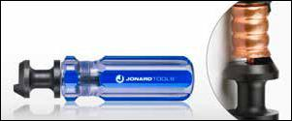

Designed to flare the outer conductor on Eupen7168, A7168 and CommScope CA519 75 ohm corrugated copper cable. Handle is sized to make gripping and flaring easier and more comfortable, and flaring feature has a black oxide finish. 4 5/8” long.

Flaring & Insertion Tool - FT-6
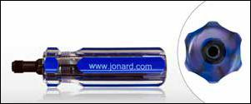

The flaring end of the tool facilitates the expansion of the cable providing easier insertion of “F” connectors. The insertion end makes “F” connector insertion fast and easy, even in cold weather. This tool is recommended for use on polyethylene jacketed cables and plenum cables, and is especially helpful when using tri-shield and quad-shield cables. 4 1/4” long.

28

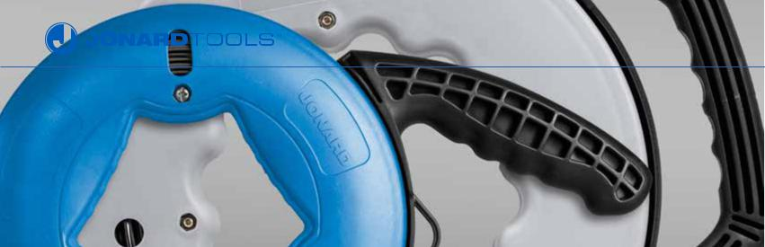

CABLE INSTALLATION
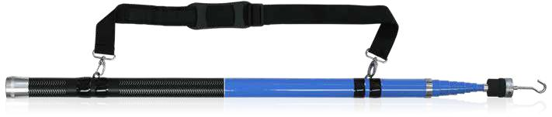

Telescoping Pole (18 Feet) - RDT-18K

The RDT-18K is the perfect tool to install or retrieve a cable in drop ceilings or other hard to reach places. This Telescopic Pole is self-supporting, so it is perfectly suited for spanning ceilings and voids to route or retrieve cable. Simply grab the wire with our hook and expand or contract the pole as needed.

Accessory Replacement Kit For RDT-18K - RDT-3RH
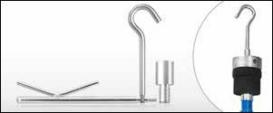

Three piece accessory kit for RDT-18K.

Kit includes:

- RDC-35 C Hook

- RDK-5 K Hook

- Adapter for use in tight locations

Fish Tapes
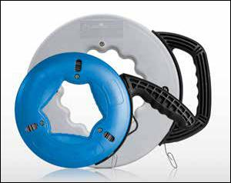

Jonard Tools FTS-50 and FTS-240 Fish Tape use a 1/8” wide x 1/16” thick steel tape with permanent laser-etched measurement markings (in English and metric units) every foot (0.3m) to assist in the process of pulling wire or cables. Ideal for long runs and where heavy duty wire pulling is required through conduit, walls, under carpets, and many other places.

The case and handle use rugged plastic for superior impact resistance, has a comfortable ergonomic grip and is designed for superior payout and rewind. The FTS-50 (50’ length) has 3 viewing ports and the FTS-240 (240’ length) has 2 viewing ports.

SPECIFICATIONS | FTS-50 | FTS-240
DESCRIPTION | Fish Tape 50 Feet | Fish Tape, 240 Feet
DIMENSIONS | 1/8” (3.175mm) wide x 1/16” (1.59mm) thick x 50 | 1/8” (3.175mm) wide x 1/16” (1.59mm) thick x 240
 | feet (15.24 meters) | feet (73.152 meters)
WEIGHT | 2.5 lbs (1.13 kg) | 6.8 lbs (3.08 kg)

29

jonard.com | Cable Installation

Magnetic Retrieval System - MRS-24
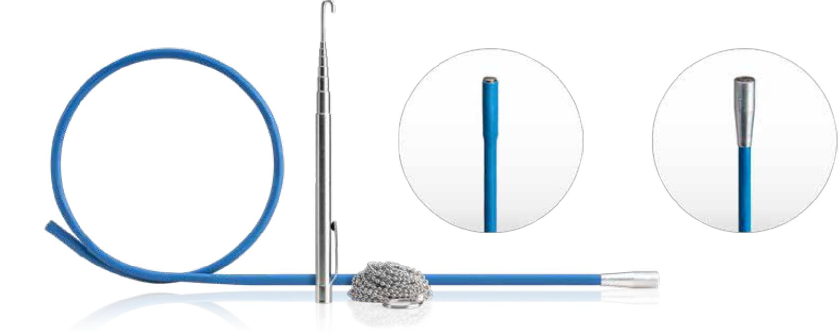

The perfect tool to help fish wires through walls.

7/32” diameter head with magnet 5/16” diameter head with larger magnet

Kit includes: |  | Easy to use:
• | 24” Flexible Magnetic Retriever | • | Drill a hole in the wall or attic plate less than ¾”
• | 10’ of Ball Chain w/ ¾” Diameter Stop Ring and Eye Loop | • | Drop ball chain in the hole, the ¾” ring stop will keep the chain
• | MRS-RH20 Expandable Retriever Hook | • | from falling through
• | Storage Pouch |  | Make a roughly 1/23” hole at the wall
 |  | • | Use blue magnetic retriever to find the chain and use the MRS-
RH20 hook to help pull chain through hole

Shown here illuminated in
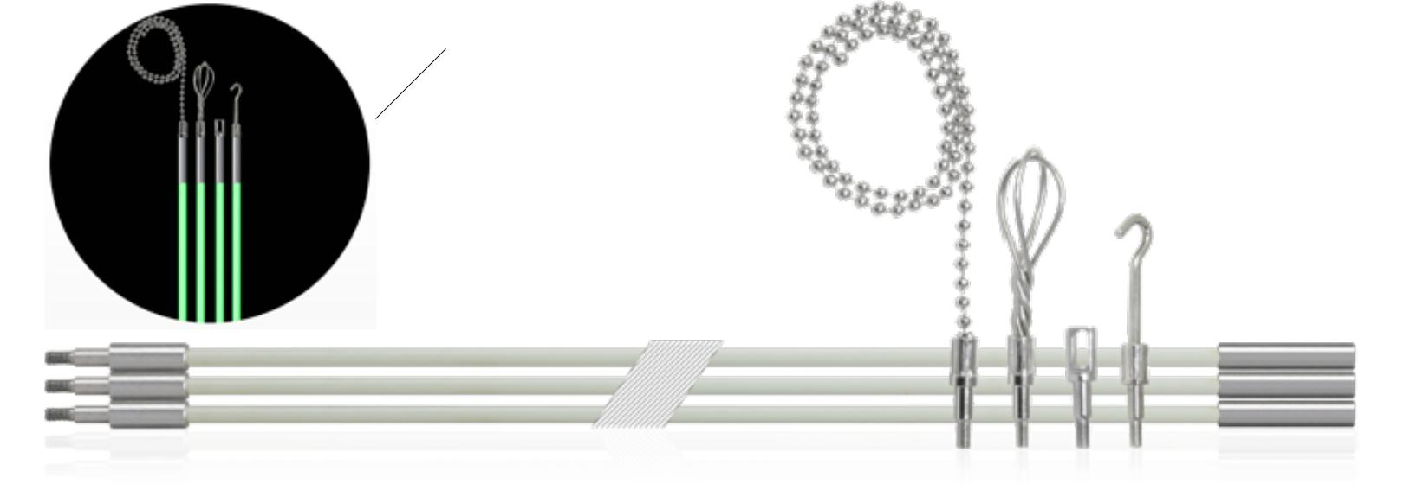
a dark setting.

Glow Rod Kits 3/16” Diameter

These glow rods (made of luminescent fiberglass) are designed to provide splinter free use over the life of the product while also providing excellent flexibility. The luminescence of the rods is brighter and lasts longer than the competition. The metal ends of the rods are secured in place and provide superior strength. The threads on the metal ends are standard 8-32 so the rods and accessories can be used with many other manufacturers glow rods.

RDG-15 (pictured above)
15’ Glow Rod Kit 3/16” Diameter extends a full 15 feet.

Kit includes:

- Three 5 foot long Rods, 3/16” diameter, for greater flexibility
- Eyelet
- Ball Chain attachment
- Wisk
- Hook
- Kit packaged in clear reusable plastic tube

RDG-30
30’ Glow Rod Kit 3/16” Diameter extends a full 30 feet.

Kit includes the same as above with three additional 5 foot long Rods (for a total of six).

Four Piece Replacement Kit Part No. RDG-RP4 (contains Eyelet, Ball Chain Attachment, Wisk, and Hook)

30

Magnamole Magnetic Cable Guide Kit - MM-800
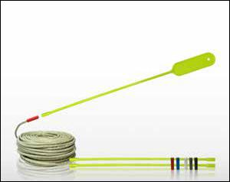

Wire Fishing Made Easy! Quickly threads wire and cable through cavity walls and void spaces. Threads at an angle and safely through other wire and cable obstacles. Saves time, saves money, and sharply reduces the risk of accidents.

To use the MM-800 follow these four simple steps:

- Drill a hole and remove the dust and debris.

- Next simply place the MM-800 specially designed magnetic rod through the hole you wish to snake the wire.

- Screw on the appropriate magnetic cap to the cable or wire end and align the magnets.

- Push the cable into the hole and through the other side of the wall. That’s it!

PATENTED.

JONARD P/N | DESCRIPTION | CAP COLOR & | CABLE USED WITH | QUANTITY
 |  | CABLE DIAMETER
MM-800 | Magnamole Magnetic Cable
 | Retrieval System
MM-110 | Replacement Magnets | (Red) .169” to .205” | CAT5 | Includes 3 magnetic caps of
 |  | (Blue) .230” to .295” | RG6, RG6 TRI, RG6 Quad | each color
MM-120 | Replacement Magnets | (White) .145” to .169” | CAT3, 3.1mm Simplex Fiber | Includes 2 magnetic caps of
 |  | (Gray) .173” to .201” | Optic Cable, CAT5, CAT5e | each color
 |  | (Black) .205” to .232” | RG59, 12AWG Romex

Cable Caddy - CC-2721
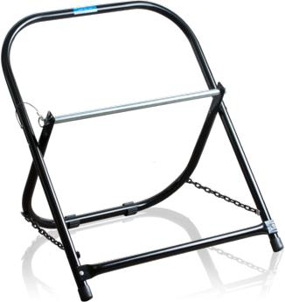

The Jonard Tools Cable Caddy is constructed of sturdy 0.060” thick tubular steel 7/8” diameter.

No setup is required, just place it on the floor, remove the cotter pin and slide the bar out of the way. Position wire spool and slide bar back in place. Reinsert cotter pin.

Includes anti-skid rubber feet to prevent the caddy from sliding while also protecting floors. Will hold Cable spools up to 20” in diameter and 17” in height.
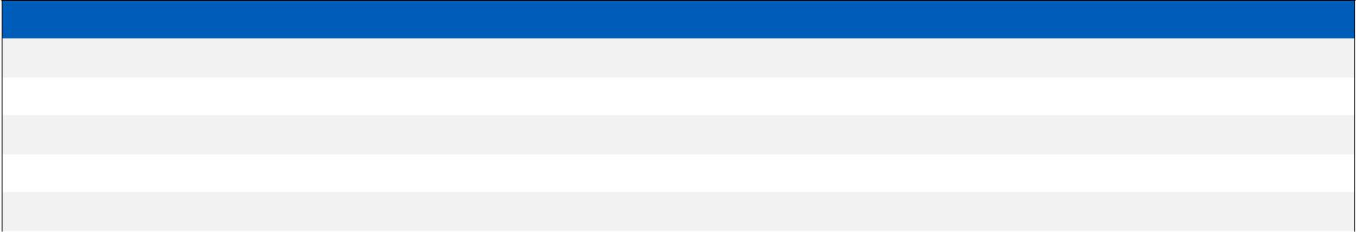

SPECIFICATIONS

OVERALL WIDTH | 21” (533.4mm)
OVERALL HEIGHT | 27” (685.8mm)
SPOOL ROD DIAMETER | 5/8” (15.88mm)
MAXIMUM SPOOL DIAMETER | 20” (508mm)
WEIGHT | 8 lbs.

31

jonard.com | Cable Installation

Magnetic Cable Retrieval System - MP-700
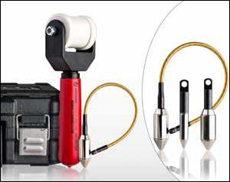

A magnetic cable retrieval system which couples the cable with the pulling device through drywall, allowing the user complete control. Designed for both residential and commercial applications. Pulls cables through insulation in seconds. Reduces cable fishing time by 70%. Eliminates wall damage from misplaced holes in the wall. Makes wire fishing a definable process. Kit includes: Retriever Unit, ¾” Drop Magnet with pull line Jack Chain, Convenient Carrying Case. PATENTED.

JONARD P/N | DESCRIPTION
MP-700 | Magnetic Cable Retrieval System
MP-100 | 1/2” Drop Magnet Without Leader
MP-210 | 3/4” Drop Magnet W/ Leader
MP-220 | 3/4” Drop Magnet W/ Leader

Reference Point Locator - MP-800
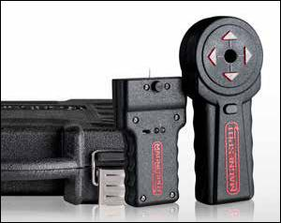

Drill or cut through walls with complete location certainty. A two component kit (transmitter & locator) allows you to pinpoint the exact location to drill or cut through a wall. Place the transmitter on one side of the wall and from the opposite side watch as the receiver draws you to the exact location of the transmitter. Mark the spot and drill. Accurate to within ½” and up to 40 inches away. Kit includes: Transmitter, Receiver, 2 9V Batteries, Tack Adhesive, Carrying Case. PATENTED.

Electrical Wall Outlet Cutter - EBC-400
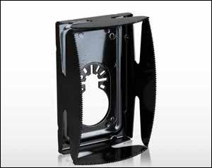

The EBC-400 Cuts drywall in seconds making installation of plastic, metal or low voltage existing construction electrical boxes fast and easy. Can be used with most brands of oscillating multi-tool power tools.

Made from stamped steel, tool cuts a hole 2-3/8” x 3 ¾”.

Electrical Knockout Kit - WBK-100
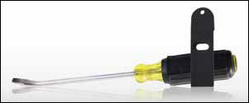

Remove panel knockouts from electrical panels embedded in drywall without cutting holes in the drywall. For use on electrical, security, alarm and datacom panels.

WARNING: DO NOT USE KIT NEAR LIVE CIRCUITS. INTENDED FOR USE BY LICENSED PROFESSIONALS.

PATENT PENDING. Lifetime Warranty.

32

Straight Metal Needle - JIC-284
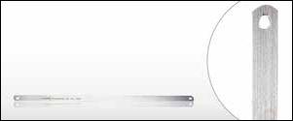

This “Chicago type” straight metal needle is designed for cable sewing. This tool, made of the finest steel is for anyone in the cable industry.

Needle is .016” thick and 12” long.

Metal Cable Sewing Needle - JIC-287
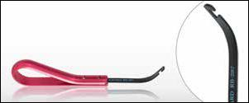

This Cable Lacing Needle (A/K/A Cable Sewing Needle) has a durable red anodized aluminum handle with curved notched sewing needle. Designed to harness or lace multiple lead bundles.

Replacement Needles: RB-287/6 (Pkg of 6)

Insulated Cable Sewing Needle - JIC-3209
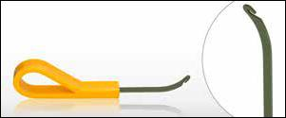

Xylan insulated cable lacing needle is designed to harness or lace multiple lead bundles. Yellow lightweight molded grip handle.

The tip is made of Spring steel and coated with a xylan insulative coating.

5 1/2” long.

Insulated Wire Loop Puller - JIC-2257
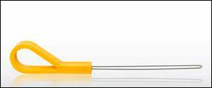

Xylan insulated wire loop puller facilitates pulling wire through terminal blocks, rings on main frame, or fanning strip holes. The yellow plastic lightweight handle fits snugly and is easy to hold in your hand.

8” long.

Metal Wire Loop Puller - JIC-2257M
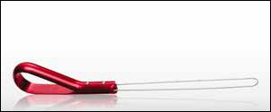

This Wire Loop Puller has a durable red anodized aluminum handle. Tool is designed to facilitate pulling wire through terminal blocks, rings on main frame or fanning strip holes. Loop is 5 1/2” long. Overall length 8 1/2”.

Replacement Loops: RB-2257/6 (Pkg of 6)

Metal Wire Loop Puller 12”Long - JIC-2257M-12

Durable red anodized aluminum handle facilitates pulling wire through terminal blocks, rings on main frame or fanning strip holes. Loop is 12” long. Overall length 15”. Loop is crimped for a narrower profile and easier use in tight terminal blocks.

The loop is coated with blue Xylan to prevent shorts and electrical shocks.

33

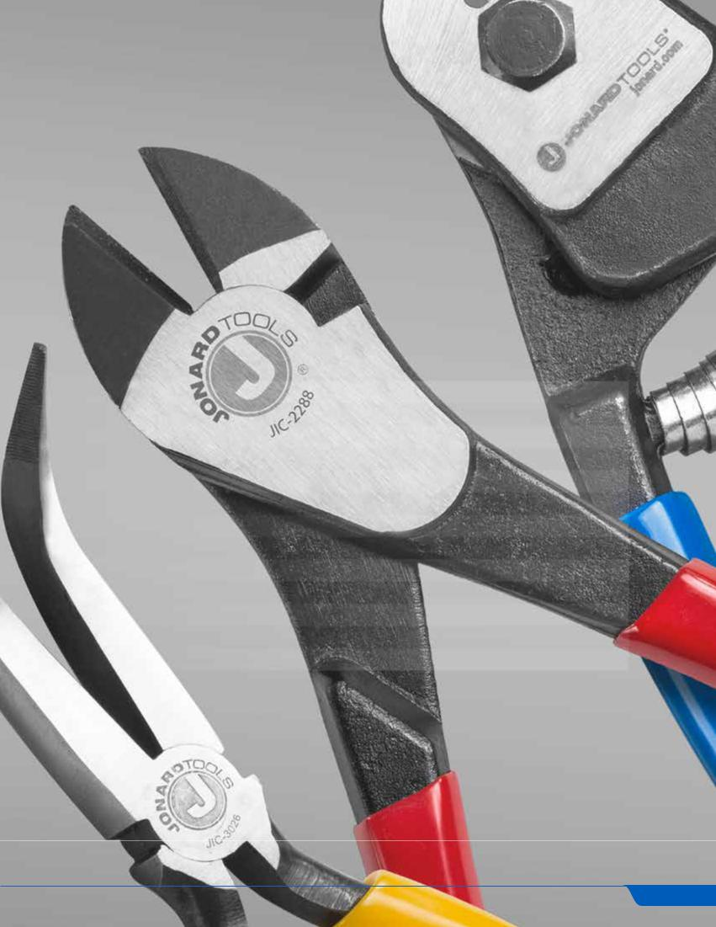

HAND TOOLS

Jonard Tools has engineered premium hand tools since 1958. All our tools are designed to provide industry solutions and undergo quality testing to ensure our Made For Life® lifetime warranties.

CONTENTS

Pliers | 35
Insulated Tools | 41
Screwdrivers | 42
Nut Drivers | 44
Flashlights | 44
Adjustable Wrenches | 45
Strippers | 45
Scissors | 45
Burnishers | 46
Tool Kits | 46
Accessories | 46
Pouches | 47
Tool Cases | 47

34

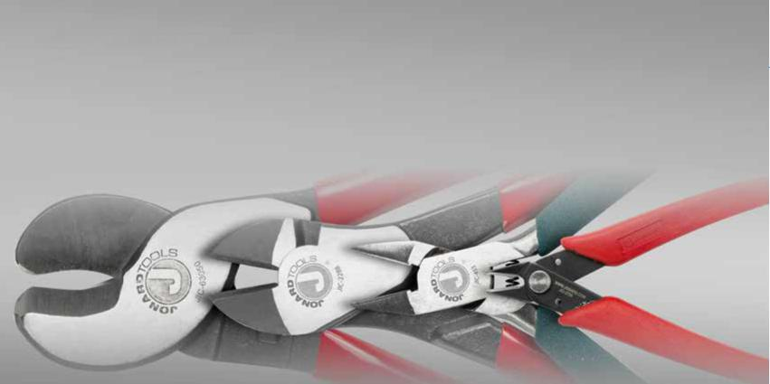
PLIERS

All Jonard pliers are heat treated and made of chrome vanadium or high carbon alloy steel for increased strength and precision cutting. These ultra durable pliers have machine cut edges to provide exceptionally smooth action and are made to exceed ASME/ANSI standards.

Plier, Diagonal, Cutter, 8” - JIC-2288
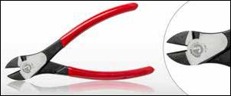

Crafted for heavy-duty wire cutting and made from chrome vanadium steel with improved heat treatment to the cutting edges for increased strength. Use for the most demanding applications, precision machined cutting edges provide exceptionally smooth action.

Jaw Length: 7/8” (22.23mm), Overall Length: 8-1/4” (209mm)

High Leverage Diagonal Cutter Curved - JIC-2488
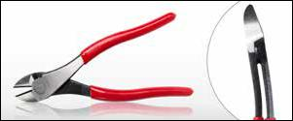

Crafted with a 13° angled head for heavy-duty wire cutting in confined spaces and made from chrome vanadium steel with improved heat treatment to the cutting edges for increased strength. Use for the most demanding applications, precision machined cutting edges provide exceptionally smooth action.

Jaw Length: 13/16” (20.64mm), Overall Length: 8” (203mm)

Telecom Diagonal Cutter Pliers - JIC-7858
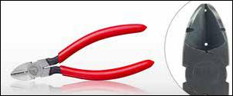

Tapered nose diagonal cutting pliers with standard bevel knives with .030” and .045” skinning holes, with crusher used for multi-purpose wire work, with two

V-shaped stripping notches. The comfortable handles are red plastic dipped. Made of chrome vanadium steel.

Jaw Length: 7/8” (22.23mm), Overall Length: 6-1/4” (158mm)

Diagonal Cutter Pliers, Tapered Nose - JIC-600
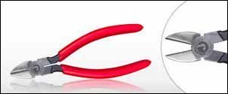

Tapered nose diagonal cutting pliers with standard bevel knives. Made of Chrome Vanadium steel and precision machined with cutting knives that are induction hardened, providing outstanding durability and extra long life. Includes crusher for multi-purpose wire work. The handles are red plastic and 6 1/4” long. Made to exceed ASME/ANSI standards.

Jaw Length: 7/8” (22.23mm), Overall Length: 6-1/4” (158mm)

35

jonard.com | Hand Tools

Diagonal Skinning Stripping Pliers - DIAGB6
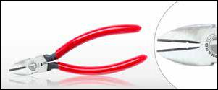

Tapered nose diagonal cutting pliers with standard bevel knives with one .045” skinning hole, crusher used for multipurpose wire work, and two V shaped stripping notches.

Jaw Length: 7/8” (22.23mm), Overall Length: 6-1/2” (158mm)

Diagonal Plier 6 1/4” Insulated - INP-3062
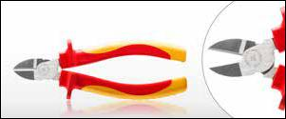

Made from 60 CRV (Chrome Vanadium Steel) for durability and long life. The high leverage design provides superior cutting ability, and the rivets are made of 40 CRV (chrome vanadium steel) for toughness and to minimize side play. Guards are integrated into the dual color TPE plastic handle design to prevent contact with conductive parts while the soft ergonomic grips meet and exceed applicable IEC (IEC 60900) and VDE standards for high voltage protection. Tested to 10,000 VAC and rated to 1,000 VAC live use.

Overall Length: 6-1/4” (158mm)

Diagonal Pliers Crushing Slitting - DIABVNOTCH
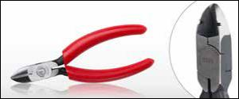

Used for cutting soft copper conductors. Has a “V” shaped notch between jaws, near the joint, for crushing the flameproof type of insulation on distributing frame wire. Also provides a “W” shaped notch on the pliers jaws for slitting textile insulation.

Jaw Length: 3/4” (19.05mm), Overall Length: 5-1/8” (130mm)

Diagonal General Use Pliers - DIAGB5
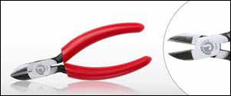

These are plain diagonal pliers for general use, including cutting soft copper conductors.

Jaw Length: 3/4” (19.05mm), Overall Length: 5-1/8” (130mm)

Semi-Flush Cut Pliers - JIC-453
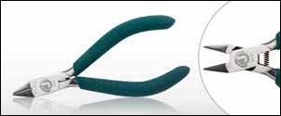

A close cutting pliers used to trim conductors from the 710 connector modules without leaving exposed conductors. Ideal for close trimming of gates and sprue on injection molded plastic parts. Jaw design aids in use in confined areas. Turquoise color handle. Made from chrome vanadium steel.

Jaw Length: 5/8” (15.88mm), Overall Length: 4-1/2” (114mm)

Flush Cut Plier - JIC-2755
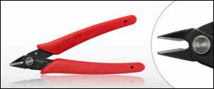

Made of high carbon steel, this lightweight flush cutter can be used on wire up to 18 AWG while minimizing fly-off. Cantilevered spring automatically opens the plier, and the head fits easily in confined work areas.

Jaw Length: 1/2” (12.7mm), Overall Length: 5” (127mm)

36

Lineman’s Side Cut Pliers - JIC-683
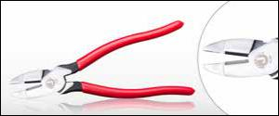

Designed for heavy duty use in construction and maintenance work. These pliers are high leverage for cutting bolts, nails, and many gauges of wire including high-strength wire. Cutting edges cut clean and remain sharp. The cushioned-grip, comfortable handles are red plastic dipped to approximately .007”. Made of chrome vanadium steel.

Cutter Length: 13/16” (20.64mm), Overall Length: 9-1/2” (241mm)

Lineman’s Plier W/ Fish Tape Puller & Crimper - JIC-685
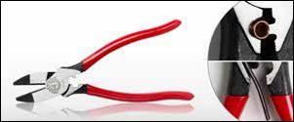

Designed for heavy duty use in construction and maintenance work. These pliers are high leverage for cutting bolts, nails, and many gauges of wire including high-strength wire. Fish tape pulling feature easily pulls 1/8” or 1/4” steel fish tape without damaging the tape. Built in crimper feature works best on non-insulated connectors, lugs and terminals. Cushioned grip, comfortable handles are red plastic coated to approximately .007”. Made of chrome vanadium steel.

Cutter Length: 3/4” (19.05mm), Overall Length: 9-1/2” (241mm)

Lineman’s Combo Plier 7 1/4” Insulated - INP-1072
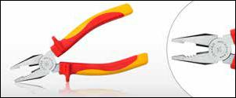

These pliers are made from 60 CRV (chrome vanadium steel). The cutting edges are strengthened using high frequency induction hardening for superior strength. Guards are integrated into the dual color TPE plastic handle design to prevent contact with conductive parts while the soft ergonomic grips meet and exceed applicable standards for high voltage protection.

Cutter Length: 3/4” (19.05mm), Overall Length: 7-1/4” (184mm)

9” Curved Jaw Cable Cutter - JIC-63020
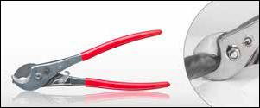

High leverage design for superior cutting ability. The curved jaws provide superior holding for a cleaner and more concentric cut. Tool is for cutting aluminum and soft copper and not for use on steel or ACSR type cables. The shear type jaws cuts up to 100-pair cables (24 AWG). Lock has a unique feature where lock is released by squeezing handles together. Made of chrome vanadium steel.

Jaw Length: 1” (25.4mm), Overall Length: 9” (228mm)

High Leverage Cable Cutter - JIC-63050
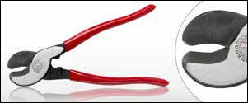

High leverage design for superior cutting ability. Designed with a shear-type jaw for cutting aluminum and soft copper. Not for use on steel or ACSR type cables. Cuts up to 100-pair cables (24 AWG). Made of chrome vanadium steel.

Jaw Length: 1-3/8” (34.93mm), Overall Length: 9-1/4” (234mm)

Connector-Crimper Pliers - JIC-891
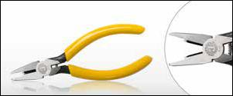

Connector-Crimping Pliers with Side Cutters designed to press UG, UR, UY, 709 series connectors, crimping “B” type connectors, and AMP tel splice connectors. A special stop behind cut out prevents damage to connectors. Utilized on combinations of plastic and pulp insulated 19, 22, 24 and 26 gauge copper conductors as well as 20 gauge plastic insulated copper steel wire. Comes with side cutter and yellow handles.

Jaw Length: 1” (25.4mm), Overall Length: 5-3/16” (131mm)

37

jonard.com | Hand Tools

Long Nose Switchboard Plier - JIC-203
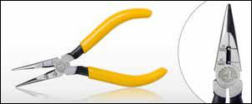

Pliers are for general use looping, bending and cutting. Grips small wires and parts and reaches into tight spaces. Jaws are knurled, serrated and have side cutting blades. Two stripping holes for 19 & 22 AWG wire. Cushion gripped yellow plastic handles.

Overall Length: 6-7/8” (174mm)

Telecom Long Nose Pliers - JIC-21257
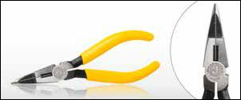

This Long nose pliers has side cutting blades, a crushing slot, one .030” stripping hole, and a thin knurled nose to facilitate handling of the wire at the central office terminals. The comfortable handles are yellow plastic dipped. Made of chrome vanadium steel.

Jaw Length: 1-7/8” (47.63mm), Overall Length: 6-7/8” (174mm)

Combo Crimper, Long Nose Pliers - JIC-22148
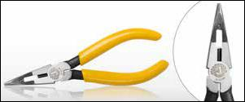

Five tools in one. Combines the functionality of a long nose plier with a crimper, stripper, cutter, and crusher. Crimper works for UR/UY/UG, AMP tel splice connectors, 709 series connectors, and crimping “B” type connectors. Stripping hole is .030”. See website for more details.

Jaw Length: 1-7/8” (47.63mm), Overall Length: 6-7/8” (174mm)

Curved Long Nose Plier - JIC-3026
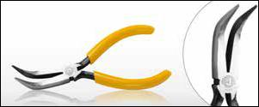

Nose is bent 70° for maximum visibility. Used in confined areas. Design includes knurled jaws for sure wrapping and looping. Comfortable ergonomic plastic handles.

Jaw Length: 2” (50.80mm), Overall Length: 6-7/8” (174mm)

Long Nose and Side Cutting Pliers - JIC-842
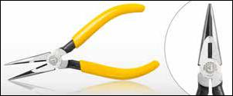

Pliers are for general use looping, bending and cutting. Grips small wires and parts and reaches into tight spaces. Jaws are knurled, serrated and have side cutting blades. Cushion gripped yellow plastic handle. Made of chrome vanadium steel.

Jaw Length: 1-7/8” (47.63mm), Overall Length: 6-3/4” (171mm)

Long Nose Plier 6 1/2” Insulated - INP-2065
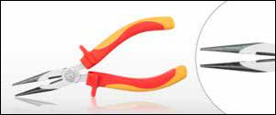

These pliers are made from 60 CRV (chrome vanadium steel) for durability and long life. The cutting edges are strengthened using high frequency induction hardening for superior strength. The high leverage design provides superior cutting ability, and the rivets are made of 40 CRV (chrome vanadium steel) for toughness and to minimize side play. Guards are integrated into the dual color TPE plastic handle design to prevent contact with conductive parts while the soft ergonomic grips meet and exceed applicable IEC (IEC 60900) and VDE standards for high voltage protection. Tested to 10,000 VAC and rated to 1,000 VAC live use.

Overall Length: 6-1/2” (165mm)

38

Long Nose General Use Pliers - BLONGNOSE
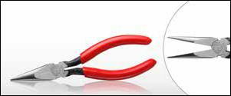

Chain nose pliers for general use. Inner surface of the jaws are knurled near the end to facilitate gripping wire, binding post nuts etc. Red plastic handle.

Jaw Length: 1-1/2” 38.10mm), Overall Length: 6-7/8” (174mm)

Long Nose Gripping Pressing Pliers - ELONGNOSE
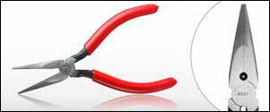

Long nose pliers for gripping and pressing. Inner surface of the jaws are knurled near the end to facilitate gripping wire, binding post nuts etc. Aluminum oxide insulation coating on the outside nose surface. The inside gripping jaws are provided with mated grooves near the joint for use in pressing .032/.035” brass sleeves. One stripping hole .054” diameter.

Jaw Length: 1-7/8” (47.63mm), Overall Length: 6-7/8” (174mm)

Short Nose B Type Plier - BSHORTNOSE
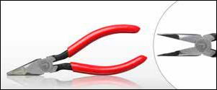

Intended for use in skinning 22-24 AWG wire and crushing insulation in nose slot. The front portion of the jaws is narrowed, and a portion of the inner face of one jaw is relieved to skin insulation from wire. The inner surface of the jaws are serrated to facilitate gripping wire.

Jaw Length: 1-1/2” 38.10mm), Overall Length: 6-1/2” (165mm)

Heat Coil Pliers - PLS-5
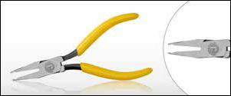

Designed for installing and extracting heat coils, fuses and other cylindrical shaped components. The thin nosed jaw allows easy access to tight restricted areas.

Jaw Length: 1-13/16” (46.04mm), Overall Length: 5” (127mm)

L3 Type Cut Crush Strip Pliers - KS21257L3
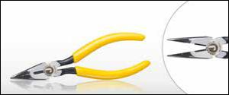

Long nose with side cutter, crushing slot, one .030” stripping hole and a thin knurled nose to facilitate handling wire at the terminals.

Jaw Length: 1-1/2” (38.10mm), Overall Length: 6-1/2” (165mm)

Tabbing Shear - TS-850
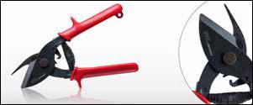

Tabbing or Cable Sheath Shear for making longitudinal cuts in the cable sheath and the metallic shield for placement of inner sheath bond clamps. Made of chrome vanadium steel. Plastic formed ergonomic handles for safety and comfort and a latch to keep the handles closed when not in use. The volute spring allows for easy opening and closing.

Overall Length: 8-1/2” (216mm)

39

jonard.com | Hand Tools

Curved Needle Nose Plier - JIC-3385
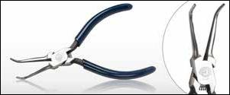

Nose is bent 60° for maximum visibility. Used in confined areas for bending and

forming fine wire. Inside jaws and jaw edges are polished to prevent nicking the

wire. Plier has a spring loaded ergonomic design with a dark blue plastic handle.

Bend Angle: 60°, Overall Length: 5-1/2” (139mm)

Slip Joint Side Cut Pliers - BCOMB
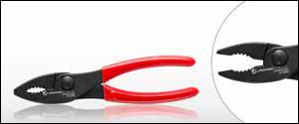

For heavy-duty use. Black phosphate finish, machined gripping teeth and 3/8” hardened wire cutter. Red plastic dipped handle.

Number of Positions: 2, Overall Length: 7-5/8” (194mm)

Wire Rope and Cable Cutter - WRC-14
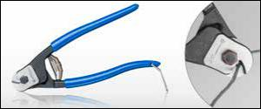

Made from chrome vanadium steel. Jaws are heat treated and precision ground for greater performance. Tool design provides greater leverage for easier cutting.

Jaw Length: 0.48” (12mm), Overall Length: 8” (203mm)

Material | Max. Wire Rope Size
Soft Wire Rope | 1/4” (6mm)
Hard Wire Rope | 3/16” (5mm)
Spring Wire | 3/32” (2.4mm)
Copper/Aluminum Cable | 3/16” (5mm)

Ratcheting Cable Cutter - RC-600
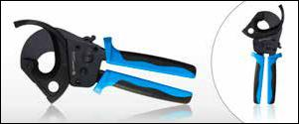

Cuts up to 600 mcm stranded copper cable, 750 mcm stranded aluminum cable. Maximum capacity is 1 3/4” (45mm) diameter. Cleanly cut copper or aluminum & multi-conductor cable up to 600 mcm (750 mcm for aluminum). Unique design to hold and cut cable quickly, easily with minimum effort. Spring design to hold cutter in the open position when needed. Quick release for easy opening. Large ergonomic handle design. (Not designed for cutting ACSR or steel).

Maximum Capacity: 1-3/4” (45mm), Overall Length: 12” (305mm)

Pump Pliers
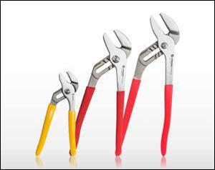

Manufactured with a secure tongue and groove design for a non-slip grip (even under heavy pressure).

Made from high quality tool steel, with a smooth positive interlock between halves.

SPECIFICATIONS | JIC-5026 | JIC-50210 | JIC-50212
DESCRIPTION | Pump Pliers 6”, 4 | Pump Plier 10”, 6 | Pump Plier 12”, 7
 | Positions | Positions | Positions
MAX JAW OPENING | 1” (25.4mm) | 1-3/4” (44.45mm) | 2-1/4” (57.15mm)
LENGTH | 6” (152mm) | 10” (254mm) | 12” (305mm)

40

Fuse Puller - FP-600
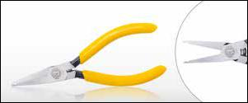

Designed for installing and extracting fuses from line amplifiers and other cylindrical shaped components including heat coils. The thin nosed jaws allow for easy access to tight restricted areas. Works great on automotive mini fuses that are packed tight. Handle color is yellow plastic dipped.

Jaw Length: 1-13/16” (46.04mm), Overall Length: 5” (127mm)

Fuse Puller Insulated - FP-600INS
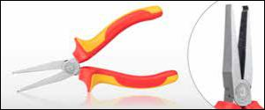

Designed for installing and extracting fuses from line amplifiers and other cylindrical shaped components including heat coils. The thin nosed jaws allow for easy access to tight restricted areas. Works great on automotive mini fuses that are packed tight. Fully insulated grips are manufactured to VDE standards.

Overall Length: 6-1/2” (165mm)

Wire Stripper 6 1/2” Insulated - INP-4065
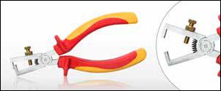

The INP-4065 Insulated Wire Stripper can be used on various types of wire, whether single conductor or stranded, from 8 AWG down to 30 AWG. 6 1/2” Long. Fully insulated grips are manufactured to VDE standards.

Overall Length: 6-1/2” (165mm)
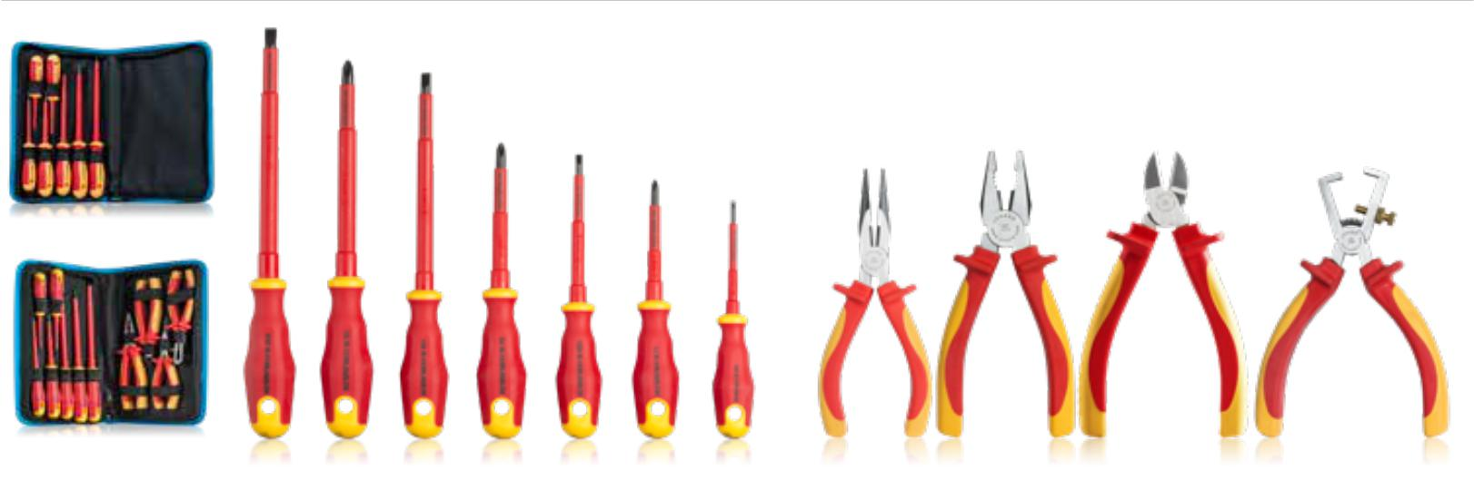

Insulated Tool Kits

Perfect for Tech Professionals and Electricians, these pliers and screwdrivers are tested to 10,000 VAC and rate to 1,000 VAC live use. They are VDE approved, made from 60 CRV (chrome vanadium steel) for strength and durability and insulated to IEC 60900 Standards. Lifetime mechanical warranty and one year insulation warranty.

TK-70INS |  | TK-110INS
7 Piece Insulated Screwdriver Set |  | 11 Piece Insulated Tool Set
Kit includes: |  | Kit includes (all tools included in TK-70INS with these additions):
• | INS-180 #1 X 3 Phillips Screwdriver | • | INP-1072 Lineman’s Combo Plier 7 1/4”
• | INS-2100 #2 X 4 Phillips Screwdriver | • | INP-2065 | Long Nose Plier 6 1/2”
• | INS-3150 #3 X 6 Phillips Screwdriver | • | INP-3062 | Diagonal Plier 6 1/4”
• | INS-4100 5/32 X 4 Slotted Screwdriver | • | INP-4065 | Wire Stripper 6 1/2”
•INS-475 1/8 X 3 Slotted Screwdriver
• | INS-6150 1/4 X 6 Slotted Screwdriver | Note: TK-70INS and TK-110INS include TKC-70 7-Pocket Tool Case
• | INS-8175 5/16 X 7 Slotted Screwdriver | and TKC-110 11-Pocket Tool Case respectively.

41

jonard.com | Hand Tools

Precision Screwdriver Phillips #00 x 60mm - SD-00/10
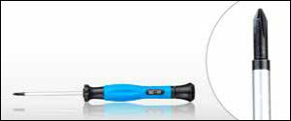

Precision screwdriver has a #00 Phillips tip and a 3mm diameter by 60mm long shaft. Shaft is made from SU11 steel. The handle is made from polypropylene and thermoplastic rubber for added comfort with a swivel at the end for ease of use. Overall tool length is 6”. Tips are magnetic. Pack of 10.

Overall Length: 6” (152mm)

Precision Screwdriver Slotted 2mm x 60mm - SD-080/10
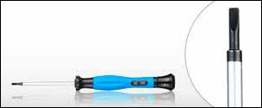

Precision screwdriver has a slotted tip 2mm wide and a 3mm diameter by 60mm long shaft. Shaft is made from SU11 steel. The handle is made from polypropylene and thermoplastic rubber for added comfort with a swivel at the end for ease of use. Overall tool length is 6”. Tips are magnetic. Pack of 10.

Overall Length: 6” (152mm)

Fiber ONT Screwdriver - SD-63
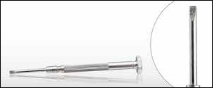

Precision Jeweler’s Screwdriver with concaved swivel knob to fit the finger and hexagonal shape to prevent rolling, knurled body for ease of use. This Jeweler’s Screwdriver is commonly used to terminate the battery backup wires in the fiber ONT and is the perfect tool to terminate battery backup sensor wires at the battery backup unit. Solid blade made of high quality hardened tool steel.

Overall Length: 4” (101mm)

Screwdriver 24” Philips #3 - SD-243

This 24” long #3 Philips Head Screwdriver is designed for use when you need an extra long screwdriver to reach the diodes in back of the rectifier. Made of chrome vanadium steel with a matte finish and a custom ergonomic tri-color handle. Tough, and durable, this is the perfect screwdriver for those unique applications. Tips are magnetic.

Overall Length: 27” (685mm)

Screwdriver Multi-Bit 6 In 1 - SD-61
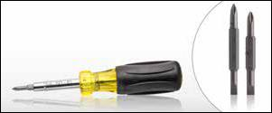

This screwdriver eliminates the need for multiple tools in your belt. This tool is configured to include: #1 & #2 Phillips Head. 9/32” & 3/16” slotted heads. Two nut drivers 5/16” & 1/4”. This screwdriver is made of special alloy steel for exceptional strength and long life. Tips are magnetic.

Kit includes: SD-RB1 Repl Bit Phillips #1 Slot 3/16”, SD-RB2 Repl Bit Phillips #2 Slot 9/32”

Overall Length: 7-1/2” (190mm)

6-In-1 Robertson Screwdriver - SD-1223
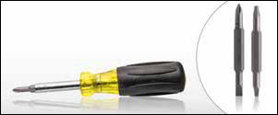

This screwdriver eliminates the need for multiple tools in your belt. This tool is configured to include: #2 Phillips Head & 9/32” Slotted Head, S1 & S2 Robertson Heads, Two nut drivers 5/16” & 1/4”, and is made of special alloy steel for exceptional strength and long life. Tips are magnetic.

Kit includes: SD-RB1 Repl Bit Phillips #1 Slot 3/16”, SD-RB3 Repl Bit S1 & S2

Overall Length: 7-1/2” (190mm)

42

Jonard Slotted, Phillips and Robertson Screwdrivers are made of special alloy steel for exceptional strength, long life and corrosion resistant. Soft rubber handles offer comfort and greater torque. The end of the handle is marked to identify the tool’s size, and the tips are magnetic. Meets and exceeds applicable ASME/ANSI specifications.
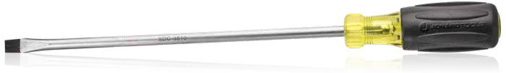

Slotted Screwdrivers

SPECIFICATIONS | SDC-3163 | SDC-3166 | SDC-144 | SDC-3810 | SDC-5166
SHAFT | 3/16” X 3” | 3/16” X 6” | 1/4” X 4” | 3/8” X 10” | 5/16” X 6”
OVERALL LENGTH | 6-3/4” (171mm) | 9-3/4” (248mm) | 8-11/32” (212mm) | 14-3/8” (365mm) | 10-3/8 (264mm)
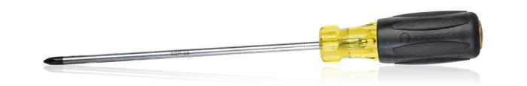

Phillips Screwdrivers

SPECIFICATIONS | SDP-1 | SDP-2 | SDP-3 | SDP-28
SHAFT | #1 X 3” | #2 X 4” | #3 X 6” | #2 x 8”
OVERALL LENGTH | 6-3/4” (171mm) | 8-5/16” (211mm) | 11” (279mm) | 12” (305mm)

Robertson Screwdrivers

SPECIFICATIONS | SDR-24 | SDR-34
SHAFT | #2 X 4” | #3 X 4”
OVERALL LENGTH | 8-1/2” (216mm) | 8-1/2” (216mm)

Stubby Screwdriver Set - Phillips & Slotted - SDS-142
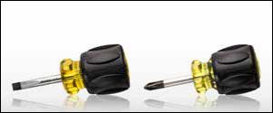

Stubby Screwdriver Set (SDSP-2 & SDSC-14). Jonard Stubby Slotted and Phillips Screwdrivers are made of special alloy steel for exceptional strength, long life and corrosion prevention. Soft rubber handles offer comfort and greater torque. The end of the handle is marked to identify the tool’s size, and the tips are magnetic. Meets applicable ASME/ANSI specifications. Overall Length 3 1/2” (89mm) each.

Set includes:

SDSP-2 Screwdriver Phillips #2 Stubby

SDSC-14 Screwdriver Slotted 1/4” Stubby

43

jonard.com | Hand Tools

8 Piece Screwdriver Set - SDK-8
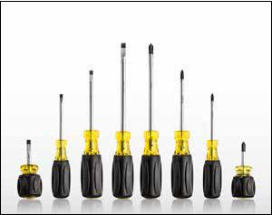

Our screwdrivers are made of special alloy steel for exceptional strength and long life. The shafts are corrosion resistant and the soft rubber handles offer user comfort with greater torque. The tips are magnetic and the size and style are marked on the end of each handle. Meets applicable ASME/ANSI specifications.

Kit includes:

- SDSP-2 Screwdriver Phillips #2 Stubby

- SDP-1 Screwdriver Phillips #1 x 3”

- SDP-2 Screwdriver Phillips #2 x 4”

- SDP-3 Screwdriver Phillips #3 x 6”

- SDSC-14 Screwdriver Slotted 1/4” Stubby

- SDC-3163 Screwdriver Slotted 3/16” x 3”

- SDC-144 Screwdriver Slotted 1/4” x 4”

- SDC-5166 Screwdriver Slotted 5/16” x 6”
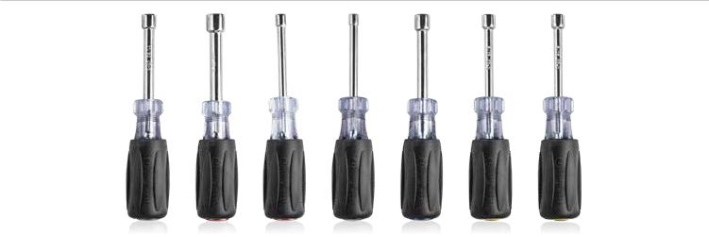

Hollow Shaft Nut Drivers

These are full length hollow shaft nut drivers intended for working with long bolts. They are designed with cushion gripped ergonomic color coded handles. Handles provide greater torque and user comfort. Overall length 7”. ASME Standard/YR: B107.12-2004.

SPECIFICATIONS | ND-63012 | ND-63014 | ND-63038 | ND-630316 | ND-630516 | ND-630716 | ND-6301132
DRIVER SIZE | 1/2” | 1/4” | 3/8” | 3/16” | 5/16” | 7/16” | 11/32”
 | (12.7mm) | (6.35mm) | (9.53mm) | (4.763mm) | (7.94mm) | (11.11mm) | (8.73mm)
COLOR CODE | Red | Red | Blue | Black | Yellow | Brown | Green

Hollow Shaft Nut Driver Kits

•
•

ND-SET4 - 4 Piece Nut Driver Set (Includes: ND-63012, ND-63038, ND-630516, ND-6301132)

ND-631 - 7 Piece Nut Driver Set (Includes: ND-63012, ND-63014, ND-63038, ND-630316, ND-630516, ND-630716, ND-6301132)

LED Flashlight With Zoom Lens - FL-2000
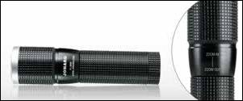

A high quality Osram LED Flashlight powered by a single AA alkaline battery. Housing is rugged aluminum suspended from a clip-on lanyard. Brightness is 120 lumens and the beam is adjustable to meet the working environment. Zoom in for a tight narrow beam and zoom out for a wide light. Hold the head of the flashlight with one hand and the body with the other. Simple in and out movement adjusts the light. Simple push-button operation.

44

Adjustable Wrenches
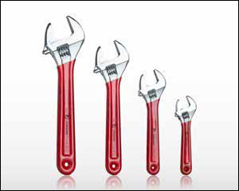

Wrenches made of chrome vanadium steel with a chrome plated finish. Wrenches are forged and heat treated for greater strength. Handles are covered with a red vinyl grip for user comfort. The knurled worm gear is precision formed and the operation is smooth and trouble free. For accurate and faster adjustments use the metric or English scales on either side of the jaws. With extra wide jaws, a smaller wrench works on bigger jobs. Great for tight spaces.

Available kit: AW-6810 Adjustable Wrench Set - 6”, 8” & 10” with Extra Wide Jaws.

3- Piece Kit includes:

AW-6 Adjustable Wrench 6” with Extra Wide Jaws

AW-8 Adjustable Wrench 8” with Extra Wide Jaws

AW-10 Adjustable Wrench 10” with Extra Wide Jaws

SPECIFICATIONS | AW-6 | AW-8 | AW-10 | AW-12
DESCRIPTION | Adjustable Wrench 6” with | Adjustable Wrench 8” with | Adjustable Wrench 10” with | Adjustable Wrench 12” with
 | Extra Wide Jaws | Extra Wide Jaws | Extra Wide Jaws | Extra Wide Jaws
JAW CAPACITY | 15/16” (24 mm) | 1-1/8” (29 mm) | 1-5/16” (33 mm) | 1-1/2” (38 mm)
OVERALL LENGTH | 6” (152mm) | 8” (203mm) | 10” (254mm) | 12” (305mm)

Self Adjusting Wire Stripping Tools
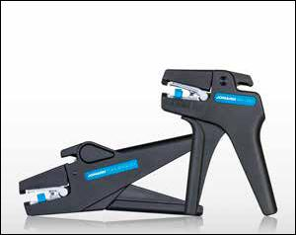

The perfect solution for stripping PVC and other insulated wire. This innovative squeeze and strip design uses precision carbon steel laminated stripping blades that automatically grasp the insulation to provide quick and accurate wire stripping. Can be used to strip one or several wires at the same time. The patented stripping mechanism is smooth, efficient and ergonomic. The built in adjustable wire stop allows you to set the stripping length and comes with a wire cutter to help make cutting and stripping even faster. Tool life expectancy over 150,000 cycles. Rugged and made from high strength plastic and the stripping blades are made from high quality carbon steel.

 | SPECIFICATIONS | WSA-1024 |  | WSA-1430
 | DESCRIPTION | Self-Adjusting Wire Stripping Tool, |  | Self-Adjusting Wire Stripping Tool,
 |  | 10-24 | AWG | 14-30 | AWG
 | WIRE GAUGE | 10-24 | AWG (2.6-0.20 mm) | 14-30 | AWG (1.63-0.25 mm)
 | REPL. BLADES | WSA-1024RB |  | WSA-1430RB

Electrician’s Scissors
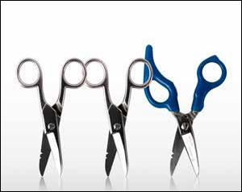

Designed for heavy duty use. Made of chrome vanadium steel with a special hardening process for greater durability and nickel plated for that professional look. Notched to strip 18-20 & 22-24 AWG wire and one blade is serrated. A scraper and file are on the back of the blade.

Note: ES-1964DS features a free-fall fingertip operation. ES-1964ERG features an ergonomic handle.

JONARD P/N | DESCRIPTION
ES-1964 | Electrician Scissor
ES-1964DS | Free Fall Electrician Scissor
ES-1964ERG | Ergonomic Electrician’s Scissors

45

jonard.com | Hand Tools
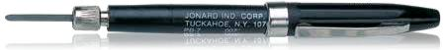

Pocket Type Burnishers

Adjustment of flexible blade-length and rigidity is possible by varying depth in chuck. Supplied with replaceable blades stored in pen barrel at other end. Plastic barrel and cap made of sturdy plastic for dielectric work. Length 4 1/2”, diameter 3/8”. Blades are 3/16” wide x 1 1/2” long. Rods are .020” diameter x 1 1/4” long.

 | B-3R/25 |  | JONARD P/N | DESCRIPTION
 |  |  | PB-3 | Pen w/ 6 Blades .0035” Thick
B-3/25 |  |  | PB-3R | PB-3 Plus 6 Abraisive Rods .020”
 |  |  | PB-7 | Pen w/ 6 Blades .007” Thick
B-7/25 |  |  | B-3/25 | Pkg 25 | Replacement Blades for PB-3 (.0035”)
 |  |  | B-3R/25 | Pkg 25 | Replacement Rods for PB-3R (.020”)
 |  |  | B-7/25 | Pkg 25 | Replacement Blades for PB-7 (.007”)

Contact Burnishers

Plastic insulated handles for working on live contacts. Available in four styles for fine, extra sensitive, general purpose and industrial use.

 |  | JONARD P/N | DESCRIPTION
 |  | OB-1/3 | Burnisher Files (Pkg. 3), Fine
 |  | OB-1/12 | Burnisher Files (Pkg. 12), Fine
 |  | OB-2/12 | Burnisher Files (Pkg. 12), Extra Sensitive
 |  | OB-3/12 | Burnisher Files (Pkg. 12), General Purpose
 |  | OB-4/12 | Burnisher Files (Pkg. 12), Industrial
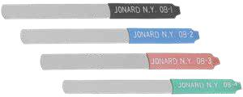

Smart Phone & Tablet Repair Tool Kit - TK-19
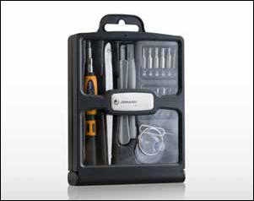

For opening and repairing all series of smartphones, tablets and many “i” series computers (iPhones & iPads). Kit contains all the tools you need to take apart these highly specialized electronic devices. Perfect for DIY repair jobs. Tools are neatly organized and labeled in a convenient storage case.

Kit includes:
- Ergonomic Handle

- Thirteen 4mm bits

- 2 Plastic Prying Tools

- Guitar Pick

- Opening Tool

- Suction Vacuum Opener

- SIM Eject Tool

- Tweezer

Opener for Tablets & Smartphones - SP-4

The Jonard Tools SP-4 makes opening today’s smartphones and tablets easy. This tool is a Must have for repair professionals and DIYer’s alike. Its thin and flexible stainless steel blade easily slides between screen and frame of most common electronic devices to pop them open quickly and easily. Unlike plastic spudgers which are too thick and for one time use, the SP-4 is thin and designed to be used over and over again.

46

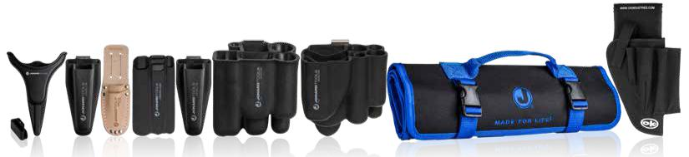

H-25 |  | H-36 H-40 | H-50 | H-60 | H-75 | H-85 | H-125 | H-1000
 | Pouches
 | JONARD P/N |  |  |  | DESCRIPTION |  | SECURING METHOD
 | H-25 |  |  |  | Pouch For JIC-186 & JIC-195 |  | Plastic Belt Clip
 | H-36 |  |  |  | Molded 2 Tool Pouch |  | Metal Belt Clip
 | H-40 |  |  |  | Leather 2 Tool Pouch |  | Belt Loop
 | H-50 |  |  |  | Molded 5 Tool Pouch |  | Belt Loop
 | H-60 |  |  |  | Molded 2 Tool Pouch |  | Metal Belt Clip
 | H-75 |  |  |  | Molded 7 Tool Pouch |  | Metal Belt Clip
 | H-85 |  |  |  | Molded 8 Tool Pouch |  | Metal Belt Clip
 | H-125 |  |  |  | 25 Pocket Tool Roll Up Pouch |  | Carrying Handle
 | H-1000 |  |  |  | Rugged Nylon 5-Pocket Tool Pouch |  | Belt Loop
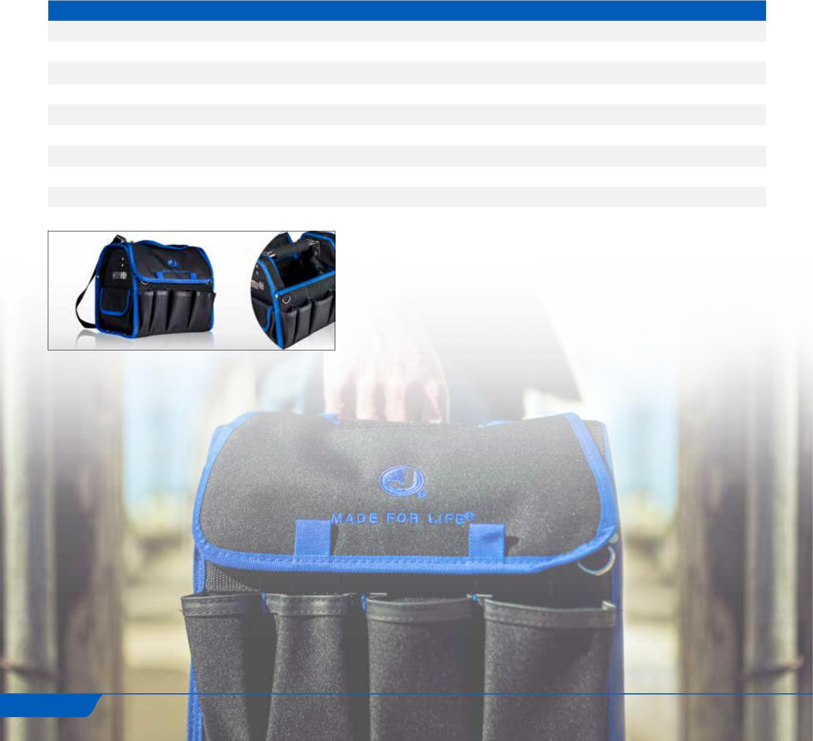

Rugged 21 Pocket Tool Case - H-90

A rugged versatile 21 pocket tool case with a removable top, made from special heavy duty material for greater durability and long life. The case is reinforced with a tough thick backing material to maintain its shape – even when loaded with tools.

Additional features include a carry strap, two additional straps for securing the case to a ladder, a metal clip on the exterior for holding a tape measure and pockets galore

47

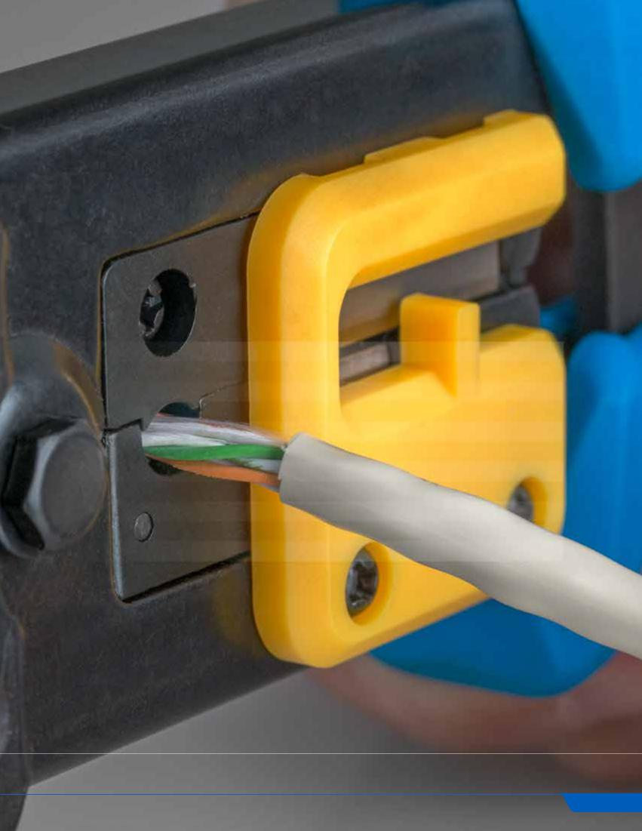

NETWORK &

TELECOMMUNICATION TOOLS

Telecom is the transfer of data through electromagnetic signals while networking is connecting devices to one main system. In both methods of communication cabling tools are critical to ensure devices transmit signals properly and bring us television, telephone, radio, internet, and more.

CONTENTS

Strippers | 49
Slitters | 49
Test Equipment | 49
Punchdown Tools | 50
Crimpers | 51
Can Wrenches | 52
Pedestal Opening Tools | 52
Booth Wrenches | 52
Wrenches | 52
Scissors/Knives | 53
Tool Kits | 54

48

Round Cable Stripper - CST-1900
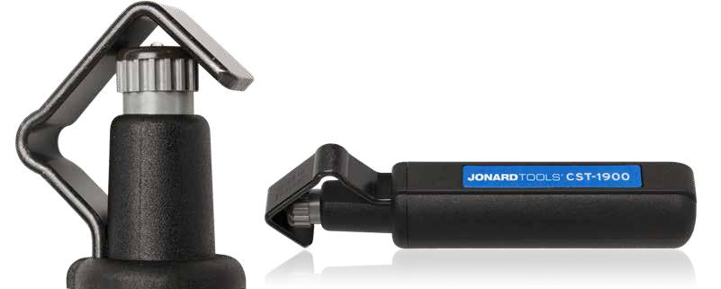

The CST-1900 is designed for fast and precise jacket removal of PVC, rubber, PE and other jacket materials, and works well on round cables with diameters ranging from 3/16” to 1-1/8” (4.5-29 mm). This is a triple action tool cutting longitudinally for mid-span and end strips, spiral cuts for mid-span access and circular cuts for mid-span jacket removal as well as jacket removal on end cuts. A simple versatile easy to use tool. Patented.

Replacement Blade: CST-7915

Cyclops Wire Stripper - CST-1i
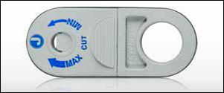

CST-1i Cyclops - Fast easy removal of outer insulation from all unshielded twisted pair, shielded twisted pair and multi-core cables. The Cyclops features a self adjusting blade and is perfect for PVC and plenum type insulation, plus other materials without damaging the inner braids, foils or conductors. Cable performance is not impacted using this cable stripper. Patented.

Cable Ring Tool - JIC-2060
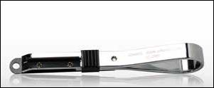

This cable ring tool is designed for cutting the sheathing of inside type plastic,

fabric or rubber covered cable 3/16” (135.38 mm), 1/4” (6.35 mm), 3/8”, &

1/2” (12.7 mm). Durable metal handle. Tool is supplied with 1 replacement blade.

Replacement Blades: RB-2060/6 (Pkg of 6)

Torque Wrench Swivel Head w/ 5/32 Hex Socket - TWSW-10SK
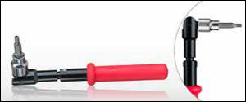

Used to properly torque 5/32” security screws used for mid mounting. Head swivels 90° and is factory set for 10 in./Lb. Can be used with any 3/8” drive sockets. NOTE: For optimum functionality be sure to use a Full-Hand Grip centered on the handle.

Includes the TWS-532.

5/32” Hex Security Socket 3/8” Drive (Pkg 10) - TWS-532/10
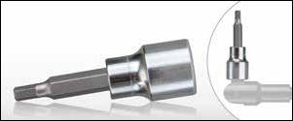

5/32” hex security socket 3/8” drive. Used on the TWSW-10 torque wrench. Made of chrome vanadium steel. Pack of 10.

Note: TWSW-10 Torque Wrench Swivel Head 10 in/lb sold separately.

49

jonard.com | Network & Telecommunication Tools

EPD Series Punchdown Tools
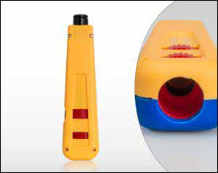

Sleek ergonomic design for easy effective wire termination. Tested up to 100,000 cycles at high-impact setting. Use to properly set, seat and terminate wire. Simply position the wire, push tool, and listen for confirming click. Wire is properly seated.

Features include:
- Hi/Low impact setting

- Combination Hook/Spudger stored in the chassis

- Color coded yellow on the CUT side

- Enlarged blade storage compartment

- Lifetime Warranty (Essentially means unlimited impacts)

Punchdown Tool Kits

JONARD P/N | EPD-914 | EPB-66 | EPB-110 | EPB-116 | EPB-KR | EPB-630 | EPB-KRONE
EPD-91466 | X | X
EPD-914110 | X |  | X
EPD-914KR | X |  |  |  | X
EPD-914116 | X |  |  | X
EPD-91461 | X | X | X
EPD-9KRONE | X |  |  |  |  |  | X
EPD-914630 | X |  |  |  |  | X
Punchdown Tool Blades
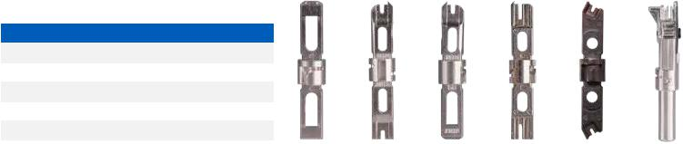

JONARD P/N | DESCRIPTION
EPB-66 | 66 Blade With & Without Cutter
EPB-110 | 110 Blade With & Without Cutter
EPB-116 | 66 & 110 Blade Combined With Cutter
EPB-KR | Krone Blade With & Without Cutter
EPB-630 | Punchdown Blade For 630 Modular Jack
EPB-KRONE | Krone Blade Scissor Style | EPB-66 | EPB-110 | EPB-116 | EPB-KR | EPB-630 | EPB-KRONE
 |  | BIX Punchdown Tool - EP-16A
 |  | This tool is designed to terminate cables, pigtails, and jumper wires on all GigaBIX,
 |  | BIX and UMOXS cross-connect system connectors. This single action, spring
 |  | activated tool will terminate 22-26 AWG plastic insulated solid copper conductors.
 |  | Button on the handle adjusts the tool for seating only, or for seating and cutting the
 |  | conductors.
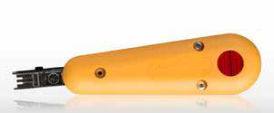

Non-Impact Punchdown Tool - ENI-110
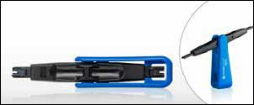

Designed for use on 110 terminal blocks. Perfect for do-it-yourself small jobs on a 110 terminal block. Fits neatly in the palm of your hand. Quickly and easily switch from cutting and non-cutting blade side with one hand. Simple - Fast - Easy.

Patent Pending.

50

Termination & Removal Tool - EP-QTH38B
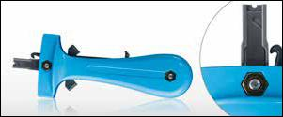

The EP-QTH38B tool is used for terminating, bridging, and removing wires from 2-beam or 3-beam, insulation-slicing, quick-clip terminals found on QCM486 (MPC) and 391Q connectors, and on Versa blocks with quick-clip pins.

Tool can be used for seating wires only or for seating and cutting operations. Tool has built in wire pick for removing already terminated cables.

Quick Clip Insertion Tool - JIC-950C
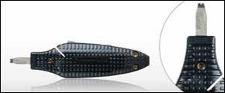

This multipurpose wire insertion tool performs several vital functions. The wire cutter is designed to cut 22 & 24 gauge wire, the hook at the back of the tool is used for both jumper and back-tap removal, and the bit inserts 22 or 24 gauge

(0.5 mm or 0.6 mm) wire into the terminal block. Ideal for wire insertion in 3-beam (112 type blocks) and 4 beam (78 type blocks) terminals in Cosmic and Cosmic II distributing frames.

Replacement Blade: JIC-955

Modular Crimping Tool 6 In 1 - UC-864

A rugged modular crimping and stripping tool for voice and data applications. The tool has 2 crimping slots; one slot used for 8 position modular plugs and the other slot is used for both 6 and 4 position modular plugs. The tool also has a round cable jacket stripper as well as a flat cable stripper and cutter. Tool works with the following modular plugs: RJ11, RJ12, RJ22 and RJ45.

Two Sets of Replacement Blades: UC-866

Regular and Feed-Thru Connector Crimper Tool - UC-4568

Durable all-steel construction crimp tool with built-in cutter and stripper.

Features:
  - Crimp and trim off excess conductors with a simple squeeze of the tool

  - Cleanly shears excess conductors leaving a smooth flat finish

  - Ratcheted, ultra-stable platform for consistent terminations with low hand force

  - Tool includes built in jacket stripper for round cables as well as flat cables plus a flat cable cutter
- Crimping dies are precision ground. Crimps 2,4,6 and 8 position RJ11 and RJ45 regular and feedthrough type modular connectors

- Heavy duty cutting blade good for 3,000 cuts

- Ergonomic handles for greater comfort
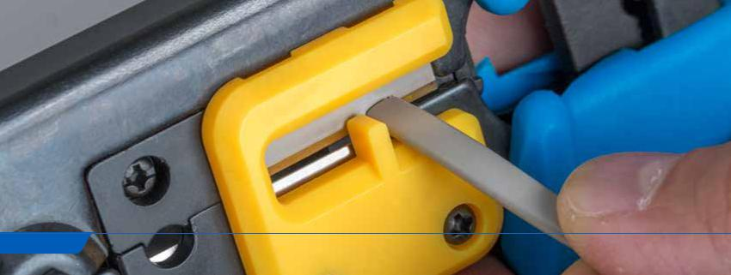

51

jonard.com | Network & Telecommunication Tools

Can Wrenches
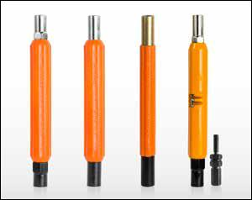

Double end can socket wrench, 3/8” and 7/16”, orange Impact resistant thermoplastic ergonomic handle. Used in placing fuses in cable terminals and connecting wires to fuses and binding posts. The walls on both sockets are thin enough so they can be used to work locking devices on most terminals and cabinets. 7” long.

 | JONARD P/N | DESCRIPTION
 | M-216C/EX | Ergonomic Hex 7/8” Diameter Handle Hex Socket
 | M-216C/REX | Ergonomic Round 7/8” Diameter Handle Round Socket
 | M-216C/RX | Standard Round 11/16” Diameter Handle Round Socket
 | M-216CKIT | Security Key Kit 7/8” Diameter Handle Hex Socket
 | M-216CS22 | Ergo, W/ Wire Stripper 7/8” Diameter Handle Hex Socket (Built In
 |  | 22-24 AWG Wire Stripper)

Security Key Insert - SK-51632
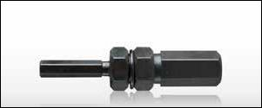

Designed with a double-ended hex adapter for two sizes of pin-in-head security fasteners. Simply slip the key into the 3/8” side of a can wrench and you are ready for either a 5/16” or 5/32” hex security screw. The 5/16” side of the SK-51632 is used on tamper-proof cross-connect cabinets, MESA,CATV closures and any other closure that requires a 5/16” tamper proof hex tool to gain access. This is a reversible insert tool. One end is for SLC Cabinets and the other is for most Network Interface Boxes.

Booth Wrenches
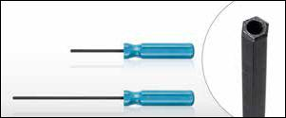

Tamper proof hex screwdrivers, also known as a booth wrench or security wrench. It features a 1” diameter screwdriver handle, 5/32” hex shaft with a hole drilled in the tip for use with security tamper proof screws used for telephone and CATV applications.

BW-532-3 Booth Wrench 3” Long Shaft

BW-532 Booth Wrench 6” Long Shaft

T Handle Security Wrench 5/16“ - BW-516
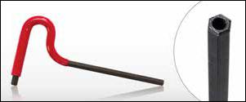

Tamper proof wrench for use on tamper-proof cross-connect cabinets, MESA and CATV closures using 5/16” tamper proof screw. Recessed at both ends, 1/4” deep. Red plastic handle for user comfort.

Linesman B Wrench - JIC-650
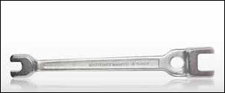

Forged and heat treated, this Lineman’s Wrench is used on pole line hardware. It is open-end double end type with two sizes of openings at each end and an oval hole for turning pole steps. The end openings accommodate nuts for 3/8”, 1/2”, 5/8” and 3/4” bolts and the head of the 1/2” drive screw. The faces of the Lineman’s Wrench openings are offset to provide handle clearance. 13” Long.
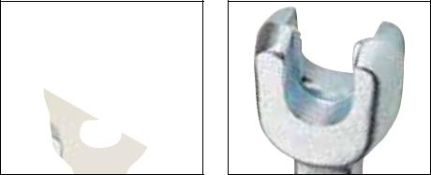

52

Electrician’s Scissors

Designed for heavy duty use. Made of chrome vanadium steel with a special hardening process for greater durability and nickel plated for that professional look. Notched to strip 18-20 & 22-24 AWG wire and one blade is serrated. A scraper and file are on the back of the blade.

Note:

ES-1964DS features a free-fall fingertip operation

ES-1964ERG features an ergonomic handle.

JONARD P/N | DESCRIPTION
ES-1964 | Electrician Scissor
ES-1964DS | Free Fall Electrician Scissor
ES-1964ERG | Ergonomic Electrician’s Scissors

Heavy Duty Scissor With Wire Stripper - JIC-183
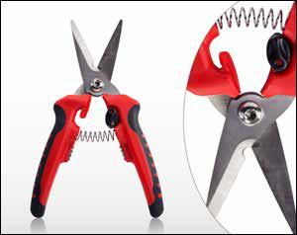

Heavy duty multi-function scissor designed to cut copper, aluminum, leather, plastic and other materials. Not designed to cut steel or other hardened/heat treated metals. Made from high carbon stainless steel blades. Three stripping holes marked 1.0, 1.5, 2.0 which is equivalent to 18, 14 & 12 AWG wire. One blade serrated for a secure grip and handles are dual component polypropylene and TPR. Includes safety locking mechanism and adjustment screw.

Communication Scissor - JIC-195
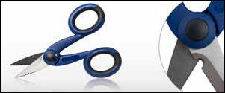

High carbon stainless steel blades, 1/4” notch for cutting & stripping, two stripping notches for 18-20 AWG and 22-24 AWG wires, one serrated non-slip blade. High carbon stainless steel blades that are both sharp and durable with serrated blade that grips and holds the wire. Ergonomic dual component nylon & santoprene handles, for user comfort and durability. A 1/4” notch cuts and strips, and the two stripping notches strip 18-20 and 22-24 AWG wires. Designed with an adjustable joint screw under the protective cap.

Ergonomic Cable Splicing Knife - KN-7
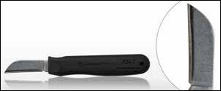

The tough cutlery steel blade is extremely sharp and cuts easily through many types of insulation. It holds its edge with repeated use and features a non-slip easy grip ergonomic handle made from TPR (thermoplastic rubber) for better control and reduced hand fatigue. Blade length is 1¾” and overall length is 6¼”

53

jonard.com | Network & Telecommunication Tools

Knife And Scissor Sharpener - KSS-1
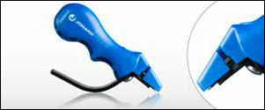

Sharpen knives and scissors with one convenient sharpener. Made of high-grade tungsten-carbide steel and diamond polished. Will restore the edge on either scissors or knives with 3-4 simple strokes. Safety finger guard, lightweight compact design makes this the ideal tool for all your sharpening needs.

Splicer’s Kit - TK-400
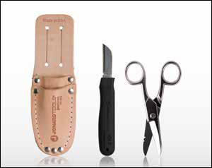

The compact TK-400 Splicer’s Kit contains ES-1964 Electrician’s Scissors, H-40 Leather Two Tool Pouch, and a special purpose KN-7 Ergonomic Cable Splicing Knife. The scissors are made of chrome vanadium steel with scraper and file on one side plus 2 stripping notches. The knife features a short 1 3/4” tough, cutlery-steel blade and a non-slip handle.

Kit includes:

- KN-7 Ergonomic Cable Splicing Knife

- ES-1964 Electrician’s Scissor

- H-40 Leather Two Tool Pouch

Telephone Installer Splicer’s Kit - TK-22148
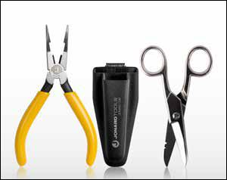

The TK-22148 Telephone Installer Splicer’s Kit is designed for stripping, splicing and crimping. The perfect kit for telephone installers.

Kit includes:

- JIC-22148 Combo Crimper Long Nose Pliers

- ES-1964 Electrician’s Scissor

- H-36 Molded Pouch

5 Piece Telecom Installer’s Kit - TK-50
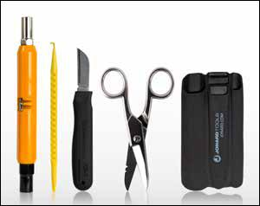

The perfect kit for simple installations, the TK-50 5 Piece Telecom Installer’s Kit includes the basic necessities for telecom installations.

Kit includes:
• M-216CS22 Can Wrench, ERgo, W/ Wire Stripper
• KN-7 Ergonomic Cable Splicing Knife
• ES-1964 Electrician’s Scissor
• JIC-22035 Probe Pick
• H-50 Molded Five Tool Pouch

54

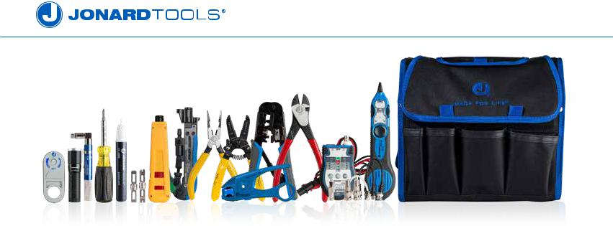

14 Pc Security & Alarm Tool Kit - TK-610

Designed specifically for the security and alarm industry, the TK-610 14 Pc Security & Alarm Tool Kit provides all the tools needed to prep coax and power cables for termination. Also includes tools for tracing and testing applications.

Kit includes:

JONARD P/N | DESCRIPTION
CST-1i | Cyclops Wire Stripper
CT-200 | Universal Compression Tool
EPD-91461 | Punchdown Tool With 2 Blades 66 & 110
FL-2000 | LED Flashlight With Zoom Lens
H-90 | Rugged 21 Pocket Tool Case
JIC-1626 | Wire Stripper 16-26 AWG
JIC-22148 | Combo Crimper, Long Nose Pliers
JIC-2288 | Plier, Diagonal, Cutter, 8"
PT-300 | Pocket Continuity Tester & Toner
SD-61 | Screwdriver Multi-Bit 6 In 1
TETP-900 | Multi-Function Cable Tester Tone & Probe Kit
UC-864 | Modular Crimping Tool 6 In 1
UST-125 | COAX Stripping Tool For RG59/6 & 7/11 With Cable Stop
VT-1000 | Voltage Detector

Punchdown Tool Kit - TK-17
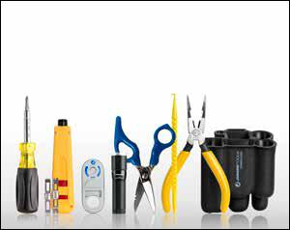

An ideal combination of tools for electrical technicians, main frame telecommunications professionals, security & alarm and datacom professionals. Kit includes punchdown tool with 66 & 110 blades, ergonomic electrician scissor, LED flashlight with zoom lens, spudger, multi-bit screwdriver, cyclops wire & cable stripper, combo crimper long nose plier and convenient pouch with metal belt clip.

Kit includes:
• EPD-91461 Punchdown Tool With 2 Blades 66 & 110
• JIC-22148 Combo Crimper Long Nose Pliers
• SD-61 Screwdriver Multi-Bit 6 In 1
• ES-1964ERG Ergonomic Electrician’s Scissor
• CST-1i Cyclops Wire Stripper, can use on UTP/STP Cable
• FL-2000 LED Flashlight with Zoom Lens
• H-75 Molded 7 Pocket Pouch with Belt Clip
• JIC-22035 Probe Pick

55

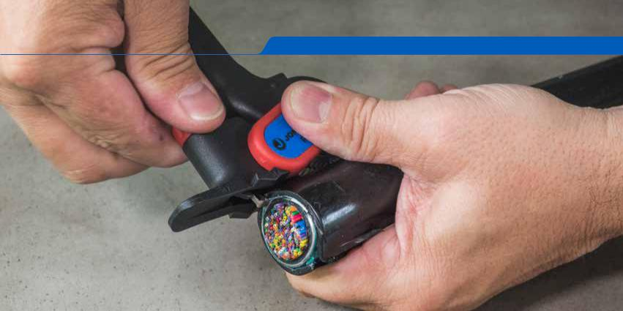
jonard.cjonardm|.comNetwork|Wire&TelecommunicationsStrippers&Slitter

WIRE STRIPPERS & SLITTERS

Ratcheting Cable Slitter - RCS-25

Slits and rings PVC, PE, rubber, and other cable jacket materials. Will work on small cables as well as cables larger than 25mm. Designed with reversible double-ended replaceable blade with adjustable cutting depth 0-5mm for each unique cable application. 10/20/30mm scaled on tool for slitting length reference. For mid-span or end cable slit and ring applications.

Replacement Blade: RCS-25RB

Cable Slit & Ring Tool - CSR-1575

The CSR-1575 is designed to slit and ring cables, buffer tubes and jackets on fiber optic cables up to 7.5mm (0.3”) in diameter. The tool features an easily adjustable slit blade and ring blade as well as a removable and reversible V block that improves slitting performance and accommodates smaller to larger diameter cables.

Replacement Blade Set: CSR-2

Round Cable Stripper - CST-1900
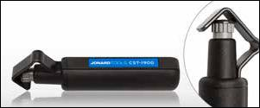

The CST-1900 is designed for fast and precise jacket removal of PVC, rubber, PE and other jacket materials, and works well on round cables with diameters ranging from 3/16” to 1-1/8” (4.5-29 mm). This is a Triple Action Tool, cutting longitudinally for end stripping, spiral for end stripping and mid-span cuts, and circular for jacket removal. A simple versatile easy to use tool. Patented.

Replacement Blade: CST-7915

Cyclops Wire Stripper - CST-1i

Fast easy removal of outer insulation from all unshielded twisted pair, shielded twisted pair and multicore cables. The Cyclops features a self adjusting blade and is perfect for PVC and plenum type insulation, plus other materials without damaging the inner braids, foils or conductors. Cable performance is not impacted using this cable stripper. Patented.

56

Adjustable Wire Stripper & Cutter - WS-5
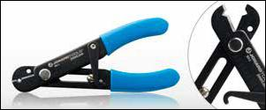

The WS-5 is designed with a precision ground “V”notch blade for superior stripping results. This tool is spring loaded for comfort and has a locking latch to keep the tool closed when not in use. A handy bending hole in the jaw is great for bending solid wire. The tool has an adjustable blade stop and the handle is marked for easy and consistent adjustments. The tool works on both stranded and solid wire from 30 AWG to 10 AWG. Made from high carbon steel with a black oxide coating. Vinyl cushion grips provide excellent comfort.

Wire Strippers
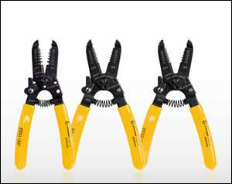

The JIC-1022, JIC-1626, JIC-2030 are wire strippers and cutters designed for 10-20 AWG, 16-26 AWG, 20-30 AWG wire respectively. Other features include a coil spring opening to reduce fatigue, wire looping, bending holes conveniently located, black oxide finish, locking mechanism, and cutting surfaces that are hardened, tempered and ground for superior performance.

JIC-1022 Wire Stripper, 10-22 AWG (2.60-0.64 mm)

JIC-1626 Wire Stripper, 16-26 AWG (1.29-0.40 mm)

JIC-2030 Wire Stripper, 20-30 AWG (0.81-0.25 mm)

Adjustable Wire Strippers
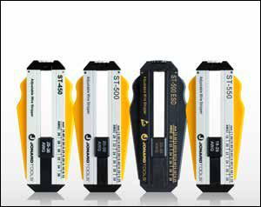

The ST-450, ST-500, ST-500ESD, ST-550 are adjustable wire strippers and cutters designed for 26-36 AWG, 20-30 AWG, 20-30 AWG ESD Safe, 18-28 AWG wire respectively. These Precision Wire Strippers feature an adjustment dial that allows the operator to select one of the six different settings. A calibrated wire stop can then be adjusted for the desired insulation strip length. In a single motion, the operator squeezes and pulls the tool. This action engages four specially hardened blades to cleanly cut the wire insulation while the pulling motion breaks the insulation/conductor bond.

ST-450 Adjustable Wire Stripper, 26-36 AWG ST-500 Adjustable Wire Stripper, 20-30 AWG ST-500ESD Adjustable Wire Stripper, 20-30 AWG ESD Safe ST-550 Adjustable Wire Stripper, 18-28 AWG
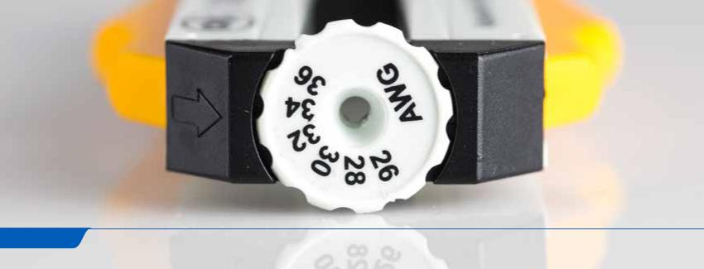

57

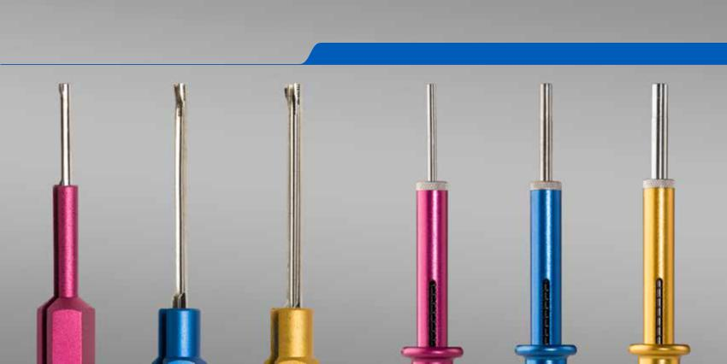
jonard.com | Insertion & Extraction Tools

INSERTION & EXTRACTION TOOLS

Insertion & Extraction Tool Kits
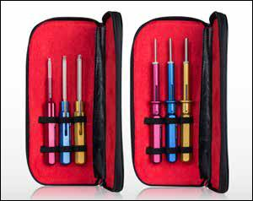

These tools service virtually all connectors conforming to Mil-C-26482, Mil-C-26500 with front release contacts. These tools contain strong, durable, stainless steel probes & color coded handles. Items sold individually as well in kits. The kits are supplied in a leather Jonard tool case.

KA-260 Insertion Tool Kit Includes:

A-4598 Insertion Tool Contact Size 20 (Military Standard: MS24256-A20)

A-4599 Insertion Tool Contact Size 16 (Military Standard: MS24256-A16)

A-4600 Insertion Tool Contact Size 12 (Military Standard: MS24256-A12)

KR-260 Removal Tool Kit Includes:

R-4601 Removal Tool Contact Size 20 (Military Standard: MS24256-R20)

R-4602 Removal Tool Contact Size 16 (Military Standard: MS24256-R16)

R-9461 Removal Tool Contact Size 12 (Military Standard: MS24256-R12)

Insertion And Extraction Tool - AR-910672
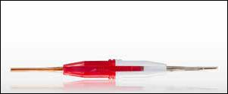

A pin & socket insertion & extraction tool for contact size 20. Tool constructed of brass and ABS plastic with the red side for insertion and the white side for extraction. Mil standard M81969/1-02.

For use on TE Connectivity Amplimite series HDP-20 plugs and pins and other similar manufacturers products. Use with: 215712-1 Plug 15 POS Crimp Snap, 215711-1 Plug 9 POS Crimp Snap, 1218266-1 Pin 18 AWG Gold Crimp, 194081-1 Pin 1.04mm without Louver Band, 205089-2 D-sub Pin 20-24 AWG Crimp

Pin Removal Tool - R-5926
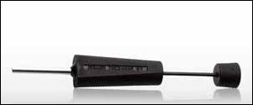

The pin extractor is a plunger style pin extractor for pushing pins out from behind the connector blocks for contact sizes 16-20. 3” long. This Amp style connector tool can be used on AMP CPC type connectors.

58

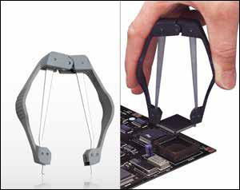
EX-6
PLCC Extractors

This PLCC Extraction Tool extracts a range of PLCC sizes from 20 pins through 128 pins from any socket without damage to the chip. Spring loaded one-hand design requires no pulling, just squeeze the handles and chip is lifted from the socket. Machined stainless steel for long life.

JONARD P/N | DESCRIPTION
EX-5 | PLCC Extractor - ESD (Electrostatic Discharge) Safe
EX-6 | PLCC Extractor

EX-5

Wire Extractor - M-724A

Metal construction wire extractor with insulated handle to remove wire from quick-connect clips and 66 & 110 terminal blocks. 3/16” diameter with a .052” slot width. 5 1/2” long.
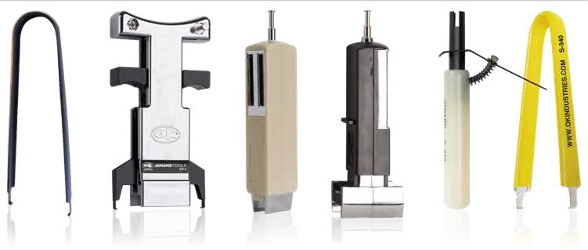

EX-1/10 | EX-2 | MOS-1416 | MOS-2428 | S-339 | S-340
IC Insertion & Extraction Tools
JONARD P/N | DESCRIPTION
EX-1/10 | DIP IC Extractor (8-24 Pins) (Pack of 10)
EX-2 | DIP IC Extractor (24-40 Pins)
MOS-1416 | Insertion Tool (14-16 Pins)
MOS-2428 | Insertion Tool (24-28 Pins)
S-339 | Lamp Extractor
S-340 | DIP/IC Extractor
WK-7 | IC Insertion/Extraction Kit (Kit includes: EX-1/10, EX-2, MOS-1416, MOS-2428)

59

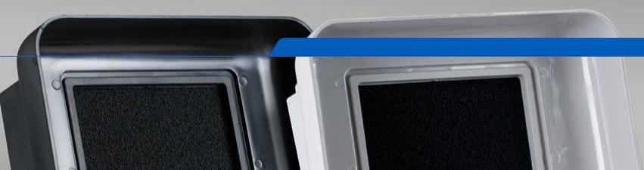
jonard.com | Soldering & Desoldering

SOLDERING & DESOLDERING TOOLS
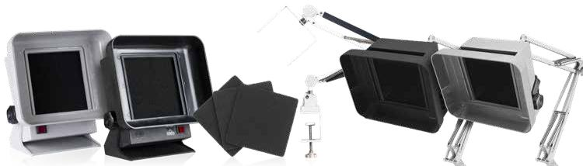

SA-9-115 SA-9-E-115 SAF-1 SAK-90 SA-91-E SA-91

Benchtop Fume Absorbers

Features:

- Aerodynamic hood design effectively draws irritating soldering fumes away from the work area
- Carbon-impregnated filters trap a limited portion of the flux fumes

- Compact size, low profile and adjustable stand allows convenient placement 6” to 8” (152 to 203mm) from work area

- SA-9-E-115 feature static-dissipative housings

- Dimensions: 8 1/2” H x 8 1/4” W x 4” D

- Articulating arm allows optimized positioning and saves bench space
- Bench mounting clamp and 3 filters come complete with unit

- SA-91-E features a static-dissipative housing

- Noise level 45-50 DB A

JONARD P/N | DESCRIPTION
SA-9-115 | Fume Absorber, 115V
SA-9-E-115 | Fume Absorber, ESD Safe 115V
SAF-1 | Replacement Filter Set, 3 pcs.
SAK-90 | Arm Assembly Kit Retro-fits SA-9/9-E to SA-91-E
SA-91-E | SA-9 | -E-115 with Articulating Arm & Bracket (ESD Safe)
SA-91 | SA-9 | -115 with Articulating Arm & Bracket

High-Vacuum Desoldering Pumps
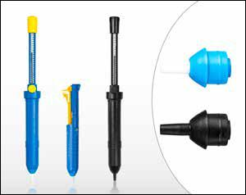

A specially engineered desolder pump made to exacting specifications and providing precise repeatable operation. Fitted with a Teflon Tip with ID .125”, OD .22” and included cleaning mechanism. DP-100 and DP-200. 13” long, DP-140 8” long.

JONARD P/N | DESCRIPTION
DP-100 | High Vacuum Desoldering Pump
DP-140 | Desoldering Pump
DP-200 | High Vacuum Desoldering Pump, ESD Safe
DPT-100 | 1 | Replacement Tip, DP-100/DP-140
DPT-200 | 1 | Replacement Tip, DP-200

60

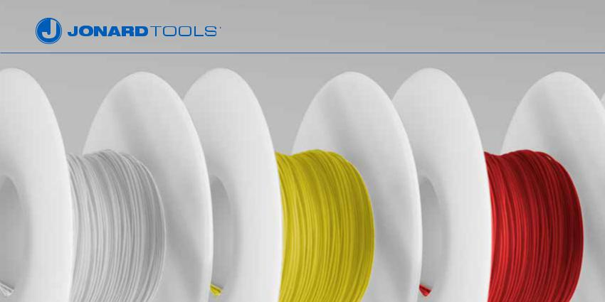

KYNAR® WIRE

KYNAR ® Insulated, Silver Plated Copper Conductor

Ideally suited for wire wrapping and many other applications. The Kynar insulation provides a flexible yet abrasion resistant wire and the conductor is made from silver plated OFHC (Oxygen Free High Conductivity) copper.

WIRE SIZE |  | INSULATION DIA. |  | ROLL SIZE
 |  |  |  |  |  | BLUE | YELLOW | WHITE | BLACK | RED | GREEN
AWG | mm | In. | mm | Feet | Meters
24 | 0.50 | .030 | 0.76 | 100 | 30.4 | R24B-0100 | R24Y-0100 | R24W-0100 | R24BLK-0100 | R24R-0100
26 | 0.40 | .027 | 0.69 | 100 | 30.4 | R26B-0100 | R26Y-0100 | R26W-0100 | R26BLK-0100 | R26R-0100
28 | 0.32 | .024 | 0.60 | 100 | 30.4 | R28B-0100 | R28Y-0100 | R28W-0100 | R28BLK-0100 | R28R-0100
30 | 0.25 | .020 | 0.50 | 100 | 30.4 | R30B-0100 | R30Y-0100 | R30W-0100 | R30BLK-0100 | R30R-0100 | R30G-0100
 |  |  |  | 1000 | 304.4 | R30B-1000 | R30Y-1000 | R30W-1000 | R30BLK-1000 | R30R-1000 | R30G-1000
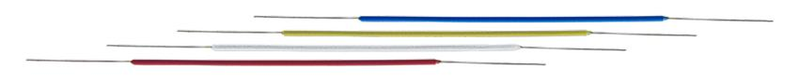

Pre-Cut & Pre-Stripped Wire Wrapping Wire

30 AWG (0.25mm) Pre-Cut/Pre-Stripped Wire 50 Pieces/Pkg.

•
•
•

50 pieces per package

Kynar® insulated

Silver plated copper conductor

•
•
•

UL listed

1” of stripped wire on either end

Add 2” to the insulation length (see chart below) for total length of wire

INSULATION LENGTH |  | BLUE | YELLOW | WHITE | RED
In. | mm
1 | 25 | 30-B-50-010 | 30-Y-50-010 | 30-W-50-010 | 30-R-50-010
2 | 51 | 30-B-50-020 | 30-Y-50-020 | 30-W-50-020 | 30-R-50-020
3 | 76 | 30-B-50-030 | 30-Y-50-030 | 30-W-50-030 | 30-R-50-030
5 | 127 | 30-B-50-050 | 30-Y-50-050 | 30-W-50-050 | 30-R-50-050

61

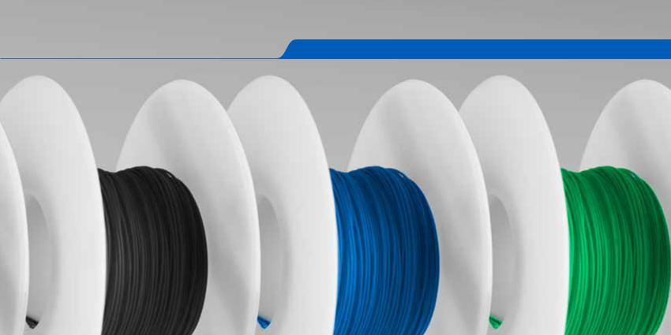
jonard.com | Kynar® Wire

KSW Wire Wrapping Wire Rolls for Cut/Strip/Wrap Applications

Low strip force Kynar® insulated silver plated copper conductor wire is further processed to provide a low strip force for use with CSW bits and sleeves. Ideally suited for wire wrapping and many other applications. The Kynar insulation provides a flexible yet abrasion resistant wire and the conductor is made from silver plated OFHC (Oxygen Free High Conductivity) copper.

WIRE SIZE |  | INSULATION DIA. |  | ROLL SIZE
 |  |  |  |  |  | BLUE | YELLOW | WHITE | BLACK | RED | GREEN
AWG | mm | In. | mm | Feet | Meters
24 | 0.50 | .030 | 0.76 | 100 | 30.4 | KSW24B-0100 | KSW24Y-0100 | KSW24W-0100 | KSW24BLK-0100 | KSW24R-0100
26 | 0.40 | .027 | 0.69 | 100 | 30.4 | KSW26B-0100 | KSW26Y-0100 | KSW26W-0100 | KSW26BLK-0100 | KSW26R-0100
28 | 0.32 | .024 | 0.60 | 100 | 30.4 | KSW28B-0100 | KSW28Y-0100 | KSW28W-0100 | KSW28BLK-0100 | KSW28R-0100
30 | 0.25 | .020 | 0.50 | 100 | 30.4 | KSW30B-0100 | KSW30Y-0100 | KSW30W-0100 | KSW30BLK-0100 | KSW30R-0100 | KSW30G-0100
 |  |  |  | 1000 | 304.4 | KSW30B-1000 | KSW30Y-1000 | KSW30W-1000 | KSW30BLK-1000 | KSW30R-1000 | KSW30G-1000

Wire Dispenser - WD-30 Series
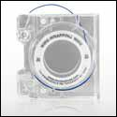

•
•
•

•

- ft. (15.2m) roll of 30 AWG (0.25mm) Kynar® wire-wrapping wire Built-in plunger cuts wire to desired length

Built-in stripper strips 1” (25.4mm) of insulation Refillable

JONARD P/N | DESCRIPTION | REPLACEMENT ROLL OF WIRE
WD-30-B | Dispenser with 50’ of Blue wire | R-30B-0050
WD-30-Y | Dispenser with 50’ of Yellow wire | R-30Y-0050
WD-30-W | Dispenser with 50’ of White wire | R-30W-0050
WD-30-R | Dispenser with 50’ of Red wire | R-30R-0050
WD-30-TRI | Dispenser with 50’ of Blue, White and Red wire | R-30-TRI

62

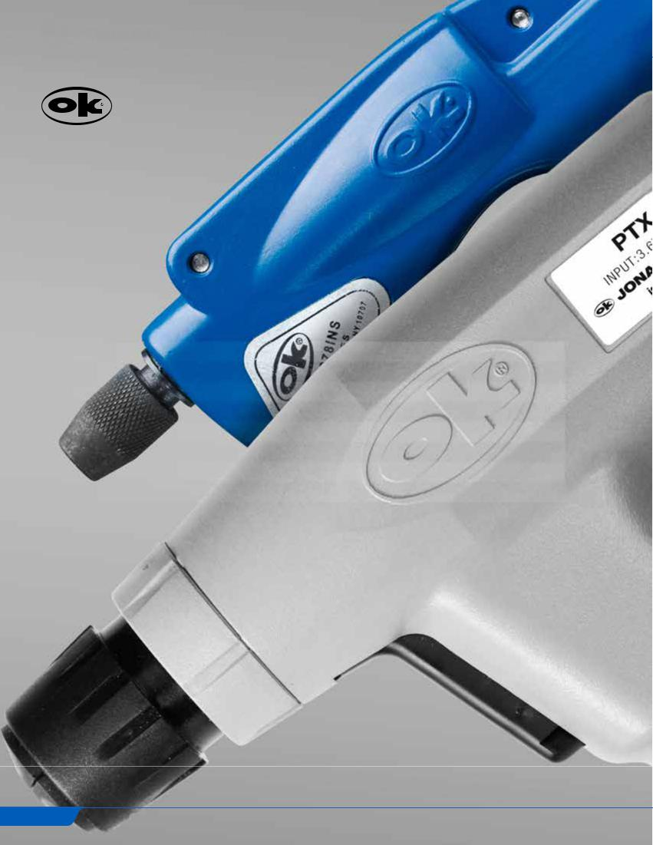

WIRE WRAP TOOLS

In February 2003 Jonard Industries acquired OK Industries and merged their operation into the “Jonard Family of Companies”. Established in 1946, OK Industries blossomed as a major force in the telecommunications and electronic industries with a special proficiency in the manufacture of Wire Wrapping Tools. These same tools have continuously been supplied by Jonard Tools.

CONTENTS

Wire Wrap Guide | 64
Battery Wire Wrap Tools | 65
Electric Wire Wrap Tools | 65
Manual Wire Wrap Tools | 66
Wire Wrap Bits & Sleeves | 67
Hand Wrap Tools | 69
Wire Cut/Strip Tools | 71
Wire Wrap Tool Kits | 72

63

jonard.com | Wire Wrap Tools

Wire Wrapping is a method of making a wire connection by coiling the bare wire around the sharp corners of a terminal under mechanical tension. The technology was developed as an alternative to soldering, which presents various safety and reliability problems in many applications. A principal advantage of wire wrapping is that it provides a high-reliability connection that is also easily removed to correct or modify a wiring layout. Wire wrapping subjects the wire to tremendous tension and compression forces, causing the oxide layer on both wire and terminal to be crushed or sheared, resulting in a clean, oxide-free metal-to-metal contact. A standard wrap is generally used for 18 AWG and larger diameter wires; a modified wrap is typically used for 26 AWG and smaller wires, and is used almost exclusively for 28 to 30 AWG wires. In either case, the wrap style affects only the connection’s mechanical stability; both styles provide suitable electrical connections.

 | Metal-to-Metal Contact |  | Strip Force Chart*
 | By bending the wire around the sharp corner of the
 |  |  |  | WIRE SIZE |  |  | MIN NUMBER OF | MIN. STRIP FORCE
 | terminal, the oxide layer on both wire and terminal is
A |  |  | AWG | DIA. | DIA. |  | TURNS | LBS. | GMS
 | crushed or sheared, and a clean, oxide-free metal-to- |  |  |  |  |  | (BARE WIRE)
 |  |  |  | INCHES | MM
 | metal contact is obtained.
 |  |  | 16 | .051 | 1.30 |  | 4 | 15 | 6800
 | B
 |  |  | 18 | .0403 | 1.00 |  | 4 | 15 | 6800
 | Types of Wrap |  | 20 | .032 | 0.80 |  | 5 | 8 | 3600
 |  |  | 22 | .0253 | 0.65 |  | 5 | 8 | 3600
 | A “Regular” bit wraps the bare wire around the terminal.
 |  |  | 24 | .0201 | 0.50 |  | 6 | 7 | 3200
 | A “Modified” bit wraps a portion of insulation around |  | 26 | .0159 | 0.40 |  | 7 | 6 | 2700
 | the terminal in addition to the bare wire. This greatly
 |  |  | 28 | .0126 | 0.32 |  | 7 | 5 | 2200
 | increases the ability to withstand vibration.
 |  |  | 30 | .0100 | 0.25 |  | 7 | 3.3 | 1500
Regular | Modified
 |  |  | *Conforms to MIL-STD-1130B
How to Make Wire Wrapped Connections |  | Some Hints on Making Wrapped Connections
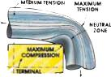
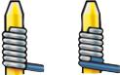
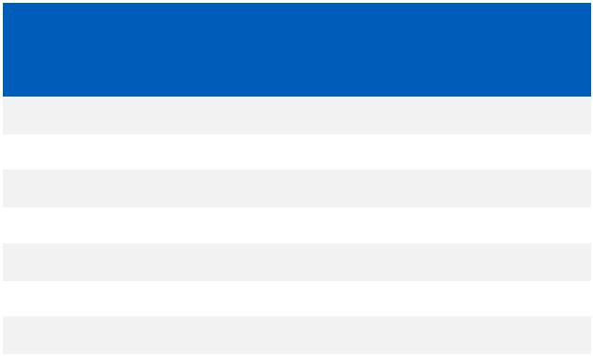

Step 1: Bit, Sleeve and Pre-Stripped Wire
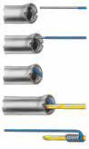

Step 2: Wire Insertion

Step 3: Wire Anchoring

Step 4: Terminal Insertion

Step 5: Finished Connection

OVERWRAP
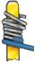
Do not press too hard. Let the

OK tools do the work. Excessive

pressure can lead to overwrapping.

Backforce “BF” to prevent

overwrapping is available on most

power tools and is recommended for

use with 26 thought 30 AWG wire.

INSUFFICIENT TURNS
It’s easy to feed wire into the slot

in the OK bit correctly. Be sure the

stripped end of the wire is “pushed-

in” all the way.

OPEN WRAP & SPIRAL WRAP
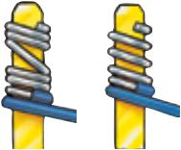
Just keep the OK tool on the terminal until the wrap is complete. Early removal can result in spiral and open wraps.

PIGTAIL
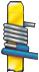
Wire wrapping is a precision technique and the wrong bit and sleeve just cannot do the job. Improper selection can cause problems ranging from “Pigtails” to loose wraps.

Terminal Diagonal Chart
Dimension B
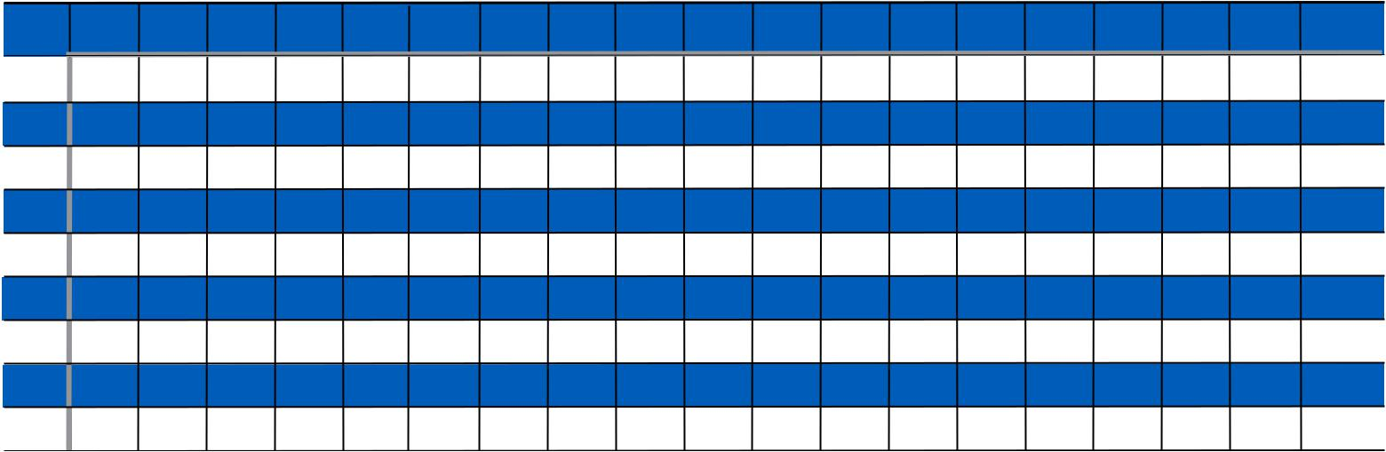

Dimension A

In. | .010 | .015 | .020 | .025 | .030 | .035 | .040 | .045 | .050 | .055 | .060 | .065 | .070 | .075 | .080 | .085 | .090 | .095 | .100
mm | 0.25 | 0.38 | 0.51 | 0.64 | 0.76 | 0.89 | 1.02 | 1.14 | 1.27 | 1.40 | 1.52 | 1.65 | 1.78 | 1.91 | 2.03 | 2.16 | 2.29 | 2.41 | 2.54
.010 | .014 | .018 | .022 | .027 | .032 | .036 | .041 | .046 | .051 | .056 | .061 | .066 | .071 | .076 | .081 | .086 | .091 | .096 | .101
0.25 | 0.36 | 0.46 | 0.56 | 0.69 | 0.81 | 0.91 | 1.04 | 1.17 | 1.30 | 1.42 | 1.55 | 1.68 | 1.80 | 1.93 | 2.06 | 2.18 | 2.31 | 2.44 | 2.57
.015 | .018 | .021 | .025 | .029 | .033 | .038 | .043 | .047 | .052 | .057 | .062 | .067 | .072 | .077 | .082 | .087 | .092 | .097 | .102
0.38 | 0.46 | 0.53 | 0.64 | 0.74 | 0.84 | 0.97 | 1.09 | 1.19 | 1.32 | 1.45 | 1.58 | 1.70 | 1.83 | 1.96 | 2.08 | 2.21 | 2.34 | 2.46 | 2.59
.020 | .022 | .025 | .028 | .032 | .036 | .040 | .045 | .049 | .053 | .058 | .063 | .068 | .073 | .078 | .083 | .088 | .093 | .098 | .103
0.51 | 0.56 | 0.64 | 0.71 | 0.81 | 0.91 | 1.02 | 1.14 | 1.25 | 1.35 | 1.47 | 1.60 | 1.73 | 1.85 | 1.98 | 2.11 | 2.24 | 2.36 | 2.49 | 2.62
.025 | .027 | .029 | .032 | .035 | .039 | .043 | .047 | .050 | .056 | .060 | .065 | .069 | .074 | .079 | .084 | .089 | .094 | .099 | .104
0.64 | 0.69 | 0.74 | 0.81 | 0.89 | 0.99 | 1.09 | 1.19 | 1.27 | 1.42 | 1.52 | 1.65 | 1.75 | 1.88 | 2.01 | 2.13 | 2.26 | 2.39 | 2.52 | 2.64
.030 | .032 | .033 | .036 | .039 | .042 | .046 | .050 | .054 | .058 | .062 | .067 | .071 | .076 | .080 | .085 | .090 | .095 | .100 | .105
0.76 | 0.81 | 0.84 | 0.91 | 0.99 | 1.07 | 1.17 | 1.27 | 1.37 | 1.47 | 1.58 | 1.70 | 1.80 | 1.93 | 2.03 | 2.16 | 2.29 | 2.41 | 2.54 | 2.67
.035 | .036 | .038 | .040 | .043 | .046 | .049 | .052 | .056 | .060 | .064 | .069 | .073 | .078 | .082 | .087 | .091 | .096 | .101 | .106
0.89 | 0.91 | 0.97 | 1.02 | 1.09 | 1.17 | 1.25 | 1.32 | 1.42 | 1.52 | 1.63 | 1.75 | 1.85 | 1.98 | 2.08 | 2.21 | 2.31 | 2.44 | 2.57 | 2.69
.040 | .041 | .043 | .045 | .047 | .050 | .052 | .056 | .060 | .064 | .068 | .072 | .076 | .080 | .084 | .089 | .092 | .097 | .102 | .107
1.02 | 1.04 | 1.09 | 1.14 | 1.19 | 1.27 | 1.32 | 1.42 | 1.52 | 1.63 | 1.73 | 1.83 | 1.93 | 2.03 | 2.13 | 2.26 | 2.34 | 2.46 | 2.59 | 2.72
.045 | .046 | .047 | .049 | .050 | .054 | .056 | .060 | .063 | .067 | .071 | .074 | .078 | .083 | .087 | .091 | .096 | .101 | .105 | .109
1.14 | 1.17 | 1.19 | 1.25 | 1.27 | 1.37 | 1.42 | 1.52 | 1.60 | 1.70 | 1.80 | 1.88 | 1.98 | 2.11 | 2.21 | 2.31 | 2.44 | 2.57 | 2.67 | 2.77
.050 | .051 | .052 | .053 | .056 | .058 | .060 | .064 | .067 | .071 | .074 | .078 | .082 | .086 | .090 | .094 | .098 | .103 | .107 | .111
1.27 | 1.30 | 1.32 | 1.35 | 1.42 | 1.47 | 1.52 | 1.63 | 1.70 | 1.80 | 1.88 | 1.98 | 2.08 | 2.18 | 2.29 | 2.39 | 2.49 | 2.62 | 2.72 | 2.82

Example: If “A”=.020”. “B”+.060”. The Terminal diagonal is .063” as shown on chart.

64

Battery Wire Wrap Tools
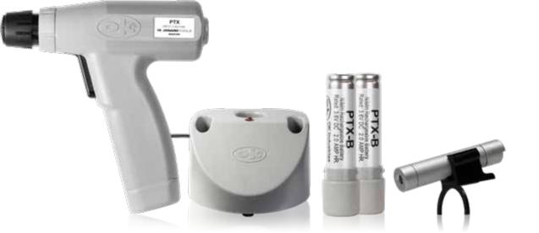

The ergonomic and patented PTX Series Wire Wrap Tools are the telecom industry standard for wire wrapping needs on main distribution frames as well as local and remote installations. It’s rugged construction and high speed motor make the tool suitable for electronic assembly work and many other wire wrapping applications.
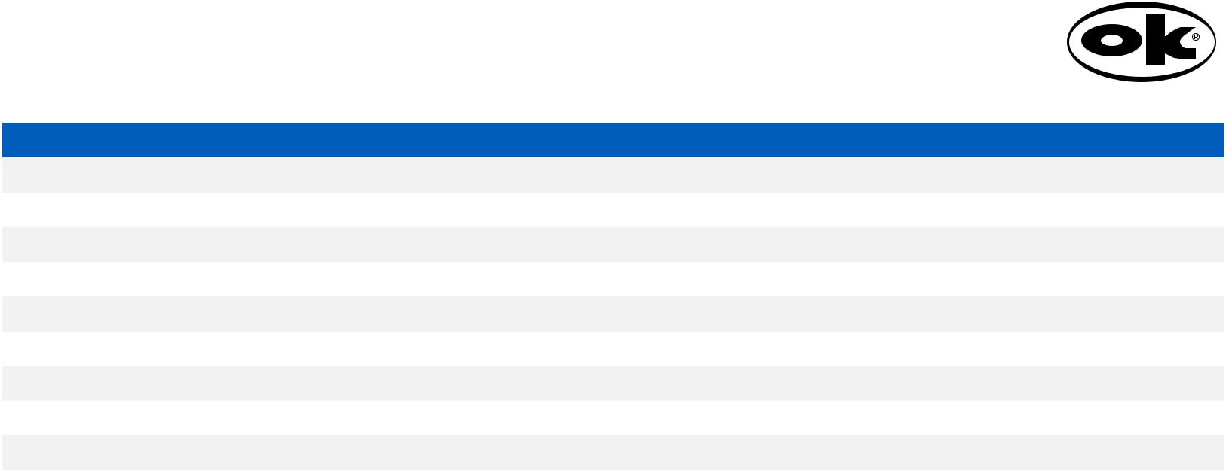

JONARD P/N | DESCRIPTION |  | WEIGHT |  | RPM
PTX | Battery Powered Wrap/Unwrap Tool | 1.13 lbs (0.51 g) |  |  | 3700
PTXFL | PTX Plus Flashlight Attachment | 1.13 lbs (0.51 g) |  |  | 3700
PTX-KIT1 | PTX Tool, 115V Battery Charger, 2 Batteries | 3.15 | lbs (1.42 kg) |  | 3700
PTX-KIT1DH | PTX Tool, DFB224, 115V Battery Charger, 2 Batteries, H-1000 | 3.44 | lbs (1.56 kg) |  | 3700
PTX-KIT1DHFL | PTX-KIT1DH Plus Flashlight Attachment | 3.52 | lbs (1.60 kg) |  | 3700
PTX-KIT1FL | PTX-KIT1 Plus Flashlight Attachment | 3.23 | lbs (1.47 kg) |  | 3700
PTX-KIT2 | PTX Tool, 230V Battery Charger, 2 Batteries | 3.18 | lbs (1.44 kg) |  | 4200
PTX-KIT2DH | PTX Tool, DFB224, 230V Battery Charger, 2 Batteries, H-1000 | 3.60 | lbs (1.63 | kg) | 4200
PTX-KIT2DHFL | PTX-KIT2DH Plus Flashlight Attachment | 3.60 | lbs (1.63 | kg) | 4200
PTX-KIT2FL | PTX-KIT2 Plus Flashlight Attachment | 3.51 | lbs (1.59 | kg) | 4200

All battery wire wrap tools above operate with a 3.6 Volt NiMH Battery.

Accessories

JONARD P/N | DESCRIPTION |  | WEIGHT
PTX-B | PTX Battery For Wrap/Unwrap Tool | 0.39 | lbs (0.18 kg)
PTX-BC1 | PTX Battery Charger, 115V | 0.77 | lbs (0.35 | kg)
PTX-BC2 | PTX Battery Charger, 230V | 0.86 | lbs (0.39 | kg)
PTX-FLA | Universal Flashlight Kit For PTX | 0.08 | lbs (0.04 | kg)

Electric Wire Wrap Tools

JONARD P/N | DESCRIPTION |  | WEIGHT |  | VOLTAGE | RPM
PTX-1 | Electric Wrap/Unwrap Tool, 115V | 1.20 | lbs (0.54 kg) |  | 115V | 3700
PTX-1BF | Electric Wrap/Unwrap Tool W/Backforce, 115V | 2.00 | lbs (0.90 kg) |  | 115V | 3700
PTX-1BFFL | PTX-1BF with Flashlight | 2.08 | lbs (0.94 kg) |  | 115V | 3700
PTX-1FL | PTX-1 with Flashlight | 2.07 | lbs (0.93 kg) |  | 115V | 3700
PTX-2 | Electric Wrap/Unwrap Tool, 230V | 2.20 | lbs (0.99 kg) |  | 230V | 4200
PTX-2BF | Electric Wrap/Unwrap Tool W/Backforce, 230V | 2.17 | lbs (0.98 | kg) | 230V | 4200
PTX-2BFFL | PTX-2BF with Flashlight | 2.25 | lbs (1.02 | kg) | 230V | 4200
PTX-2FL | PTX-2 with Flashlight | 2.28 | lbs (1.03 | kg) | 230V | 4200

All tools with “BF” in the part number include back force protection to prevent overwrapping.

65

jonard.com | Wire Wrap Tools
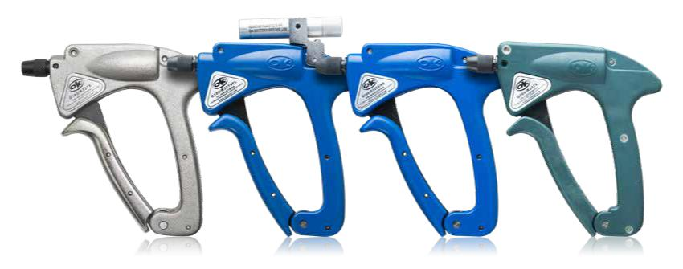

G100/R3278 G100/R3278FL G100/R3278INS G200/R3278

Manual Wire Wrap Tools

Manual Wire Wrap Tools from Jonard OK Industries are ideal for between 50 and 200 wire wrap jobs per day. The nose piece should be tightened when the trigger is squeezed to minimize drag and ensure the wire wrapping bit and sleeve (sold separately) are properly oriented.

JONARD P/N | DESCRIPTION
G100/R3278 | Aluminum Wire Wrapping Tool
G100/R3278FL | Insulated Aluminum Wire Wrapping Tool with Flashlight
G100/R3278INS | Insulated Aluminum Wire Wrapping Tool
G200/R3278 | Wire Wrapping Tool with Lexan® Housing

LED Flashlight Kit For G100 Tools - G100-FL
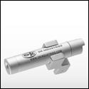

For use with G100/R3278 & G100/ R3278INS. Add the convenience of task lighting to your wire wrapping gun with this Wire Wrapping Flashlight Kit. Compatible with all wire wrapping tools.

Universal Flashlight Kit For WW Gun - G100-FLA
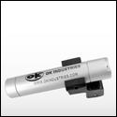

Universal - for use with most manual wire wrapping guns. Add the convenience of task lighting to your wire wrapping gun with this Wire Wrapping Flashlight Kit. Compatible with all wire wrapping tools.

Manual Wire Unwrapping Tool - G100/R3394CT
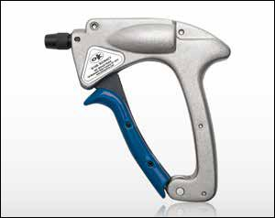

The G100/R3394CT is an insulated aluminum wire unwrapping tool great for high speed wire unwrapping. The PUW2226 is the kit containing the bit and sleeve to unwrap wire AWG 20 - 26 (0.80 - 0.40mm). You can also purchase the bit and sleeve separately (part numbers below).
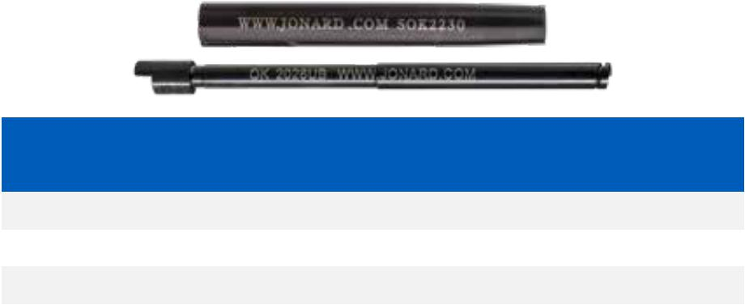

JONARD P/N | WIRE SIZE |  | TERMINAL HOLE
 | AWG | MM | INCHES | MM
2026UB | 20-26 | 0.80-0.40 | .070 | 1.77
SOK2230 | 20-26 | 0.80-0.40 | .070 | 1.77
PUW2226 | 20-26 | 0.80-0.40 | .070 | 1.77

66

3” Wire Wrap Bits & Sleeves

Fully compatible with any make or model wrapping tool. Modified bits provide an additional 1 ½” turns of insulated wire to the wrap.

 |  |  |  |  | MAXIMUM | MINIMUM | MAXIMUM | TERMINAL | EFFECTIVE | TERMINAL
WIRE GAUGE | REGULAR | MODIFIED | BIT P/N | SLEEVE P/N | INSULATION | TERMINAL | TERMINAL | HOLE |  | HOLE
 |  |  |  |  |  |  |  |  | RADIUS
 |  |  |  |  | DIAMETER | DIAGONAL | DIAGONAL | DEPTH |  | DIAMETER
18 AWG | • |  | KB18 | P194LN |  | .060” | .073” | 1.000” | .150” | .075”
1.00mm | • |  | KB18 | P194LN |  | 1.52mm | 1.85mm | 25.40mm | 3.81mm | 1.90mm
20-22 AWG | • |  | KB2075 | P194LN |  | .042” | .073” | 1.000” | .123” | .075”
0.65-0.80mm | • |  | KB2075 | P194LN |  | 1.07mm | 1.85mm | 25.40mm | 3.12mm | 1.90mm
22 AWG | • |  | KB22 | P2224 |  | .054” | .073” | .750” | .117” | .075”
0.65mm | • |  | KB22 | P2224 |  | 1.37mm | 1.85mm | 19.05mm | 2.97mm | 1.90mm
22 AWG |  | • | WB2275M | P2224 | .052” | .049” | .074” | 1.000” | .132” | .075”
0.65mm |  | • | WB2275M | P2224 | 1.32mm | 1.24mm | 1.87mm | 25.40mm | 3.35mm | 1.90mm
22-24 AWG | • |  | KB224LH | P2224 |  | .061” | .085” | 1.000” | .117” | .086”
0.50-0.65mm | • |  | KB224LH | P2224 |  | 1.54mm | 2.15mm | 25.40mm | 2.97mm | 2.18mm
22-24 AWG | • |  | KB224-1 | P2224 |  | .054” | .073 | 1.000” | .111” | .075”
0.50-0.65mm | • |  | KB224-1 | P2224 |  | 1.37mm | 1.85mm | 25.40mm | 2.82mm | 1.90mm
22-24 AWG | • |  | KB224 | P2224 |  | .054” | .073” | .807” | .111” | .075”
0.50-0.65mm | • |  | KB224 | P2224 |  | 1.37mm | 1.85mm | 20.50mm | 2.82mm | 1.90mm
22-24 AWG |  | • | WB224M | P2224 | .050” | .049” | .074” | 1.250” | .121” | .075”
0.50-0.65mm |  | • | WB224M | P2224 | 1.27mm | 1.24mm | 1.87mm | 31.75mm | 3.07mm | 1.90mm
24 AWG |  | • | WB24DH | P2224 | .046” | .054” | .073” | 1.750” | .117” | .075”
0.50mm |  | • | WB24DH | P2224 | 1.17mm | 1.37mm | 1.85mm | 44.50mm | 2.97mm | 1.90mm
24 AWG | • |  | KB24 | P2426 |  | .055” | .074” | .750” | .100” | .075”
0.50mm | • |  | KB24 | P2426 |  | 1.39mm | 1.87mm | 19.05mm | 2.54mm | 1.90mm
24 AWG |  | • | WB24SM* | P3032LN | .044” | .024” | .043” | .750” | .098” | .044”
0.50mm |  | • | WB24SM* | P3032LN | 1.11mm | 0.60mm | 1.09mm | 19.05mm | 2.48mm | 1.11mm
24-26 AWG |  | • | WB2426M | P2224 | .046” | .054” | .073” | .750” | .118” | .075”
0.40-0.50mm |  | • | WB2426M | P2224 | 1.17mm | 1.37mm | 1.85mm | 19.05mm | 2.99mm | 1.90mm
24-26 AWG | • |  | KB2466 | OK8519 |  | .054” | .065” | 1.000” | .098” | .066”
0.40-0.50mm | • |  | KB2466 | OK8519 |  | 1.37mm | 1.65mm | 25.40mm | 2.48mm | 1.67mm
26 AWG | • |  | KB26 | P2426 |  | .058” | .073” | 1.000” | .100” | .075”
0.40mm | • |  | KB26 | P2426 |  | 1.47mm | 1.85mm | 25.40mm | 2.54mm | 1.90mm
26 AWG |  | • | WB26SM* | P26LN | .031” | .023” | .038” | .750” | .075” | .040”
0.40mm |  | • | WB26SM* | P26LN | 0.79mm | 0.58mm | 0.96mm | 19.05mm | 1.90mm | 1.02mm
26 AWG |  | • | WB2669M | P2426 | .041” | .053” | .068” | 1.000” | .109” | .040”
0.40mm |  | • | WB2669M | P2426 | 1.04mm | 1.34mm | 1.72mm | 25.40mm | 2.77mm | 1.02mm
28 AWG |  | • | WB28SHM | P3032 | .030” | .031” | .035” | .750” | .066” | .069”
0.32mm |  | • | WB28SHM | P3032 | 0.76mm | 0.79mm | 0.89mm | 19.05mm | 1.67mm | 1.75mm
30 AWG |  | • | SB30MSH-B | P3032 | .027” | .031” | .035” | .750” | .064” | .036
0.25mm |  | • | SB30MSH-B | P3032 | 0.69mm | 0.79mm | 0.89mm | 19.05mm | 1.62mm | 0.91mm
30.32 AWG |  | • | WB3032M* | P3032 | .027” | .034” | .038” | .750” | .064” | .040”
0.20-0.25mm |  | • | WB3032M* | P3032 | 0.69mm | 0.86mm | 0.96mm | 19.05mm | 1.62mm | 1.02mm
30.32 AWG |  | • | WB3032MIL† | P3032 | .027” | .034” | .038” | .750” | .064” | .040”
0.20-0.25mm |  | • | WB3032MIL† | P3032 | 0.69mm | 0.86mm | 0.96mm | 19.05mm | 1.62mm | 1.02mm

*These tools are recommended for .025” square terminals on .100” center to center of the pins

†Provides 2.5 turns of insulation

67

jonard.com | Wire Wrap Tools

3” Wire Wrap Bits & Insulated Sleeves

The insulated sleeves are covered with a material that provides 1000V dielectric strength which helps to prevent shorting between pins and enhances worker safety. These bits and sleeves provide a regular wrap.

 |  | WIRE SIZE |  | MIN. TERMINAL DIAG- |  |  | MAX. TERMINAL DIAG- |  |  | TERMINAL HOLE |  |  | EFFECTIVE RADIUS |  | TERMINAL HOLE DIAM-
 |  |  |  |  | ONAL |  |  | ONAL |  |  | DEPTH |  |  |  |  | ETER
BIT P/N | SLEEVE P/N
 |  | AWG | MM | IN. |  | MM | IN. |  | MM | IN. |  | MM | IN. | MM | IN. |  | MM
KB22 | P2224INS | 22 | 0.65 | .054 |  | 1.37 | .073 |  | 1.85 | .750 |  | 19.05 | .117 | 2.97 | .075 |  | 1.90
KB224 | P2224INS | 22-24 | 0.50-0.65 | .054 |  | 1.37 | .073 |  | 1.85 | .807 |  | 20.50 | .111 | 2.82 | .075 |  | 1.90
KB24 | P2426INS | 26 | 0.50 | .055 |  | 1.39 | .074 |  | 1.87 | .750 |  | 19.05 | .100 | 2.54 | .075 |  | 1.90
KB26 | P2426INS | 26 | 0.40 | .058 |  | 1.47 | .073 |  | 1.85 | 1.000 |  | 25.40 | .100 | 2.54 | .075 |  | 1.90
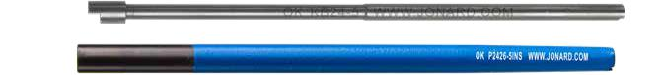

5” Wire Wrap Bits & Sleeves (Extended Length)

These bits and sleeves are designed for wire wrapping in areas requiring deep penetration. Their 5” (127mm) length ensures “true” connections in hard-to-get-at locations. Available with or without insulation. These bits and sleeves provide a regular wrap.

 |  |  | WIRE SIZE |  | MIN. TERMINAL |  | MAX. TERMINAL |  | TERMINAL HOLE |  |  | EFFECTIVE RADIUS |  | TERMINAL HOLE
 | INSULATED | UNINSULATED |  |  | DIAGONAL |  | DIAGONAL |  |  | DEPTH |  |  |  | DIAMETER
BIT P/N
 | SLEEVE P/N | SLEEVE P/N
 |  |  | AWG | MM | IN. | MM | IN. | MM | IN. |  | MM | IN. | MM | IN. | MM
KB22-5 | P2224-5INS | P2224-5 | 22 | 0.65 | .054 | 1.37 | .073 | 1.85 | .750 |  | 19.05 | .117 | 2.97 | .075 | 1.90
KB24-5 | P2426-5INS | P2426-5 | 24 | 0.50 | .055 | 1.39 | .073 | 1.85 | .750 |  | 19.05 | .100 | 2.54 | .075 | 1.90
KB26-5 | P2426-5INS | P2426-5 | 26 | 0.40 | .058 | 1.47 | .073 | 1.85 | .750 |  | 19.05 | .100 | 2.54 | .075 | 1.90

DFB Series Wrap & Unwrap Bit & Sleeve Sets

 |  | WIRE SIZE |  | MIN. TERMINAL |  | MAX. TERMINAL |  | TERMINAL |  | TERMINAL |  | EFFECTIVE
 |  |  |  | DIAGONAL |  | DIAGONAL |  | HOLE DEPTH |  | HOLE DIAMETER |  |  | RADIUS
JONARD P/N | DESCRIPTION
 |  | AWG | MM | IN. | MM | IN. | MM | AWG | MM | AWG | MM | AWG |  | MM
DFB224 | Wrap/Unwrap Bit & Sleeve Set, 22-24 AWG | 22/24 | .50/.65 | .054 | 1.37 | .073 | 1.85 | 0.50 | 12.70 | .075 | 1.90 | .111 |  | 2.82
DFB2426 | Wrap/Unwrap Bit & Sleeve Set, 24-26 AWG | 24/26 | .40/.50 | .54 | 1.37 | .065 | 1.65 | 0.50 | 12.70 | .066 | 1.67 | .098 |  | 2.48

DFB224 Includes: KB-DF224 Bit, P-DF224 Sleeve; DFB2426 Includes: KB-DF2426 Bit, P-DF2426 Sleeve

Wire Wrapping Extension Attachment - EXT-400
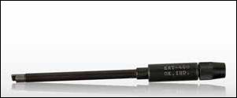

Precision device which attaches easily to your manual or powered wire wrapping tool for applications requiring extra “reach”.

68

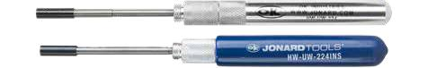

Hand Wire Wrap & Unwrap Tools

To switch from wire wrapping to unwrapping takes only seconds - just a quick change of the cap from one end of the tool to the other.

 |  |  | WRAPPING SIDE |  |  |  |  |  |  |  |  |  |  |  |  | UNWRAPPING SIDE
 |  |  |  |  |  | MAX. |  | TERMINAL |  | TERMINAL |  | OUTSIDE |  |  |  | TERMINAL |  | TERMINAL |  |  | OUTSIDE
 |  |  |  | WIRE SIZE |  | INSULATION |  | HOLE |  | HOLE |  |  |  | WIRE SIZE |  | HOLE |  | HOLE
 |  |  |  |  |  |  |  |  |  |  |  | DIAMETER |  |  |  |  |  |  |  |  | DIAMETER
JONARD P/N | DESCRIPTION | REG | MOD |  |  | DIAMETER |  | DIAMETER |  | DEPTH |  |  |  |  |  | DIAMETER |  | DEPTH
 |  |  |  | AWG | MM | IN. | MM | AWG | MM | AWG | MM | AWG | MM | AWG | MM | AWG | MM | AWG |  | MM | AWG | MM
HW-UW-18-19 | Wrap-Unwrap Tool, 18-19 AWG | • |  | 18-19 | 1.00 - | - | - | .075 | 1.90 | 1.000 | 25.40 | .250 | 6.35 | 18-19 | 1.00 - | .075 | 1.90 | 1.000 |  | 25.40 | .187 | 4.74
 |  |  |  |  | 0.91 |  |  |  |  |  |  |  |  |  | 0.91
HW-UW-20 | Wrap-Unwrap Tool, 20 AWG | • |  | 20 | 0.80 | - | - | .075 | 1.90 | 1.000 | 25.40 | .250 | 6.35 | 20-26 | 1.00 - | .075 | 1.90 | 1.000 |  | 25.40 | .156 | 3.96
 |  |  |  |  |  |  |  |  |  |  |  |  |  |  | 0.91
HW-UW-224 | Wrap-Unwrap Tool, 22-24 AWG | • |  | 22-24 | 0.65 - | - | - | .075 | 1.90 | .807 | 20.50 | .218 | 5.53 | 20-26 | 0.80 - | .070 | 1.77 | 1.000 |  | 25.40 | .156 | 3.96
 |  |  |  |  | 0.50 |  |  |  |  |  |  |  |  |  | 0.40
HW-UW-224-1 | Wrap-Unwrap Tool, 22-24 AWG | • |  | 22-24 | 0.65 - | - | - | .075 | 1.90 | 1.000 | 25.40 | .218 | 5.53 | 20-26 | 0.80 - | .070 | 1.77 | 1.000 |  | 25.40 | .156 | 3.96
 |  |  |  |  | 0.50 |  |  |  |  |  |  |  |  |  | 0.40
HW-UW-2426 | Wrap-Unwrap Tool, 24-26 AWG | • |  | 24-26 | 0.50 - | - | - | .075 | 1.90 | .750 | 19.05 | .218 | 5.53 | 20.26 | 0.80 - | .070 | 1.77 | 1.000 |  | 25.40 | .156 | 3.96
 |  |  |  |  | 0.40 |  |  |  |  |  |  |  |  |  | 0.40
HW-UW-26SM* | Wrap-Unwrap Tool, 26 AWG |  | • | 26 | 0.40 | .031 | 0.79 | .040 | 1.02 | .750 | 19.05 | .125 | 3.17 | 24.32 | 0.50- | .038 | 0.96 | 1.000 |  | 25.40 | .093 | 2.36
 |  |  |  |  |  |  |  |  |  |  |  |  |  |  | 0.20
HW-UW-2829M* | Wrap-Unwrap Tool, 28-29 AWG |  | • | 28-29 | 0.32 - | .036 | 0.91 | .040 | 1.02 | .750 | 19.05 | .156 | 3.96 | 24-32 | 0.50 - | .038 | 0.96 | 1.000 |  | 25.40 | .093 | 2.36
 |  |  |  |  | 0.29 |  |  |  |  |  |  |  |  |  | 0.20
HW-UW-30* | Wrap-Unwrap Tool, 30 AWG |  | • | 30 | 0.25 | .027 | 0.69 | .036 | 0.91 | .750 | 19.05 | .125 | 3.17 | 24-32 | 0.50 - | .038 | 0.96 | 1.000 |  | 25.40 | .093 | 2.36
 |  |  |  |  |  |  |  |  |  |  |  |  |  |  | 0.20

*These tools are recommended for .025” (0.63mm) square terminals on .100” (2.54mm) centers. A modified wrap provides 1.5 - 2 turns of insulation.

Insulated Hand Wire Wrap & Unwrap Tools

INSULATED HAND WRAP AND UNWRAP TOOLS

HW-UW-224INS |  | † | Wrap-Unwrap Tool, 22-24 AWG | • |  | 22-24 | 0.65 - | - | - | .075 | 1.90 | 1.000 | 25.40 | .218 | 5.53 | 20-26 | 0.80 | - | .070 | 1.77 | 1.000 | 25.40 | .156 | 3.96
 |  |  | Insulated |  |  |  | 0.50 |  |  |  |  |  |  |  |  |  | 0.40
WDUD-26DS | † |  | DSL Wrap And Unwrap Tool | • |  | 26 | 0.40 | - | - | .075 | 1.90 | 1.000 | 25-40 | .218 | 5.53 | 20-26 | 0.80 | - | .070 | 1.77 | 1.000 | 25.40 | .156 | 3.96
 |  |  |  |  |  |  |  |  |  |  |  |  |  |  |  |  | 0.40

†Insulated handle for dielectric protection.

TYPE “B”

TYPE “C”

TYPE “D”

Hand Unwrap Tools

These tools are used to remove wire connections made with 20 thru 32 gauge wire.

 |  |  | WIRE SIZE |  |  | MAX. TERMINAL |  | TERMINAL |  |  | OUTSIDE
 |  |  |  |  |  | DIAMETER |  | HOLE DEPTH |  | DIAMETER
JONARD P/N | DESCRIPTION | TYPE |  |  | TYPE OF UNWRAP
 |  |  | AWG | MM |  | IN. | MM | AWG | MM | AWG |  | MM
UW1 | Unwrap Tool, 20-26 AWG | D | 20-26 | 0.80-0.40 | Left Hand | .070 | 1.77 | 1.000 | 25.40 | .156 |  | 3.96
UW2 | Unwrap Tool, 20-26 AWG | C | 20-26 | 0.80-0.40 | Left and Right Hand | .070 | 1.77 | 1.000 | 25.40 | .156 |  | 3.96
UW4 | Unwrap Tool, 20-26 AWG | B | 20-26 | 0.80-0.40 | Left Hand | .070 | 1.77 | 2.360 | 60.00 | 1.95 |  | 4.95
UW5 | Unwrap Tool, 20-26 AWG | B | 20-26 | 0.80-0.40 | Left and Right Hand | .070 | 1.77 | 2.360 | 60.00 | 1.95 |  | 4.95
UW093R | Unwrap Tool, 24-32 AWG | D | 24-32 | 0.50-0.20 | Left Hand | .038 | 0.96 | 1.000 | 25.40 | .093 |  | 2.36
UWD93-93 | Unwrap Tool, 24-32 AWG | C | 24.32 | 0.50-0.20 | Left and Right Hand | .038 | 0.96 | 1.000 | 25.40 | .093 |  | 2.36
UW2832C | Unwrap Tool, 28-32 AWG | B | 28.32 | 0.32-0.20 | Left and Right Hand | .038 | 0.96 | .750 | 19.05 | .156 |  | 3.96

69

jonard.com | Wire Wrap Tools

TYPE “A”

HW-30

Hand Wrap Tools

These Hand Wire Wrapping Tools are carefully designed to produce perfect wire wrapped connections. Precision, long-lasting tools for use where occasional wraps are required or where power wire-wrapping tools are not practical. Compact and convenient.

 |  |  |  |  | WIRE SIZE |  | MAX. TERMINAL |  | TERMINAL HOLE |  | TERMINAL HOLE |  |  |  | OUTSIDE
JONARD |  |  |  |  |  |  | DIAGONAL |  | DIAMETER |  |  | DEPTH |  | DIAMETER
 | DESCRIPTION | REG | MOD | TYPE
P/N
 |  |  |  |  | AWG | MM | IN. | MM | AWG | MM | AWG |  | MM | AWG |  | MM
HW-20 | Hand Wrap Tool, 20 AWG | • |  | A | 20 | 0.80 | - | - | .075 | 1.90 | 1.000 |  | 25.40 | .218 |  | 5.53
HW-224 | Hand Wrap Tool, 22-24 AWG | • |  | A | 22-24 | 0.65-0.50 | - | - | .075 | 1.90 | .807 |  | 20.50 | .218 |  | 5.53
HW-26 | Hand Wrap Tool, 26 AWG | • |  | A | 26 | 0.40 | - | - | .075 | 1.90 | 1.000 |  | 25.40 | .218 |  | 5.53
HW-30* | Hand Wrap Tool, 30 AWG |  | • |  | 30 | 0.25 | .027 | 0.69 | .036 | 0.91 | .750 |  | 19.05 | .125 |  | 3.17

*This tool are recommended for .025” (0.63mm) square terminals on .100” (2.54mm) centers. A modified wrap provides 1.5 - 2 turns of insulation.
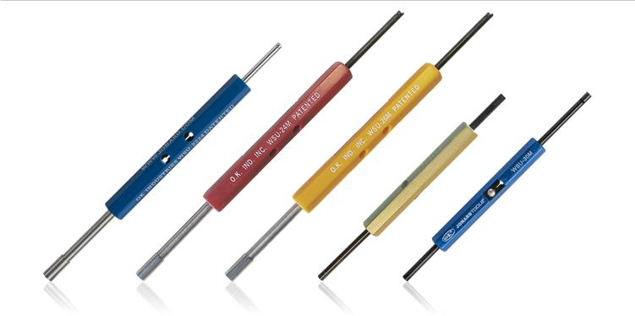

WSU-2224 WSU-24M WSU-26M WSU-30 WSU-30M

Wrap/Strip/Unwrap Tools

Each WSU tool wraps, unwraps and even strips the appropriate wire diameter with a unique built-in stripper blade. Ideal for bench use or tool kit in all service and repair applications. In addition to versatility, convenience, and reliability, the WSU Series offers exceptional value.

 |  |  |  | WIRE SIZE |  | MAX. INSULATION |  | TERMINAL HOLE |  | TERMINAL HOLE |  |  | OUTSIDE |  | SQUARE
JONARD |  |  |  |  |  | DIAMETER |  | DIAMETER |  |  | DEPTH |  | DIAMETER |  |  | POST
 | DESCRIPTION | REG | MOD
P/N
 |  |  |  | AWG | MM | IN. | MM | AWG | MM | AWG |  | MM | AWG | MM | AWG |  | MM
WSU-2224 | Wrap-Strip-Unwrap Tool, 22-24 AWG | • |  | 22-24 | 0.65 - | - | - | .075 | 1.90 | 1.50 |  | 38.1 | .213 | 5.4 | .045 |  | 1.14
 |  |  |  |  | 0.50
WSU-24M | Wrap-Strip-Unwrap Tool, 24 AWG |  | • | 24 | 0.50 | .036 | 0.92 | .075 | 1.90 | 1.50 |  | 38.1 | .213 | 5.4 | .045 |  | 1.14
WSU-26M | Wrap-Strip-Unwrap Tool, 26 AWG |  | • | 26 | 0.40 | .034 | 0.86 | .075 | 1.90 | 1.50 |  | 38.1 | .213 | 5.4 | .045 |  | 1.14
WSU-30 | Wrap-Strip-Unwrap Tool, 30 AWG | • |  | 30 | 0.25 | - | - | .036 | 0.91 | 1.50 |  | 38.1 | .125 | 3.2 | .025 |  | 0.63
WSU-30M | Wrap-Strip-Unwrap Tool, 30 AWG |  | • | 30 | 0.25 | .021 | 0.53 | .036 | 0.91 | 1.50 |  | 38.1 | .125 | 3.2 | .025 |  | 0.63

70

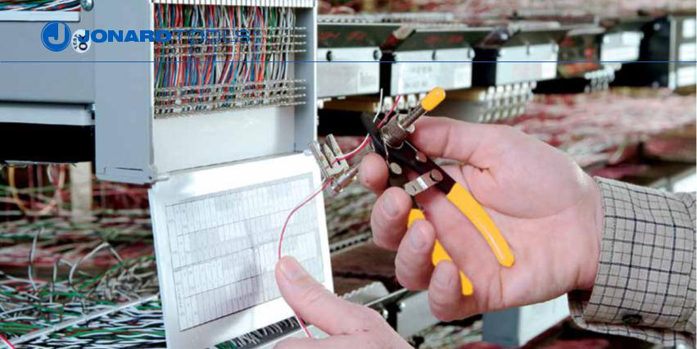

Adjustable Precision Wire Strippers - OK-3907 Series
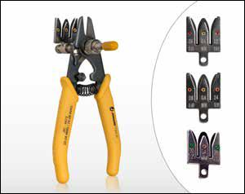

The OK-3907 Series is the industry’s leading cut-and-strip tool for copper interconnect applications. Installers and telecom technicians enjoy its rugged construction, ergonomic plastic grips, and high-leverage handle design, which allows time savings through the simultaneous cutting of multiple wires. Blades are made from specially tempered spring steel for clean, nick-free wire stripping.

 | WIRE SIZE |  | ADJUSTABLE STRIP-OFF LENGTH |  |  | REPLACEMENT
JONARD P/N
 | AWG | MM | AWG |  | MM | BLADE
OK-3907-2224 | 22-24 | 0.65-0.50 | 1-1/2” to 1-3/4” | 38.10 | to 44.45 | SB-2224
OK-3907-2426 | 24-26 | 0.50-0.40 | 1-1/2” to 1-3/4” | 38.10 | to 44.45 | SB-2426
OK-3907-2830 | 28-30 | 0.32-0.25 | 7/8” to 1-1/8” | 22.22 | to 28.57 | SB-2830
JIC-4473* | 22-24 | 0.65-0.50 | 1-1/2” to 1-3/4” | 38.10 | to 44.45 | SB-2224
 | 24-26 |  |  |  |  | SB-2426

*Supplied with 2 blades, SB-2224 and SB-2426

Wire Cut-and-Strip Tools - ST-100 Series
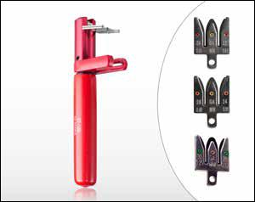

A revolutionary concept for easy and clean stripping of wires of wire wrapping, electronic and appliance applications. Biomechanically designed for maximum efficiency. Easy to operate... place wire (up to 4) in stripping slot with ends extending beyond cutter blades... press tool and pull... wire is cut and stripped to proper “wire wrapping” length. The hardened steel cutting blades and sturdy construction of the tool ensure long life. Strip length easily adjustable for your application. Blades are made from specially tempered spring steel for clean, nick-free wire stripping.

 | WIRE SIZE |  |  | ADJUSTABLE STRIP-OFF LENGTH |  |  | REPLACEMENT
JONARD P/N
 | AWG | MM |  | AWG |  | MM | BLADE
ST-100 | 22-24 | 0.65-0.50 | 1 | -5/16” to 1-9/16” | 33.33 | to 39.68 | SB-2224
ST-100-2426 | 24-26 | 0.50-0.40 | 1 | -15/16” to 1-11/16” | 39-68 to 42.86 |  | SB-2426
ST-100-2830 | 28-30 | 0.32-0.25 | 7/8” to 1-1/8” |  | 22.22 | to 28.57 | SB-2830

71

jonard.com | Wire Wrap Tools
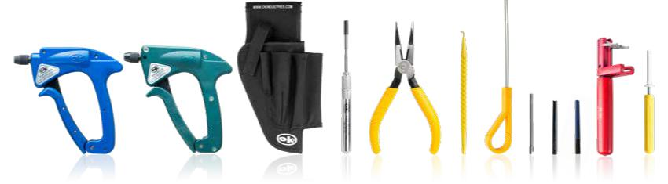

G100/R3278INS G200/R3278 H-1000 HW-UW-224 JIC-21257 JIC-22035 JIC-2257 KB224 P2224 P2224INS ST-100 UW4

Manual Wire Wrap Tool Kits

These are complete kits for technician’s working at a main distributing frame or for field service where wire wrapping is required.

•
•
•

WWK-1 Wire Wrapping Kit

WWK-1INS Insulated Wire Wrap Kit

WWK-CO Wire Wrap Kit Central Office

Kits Include:
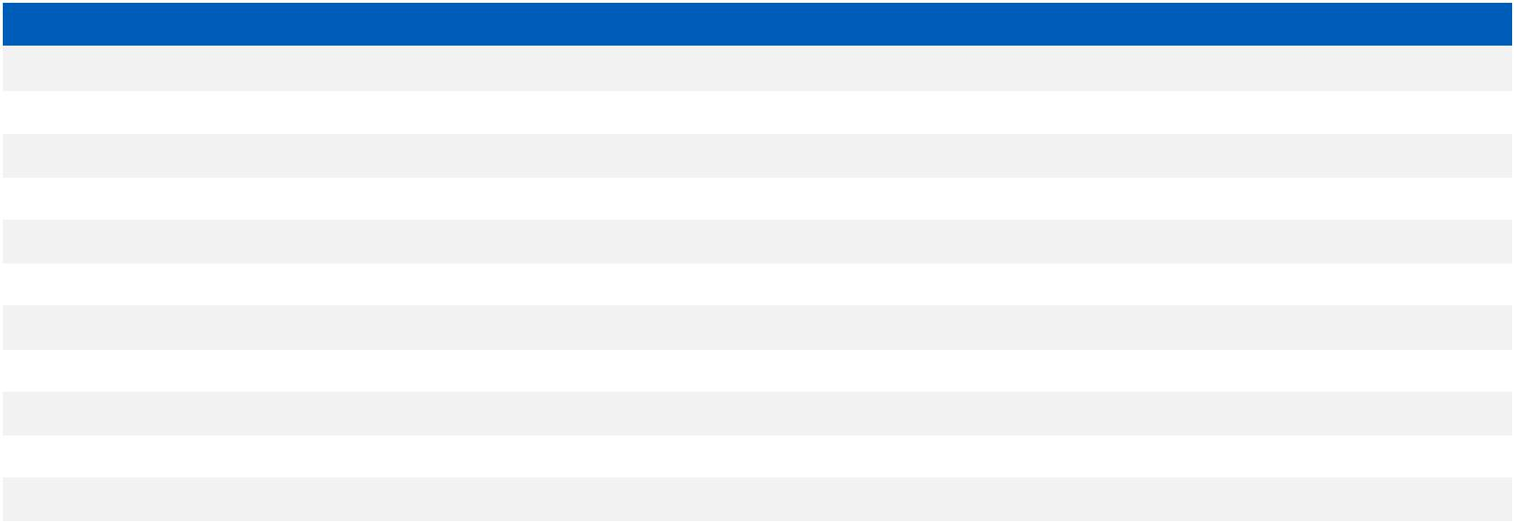

JONARD P/N | DESCRIPTION | WWK-1 | WWK-1INS | WWK-CO
G100/R3278INS | Insulated Wire Wrapping Tool |  | X | X
G200/R3278 | Lexan® Wire Wrapping Tool | X
H-1000 | Rugged Nylon 5-Pocket Tool Pouch | X | X | X
HW-UW-224 | Wrap-Unwrap Tool, 22-24 AWG | X
JIC-21257 | Telecom Long Nose Pliers |  |  | X
JIC-22035 | Probe Pick |  |  | X
JIC-2257 | Insulated Wire Loop Puller |  |  | X
KB224 | Wire Wrapping Bit, 22-24 AWG | X | X | X
P2224 | Wire Wrapping Sleeve, 22-24 AWG | X
P2224INS | Wire Wrapping Sleeve, Insulated, 22-24 AWG |  | X | X
ST-100 | Cut-Strip Tool 22-24 AWG | X | X
UW4 | Unwrap Tool, 20-26 AWG |  | X | X
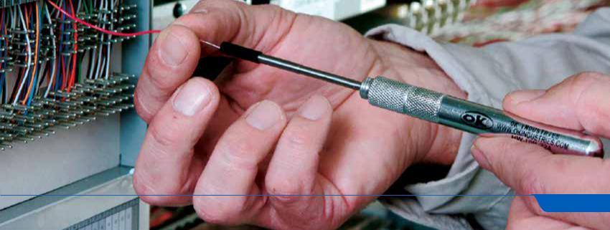

72

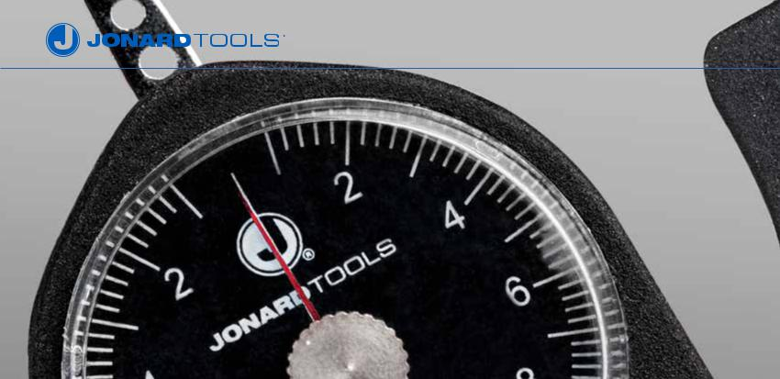

FORCE GAUGES

Jonard force gauges are all ergonomically designed and have become the industry standard for measuring force. Our 3 different lines of force gauges are used by a multitude of industries and these gauges are being used in over 1000 different applications for measuring, calibrating, standardizing, testing and evaluating.

Measurement is extremely simple. Just place point of gauge arm perpendicular to the force to be measured. Reading can be taken in both directions

- clockwise and counter clockwise. Gauges offer extreme precision and durability. The measuring springs are made of hard tempered annealed beryllium copper. All gauges equipped with maximum reading pointer.

Small Gauges

(Flat Tip, Dial Diameter 1 1/2”)
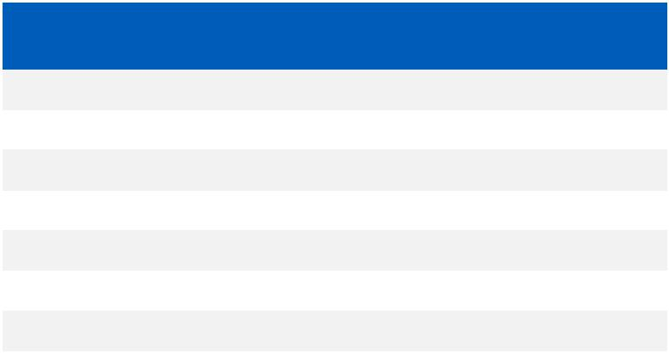

JONARD P/N | RANGE IN | GRADUATION | ACCURACY
 | GRAMS | IN GRAMS
GD-1 | 0-10 | .20 | ± .20
GD-3 | 5-35 | 1.00 | ± 1
GD-5 | 10-50 | 1.00 | ± 1
GD-10 | 20-100 | 2.00 | ± 2
GD-15 | 50-150 | 5.00 | ± 5
GD-25 | 30-250 | 10.00 | ± 10
GD-30 | 40-350 | 10.00 | ± 10

Large Gauges

(Round Tip, Dial Diameter 2 1/2”)

JONARD P/N | RANGE IN | GRADUATION | ACCURACY
 | GRAMS | IN GRAMS
GD-50 | 60-500 | 20.00 | ± 20
GD-100 | 100-1000 | 25.00 | ± 25
GD-200 | 300-2000 | 50.00 | ± 50
GD-400 | 700-4000 | 100.00 | ± 100

73

jonard.com | Force Gauges

Economy Push-Pull Tension Gauges

These high impact polystyrene cased instruments accurately measure push pull forces. Gauge is graduated in two scales: grams and ounces.

Precision springs. Full scale accuracy is held to ± 1 graduation.

Size: 1 1/2” wide x 1” deep x 14” long.
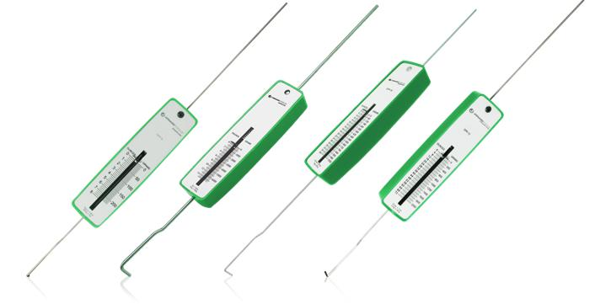

GPP-8 | GPP-15 | GPP-36 | GPP-72
Economy Push-Pull Tension Gauges
JONARD P/N |  | AVOIRDUPOIS CAPACITY |  | METRIC CAPACITY
GPP-8 |  | 8 oz. x 0.25 oz. |  | 220 g x 5 g
GPP-15 |  | 15 lb. x 4 oz. |  | 6,804 x 100 g
GPP-36 |  | 36 oz. x 0.5 oz. |  | 1,020 g x 20 g
GPP-72 |  | 72 oz. x 1 oz. |  | 2,025 g x 25 g

74

Trimpot (Pkg of 10) - AT-3767/10

Double ended Trimpot with a hex (Allen) steel .050” and 3/32” long steel screwdriver tip. Ideal for aligning, adjusting, calibrating and fine tuning of electronic circuitry, potentiometers, oscilloscopes and electronic equipment. Made of a high impact non-conductive thermoplastic material. 5” long.”

Alignment Tool (Pkg of 10) - AT-6241/10

2-in-1 non-conductive Alignment Tool 1/4” diameter, stepped down to 5/32” diameter. Ideal for most variable capacitors, coils and resistors. Also used to harness and separate fine wire terminals in computers, telephones and cables. Made of non-conductive thermoplastic material.

Clip Setter - CS-1022

For setting and withdrawing E and C clips with inside diameter of .156” min. and thickness of .025” min. Max inside diameter of 3” and thickness of .093” One end has a hook with leaf spring tension for removing the clip, the other end has leaf spring for holding clip in position to insert.

Orange Sticks

Static free double ended economical tool made of birch wood. Used for cleaning electrical components and separating contact points, fine wire and other delicate components. 3/16” diameter x 7” long. The S-389 has one end tapered to a point and the other end to a flat screwdriver type tip. The S-389M has both ends tapered with a flat screwdriver type tip.

JONARD P/N | DESCRIPTION
S-389/10 | Orange Sticks Point & Flat end Pkg of 10
S-389/100 | Orange Sticks Point & Flat end Pkg of 100
S-389M/10 | Orange Sticks 2 | Flat End Pkg of 10
S-389M/100 | Orange Sticks 2 | Flat End Pkg of 100
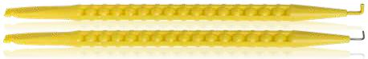

Probe Picks

Tough resilient yellow nylon probe “spudger.” One end is tapered to a 1/16” diameter point having an “L” shaped wire hook extension. The other end tapers to a flat, 3/16” wide and 1/16” thick, with 2 small notches. Used in electrical contacts. 7” long.

JONARD P/N | AVOIRDUPOIS CAPACITY
JIC-22035/10 | Insulated Probe Pick Pkg of 10
JIC-22035NT/10 | Uninsulated Probe Pick Pkg of 10

Spudger (Pkg of 10) - AT-3112/10

Plastic pencil type spudger tapered to a point on one end and screwdriver tip on other end. Used to form, shape, guide, spudge and separate fine computer wire terminals, telephone wires and cables. Also used for breaking solder bridges, probing or positioning loose components. Made of a high impact non-conductive thermoplastic material. 6” long double ended 5/16” diameter.

75

jonard.com | Alignment Tools

Alignment Tool Kit - TK-AT5
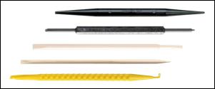

This 5 piece pocket alignment tool kit contains a selection of the most popular non-conductive tools for aligning and adjusting components.

Kit Includes:

AT-3112 Spudger

AT-3767 Trimpot

AT-6241 Alignment Tool

S-389 Orange Stick

JIC-22035 Probe Pick

Used for inserting, removing and adjusting fine springs and other small parts in tight areas. Indispensable for precision work in production and maintenance of precision products, electronics, electromechanics and even maintenance jobs. All spring hooks are tapered to a fine point. Produced of the finest quality high carbon steel with a nickel-plated finish. We will custom design Spring Hooks to meet your specific requirements.
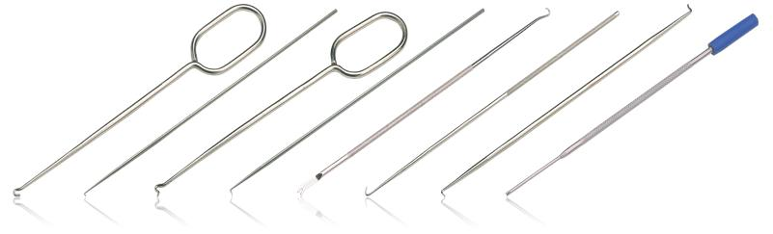

M-120 |  | M-121 | M-125 | M-126 | M-130 | M-135 | M-137 | M-145
 | Spring Hooks
 | JONARD P/N |  | DESCRIPTION |  |  | DETAILS
 | M-120/5 |  | Spring Hook, Pull, 6” (Pkg of 5) |  |  | Pull Hook with looped handle for maximum control
 | M-121/5 |  | Spring Hook, Pull, 11” (Pkg of 5) |  |  | Pull Hook for difficult to reach areas
 | M-125/5 |  | Spring Hook, Push, 6” (Pkg of 5) |  |  | Push Hook with looped handle for maximum control
 | M-126/5 |  | Spring Hook, Push, 11” (Pkg of 5) |  |  | Push Hook for difficult to reach areas
 | M-130/SX5 |  | Spring Hook, Pull & Lifter (Pkg of 5) |  |  | Pull Hook and lifter with a knurled grip
 | M-135/5 |  | Hook Pull (Pkg of 5) |  |  | Pull Hook
 | M-137/5 |  | Spring Hook, Push & Pull, 7” (Pkg of 5) |  |  | Push & Pull 2 sided Hook
 |  |  |  |  |  | Captive Spring Hook. Spring loaded hook is exposed by depressing plunger on top of
 | M-145/5 |  | Spring Hook, Captive, 7” (Pkg of 5) |  |  | tool. Internal spring retracts hook automatically. This hook is ideal for capturing small
 |  |  |  |  |  | wires, springs or parts and holding them.
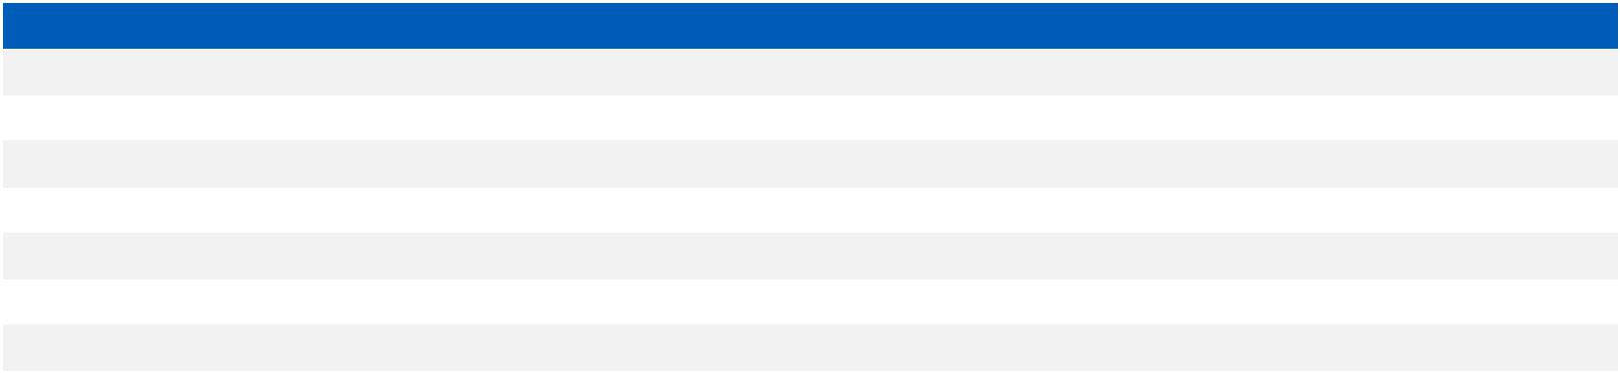

T Key Tool - JIC-719A
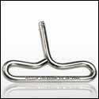

Ergonomic design hand grip T Key Tool made from a formed metal rod with a smooth tapered end which allows easier access. The solid pin at the end of the tool is a special heat treated alloy. The T Key is used to release the housing and door locking mechanism of the number 1A type coin telephone sets.

Coin Leveling Tool - JIC-139B
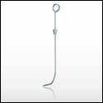

Coin Leveling Tool - JIC-139B.Coin Leveling Tool is used for leveling coins in coin collectors when the coin receptacle becomes so full as to interfere with operation of the collector. May also be used to measure the degree of fullness by means of a calibrated scale and metal slider. 7” long.

76

INDEX

FC-220 10

FCC-120 9
FCC-125 9
FCC-250 9
FCC-300 9
FCT-100 10
FCT-200 10

HS-RB ..... | 20
HW-20 ..... | 70
HW-26 ..... | 70
HW-30 ..... | 70
HW-224 ..... |  | 70
HW-UW-18-19 ..... |  |  |  | 69
HW-UW-20 ..... |  |  |  | 69

JIC-22035/10 | ..... | 75
JIC-22035NT/10 ..... |  | 75
JIC-22148 ..... | 38
JIC-50210 ..... | 40
JIC-50212 ..... | 40
JIC-63020 ..... | 37
JIC-63050 ..... | 37

#
30-B-50-010 |  | ..... 61
30-B-50-020 |  | ..... 61
30-B-50-030 |  | ..... 61
30-B-50-050 |  | ..... 61
30-R-50-010 |  | ..... 61
30-R-50-020 |  | ..... 61
30-R-50-030 |  | ..... 61
30-R-50-050 |  | ..... 61
30-W-50-010 |  | ..... 61
30-W-50-020 |  | ..... 61
30-W-50-030 |  | ..... 61
30-W-50-050 |  | ..... 61
30-Y-50-010 |  | ..... 61
30-Y-50-020 |  | ..... 61
30-Y-50-030 |  | ..... 61
30-Y-50-050 |  | ..... 61
2026UB ..... |  | 66
21881 ..... | 16
21912 ..... | 16
A
A-4598 ..... | 58
A-4599 ..... | 58
A-4600 ..... | 58
AR-910672 ..... |  | 58
ASW-12 ..... |  | 22
ASW-716 | ..... | 22
ASW-916 | ..... | 22
ASW-7916 ..... |  | 22
ASW-r12 | ..... | 22
ASW-r716 ..... |  | 22
ASWS-716 ..... |  | 22
ASWS-r716 ..... |  | 22
AT-3112/10 ..... |  | 75
AT-3767/10 ..... |  | 75
AT-6241/10 ..... |  | 75
AW-6 ..... | 45
AW-8 ..... | 45
AW-10 ..... | 45
AW-12 ..... | 45
AW-6810 | ..... | 45
B
B-3/25 ..... | 46
B-3R/25 | ..... | 46
B-7/25 ..... | 46
BCOMB ..... | 40
BLONGNOSE ..... |  | 39
BSHORTNOSE |  | ..... 39
BW-516 ..... |  | 52
BW-532 ..... |  | 52
BW-532-3 ..... |  | 52
C
CC-4 ..... | 20
CC-120 ..... | 20
CC-2721 | ..... | 31
CM-8 ..... | 26
CM-17 ..... | 26
CMI-RJ45 ..... |  | 26
CMI-SET8 ..... |  | 26
CS-1022 | ..... | 75
CSR-2 ..... | 56
CSR-1575 ..... |  | 5, 56
CSS-105 | ..... | 15

CSS-110 | ..... | 15
CSS-115 | ..... | 15
CSS-120 | ..... | 15
CSS-125 | ..... | 15
CSS-596 | ..... | 15
CSS-5097 ..... |  | 15
CSS-5110 ..... |  | 15
CSS-5127 ..... |  | 15
CSS-5610 ..... |  | 15
CST-1i ..... | 49, 56
CST-1900 ..... |  | 49, 56
CST-7915 ..... |  | 49, 56
CT-200 ..... |  | 16
CTF-180 | ..... | 16
CTF-200 | ..... | 16
CTF-200CG ..... |  | 16
CTF-230 | ..... | 16
CTF-300 | ..... | 16
CW-716 | ..... | 22
CWRR-716 ..... |  | 22
CWS-716 ..... |  | 22
D
DFB224 ..... |  | 68
DFB2426 | ..... | 68
DIABVNOTCH |  | ..... 36
DIAGB5 ..... |  | 36
DIAGB6 ..... |  | 36
DP-100 ..... |  | 60
DP-140 ..... |  | 60
DP-200 ..... |  | 60
DPT-100 | ..... | 60
DPT-200 | ..... | 60
E
EBC-400 | ..... | 32
ELONGNOSE |  | ..... 39
ENI-110 ..... |  | 50
EP-16A ..... |  | 50
EPB-66 ..... |  | 50
EPB-110 | ..... | 50
EPB-116 | ..... | 50
EPB-630 | ..... | 50
EPB-KR ..... |  | 50
EPB-KRONE ..... |  | 50
EPD-914 | ..... | 50
EPD-91461 ..... |  | 50
EPD-91466 ..... |  | 50
EPD-914110 |  | ..... 50
EPD-914116 |  | ..... 50
EPD-914630 |  | ..... 50
EPD-914KR ..... |  | 50
EPD-9KRONE |  | ..... 50
EP-QTH38B ..... |  | 51
ES-1964 | ..... | 45, 53
ES-1964DS ..... |  | 45, 53
ES-1964ERG |  | ..... 45, 53
EX-1/10 ..... |  | 59
EX-2 ..... | 59
EX-5 ..... | 59
EX-6 ..... | 59
EXT-400 | ..... | 68
F
FC-4 ..... | 10
FC-65 ..... | 10

FIM-200 | ..... | 8
FIM-400 | ..... | 8
FL-2000 | ..... | 44
FOD-2000 |  | ..... 5
FOD-RB25 |  | ..... 5
FP-600 ..... |  | 41
FP-600INS |  | ..... 41
FPM-50 ..... |  | 8
FS-616 ..... |  | 10
FT-6 ..... | 28
FT-2075 | ..... | 28
FTS-50 ..... |  | 29
FTS-240 | ..... | 29
FW-5 ..... | 10
FW-50 ..... |  | 10
G
G100-FL | ..... | 66
G100-FLA |  | ..... 66
G100/R3278 ..... |  |  | 66
G100/R3278FL ..... |  |  | 66
G100/R3278INS ..... |  |  | 66
G100/R3394CT ..... |  |  | 66
G200/R3278 ..... |  |  | 66
GD-1 ..... |  | 73
GD-3 ..... |  | 73
GD-5 ..... |  | 73
GD-10 ..... |  | 73
GD-15 ..... |  | 73
GD-25 ..... |  | 73
GD-30 ..... |  | 73
GD-50 ..... |  | 73
GD-100 ..... |  | 73
GD-200 ..... |  | 73
GD-400 ..... |  | 73
GPP-8 ..... |  | 74
GPP-15 ..... |  | 74
GPP-36 ..... |  | 74
GPP-72 ..... |  | 74
H
H-25 ..... |  | 47
H-36 ..... |  | 47
H-40 ..... |  | 47
H-50 ..... |  | 47
H-60 ..... |  | 47
H-75 ..... |  | 47
H-85 ..... |  | 47
H-90 ..... |  | 47
H-125 ..... |  | 47
H-1000 ..... |  | 47
HC-50 ..... |  | 20
HC-75 ..... |  | 20
HC-625 ..... |  | 20
HCB-50 ..... |  | 20
HCB-75 ..... |  | 20
HCB-625 | ..... | 20
HC-RB ..... |  | 20
HS-50 ..... |  | 20
HS-75 ..... |  | 20
HS-625 ..... |  | 20
HSC-50 ..... |  | 20
HSC-75 ..... |  | 20
HSC-540QR ..... |  |  | 20
HSC-625 | ..... | 20
HSC-860QR ..... |  |  | 20

HW-UW-26SM ..... |  | 69
HW-UW-30 ..... | 69
HW-UW-224 | ..... 69
HW-UW-224-1 ..... |  | 69
HW-UW-224INS ..... |  | 69
HW-UW-2426 | ..... | 69
HW-UW-2829M ..... |  | 69
I
INP-1072 ..... | 37, 41
INP-2065 ..... | 38, 41
INP-3062 ..... | 36, 41
INP-4065 ..... | 41
INS-180 ..... | 41
INS-475 ..... | 41
INS-2100 ..... | 41
INS-3150 ..... | 41
INS-4100 ..... | 41
INS-6150 ..... | 41
INS-8175 ..... | 41
J
JIC-125 ..... | 4
JIC-139B ..... | 76
JIC-175 ..... | 4
JIC-183 ..... | 53
JIC-186 ..... | 7
JIC-195 ..... | 53
JIC-200 ..... | 4
JIC-203 ..... | 38
JIC-284 ..... | 33
JIC-287 ..... | 33
JIC-375 ..... | 4
JIC-453 ..... | 36
JIC-600 ..... | 35
JIC-625 ..... | 27
JIC-650 ..... | 52
JIC-683 ..... | 37
JIC-685 ..... | 37
JIC-719A ..... | 76
JIC-725 ..... | 27
JIC-750 ..... | 27
JIC-755 ..... | 27
JIC-842 ..... | 38
JIC-891 ..... | 37
JIC-950C ..... | 51
JIC-955 ..... | 51
JIC-1022 ..... | 57
JIC-1626 ..... | 57
JIC-2030 ..... | 57
JIC-2060 ..... | 49
JIC-2257 ..... | 33
JIC-2257M ..... | 33
JIC-2257M-12 ..... |  | 33
JIC-2288 ..... | 35
JIC-2488 ..... | 35
JIC-2755 ..... | 36
JIC-3026 ..... | 38
JIC-3209 ..... | 33
JIC-3385 ..... | 40
JIC-4366 ..... | 7
JIC-4377 ..... | 7
JIC-4473 ..... | 71
JIC-5026 ..... | 40
JIC-7858 ..... | 35
JIC-21257 ..... | 38

K
KA-260 ..... | 58
KB18 ..... | 67
KB22 ..... | 67
KB22-5 ..... | 68
KB24 ..... | 67
KB24-5 ..... | 68
KB26 ..... | 67
KB26-5 ..... | 68
KB224 ..... | 67
KB224-1 ..... | 67
KB224LH ..... | 67
KB2075 ..... | 67
KB2466 ..... | 67
KB-DF224 | ..... 68
KB-DF2426 ..... |  |  | 68
KN-7 ..... | 53
KR-260 ..... | 58
KS21257L3 ..... |  |  | 39
KSS-1 ..... | 54
KSW24B-0100 ..... |  |  | 62
KSW24BLK-0100 |  |  | ..... 62
KSW24R-0100 ..... |  |  | 62
KSW24W-0100 ..... |  |  | 62
KSW24Y-0100 ..... |  |  | 62
KSW26B-0100 ..... |  |  | 62
KSW26BLK-0100 |  |  | ..... 62
KSW26R-0100 ..... |  |  | 62
KSW26W-0100 ..... |  |  | 62
KSW26Y-0100 ..... |  |  | 62
KSW28B-0100 ..... |  |  | 62
KSW28BLK-0100 |  |  | ..... 62
KSW28R-0100 ..... |  |  | 62
KSW28W-0100 ..... |  |  | 62
KSW28Y-0100 ..... |  |  | 62
KSW30B-0100 ..... |  |  | 62
KSW30B-1000 ..... |  |  | 62
KSW30BLK-0100 |  |  | ..... 62
KSW30BLK-1000 |  |  | ..... 62
KSW30G-0100 ..... |  |  | 62
KSW30G-1000 ..... |  |  | 62
KSW30R-0100 ..... |  |  | 62
KSW30R-1000 ..... |  |  | 62
KSW30W-0100 ..... |  |  | 62
KSW30W-1000 ..... |  |  | 62
KSW30Y-0100 ..... |  |  | 62
KSW30Y-1000 ..... |  |  | 62
M
M-120/5 ..... | 76
M-121/5 ..... | 76
M-125/5 ..... | 76
M-126/5 ..... | 76
M-130/SX5 ..... |  |  | 76
M-135/5 ..... | 76
M-137/5 ..... | 76
M-145/5 ..... | 76
M-216C/EX ..... |  | 52
M-216CKIT ..... |  | 52
M-216C/REX ..... |  | 52
M-216C/RX ..... |  | 52
M-216CS22 ..... |  | 52
MCT-468 ..... |  | 26
MDC-14 ..... |  | 7
MDC-64 ..... |  | 7

77

jonard.com | Index

MM-110 ..... |  |  |  | 31
MM-120 ..... |  |  |  | 31
MM-800 ..... |  |  |  | 31
MOS-1416 |  | ..... |  | 59
MOS-2428 |  | ..... |  | 59
MP-100 ..... |  |  |  | 32
MP-210 ..... |  |  |  | 32
MP-220 ..... |  |  |  | 32
MP-700 ..... |  |  |  | 32
MP-800 ..... |  |  |  | 32
MRS-24 ..... |  |  |  | 30
MRS-RH20 |  | ..... |  | 30
MS-6 ..... |  | 6
MS-26 ..... |  | 6
MS-306 ..... |  |  |  | 6
MS-306RB |  | ..... |  | 6
MS-316 ..... |  |  |  | 6
MS-316RB |  | ..... |  | 6
MS-326 ..... |  |  |  | 6
MSB-1533 |  | ..... |  | 6
MSB-2968 |  | ..... |  | 6
MSB-5010 |  | ..... |  | 6
N
ND-631 ..... |  |  |  | 44
ND-63012 |  | ..... |  | 44
ND-63014 |  | ..... |  | 44
ND-63038 |  | ..... |  | 44
ND-630316 ..... |  |  |  | 44
ND-630516 ..... |  |  |  | 44
ND-630716 ..... |  |  |  | 44
ND-6301132 |  |  |  | ..... 44
ND-SET4 ..... |  |  |  | 44
O
OB-1/3 ..... |  |  |  | 46
OB-1/12 ..... |  |  |  | 46
OB-2/12 ..... |  |  |  | 46
OB-3/12 ..... |  |  |  | 46
OB-4/12 ..... |  |  |  | 46
OK-3907-2224 ..... |  |  |  |  | 71
OK-3907-2426 ..... |  |  |  |  | 71
OK-3907-2830 ..... |  |  |  |  | 71
OK8519 | ..... |  | 67
OW-38716 |  |  | ..... 22
P
P26LN ..... |  |  | 67
P194LN ..... |  |  | 67
P2224 ..... |  |  | 67
P2224-5 | ..... |  | 68
P2224-5INS ..... |  |  |  |  | 68
P2224INS ..... |  |  | 68
P2426 ..... |  |  | 67
P2426INS ..... |  |  | 68
P2426-5 | ..... |  | 68
P2426-5INS ..... |  |  |  |  | 68
P3032 ..... |  |  | 67
P3032LN | ..... |  | 67
PB-3 ..... | 46
PB-3R ..... |  |  | 46
PB-7 ..... | 46
P-DF224 | ..... |  | 68
P-DF2426 ..... |  |  | 68
PLS-5 ..... |  |  | 39
PT-300 ..... |  |  | 26
PT-350 ..... |  |  | 26
PTX ..... | 65
PTX-1 ..... |  |  | 65
PTX-1BF | ..... |  | 65
PTX-1BFFL |  |  | ..... 65
PTX-1FL | ..... |  | 65
PTX-2 ..... |  |  | 65

PTX-2BF ..... |  | 65 |  | RST-RB25 | ..... | 5
PTX-2BFFL | ..... |  | 65 | S
PTX-2FL ..... |  | 65
PTX-B ..... | 65 |  |  | S-339 ..... |  | 59
PTX-BC1 ..... |  |  | 65 | S-340 ..... |  | 59
PTX-BC2 ..... |  |  | 65 | S-389/10 | ..... | 75
PTXFL ..... | 65 |  |  | S-389/100 |  | ..... 75
PTX-FLA ..... |  | 65 |  | S-389M/10 |  | ..... 75
PTX-KIT1 ..... |  |  | 65 | S-389M/100 ..... |  |  | 75
PTX-KIT1DH | ..... |  | 65 | SA-9-115 | ..... | 60
PTX-KIT1DHFL |  |  | ..... 65 | SA-9-E-115 |  | ..... 60
PTX-KIT1FL | ..... |  | 65 | SA-91 ..... |  | 60
PTX-KIT2 ..... |  |  | 65 | SA-91-E ..... |  | 60
PTX-KIT2DH | ..... |  | 65 | SAF-1 ..... |  | 60
PTX-KIT2DHFL |  |  | ..... 65 | SAK-90 ..... |  | 60
PTX-KIT2FL | ..... |  | 65 | SB30MSH-B ..... |  |  | 67
PUW2226 ..... |  |  | 66 | SB-224 ..... |  | 71
R |  |  |  | SB-2224 ..... |  | 71
 |  |  |  | SB-2426 ..... |  | 71
R24B-0100 | ..... |  | 61 | SB-2830 ..... |  | 71
R24BLK-0100 |  |  | ..... 61 | SD-00/10 | ..... | 42
R24R-0100 | ..... |  | 61 | SD-61 ..... |  | 42
R24W-0100 |  | ..... | 61 | SD-63 ..... |  | 42
R24Y-0100 | ..... |  | 61 | SD-080/10 |  | ..... 42
R26B-0100 | ..... |  | 61 | SD-243 ..... |  | 42
R26BLK-0100 |  |  | ..... 61 | SD-1223 ..... |  | 42
R26R-0100 | ..... |  | 61 | SDC-144 ..... |  | 43
R26W-0100 |  | ..... | 61 | SDC-3163 | ..... | 43
R26Y-0100 | ..... |  | 61 | SDC-3166 | ..... | 43
R28B-0100 | ..... |  | 61 | SDC-3810 | ..... | 43
R28BLK-0100 |  |  | ..... 61 | SDC-5166 | ..... | 43
R28R-0100 | ..... |  | 61 | SDK-8 ..... |  | 44
R28W-0100 |  | ..... | 61 | SDP-1 ..... |  | 43
R28Y-0100 | ..... |  | 61 | SDP-2 ..... |  | 43
R-30B-0050 |  | ..... | 62 | SDP-2 ..... |  | 44
R30B-0100 | ..... |  | 61 | SDP-3 ..... |  | 43
R30B-1000 | ..... |  | 61 | SDP-3 ..... |  | 44
R30BLK-0100 |  |  | ..... 61 | SDP-28 ..... |  | 43
R30BLK-1000 |  |  | ..... 61 | SDR-24 ..... |  | 43
R30G-0100 | ..... |  | 61 | SDR-34 ..... |  | 43
R30G-1000 | ..... |  | 61 | SD-RB1 ..... |  | 42
R-30R-0050 |  | ..... | 62 | SD-RB2 ..... |  | 42
R30R-0100 | ..... |  | 61 | SD-RB3 ..... |  | 42
R30R-1000 | ..... |  | 61 | SDS-142 ..... |  | 43
R-30-TRI ..... |  |  | 62 | SDSC-14 ..... |  | 43
R-30W-0050 |  | ..... | 62 | SDSP-2 ..... |  | 43
R30W-0100 |  | ..... | 61 | SK-51632 | ..... | 52
R30W-1000 |  | ..... | 61 | SOK2230 ..... |  | 66
R-30Y-0050 |  | ..... | 62 | SP-4 ..... | 46
R30Y-0100 | ..... |  | 61 | SSK-70 ..... |  | 25
R30Y-1000 | ..... |  | 61 | SSK-75 ..... |  | 25
R-4601 ..... |  | 58 |  | SSK-80 ..... |  | 25
R-4602 ..... |  | 58 |  | SSK-85 ..... |  | 25
R-5926 ..... |  | 58 |  | SSK-90 ..... |  | 25
R-9461 ..... |  | 58 |  | SSK-700 ..... |  | 25
RB-287/6 ..... |  |  | 33 | SSK-716 ..... |  | 25
RB-2060/6 | ..... |  | 7, 49 | SSK-750 ..... |  | 25
RB-2257/6 ..... |  |  | 33 | SSK-800 ..... |  | 25
RB-2878/6 | ..... |  | 7 | SSK-850 ..... |  | 25
RBNC-12 ..... |  |  | 28 | SSK-876 ..... |  | 25
RC-600 ..... |  | 40 |  | SSK-900 ..... |  | 25
RCS-25 ..... |  | 5, 56 |  | SSK-950 ..... |  | 25
RCS-25RB ..... |  |  | 56 | SST-716 ..... |  | 28
RDC-35 ..... |  | 29 |  | SST-716AT |  | ..... 28
RDG-15 ..... |  | 30 |  | SST-916 ..... |  | 28
RDG-30 ..... |  | 30 |  | ST-100 ..... |  | 71
RDG-RP4 ..... |  | 30 |  | ST-100-2426 ..... |  |  | 71
RDK-5 ..... | 29 |  |  | ST-100-2830 ..... |  |  | 71
RDT-3RH ..... |  |  | 29 | ST-450 ..... |  | 57
RDT-18K ..... |  |  | 29 | ST-500 ..... |  | 57
RF-12 ..... | 28 |  |  | ST-500ESD |  | ..... 57
RF-18 ..... | 28 |  |  | ST-550 ..... |  | 57
RST-8514 ..... |  |  | 5

T
TEP-200 ..... |  | 27
TET-6 ..... |  | 27
TET-700 ..... |  | 27
TETP-900 | ..... | 27
TK-17 ..... |  | 55
TK-19 ..... |  | 46
TK-50 ..... |  | 54
TK-70INS | ..... | 41
TK-78 ..... |  | 19
TK-78E ..... |  | 19
TK-82 ..... |  | 19
TK-83 ..... |  | 19
TK-85 ..... |  | 19
TK-87 ..... |  | 19
TK-89 ..... |  | 19
TK-110INS |  | ..... 41
TK-120 ..... |  | 12
TK-150 ..... |  | 12
TK-160 ..... |  | 12
TK-170 ..... |  | 12
TK-186 ..... |  | 11
TK-188 ..... |  | 11
TK-189 ..... |  | 11
TK-325 ..... |  | 11
TK-350 ..... |  | 11
TK-375 ..... |  | 11
TK-400 ..... |  | 54
TK-610 ..... |  | 55
TK-822 ..... |  | 18
TK-22148 | ..... | 54
TK-AT5 ..... |  | 76
TKC-70 ..... |  | 41
TKC-110 ..... |  | 41
TS-850 ..... |  | 39
TSAB-40 ..... |  | 13
TSFB-125 | ..... | 13
TSPE-125 | ..... | 13
TSPF-125 | ..... | 13
TSUC-40 ..... |  | 13
TSUC-510 | ..... | 13
TSUC-512 | ..... | 13
TSUC-516 | ..... | 13
TSUC-518 | ..... | 13
TSUC-5000 |  | ..... | 13
TT-4 ..... | 23
TT-7 ..... | 23
TT-7PT ..... |  | 23
TT-7V ..... |  | 23
TT-812 ..... |  | 24
TTB-6 ..... |  | 24
TTCG-6270-5 ..... |  |  | 23
TTCG-6270-9 ..... |  |  | 23
TTK-225 ..... |  | 24
TT-PPLTT4 |  | ..... 24
TTS-716 ..... |  | 24
TWAF-1130 ..... |  |  | 21
TWAF-1220 ..... |  |  | 21
TWAF-71620 ..... |  |  | 21
TWAF-71625 ..... |  |  | 21
TWAF-71630 ..... |  |  | 21
TWAF-71640 ..... |  |  | 21
TWAF-91620 ..... |  |  | 21
TWAF-91630 ..... |  |  | 21
TWAF-91640 ..... |  |  | 21
TWAFST-71622 ..... |  |  | 21
TWAFST-71630 ..... |  |  | 21
TWAS-71620 ..... |  |  | 21
TWAS-71630 ..... |  |  | 21
TWS-38/10 |  | ..... | 20
TWS-532/10 ..... |  |  | 49
TWSW-10 | ..... | 49
TWSW-10SK ..... |  |  | 49

TWSW-40 | ..... | 20
U
UC-864 ..... |  | 17, 51
UC-866 ..... |  | 17, 51
UC-4568 ..... |  | 17, 51
UC-8000 ..... |  | 8, 17
UC-8012 ..... |  | 17
UC-8039 ..... |  | 8
UCD-2045 | ..... | 17
UCD-2685 | ..... | 8
UST-100 ..... |  | 15
UST-125 ..... |  | 15
UST-150 ..... |  | 15
UST-175 ..... |  | 15
UST-185 ..... |  | 15
UST-205 ..... |  | 15
UST-210 ..... |  | 15
UST-215 ..... |  | 15
UST-220 ..... |  | 15
UST-225 ..... |  | 15
UST-230 ..... |  | 15
UST-500 ..... |  | 15
UST-525 ..... |  | 15
UST-596 ..... |  | 15
UST-1596 | ..... | 15
UW1 ..... | 69
UW2 ..... | 69
UW4 ..... | 69
UW5 ..... | 69
UW093R ..... |  | 69
UW2832C | ..... | 69
UWD93-93 ..... |  | 69
V
VFL-25 ..... |  | 8
VFL-150 ..... |  | 8
VFL-25125 ..... |  | 8
VT-1000 ..... |  | 26
W
WB24DH ..... |  | 67
WB24SM ..... |  | 67
WB26SM ..... |  | 67
WB28SHM | ..... | 67
WB224M ..... |  | 67
WB2275M | ..... | 67
WB2426M | ..... | 67
WB2669M | ..... | 67
WB3032M | ..... | 67
WB3032MIL |  | ..... 67
WBK-100 | ..... | 32
WD-30-B | ..... | 62
WD-30-R | ..... | 62
WD-30-TRI ..... |  | 62
WD-30-W | ..... | 62
WD-30-Y ..... |  | 62
WDUD-26DS |  | ..... 69
WK-7 ..... | 59
WRC-14 ..... |  | 40
WS-5 ..... | 57
WSA-1024 ..... |  | 45
WSA-1024RB ..... |  |  | 45
WSA-1430 ..... |  | 45
WSA-1430RB ..... |  |  | 45
WSU-24M | ..... | 70
WSU-26M | ..... | 70
WSU-30 ..... |  | 70
WSU-30M | ..... | 70
WSU-2224 ..... |  | 70
WWK-1 ..... |  | 72
WWK-1INS ..... |  | 72
WWK-CO ..... |  | 72

78

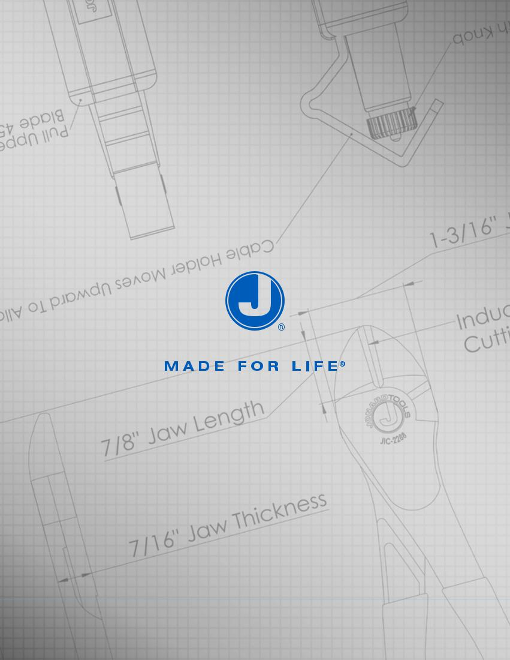

79

