App HTanalysis™ - HTCloud™ Pag. 2

Solution for industry Pag. 4

Professional TRMS multimeters Pag. 6

Digital multimeters Pag. 8

App HT Sales Pag. 8

Clamp meters Pag. 10

Power quality analyzers Pag. 12

Data loggers Pag. 13

Tablet AnalysisTAB2 Pag. 13

Electrical installation safety testers Pag. 14

Accessory for loop impedance measurement

with high resolution Pag. 16

Earth resistance and step/contact voltage

measuring devices Pag. 17

RCD and Loop verification devices Pag. 18

Insulation and continuity measuring devices................ Pag. 19
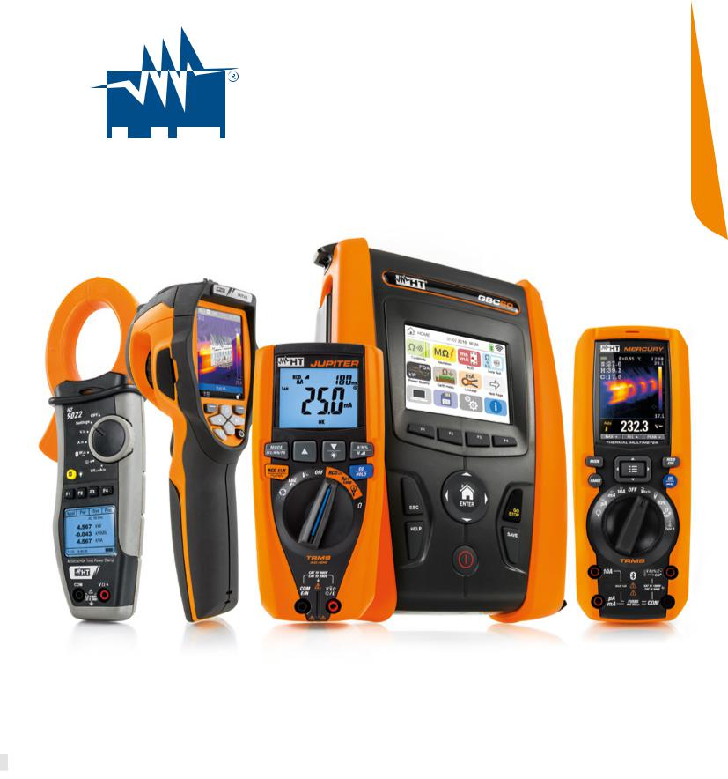

Switchboards and machine safety testers................... Pag. 20

Verification photovoltaic field...................................... Pag. 21

Process calibrators.................................................... Pag. 24

Infrared thermal cameras........................................... Pag. 25

Thermometers and thermo-anemometers................... Pag. 28

Sound level meters.................................................... Pag. 29

Light meters and solar meters.................................... Pag. 30

Devices for lan network verification............................ Pag. 31

Phase detectors, switch detectors and phase

sequence indicators................................................... Pag. 32

Laser meters............................................................. Pag. 33

Lamps...................................................................... Pag. 34

Scissors.................................................................... Pag. 35

HTANALYSIS
Artificial Intelligence.

With the latest-generation HT devices and the HTanalysis App it is possible to interface with tablets and smartphones. The HTanalysis App allows transferring, displaying and analysing data on your mobile device. Professional report generation is eased with inclusion of images, videos, text and voice notes. Sharing is simplified, with the HTCloud database sharing worldwide or within the same office is free and easy.

WITH WITH
GSC60, MacroTestG3, G2, G1 GSC60, PQA820, PQA819

and CombiG2 and HT9022*

Safety first and always

Further to carrying out their function, devices for electric measurement must focus on the operator’s safety as a basic requirement. At HT labs, we take safety into account in all our design decisions.

HT laboratories adhere to the most stringent safety and production quality regulations.

IEC/EN 61010-1 consists of precise rules for electric devices used for measurements in low voltage (<1000VAC, <1500VDC). There are four Measurement Categories (also called Overvoltage Categories), which define the protection level against voltage spikes of each device according to the proximity to the power source. Devices in the highest category require robust internal protection as they can operate nearest to the power source. A short description is outlined below:

M E A S U R E M E N T C A T E G O R Y

- Generate reports complete with photos, videos, text and voice notes.

- Archive reports in the HTCloud database.

WITH
SOLAR I-Ve, I-V 500w and I-V400w

- Display and analyze the I-V curves downloaded from the instrument, attach photos, videos, text and voice notes.

- Display voltage, current, power, harmonics, THD%, cosphi and frequency.

- Observe in real time all waveforms, vector diagrams and harmonics.

- Archive readings in the HTCloud database.

*Only compatible with Android

Available on the Available on the

TYPE OF MEASUREMENT | TYPE OF MEASUREMENT | TYPE OF MEASUREMENT | TYPE OF MEASUREMENT
Measurements carried out on | Measurements carried out on | Measurements carried out | Measurements carried out on a
circuits not directly connected | circuits directly connected | on installations inside | source of a low-voltage
to the distribution mains | to the low-voltage installation | buildings | installation
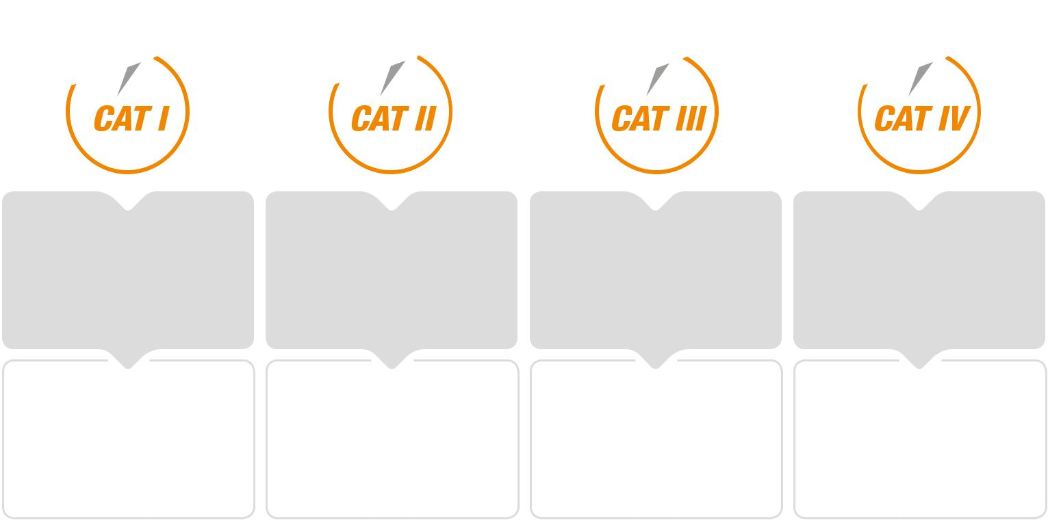

APPLICATION | APPLICATION | APPLICATION | APPLICATION
Household | Household | Distribution panels, | Electricity meters, measurements
devices, measurements on | devices, | wirings, switches, sockets | on primary overcurrent protection
circuits | mobile devices and similar | in fixed installations, electric | devices, ripple control units.
not derived from mains |  | motors, industrial devices

Why use TRMS devices?

In a modern home, business or industrial installation, we often experience “non-linear loads” (e.g. computer networks, variable speed devices, switching suppliers, etc). These loads contribute to deforming the power source from the traditional sinusoidal waveform typical of “linear” loads (consisting in resistors, inductances and capacitances). Non-TRMS measuring devices (multimeters and clamp meters) for alternating voltage and current display the “average-value” thus missing voltage and current irregularities caused by non-linear loads.

HTCLOUD
Share everything.

When, how and where you like.

Install the HTanalysis App to access the HTCloud

database to archive and share measured

and recorded data with colleagues and partners

from all around the world.

To measure installations that contain non-linear loads, we must capture higher order harmonic components that cause the distortion. Using TRMS (True Root Mean Square) devices provide visibility into the power source beyond the 50 or 60 Hz fundamental to the bandwidth of the instrument.

Therefore, given the presence of non-linear devices in our homes, work and factories the use of TRMS measuring device is in order to obtain reliable reading values of the measured quantities.

2 3

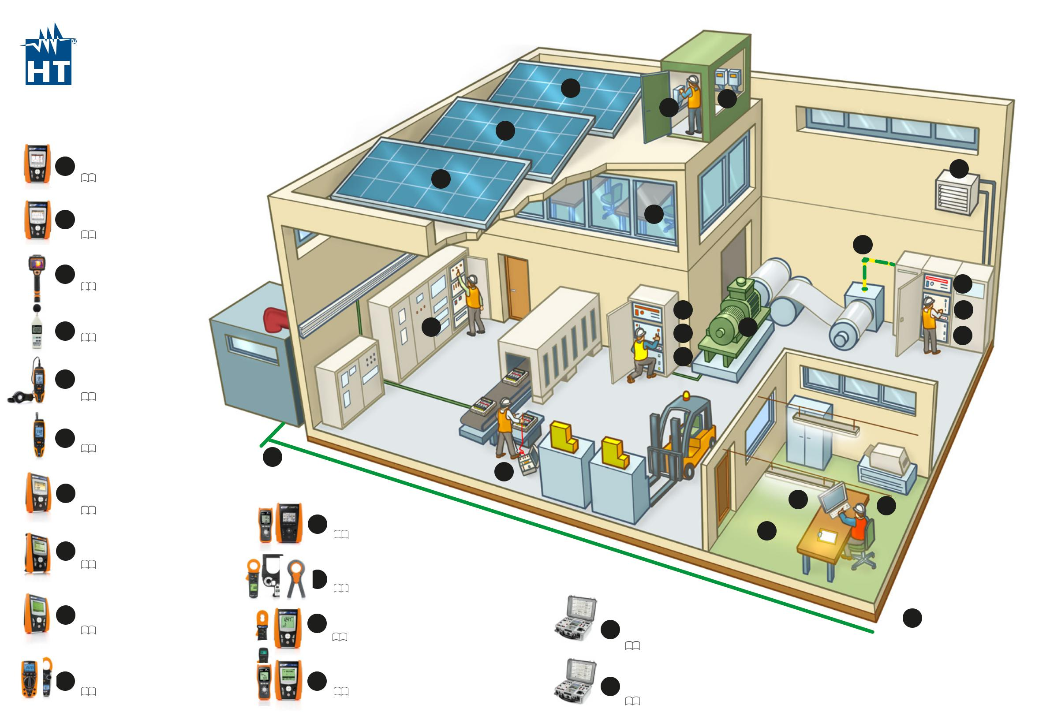
SOLUTION
FOR INDUSTRY
7c

 |  |  | 7a | 7c
 |  |  | 7b
 | PROFESSIONAL
1 | POWER QUALITY
 | ANALYZERS |  |  | 6
 | Page 12 |  | 3
2 | POWER QUALITY ANALYZERS |  | 4
 | AND DATA LOGGERS
 | Page 12 - 13 - 14 |  |  | 9b
3 | CAMERAS^{IR} |  |  | 2
 | Page 25
 | SOUND |  | 3 | 11
4
 | LEVEL METERS | 1 | 8 | 3
 | Page 29 |  |  | 9a
 |  |  | 12

- ^{ILLUMINANCE}_{METERS}

Page 30

 | ENVIRONMENT
6 | PARAMETER ANALYZERS
 | Page 28
 |  |  |  |  |  | 10 |  |  | 13
 | PV INSTALLATION TESTERS
7a
 | (EFFICIENCY MEASUREMENTS |  |  |  |  |  |  |  |  |  | 5
 | AND YIELD ANALYSIS) |  |  |  |  |  |  |  |  |  |  | 4
 | Page 21 |  |  |  |  |  |  | INSTALLATION
 |  |  |  |  |  |  | 9a
 |  |  |  |  |  |  |  | SAFETY TESTERS |  |  | 6
 |  |  |  |  |  |  |  | Page 14 - 15
 | PV INSTALLATION TESTERS
7b
 | (TROUBLESHOOTING)
 | Page 21 |  |  |  |  |  |  | LEAKAGE CURRENT
 |  |  |  |  |  |  | 9b | TESTERS
 |  |  |  |  |  |  |  | Page 6 - 11 - 14 - 15
7c | PV INSTALLATION TESTERS |  |  |  |  |  |  | EARTH GROUND |  | SWITCHGEAR |  |  |  |  |  | 10
 | (COMMISSIONING TESTS) | 10
 | Page 21 |  |  |  |  |  |  | RESISTANCE TESTERS | 12 | AND SWITCHBOARD
 |  |  |  |  |  |  |  | Page 14 - 17 |  | SAFETY TESTERS
 |  |  |  |  |  |  |  |  |  | Page 15
8 | DMMS |  |  |  |  |  |  | INSULATION |  | ELECTRICAL
 | AND CLIP-CLAMPS |  |  |  |  |  | 11 RESISTANCE TESTERS |  | 13 | MACHINERY
 | Page 6 - 7 - 8 - 9 - 10 - 11 |  |  |  |  |  |  | Page 19 |  | SAFETY TESTERS
 |  |  |  |  |  |  |  |  |  | Page 15

4 5

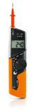  PROFESSIONAL |  |  |  |  |  |  |  |  |  |  |  |  |  |  |  |  |  |  |  |  |  |  | NEW |  | NEW
TRMS
MULTIMETERS
Scan the QR code
to discover our whole
line of accessories. |  |  |  |  |  |  |  |  |  |  |  |  | HT64 |  | HT63 |  | HT62 |  | HT61 |  | HT60 |  | JUPITER |  | MERCURY |  | FLASHMETER |  | IRONMETER |  | HT39 |  | HT37 |  | HT701 |  | HT401 |  | HT712
MAIN MEASUREMENTS |  |  |  |  |  |  |  |  |  |  |  |  |  |  |  | PROFESSIONAL TRMS MULTIMETERS |  |  |  |  |  |  |  |  |  |  |  |  |  |  | PROFESSIONAL TRMS MULTIMETERS
TRMS |  |  |  |  |  |  |  |  |  |  |  |  | • |  | • |  | • |  | • |  | • |  | • |  | • |  | • |  | • |  | • |  | • |  | • |  | • |  | •
AC/DC voltage |  |  |  |  |  |  |  |  |  |  |  |  | • AC+DC |  | • |  | • |  | • |  | • |  | • AC+DC |  | • AC+DC |  | • |  | • |  | • |  | • |  | • |  | • AC+DC |  | •
AC/DC voltage with low impedance (LoZ) |  |  |  |  |  |  |  |  |  |  |  |  | • |  | • |  | • |  | • |  | • |  | • |  | - |  | - |  | - |  | - |  | - |  | - |  | • AC |  | -
AC/DC current with external transducer |  |  |  |  |  |  |  |  |  |  |  |  | • |  | • |  | - |  | - |  | - |  | • Inrush |  | • AC+DC |  | - |  | - |  | - |  | - |  | - |  | - |  | -
AC/DC current with leads |  |  |  |  |  |  |  |  |  |  |  |  | • AC+DC |  | • AC+DC |  | • |  | • |  | - |  | - |  | • |  | - |  | • |  | • |  | • |  | • |  | • AC+DC |  | -
4-20mA% reading |  |  |  |  |  |  |  |  |  |  |  |  | • |  | • |  | - |  | - |  | - |  | - |  | - |  | - |  | - |  | - |  | - |  | - |  | - |  | -
Frequency |  |  |  |  |  |  |  |  |  |  |  |  | • |  | • |  | • |  | • |  | • |  | • |  | • |  | - |  | • |  | • |  | • |  | • |  | • |  | •
Resistance |  |  |  |  |  |  |  |  |  |  |  |  | • |  | • |  | • |  | • |  | • |  | • |  | • |  | • |  | • |  | • |  | • |  | • |  | • |  | •
Continuity with buzzer |  |  |  |  |  |  |  |  |  |  |  |  | • |  | • |  | • |  | • |  | • |  | • |  | • |  | • |  | • |  | • |  | • |  | • |  | • |  | •
Capacitance |  |  |  |  |  |  |  |  |  |  |  |  | • |  | • |  | • |  | - |  | • |  | - |  | • |  | - |  | • |  | • |  | • |  | • |  | • |  | -
Diode test |  |  |  |  |  |  |  |  |  |  |  |  | • |  | • |  | • |  | • |  | • |  | - |  | • |  | - |  | • |  | • |  | • |  | • |  | • |  | -
Duty Cycle (%) |  |  |  |  |  |  |  |  |  |  |  |  | • |  | • |  | • |  | • |  | • |  | - |  | • |  | - |  | • |  | • |  | • |  | - |  | - |  | -
Temperature with K-type probe |  |  |  |  |  |  |  |  |  |  |  |  | • |  | • |  | • |  | - |  | • |  | - |  | • |  | - |  | - |  | - |  | - |  | • |  | • |  | -
Insulation measurement (50,100,250,500,1000VDC) |  |  |  |  |  |  |  |  |  |  |  |  | - |  | - |  | - |  | - |  | - |  | - |  | - |  | - |  | - |  | - |  | - |  | • |  | - |  | -
Phase sequence and concordance |  |  |  |  |  |  |  |  |  |  |  |  | - |  | - |  | - |  | - |  | - |  | • |  | - |  | - |  | - |  | - |  | - |  | - |  | - |  | •
Built-in LED torch |  |  |  |  |  |  |  |  |  |  |  |  | - |  | - |  | - |  | - |  | - |  | - |  | • |  |  |  | • |  | - |  | - |  | - |  | - |  | -
Test on A and AC general RCDs |  |  |  |  |  |  |  |  |  |  |  |  | - |  | - |  | - |  | - |  | - |  | • |  | - |  | - |  | - |  | - |  | - |  | - |  | - |  | -
L-L,L-N,L-PE, RA loop impedance |  |  |  |  |  |  |  |  |  |  |  |  | - |  | - |  | - |  | - |  | - |  | • |  | - |  | - |  | - |  | - |  | - |  | - |  | - |  | -
Voltage/Current harmonics + THD% |  |  |  |  |  |  |  |  |  |  |  |  | - |  | - |  | - |  | - |  | - |  | • |  | - |  | - |  | - |  | - |  | - |  | - |  | - |  | -
ADDITIONAL CHARACTERISTICS
Measurement category |  |  |  |  |  |  |  |  |  |  |  |  | CAT IV 600V |  | CAT IV 600V |  | CAT IV 600V |  | CAT IV 600V |  | CAT IV 600V |  | CAT IV 600V |  | CAT IV 600V |  | CAT IV 600V |  | CAT III 600V |  | CAT IV 600V |  | CAT IV 600V |  | CAT IV 600V |  | CAT IV 600V |  | CAT IV 600V
 |  |  |  |  |  |  |  |  |  |  |  |  |  |  |  |  |  |  |  |  |  |  | CAT III 690V |  | CAT III 1000V |  |  |  |  |  | CAT III 1000V |  | CAT III 1000V |  | CAT III 1000V |  | CAT III 1000V
Measuring counts |  |  |  |  |  |  |  |  |  |  |  |  | 6000 |  | 60.000 |  | 6000 |  | 6000 |  | 4000 |  | 9999 |  | 6000 |  | 4000 |  | 4000 |  | 4000 |  | 4000 |  | 10000 |  | 6000 |  | 4000
Backlight |  |  |  |  |  |  |  |  |  |  |  |  | • |  | • |  | • |  | • |  | • |  | • |  | • |  | • |  | • |  | • |  | - |  | • |  | • |  | -
IR sensor resolution |  |  |  |  |  |  |  |  |  |  |  |  | - |  | - |  | - |  | - |  | - |  | - |  | • 80 x 80 pxl |  | - |  | - |  | - |  | - |  | - |  | - |  | -
Bluetooth |  |  |  |  |  |  |  |  |  |  |  |  | - |  | - |  | - |  | - |  | - |  | - |  | • with APP HTMercury |  | - |  | - |  | - |  | - |  | - |  | - |  | -
Bargraph |  |  |  |  |  |  |  |  |  |  |  |  | • |  | • |  | • |  | • |  | - |  | • |  | • |  | - |  | - |  | • |  | • |  | • |  | • |  | -
Autorange |  |  |  |  |  |  |  |  |  |  |  |  | • |  | • |  | • |  | • |  | • |  | • |  | • |  | - |  | • |  | • |  | • |  | • |  | • |  | •
Auto power off |  |  |  |  |  |  |  |  |  |  |  |  | • |  | • |  | • |  | • |  | • |  | • |  | • |  | • |  | • |  | • |  | • |  | • |  | • |  | •
Detection of AC voltage without contact |  |  |  |  |  |  |  |  |  |  |  |  | - |  | - |  | - |  | - |  | - |  | - |  | • |  | • |  | - |  | - |  | - |  | - |  | • |  | -
Data HOLD function |  |  |  |  |  |  |  |  |  |  |  |  | • |  | • |  | • |  | • |  | • |  | • |  | • |  | • |  | • |  | • |  | • |  | • |  | • |  | •
MIN/MAX/AVG functions |  |  |  |  |  |  |  |  |  |  |  |  | • |  | • MIN/MAX |  | • MIN/MAX |  | • MIN/MAX |  | - |  | • MIN/MAX |  | • MIN/MAX |  | - |  | • MIN/MAX |  | • MIN/MAX |  | • MIN/MAX |  | • |  | • MIN/MAX |  | -
PEAK function |  |  |  |  |  |  |  |  |  |  |  |  | • (1ms) |  | • (1ms) |  | - |  | - |  | - |  | • (1ms) |  | • |  | - |  | - |  | • |  | • |  | - |  | • |  | -
Automatic recognition of AC/DC |  |  |  |  |  |  |  |  |  |  |  |  | - |  | - |  | - |  | - |  | - |  | • |  | - |  | • |  | - |  | - |  | - |  | - |  | - |  | •
Automatic recognition of internal functions |  |  |  |  |  |  |  |  |  |  |  |  | - |  | - |  | - |  | - |  | - |  | - |  | - |  | • |  | - |  | - |  | - |  | - |  | - |  | -
Relative measurement |  |  |  |  |  |  |  |  |  |  |  |  | • |  | • |  | • |  | • |  | • |  | - |  | • |  | - |  | - |  | • |  | • |  | • |  | - |  | -
Data logger and graph |  |  |  |  |  |  |  |  |  |  |  |  | • |  | - |  | - |  | - |  | - |  | - |  | • |  | - |  | - |  | • (through SW) |  | - |  | - |  | - |  | -
Memory for data saving |  |  |  |  |  |  |  |  |  |  |  |  | • |  | - |  | - |  | - |  | - |  | - |  | • (micro SD card) |  | - |  | - |  | - |  | - |  | • |  | - |  | -
Power supply |  |  |  |  |  |  |  |  |  |  |  |  | 1x7.4V rechargeable |  | 4x 1.5V AAA |  | 1x 9V 6F22 |  | 1x 9V 6F22 |  | 1x 9V 6F22 |  | 4x 1.5V AAA |  | 1x7.4V rechargeable |  | 2x 1.5V AAA |  | 2x 1.5V AAA |  | 1x 9V 6F22 |  | 1x 9V 6F22 |  | 4x 1.5V AA |  | 1x 9V 6F22 |  | 2x 1.5V AAA
 |  |  |  |  |  |  |  |  |  |  |  |  | Li-ION battery |  |  |  |  |  |  |  |  |  |  |  | Li-ION battery
Size in mm (L x W x H) |  |  |  |  |  |  |  |  |  |  |  |  | 175x85x55 |  | 175x85x55 |  | 175x85x55 |  | 175x85x55 |  | 175x85x55 |  | 175x85x55 |  | 190x75x55 |  | 135x75x40 |  | 120x85x45 |  | 164x82x44 |  | 164x82x44 |  | 207x95x52 |  | 190x94x48 |  | 250x51x30
Weight in grams |  |  |  |  |  |  |  |  |  |  |  |  | 400 |  | 400 |  | 400 |  | 400 |  | 400 |  | 420 |  | 555 |  | 220 |  | 200 |  | 400 |  | 400 |  | 630 |  | 460 |  | 150
Safety |  |  |  |  |  |  |  |  |  |  |  |  | IEC/EN61010-1 |  | IEC/EN61010-1 |  | IEC/EN61010-1 |  | IEC/EN61010-1 |  | IEC/EN61010-1 |  | IEC/EN61010-1 |  | IEC/EN61010-1 |  | IEC/EN61010-1 |  | IEC/EN61010-1 |  | IEC/EN61010-1 |  | IEC/EN61010-1 |  | IEC/EN61010-1 |  | IEC/EN61010-1 |  | IEC/EN61010-1
Order code |  |  |  |  |  |  |  |  |  |  |  |  | HR000010 |  | HR000001 |  | HR000002 |  | HR000003 |  | HR000004 |  | HR00JUPI |  | HR000MER |  | HR000011 |  | HR000005 |  | HR000039 |  | HR000037 |  | HR000701 |  | HR000401 |  | HR000712
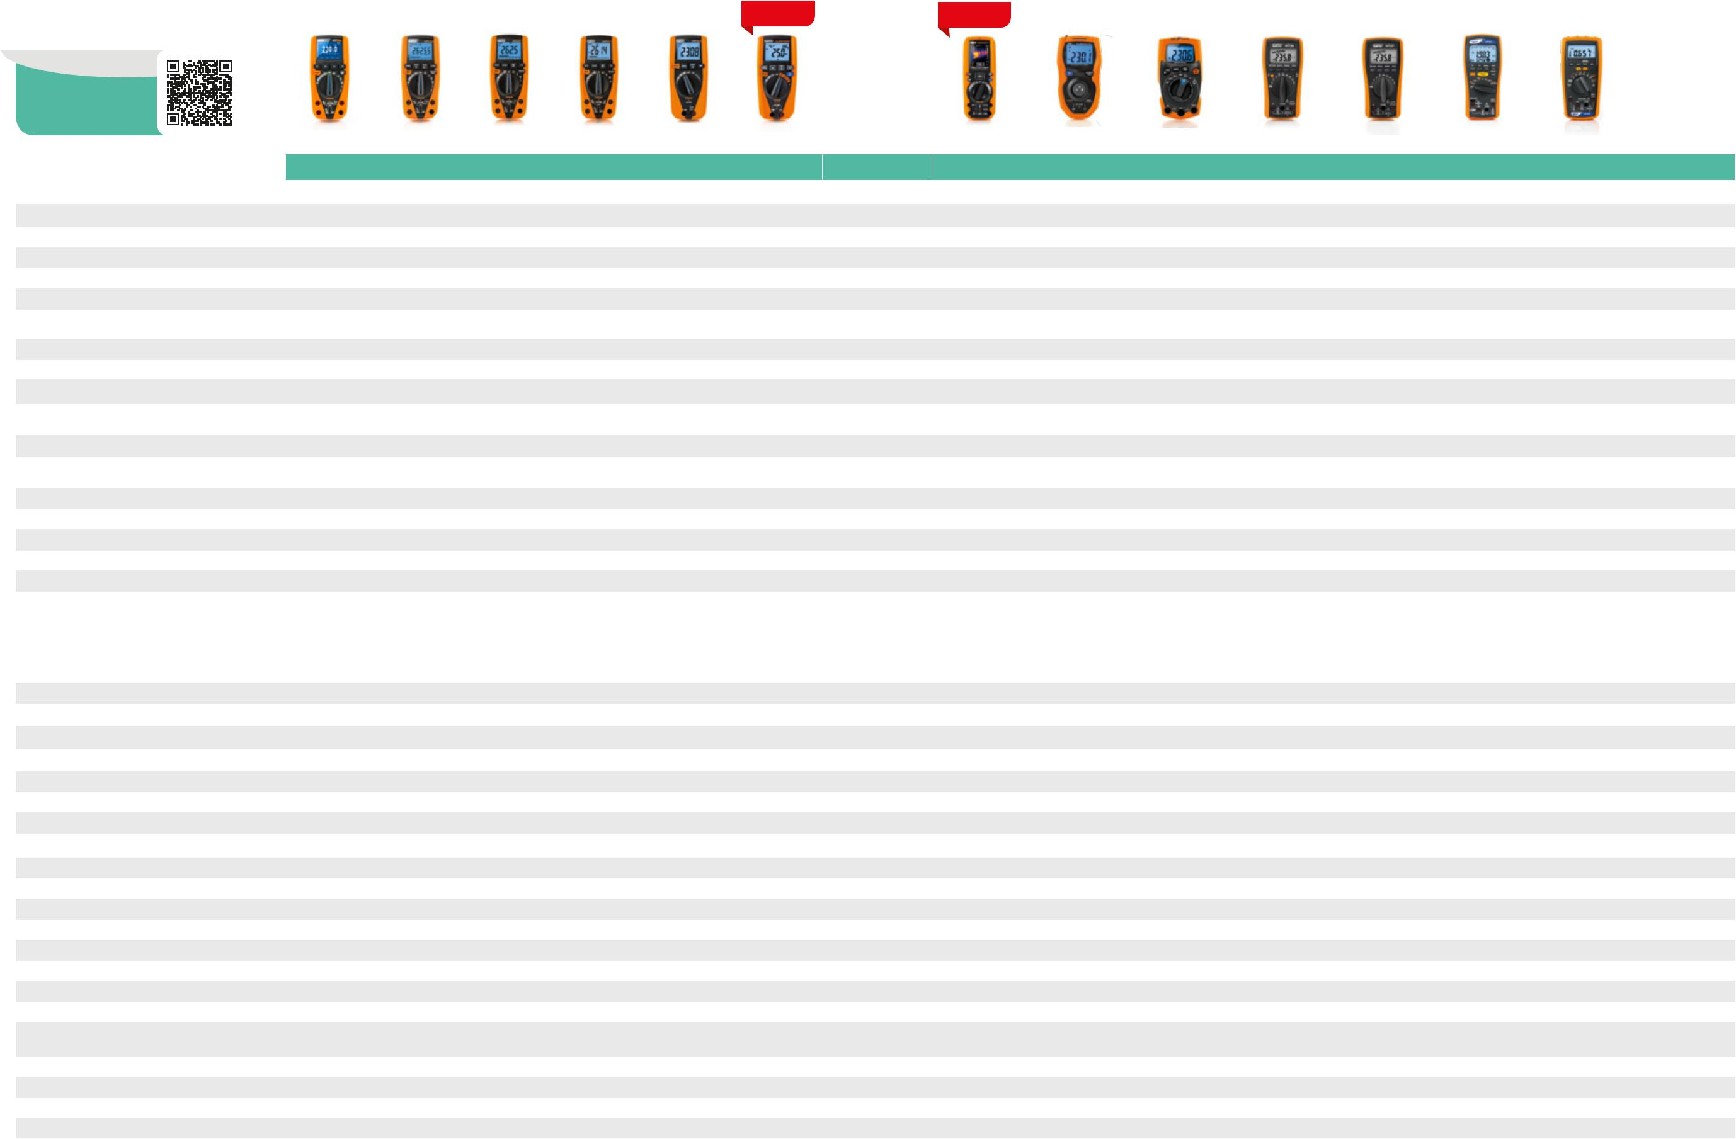

6 7

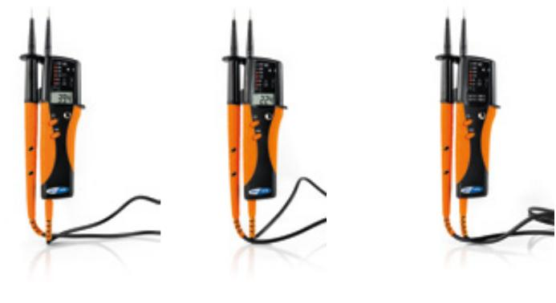  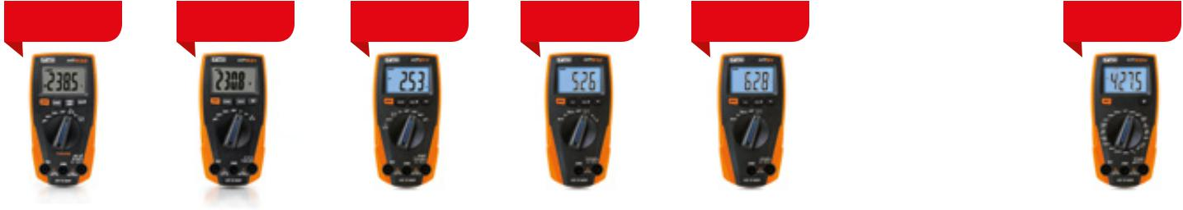  DIGITAL |  |  |  |  |  |  |  |  |  |  |  |  |  |  |  |  |  |  |  |  |  |  |  |  | NEW |  | NEW |  | NEW |  | NEW |  | NEW |  | NEW
MULTIMETERS
Scan the QR code
to discover our whole
line of accessories. |  |  |  |  |  |  |  |  |  |  |  |  |  |  |  |  |  |  |  |  |  |  |  |  | HT232 |  | HT231 |  | HT211 |  | HT210 |  | HT21 |  | HT25N |  | HT14D |  | HT12 |  | HT9 |  | HT8 |  | HT6
MAIN MEASUREMENTS |  |  |  |  |  |  |  |  |  |  |  |  |  |  |  |  |  |  |  |  |  |  |  |  |  |  |  | DIGITAL MULTIMETERS |  |  |  |  |  |  |  |  |  |  | DIGITAL MULTIMETERS
TRMS |  |  |  |  |  |  |  |  |  |  |  |  |  |  |  |  |  |  |  |  |  |  |  |  | • |  | - |  | • |  | - |  | - |  | - |  | - |  | - |  | - |  | - |  | -
AC/DC voltage |  |  |  |  |  |  |  |  |  |  |  |  |  |  |  |  |  |  |  |  |  |  |  |  | • |  | • |  | • |  | • |  | • |  | • |  | • |  | • |  | • |  | • |  | •
AC/DC current |  |  |  |  |  |  |  |  |  |  |  |  |  |  |  |  |  |  |  |  |  |  |  |  | • |  | • |  | • |  | - |  | - |  | • DC |  | • DC |  | • |  | - |  | - |  | -
Frequency |  |  |  |  |  |  |  |  |  |  |  |  |  |  |  |  |  |  |  |  |  |  |  |  | • |  | - |  | • |  | • |  | • |  | - |  | - |  | • |  | - |  | - |  | -
Resistance |  |  |  |  |  |  |  |  |  |  |  |  |  |  |  |  |  |  |  |  |  |  |  |  | • |  | • |  | • |  | • |  | • |  | • |  | • |  | • |  | - |  | - |  | -
Continuity with buzzer |  |  |  |  |  |  |  |  |  |  |  |  |  |  |  |  |  |  |  |  |  |  |  |  | • |  | • |  | • |  | • |  | • |  | • |  | - |  | • |  | • |  | • |  | •
Capacitance |  |  |  |  |  |  |  |  |  |  |  |  |  |  |  |  |  |  |  |  |  |  |  |  | • |  | - |  | • |  | • |  | • |  | - |  | - |  | - |  | - |  | - |  | -
Diode test |  |  |  |  |  |  |  |  |  |  |  |  |  |  |  |  |  |  |  |  |  |  |  |  | • |  | • |  | • |  | • |  | • |  | • |  | • |  | - |  | • |  | • |  | •
Duty Cycle (%) |  |  |  |  |  |  |  |  |  |  |  |  |  |  |  |  |  |  |  |  |  |  |  |  | • |  | - |  | • |  | • |  | • |  | - |  | - |  | - |  | - |  | - |  | -
Temperature with K-type probe |  |  |  |  |  |  |  |  |  |  |  |  |  |  |  |  |  |  |  |  |  |  |  |  | - |  | - |  | • |  | • |  | - |  | - |  | - |  | - |  | - |  | - |  | -
Phase sequence and phase concordance |  |  |  |  |  |  |  |  |  |  |  |  |  |  |  |  |  |  |  |  |  |  |  |  | - |  | - |  | - |  | - |  | - |  | - |  | - |  | - |  | • |  | • |  | •
Built-in LED torch |  |  |  |  |  |  |  |  |  |  |  |  |  |  |  |  |  |  |  |  |  |  |  |  | - |  | - |  | - |  | - |  | - |  | - |  | - |  | - |  | • |  | • |  | •
ADDITIONAL CHARACTERISTICS
Measurement category |  |  |  |  |  |  |  |  |  |  |  |  |  |  |  |  |  |  |  |  |  |  |  |  | CAT III 600V |  | CAT III 600V |  | CAT III 600V |  | CAT III 600V |  | CAT III 600V |  | CAT III 600V |  | CAT III 300V |  | CAT III 300V |  | CAT IV 600V |  | CAT IV 600V |  | CAT IV 600V
 |  |  |  |  |  |  |  |  |  |  |  |  |  |  |  |  |  |  |  |  |  |  |  |  |  |  |  |  |  |  |  |  |  |  |  |  | CAT II 600V |  | CAT II 600V |  | CAT III 690V |  | CAT III 690V |  | CAT III 690V
Measuring counts |  |  |  |  |  |  |  |  |  |  |  |  |  |  |  |  |  |  |  |  |  |  |  |  | 4000 |  | 2000 |  | 4000 |  | 4000 |  | 4000 |  | 2000 |  | 2000 |  | 3400 |  | 6900 |  | 6900 |  | LED
 |  |  |  |  |  |  |  |  |  |  |  |  |  |  |  |  |  |  |  |  |  |  |  |  |  |  |  |  |  |  |  |  |  |  |  |  |  |  |  |  |  |  |  |  | indications
Backlight |  |  |  |  |  |  |  |  |  |  |  |  |  |  |  |  |  |  |  |  |  |  |  |  | • |  | • |  | • |  | • |  | • |  | • |  | - |  | - |  | - |  | - |  | -
Bargraph |  |  |  |  |  |  |  |  |  |  |  |  |  |  |  |  |  |  |  |  |  |  |  |  | - |  | - |  | - |  | - |  | - |  | - |  | - |  | • |  | - |  | - |  | -
Autorange |  |  |  |  |  |  |  |  |  |  |  |  |  |  |  |  |  |  |  |  |  |  |  |  | • |  | • |  | • |  | • |  | • |  | - |  | - |  | • |  | - |  | - |  | -
Auto power off |  |  |  |  |  |  |  |  |  |  |  |  |  |  |  |  |  |  |  |  |  |  |  |  | • |  | • |  | • |  | • |  | • |  | - |  | - |  | • |  | • |  | • |  | •
Data HOLD function |  |  |  |  |  |  |  |  |  |  |  |  |  |  |  |  |  |  |  |  |  |  |  |  | • |  | • |  | • |  | • |  | • |  | • |  | • |  | • |  | • |  | • |  | •
MIN/MAX function |  |  |  |  |  |  |  |  |  |  |  |  |  |  |  |  |  |  |  |  |  |  |  |  | • |  | - |  | • |  | - |  | - |  | - |  | - |  | - |  | - |  | - |  | -
PEAK function |  |  |  |  |  |  |  |  |  |  |  |  |  |  |  |  |  |  |  |  |  |  |  |  | - |  | - |  | - |  | - |  | - |  | - |  | - |  | - |  | - |  | - |  | -
Relative measurement |  |  |  |  |  |  |  |  |  |  |  |  |  |  |  |  |  |  |  |  |  |  |  |  | - |  | - |  | - |  | • |  | • |  | - |  | - |  | - |  | - |  | - |  | -
Power supply |  |  |  |  |  |  |  |  |  |  |  |  |  |  |  |  |  |  |  |  |  |  |  |  | 2x 1.5V AAA |  | 2x 1.5V AAA |  | 2x 1.5V AAA |  | 1x 9V 6F22 |  | 1x 9V 6F22 |  | 1x 9V 6F22 |  | 1x 12V |  | 2x 1.5V AAA |  | 2x 1.5V AA |  | 2x 1.5V AA |  | 2x 1.5V AA
 |  |  |  |  |  |  |  |  |  |  |  |  |  |  |  |  |  |  |  |  |  |  |  |  |  |  |  |  |  |  |  |  |  |  |  |  | MS21/MN21
Size in mm (L x W x H) |  |  |  |  |  |  |  |  |  |  |  |  |  |  |  |  |  |  |  |  |  |  |  |  | 138x68x37 |  | 138x68x37 |  | 138x68x37 |  | 138x68x37 |  | 138x68x37 |  | 150x70x48 |  | 105x50x25 |  | 128x87x24 |  | 255x60x35 |  | 255x60x35 |  | 255x60x35
Weight in grams |  |  |  |  |  |  |  |  |  |  |  |  |  |  |  |  |  |  |  |  |  |  |  |  | 235 |  | 210 |  | 235 |  | 210 |  | 210 |  | 255 |  | 100 |  | 210 |  | 170 |  | 170 |  | 170
Safety |  |  |  |  |  |  |  |  |  |  |  |  |  |  |  |  |  |  |  |  |  |  |  |  | IEC/EN61010-1 |  | IEC/EN61010-1 |  | IEC/EN61010-1 |  | IEC/EN61010-1 |  | IEC/EN61010-1 |  | IEC/EN61010-1 |  | IEC/EN61010-1 |  | IEC/EN61010-1 |  | IEC/EN61010-1 |  | IEC/EN61010-1 |  | IEC/EN61010-1
Order code |  |  |  |  |  |  |  |  |  |  |  |  |  |  |  |  |  |  |  |  |  |  |  |  | HR000232 |  | HR000231 |  | HR000211 |  | HR000210 |  | HR000021 |  | HR00025N |  | HR00014D |  | HR000012 |  | HR000009 |  | HR000008 |  | HR000006
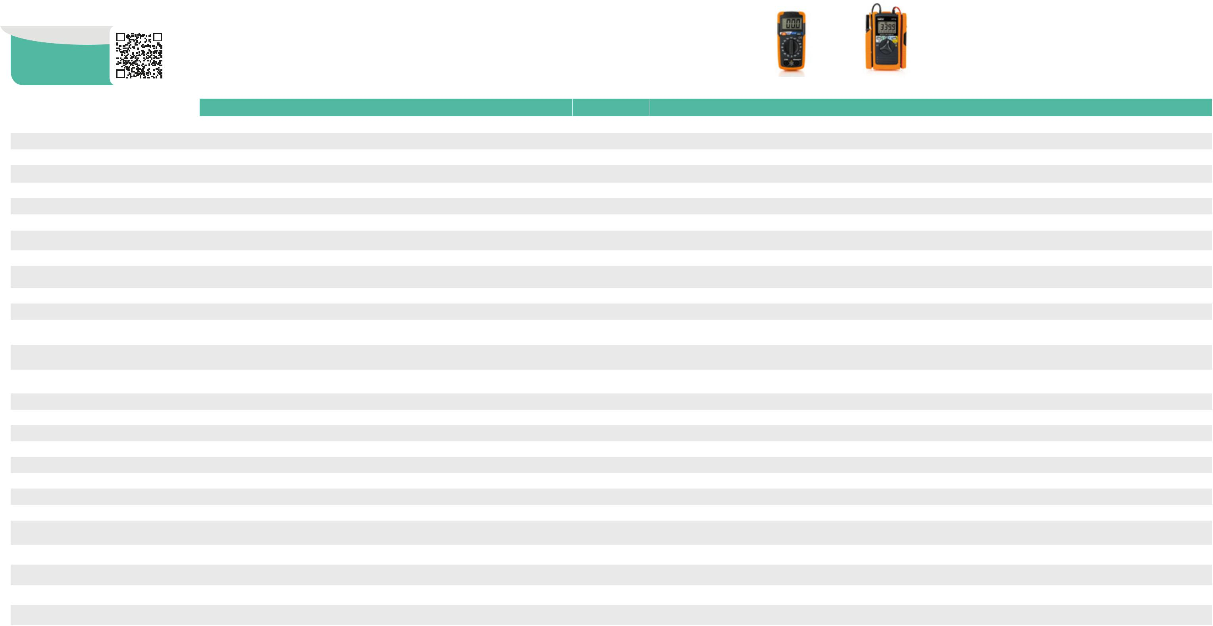

8 9

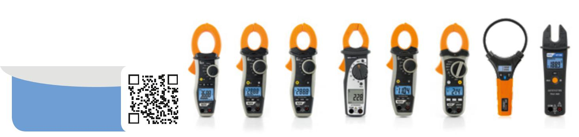

CLAMP |  |  |  |  |  |  |  |  |  |  |  |  |  |  |  |  |  |  |  |  |  |  |  |  |  |  |  |  |  |  |  |  |  |  |  |  | NEW
METERS
Scan the QR code
to discover our whole
line of accessories. |  |  |  |  |  |  |  |  |  |  |  |  |  |  |  |  |  |  |  |  | HT9019 |  | HT9014 |  | HT9012 |  | HT4012 |  | HT4011 |  | HT4010 |  | F3000 |  | HT100 |  | HT7004
MAIN MEASUREMENTS
 |  |  |  |  |  |  |  |  |  |  |  |  |  |  |  |  |  |  |  |  |  |  |  |  |  |  |  |  | AC
TRMS |  |  |  |  |  |  |  |  |  |  |  |  |  |  |  |  |  |  |  |  | • |  | • |  |  |  |  |  |  |  |  |  | • |  | • |  | •
 |  |  |  |  |  |  |  |  |  |  |  |  |  |  |  |  |  |  |  |  |  |  |  |  | - |  | - |  | - |  | -
Current measuring range |  |  |  |  |  |  |  |  |  |  |  |  |  |  |  |  |  |  |  |  | 1000A |  | 600A |  | 600A |  | 400A |  | 400A |  | 600A |  | 3000A |  | 200A |  | 300A
AC/DC current |  |  |  |  |  |  |  |  |  |  |  |  |  |  |  |  |  |  |  |  | • AC |  | • AC |  | • AC |  | • AC |  | • AC |  | • AC |  | • AC |  | • AC |  | • AC
AC/DC voltage |  |  |  |  |  |  |  |  |  |  |  |  |  |  |  |  |  |  |  |  | • |  | • |  | • |  | • |  | • |  | • |  | - |  | • |  | -
Leakage current |  |  |  |  |  |  |  |  |  |  |  |  |  |  |  |  |  |  |  | - |  |  | - |  | - |  | - |  | - |  | - |  | - |  | - |  | -
Frequency |  |  |  |  |  |  |  |  |  |  |  |  |  |  |  |  |  |  |  | - |  |  | • |  | - |  | - |  | • |  | - |  | - |  | - |  | -
Resistance and continuity test with buzzer |  |  |  |  |  |  |  |  |  |  |  |  |  |  |  |  |  |  |  |  | • |  | • |  | • |  | • |  | • |  | • |  | - |  | • |  | -
Capacitance |  |  |  |  |  |  |  |  |  |  |  |  |  |  |  |  |  |  |  | - |  |  | • |  | - |  | - |  | • |  | - |  | - |  | - |  | -
Diode test |  |  |  |  |  |  |  |  |  |  |  |  |  |  |  |  |  |  |  | - |  |  | • |  | • |  | • |  | • |  | • |  | - |  | • |  | -
Duty Cycle (%) |  |  |  |  |  |  |  |  |  |  |  |  |  |  |  |  |  |  |  | - |  |  | • |  | - |  | - |  | • |  | - |  | - |  | - |  | -
Temperature with K-type probe |  |  |  |  |  |  |  |  |  |  |  |  |  |  |  |  |  |  |  | - |  |  | • |  | - |  | - |  | • |  | - |  | - |  | - |  | -
Phase sequence and phase concordance |  |  |  |  |  |  |  |  |  |  |  |  |  |  |  |  |  |  |  | - |  |  | - |  | - |  | - |  | - |  | - |  | - |  | - |  | -
Automatic recognition of internal functions |  |  |  |  |  |  |  |  |  |  |  |  |  |  |  |  |  |  |  | - |  |  | - |  | - |  | - |  | - |  | - |  | - |  | • |  | -
MAINS ANALYSIS
AC/DC voltage, current measurement/ |  |  |  |  |  |  |  |  |  |  |  |  |  |  |  |  |  |  |  | - |  |  | - |  | - |  | - |  | - |  | - |  | - |  | - |  | -
recording
AC/DC power measurement/recording |  |  |  |  |  |  |  |  |  |  |  |  |  |  |  |  |  |  |  | - |  |  | - |  | - |  | - |  | - |  | - |  | - |  | - |  | -
AC/DC energy measurement/recording |  |  |  |  |  |  |  |  |  |  |  |  |  |  |  |  |  |  |  | - |  |  | - |  | - |  | - |  | - |  | - |  | - |  | - |  | -
Cosphi, PF measurement/recording |  |  |  |  |  |  |  |  |  |  |  |  |  |  |  |  |  |  |  | - |  |  | - |  | - |  | - |  | - |  | - |  | - |  | - |  | -
U/I + THD% harmonics measurement/recording |  |  |  |  |  |  |  |  |  |  |  |  |  |  |  |  |  |  |  | - |  |  | - |  | - |  | - |  | - |  | - |  | - |  | - |  | -
Inrush current measurement (INRUSH) |  |  |  |  |  |  |  |  |  |  |  |  |  |  |  |  |  |  |  | - |  |  | - |  | - |  | - |  | - |  | - |  | - |  | - |  | -
ADDITIONAL CHARACTERISTICS
Measurement category |  |  |  |  |  |  |  |  |  |  |  |  |  |  |  |  |  |  |  |  | CAT IV 600V |  | CAT IV 600V |  | CAT IV 600V |  | CAT III 600V |  | CAT III 600V |  | CAT III 600V |  | CAT IV 600V |  | CAT IV 600V |  | CAT III 300V
 |  |  |  |  |  |  |  |  |  |  |  |  |  |  |  |  |  |  |  | CAT III 1000V |  |  | CAT III 1000V |  | CAT III 1000V |  |  |  |  |  |  |  | CAT III 1000V |  | CAT III 1000V
Maximum cable diameter |  |  |  |  |  |  |  |  |  |  |  |  |  |  |  |  |  |  |  |  | 45mm |  | 30mm |  | 30mm |  | 30mm |  | 30mm |  | 30mm |  | 110mm |  | 16mm |  | 20mm
Measuring counts |  |  |  |  |  |  |  |  |  |  |  |  |  |  |  |  |  |  |  | 6000 |  |  | 6000 |  | 2000 |  | 2000 |  | 4000 |  | 2000 |  | 3000 |  | 10000 |  | 4000
Backlight |  |  |  |  |  |  |  |  |  |  |  |  |  |  |  |  |  |  |  |  | • |  | • |  | • |  | - |  | - |  | • |  | • |  | • |  | •
Bargraph |  |  |  |  |  |  |  |  |  |  |  |  |  |  |  |  |  |  |  |  | • |  | • |  | - |  | - |  | - |  | - |  | - |  | - |  | -
Autorange |  |  |  |  |  |  |  |  |  |  |  |  |  |  |  |  |  |  |  |  | • |  | • |  | • |  | • |  | • |  | • |  | • |  | • |  | •
Auto power off |  |  |  |  |  |  |  |  |  |  |  |  |  |  |  |  |  |  |  |  | • |  | • |  | • |  | • |  | • |  | • |  | • |  | • |  | •
Contactless AC voltage detection |  |  |  |  |  |  |  |  |  |  |  |  |  |  |  |  |  |  |  |  | • |  | • |  | • |  | - |  | • |  | • |  | - |  | • |  | •
Data HOLD function |  |  |  |  |  |  |  |  |  |  |  |  |  |  |  |  |  |  |  |  | • |  | • |  | • |  | • |  | • |  | • |  | • |  | • |  | •
MIN/MAX function |  |  |  |  |  |  |  |  |  |  |  |  |  |  |  |  |  |  |  |  | • |  | • |  | • MAX |  | - |  | - |  | • MAX |  | - |  | - |  | -
AVG function (AVERAGE) |  |  |  |  |  |  |  |  |  |  |  |  |  |  |  |  |  |  |  | - |  |  | - |  | - |  | - |  | - |  | - |  | - |  | - |  | -
PEAK function |  |  |  |  |  |  |  |  |  |  |  |  |  |  |  |  |  |  |  |  | • |  | • |  | - |  | - |  | - |  | - |  | - |  | - |  | -
Relative measurement (ZERO) |  |  |  |  |  |  |  |  |  |  |  |  |  |  |  |  |  |  |  | - |  |  | • |  | - |  | - |  | • |  | - |  | - |  | - |  | -
Low-pass filter for harmonic reduction |  |  |  |  |  |  |  |  |  |  |  |  |  |  |  |  |  |  |  | - |  |  | - |  | - |  | - |  | - |  | - |  | - |  | - |  | -
Analogue output |  |  |  |  |  |  |  |  |  |  |  |  |  |  |  |  |  |  |  | - |  |  | - |  | - |  | - |  | - |  | - |  | - |  | - |  | -
Electrical parameter logging |  |  |  |  |  |  |  |  |  |  |  |  |  |  |  |  |  |  |  | - |  |  | - |  | - |  | - |  | - |  | - |  | - |  | - |  | -
Memory for data saving |  |  |  |  |  |  |  |  |  |  |  |  |  |  |  |  |  |  |  | - |  |  | - |  | - |  | - |  | - |  | - |  | - |  | - |  | -
PC / Smartphone or Tablet interface |  |  |  |  |  |  |  |  |  |  |  |  |  |  |  |  |  |  |  | - |  |  | - |  | - |  | - |  | - |  | - |  | - |  | - |  | -
Power supply |  |  |  |  |  |  |  |  |  |  |  |  |  |  |  |  |  |  |  |  | 1x 9V 6F22 |  | 1x 9V 6F22 |  | 1x 9V 6F22 |  | 2x 1.5V AAA |  | 2x 1.5V AAA |  | 1x 9V 6F22 |  | 2x 1.5V AAA |  | 2x 1.5V AAA |  | 2x 1.5V AAA
Size in mm (L x W x H) |  |  |  |  |  |  |  |  |  |  |  |  |  |  |  |  |  |  |  |  | 252x88x44 |  | 215x74x43 |  | 215x74x43 |  | 205x64x39 |  | 200x66x37 |  | 197x70x40 |  | 280x120x25 |  | 193x54x31 |  | 160x55x30
Weight in grams (batteries included) |  |  |  |  |  |  |  |  |  |  |  |  |  |  |  |  |  |  |  | 402 |  |  | 285 |  | 285 |  | 280 |  | 205 |  | 180 |  | 170 |  | 280g |  | 140
Reference standard for safety |  |  |  |  |  |  |  |  |  |  |  |  |  |  |  |  |  |  |  |  | IEC/ |  | IEC/ |  | IEC/ |  | IEC/ |  | IEC/ |  | IEC/ |  | IEC/ |  | IEC/ |  | IEC/
 |  |  |  |  |  |  |  |  |  |  |  |  |  |  |  |  |  |  |  |  | EN61010-1 |  | EN61010-1 |  | EN61010-1 |  | EN61010-1 |  | EN61010-1 |  | EN61010-1 |  | EN61010-1 |  | EN61010-1 |  | EN61010-1
Order code |  |  |  |  |  |  |  |  |  |  |  |  |  |  |  |  |  |  |  |  | HP009019 |  | HP009014 |  | HP009012 |  | HP004012 |  | HP004011 |  | HP004010 |  | HP030000 |  | HP000100 |  | HP007004
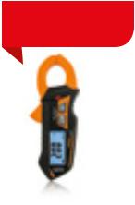
NEW
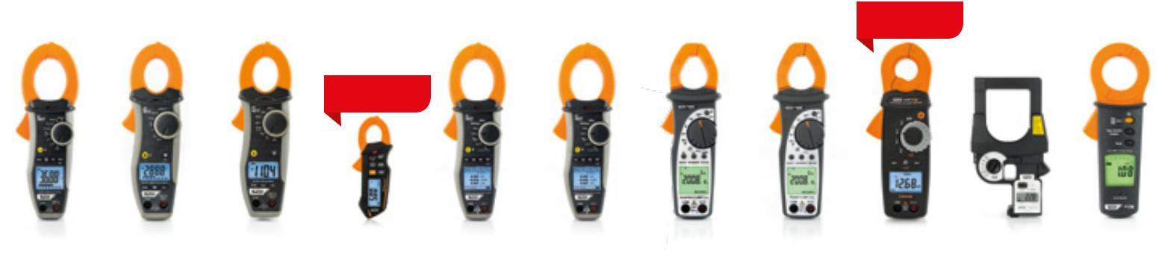

NEW

HT9021 |  | HT9015 |  | HT4013 |  | HT7005 |  | HT9022 |  | HT9020 |  | HT4022 |  | HT4020 |  | HT79 |  | HT78 |  | HT77N
 |  | AC/DC |  |  |  |  |  |  | HARMONICS AND/OR POWER |  |  |  |  |  |  |  |  | LEAKAGE
• |  | • |  |  |  | • |  | • |  | • |  | • |  | • |  | • |  | • |  | •
 |  |  |  | -
1000A |  | 600A |  | 400A |  | 400A |  | 1000A |  | 1000A |  | 400A |  | 400A |  | 10A (DC) |  | 3000A |  | 100A
 |  |  |  |  |  |  |  |  |  |  |  |  |  |  |  | 20A (AC)
• |  | • |  | • |  | • |  | • AC+DC |  | • AC+DC |  | • AC |  | • AC |  | • |  | • AC |  | • AC
• |  | • |  | • |  | - |  | • |  | • |  | • |  | • |  | • |  | - |  | -
- |  | - |  | - |  | - |  | - |  | - |  | - |  | - |  | • AC/DC |  | • |  | •
• |  | • |  | • |  | - |  | • |  | • |  | • |  | • |  | - |  | - |  | -
• |  | • |  | • |  | - |  | • |  | • |  | • |  | • |  | • |  | - |  | -
• |  | • |  | • |  | - |  | - |  | - |  | - |  | - |  | - |  | - |  | -
• |  | • |  | • |  | - |  | - |  | - |  | - |  | - |  | - |  | - |  | -
• |  | • |  | • |  | - |  | - |  | - |  | - |  | - |  | - |  | - |  | -
• |  | • |  | • |  | - |  | - |  | - |  | - |  | - |  | - |  | - |  | -
- |  | - |  | - |  | - |  | • |  | • |  | • |  | • |  | - |  | - |  | -
- |  | - |  | - |  | - |  | - |  | - |  | - |  | - |  | - |  | - |  | -
- |  | - |  | - |  | - |  | • |  | •* |  | •* |  | •* |  | - |  | - |  | -
- |  | - |  | - |  | - |  | • |  | •* |  | •* |  | •* |  | - |  | - |  | -
- |  | - |  | - |  | - |  | • |  | •* |  | •* |  | •* |  | - |  | - |  | -
- |  | - |  | - |  | - |  | • |  | •* |  | •* |  | •* |  | - |  | - |  | -
- |  | - |  | - |  | - |  | • |  | •* |  | •* |  | - |  | - |  | - |  | -
- |  | - |  | - |  | • |  | • |  | • Dynamic |  | - |  | - |  | - |  | - |  | -
 |  |  |  |  |  |  |  |  |  | INRUSH
CAT IV 600V |  | CAT IV 600V |  | CAT III 600V |  | CAT III 300V |  | CAT IV 600V |  | CAT IV 600V |  | CAT III 600V |  | CAT III 600V |  | CAT IV 300V |  | CAT II 600V |  | CAT III 300V
CAT III 1000V |  | CAT III 1000V |  |  |  |  |  | CAT III 1000V |  | CAT III 1000V |  |  |  |  |  |  |  | CAT III 300V
45mm |  | 30mm |  | 30mm |  | 20mm |  | 45mm |  | 45mm |  | 30mm |  | 30mm |  | 23mm |  | 108mm |  | 40mm
6000 |  | 6000 |  | 4000 |  | 4000 |  | 9999 |  | 9999 |  | 10000 |  | 10000 |  | 5000 |  | 3200 |  | 6000
• |  | • |  | - |  | • |  | • |  | • |  | • |  | • |  | • |  | - |  | •
• |  | • |  | - |  | - |  | - |  | - |  | • |  | • |  | - |  | - |  | •
• |  | • |  | - |  | • |  | • |  | • |  | • |  | • |  | • |  | - |  | •
• |  | • |  | • |  | • |  | • |  | • |  | • |  | • |  | • |  | • |  | •
• |  | • |  | • |  | • |  | • |  | • |  | - |  | - |  | - |  | - |  | -
• |  | • |  | • |  | • |  | • |  | • |  | • |  | • |  | • |  | • |  | •
• |  | • |  | - |  | - |  | • |  | • |  | • |  | • |  | • |  | - |  | -
- |  | - |  | - |  | - |  | - |  | - |  | • |  | • |  | - |  | - |  | -
• |  | • |  | - |  | - |  | • |  | • |  | • |  | • |  | - |  | - |  | •
• |  | • |  | • |  | - |  | - |  | - |  | - |  | - |  | • |  | - |  | -
- |  | - |  | - |  | - |  | - |  | - |  | - |  | - |  | - |  | • 150Hz |  | • 100Hz
- |  | - |  | - |  | - |  | - |  | - |  | - |  | - |  | - |  | - |  | •
- |  | - |  | - |  | - |  | • |  | • |  | - |  | - |  | - |  | - |  | -
- |  | - |  | - |  | - |  | • |  | • |  | - |  | - |  | - |  | - |  | -
- |  | - |  | - |  | - |  | • Bluetooth |  | - |  | - |  | - |  | - |  | - |  | -
1x 9V 6F22 |  | 1x 9V 6F22 |  | 2x 1.5V AAA |  | 2x 1.5V AAA |  | 2x 1.5V AAA |  | 2x 1.5V AAA |  | 2x 1.5V AAA |  | 2x 1.5V AAA |  | 2x 1.5V AAA |  | 2x 1.5V AAA |  | 2x 1.5V AAA
252x88x44 |  | 215x74x43 |  | 200x66x37 |  | 160x55x30 |  | 252x88x44 |  | 252x88x44 |  | 205x64x39 |  | 205x64x39 |  | 206x76x34 |  | 341x194x52 |  | 200x70x40
442 |  | 285 |  | 205 |  | 140 |  | 420 |  | 420 |  | 280 |  | 280 |  | 262 |  | 1900 |  | 265
IEC/ |  | IEC/ |  | IEC/ |  | IEC/ |  | IEC/ |  | IEC/ |  | IEC/ |  | IEC/ |  | IEC/ |  | IEC/ |  | IEC/
EN61010-1 |  | EN61010-1 |  | EN61010-1 |  | EN61010-1 |  | EN61010-1 |  | EN61010-1 |  | EN61010-1 | EN61010-1 |  |  | EN61010-1 |  | EN61010-1 |  | EN61010-1
HP009021 |  | HP009015 |  | HP004013 |  | HP007005 |  | HP009022 |  | HP009020 |  | HP004022 |  | HP004020 |  | HP000079 |  | HP000078 |  | HP00077N

10 | * Real-time measurement only. | 11

POWER QUALITY ANALYZERS
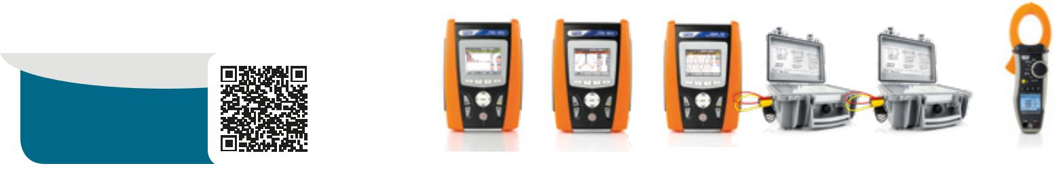

Scan the QR code
to discover our whole
line of accessories.

 |  | PQA824 | PQA823 | VEGA78 | PQA820 | PQA819 | HT9022
MAIN MEASUREMENTS
 |  |  |  | POWER QUALITY ANALYZERS
AC/DC voltage in single-phase/three-phase systems |  | • | • | • | • | • | • Single-phase
AC/DC current in single-phase/three-phase systems |  | • | • | • | • | • | • Single-phase
Cosphi, Power Factor |  | • | • | • | • | • | •
Voltage unbalance (NEG%, ZERO%) |  | • | • | • | • | - | -
Active, reactive, apparent power/energy and DC power |  | • | • | • | • | • | •
Voltage and current harmonics up to the 49th with calculation of THD% |  | • | • | • | • | • | • 25th
 |  |  |  |  |  | Only THD
Voltage anomalies (dips, peaks) with a resolution of 10ms (@ 50Hz) |  | • | • | • | • | - | -
Voltage spikes with a resolution of 5µs (200kHz) |  | • | - | - | - | - | -
Electric motor starting current (INRUSH) |  | • | • | - | - | - | •
Voltage flickers (Pst, Plt) |  | • | • | - | - | - | -
Full analysis EN50160 |  | • | • | - | - | - | -
Phase sequence |  | • | • | • | • | • | •
Neutral-Ground Voltage |  | • | • | • | - | - | •
Neutral current |  | • | • | • | • | - | •

DATA LOGGERS
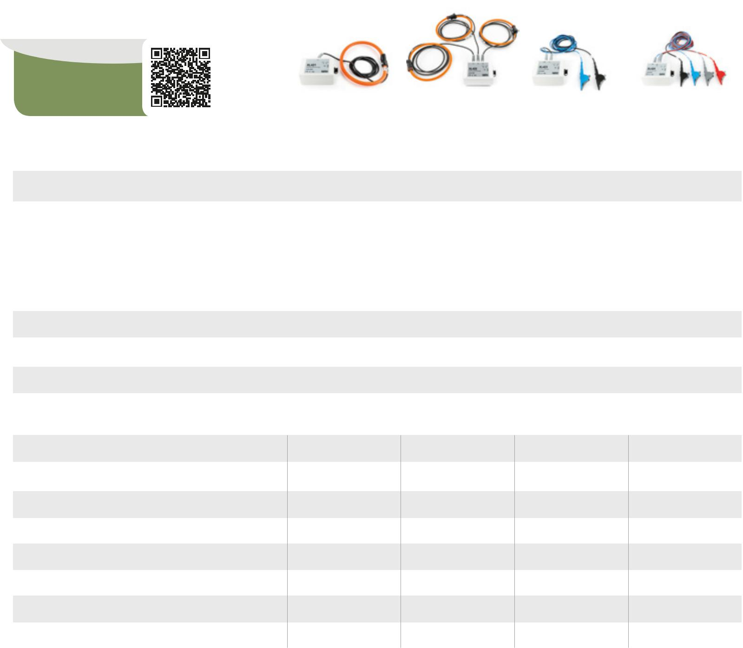

Scan the QR code
to discover our whole
line of accessories.

 | XL421 | XL422 | XL423 | XL424
MAIN MEASUREMENTS |  | DATA LOGGERS
TRMS | • | • | • | •
AC voltage in single-phase/three-phase systems | - | - | • | •
 |  |  | Single-phase | Single-phase / three-phase
AC current in single-phase/three-phase systems | • | • | - | -
 | Single-phase | Single-phase / three-phase
MEMORY AND RECORDING
Max number of simultaneously selectable parameters | 1 | 3 | 1 | 3
Recording with selectable integration period | 1s, 6s, 30s, 1min, 5min | 1s, 6s, 30s, 1min, 5min | 1s, 6s, 30s, 1min, 5min | 1s, 6s, 30s, 1min, 5min
Indicative memory duration | 455 | 455 / 1820* | 455 | 455 / 1820*
(single-/three-phase in days @ PI=5min)
Internal memory capacity | 1MB | 1MB | 1MB | 1MB

ADDITIONAL CHARACTERISTICS

MEMORY AND RECORDING

Max number of simultaneously selectable parameters

Recording with selectable integration period

Indicative memory duration
(in days @ PI=10min @ max number of parameters)

Indication of recording duration

Internal memory capacity

External compact flash card

Default and custom recordings

Snapshot saving

251 | 251 | 251 | 383 | 44 | 60
1s-60m | 1s-60m | 1s-60m | 5s-60m | 5s-60m | 1s-15min
90 days | 90 days | 90 days | 30 days | 153 days | 2 days
• | • | • | •* | •* | •
15MB | 15MB | 15MB | 8MB | 8MB | 2MB
• | • | • | - | - | -
• | • | • | - | - | -
• | • | • | •* | •* | •*

Protection rating

Measurement category

Power supply

Provided PC interface with software for Windows

Size (LxWxH) (mm)

Weight (batteries included)

Reference standard for safety

IP65 | IP65 | IP65 | IP65
CAT IV 600V | CAT IV 600V | CAT IV 600V | CAT IV 600V
CAT III 1000V | CAT III 1000V | CAT III 1000V | CAT III 1000V
2x Batteries AA | 2x Batteries AA | 2x Batteries AA | 2x Batteries AA
• | • | • | •
120x80x43 | 120x80x43 | 120x80x43 | 120x80x43
500g | 500g | 500g | 500g
IEC/EN61010-1 | IEC/EN61010-1 | IEC/EN61010-1 | IEC/EN61010-1

According to battery duration.

REAL-TIME DISPLAY

Summary table of main electric parameters | • | • | • | •* | •* | •*
Voltage/current waveforms | • | • | • | •* | •* | •*
Tables or histograms of Harmonics and THD% | • | • | • | •* | •* | •*
Voltage/current vector diagram | • | • | • | •* | •* | •*

ADDITIONAL CHARACTERISTICS

Measurement category CAT IV 600V CAT IV 600V CAT IV 600V CAT IV 300V CAT IV 300V CAT IV 600V
Measurement by means of external CT and VT • • • • • -

Order code

ORDER CODE HA000407

HV000421 | HV000422 | HV000423 | HV000424
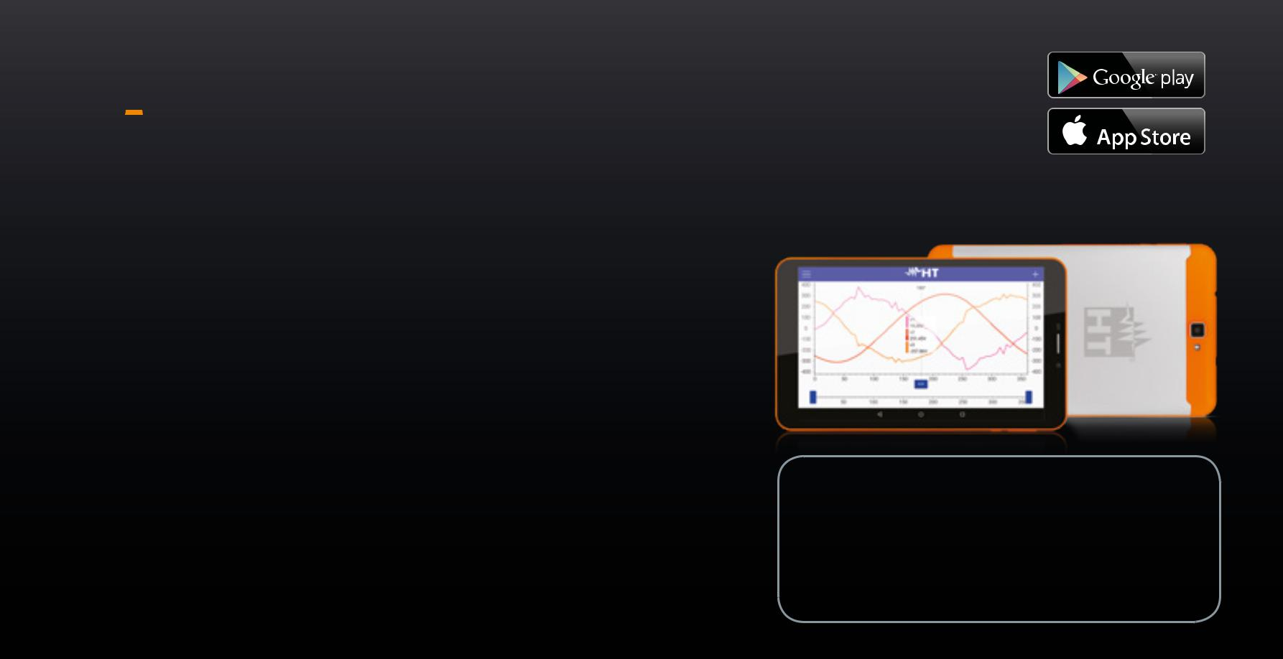

*

Available on the
ANALYSIS TAB2

8” Quad Core Wi-Fi 4G hd IPS tablet

Available on the

Touchscreen colour display | • | • | • | - | - | -
Power supply and rechargeable battery recharging | • | • | • | • Auto power | • Auto power | -
 |  |  |  | supplied | supplied
Auto power off | • | • | • | • | • | •
USB port for data download onto Pen Drive | • | • | • | • Only PC | • Only PC | -
Provided PC interface with software for Windows | • USB | • USB | • USB | • Wi-Fi / USB | • Wi-Fi / USB | • Bluetooth
Context help active on each screen | • | • | • | - | - | •
Protection password | • | • | • | - | - | -
Size (LxWxH) (mm) | 235x165x75 | 235x165x75 | 235x165x75 | 235x165x75 | 235x165x75 | 252x88x44
Weight in kg (batteries included) | 1 | 1 | 1 | 0,7 | 0,7 | 0,5
Reference standard for mains quality | EN50160 | EN50160 | - | - | - | -
Reference standard for safety | IEC/EN61010-1 IEC/EN61010-1 IEC/EN61010-1 IEC/EN61010-1 |  |  |  | IEC/EN61010-1 IEC/EN61010-1
Order code | HV000824 | HV000823 | HV000078 | HV000820 | HV000819 | HP009022

- * Through App HTANALYSIS and software TOPVIEW.

HT introduces the new tablet with pre-installed HTanalysis App.

With ANALYSISTAB2:

- Time to insight is reduced
- Sharing is simplified
- The user works more safely, protected from any danger of direct contact

- Through HTCLOUD you will be able to share all measures with your colleagues and/or download them from the PC without physically connecting the device to the PC

Technical features:

CPU: MTK8735 Quad Core 1.3Ghz Cortex-A53 Display: 8” LCD 800×1280 IPS
GPU: Mali-T720 Capacitive touch screen
RAM: 2GB DDR3 OS: Android 5.1 Lollipop
Cell network: 4G Photo camera: 2MP (Front),
Internal memory: 16 GB 5MP (Back)
External memory: MicroSD Slot

COMPATIBLE WITH

• MacroTestG3, G2, G1
• CombiG2
• PQA820, PQA819
• HT9022
• GSC60
13

ELECTRICAL
INSTALLATION SAFETY TESTERS

WIRE MAPPING
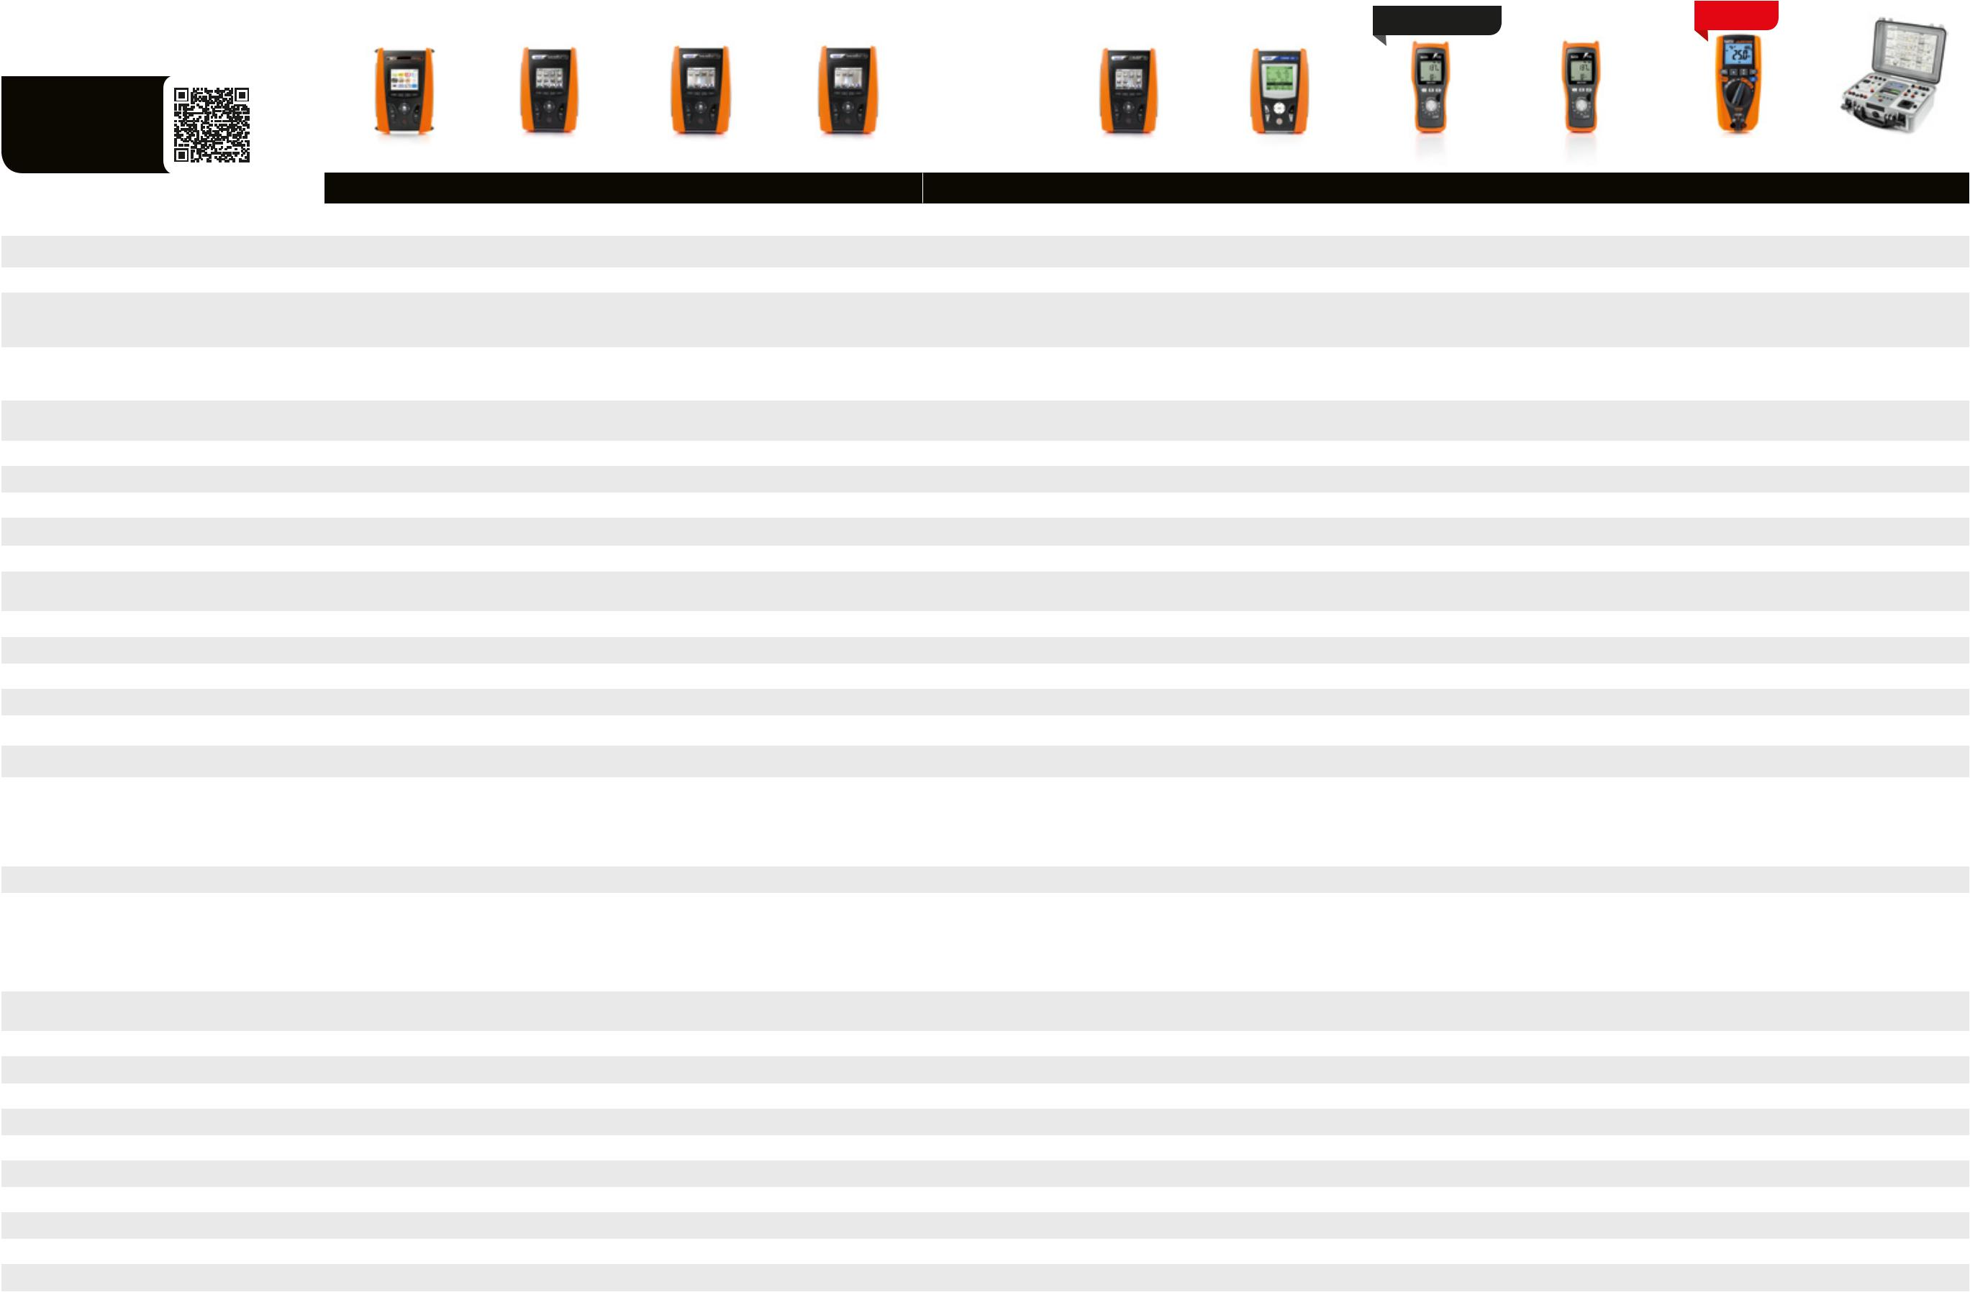
NEW

Scan the QR code
to discover our whole
line of accessories.

 |  |  |  |  |  |  |  | GSC60 |  | MACROTEST G3 |  |  | MACROTEST G2 |  | MACROTEST G1 |  | COMBI G2 |  | COMBI 420/421 |  | M75 |  | M74 |  | JUPITER |  | FULLTEST3
ELECTRIC SAFETY MEASUREMENTS
 |  |  |  |  |  |  |  |  |  | ELECTRICAL INSTALLATION SAFETY TESTERS |  |  |  |  |  |  |  |  |  |  | ELECTRICAL INSTALLATION SAFETY TESTERS
TRMS |  |  |  |  |  |  |  | • |  | • |  |  | • |  | • |  | • |  | • |  | • |  | • |  | • |  | •
Insulation with voltage 50, 100, 250, 500, 1000VDC |  |  |  |  |  |  |  | • |  | • |  |  | • |  | - |  | • |  | • |  | • 250V, 500V |  | • 250V, 500V |  | - |  | •
Continuity of protective conductors with 200mA / 10A |  |  |  |  |  |  |  | • 200mA |  | • 200mA |  |  | • 200mA |  | • 200mA |  | • 200mA |  | • 200mA |  | • 200mA |  | • 200mA |  | - |  | •
Tripping time of RCDs type B, A, AC Standard, |  |  |  |  |  |  |  |  |  |  |  |  |  |  |  |  |  |  | • Only A, AC standard |  | • A = 30mA |  | • A = 30mA |  | •
 |  |  |  |  |  |  |  | • |  | • |  |  | - |  | - |  | • |  |  |  | AC = 300mA |  | AC = 300mA |  | Only A, AC standard |  | •
Selective and Delayed up to 1A |  |  |  |  |  |  |  |  |  |  |  |  |  |  |  |  |  |  | and selective
 |  |  |  |  |  |  |  |  |  |  |  |  |  |  |  |  |  |  |  |  | Only standard |  | Only standard |  | up to 300mA
 |  |  |  |  |  |  |  |  |  |  |  |  |  |  |  |  |  |  |  |  | • A = 30mA |  | • A = 30mA |  | •
Tripping current of type A, AC Standard up to 650mA |  |  |  |  |  |  |  | • |  | • |  |  | - |  | - |  | • |  | • |  | AC = 30mA |  | AC = 30mA |  | Only A, AC standard |  | •
 |  |  |  |  |  |  |  |  |  |  |  |  |  |  |  |  |  |  |  |  | Only standard |  | Only standard |  | 30mA
Tripping time and current of earth leakage relays type B, A, |  |  |  |  |  |  |  | •*** |  | •*** |  |  | - |  | - |  | •*** |  | - |  | - |  | - |  | - |  | -
AC Standard, Selective and Delayed up to 10A
Non-trip earth resistance |  |  |  |  |  |  |  | •*** |  | • |  |  | - |  | - |  | • |  | • |  | • |  | • |  | • |  | •
Earth resistance by voltammetric method |  |  |  |  |  |  |  | • |  | • |  |  | • |  | • |  | • |  | - |  | - |  | - |  | - |  | -
Earth resistance by stakeless testing method |  |  |  |  |  |  |  | •** |  | •** |  |  | •** |  | •** |  | •** |  | - |  | - |  | - |  | - |  | -
Ground resistivity by 4-wire method |  |  |  |  |  |  |  | • |  | • |  |  | • |  | • |  | • |  | - |  | - |  | - |  | - |  | -
Loop/Line impedance, Phase-Phase, Phase-Neutral, Phase-PE |  |  |  |  |  |  |  | • |  | • |  |  | - |  | - |  | • |  | • |  | - |  | - |  | • |  | •
Loop/Line impedance Phase-Phase, Phase-Neutral, |  |  |  |  |  |  |  | •* |  | •* |  |  | - |  | - |  | •* |  | •* |  | - |  | - |  | - |  | •
Phase-PE with high resolution (0.1mΩ)
Measurement of percentage voltage drop on the line |  |  |  |  |  |  |  | • |  | • |  |  | - |  | - |  | • |  | - |  | - |  | - |  | - |  | -
Contact voltage |  |  |  |  |  |  |  | • |  | • |  |  | - |  | - |  | • |  | • |  | • |  | • |  | • |  | -
Wire mapping of LAN cables with RJ45 plug |  |  |  |  |  |  |  | - |  | - |  |  | - |  | - |  | - |  | - |  | • |  | - |  | - |  | -
Phase sequence |  |  |  |  |  |  |  | • |  | • |  |  | - |  | - |  | • |  | • |  | • |  | • |  | • |  | -
Leakage current with optional clamp meter |  |  |  |  |  |  |  | • |  | • |  |  | - |  | - |  | • |  | • |  | • |  | • |  | - |  | -
Dielectric strength with test voltage up to 5100V AC |  |  |  |  |  |  |  | - |  | - |  |  | - |  | - |  | - |  | - |  | - |  | - |  | - |  | •
Measurement of discharge time of internal capacitances |  |  |  |  |  |  |  | - |  | - |  |  | - |  | - |  | - |  | - |  | - |  | - |  | - |  | •
MAINS ANALYSIS
Measurement of Voltage, Current, Active, Reactive, Apparent Power |  |  |  |  |  |  | • (3) with Recording |  |  | • (1) |  |  | • (1) |  |  |  | • (1) |  | • (1) |  |  |  |  |  |  |  | • (1)
 |  |  |  |  |  |  |  |  |  |  |  |  |  |  | - |  |  |  |  |  | - |  | - |  | -
Measurement of Cosphi, Power Factor |  |  |  |  |  |  | • (3) with Recording |  |  | • (1) |  |  | • (1) |  | - |  | • (1) |  | • (1) |  | - |  | - |  | - |  | • (1)
U/I harmonics up to the 49th +THD% + Voltage anomalies |  |  |  |  |  |  | • (3) with Recording |  |  | • 25th no Anomalies |  |  | • 25th no Anomalies |  | - |  | • 25th |  | • 49th |  | - |  | - |  | • 25th no Anomalies |  | -
ADDITIONAL CHARACTERISTICS
Measurement category |  |  |  |  |  |  |  | CAT IV 300V |  | CAT IV 300V |  |  | CAT IV 300V |  | CAT IV 300V |  | CAT III 240V |  | CAT III 240V |  | CAT III 550V |  | CAT III 550V |  | CAT IV 600V |  | CAT III 300V
 |  |  |  |  |  |  |  |  |  |  |  |  |  |  |  |  |  |  |  |  |  |  |  |  | CAT III 690V |  | CAT II 300V
DC/AC TRMS voltage and current, Frequency, Resistance, |  |  |  |  |  |  |  | - |  | - |  |  | - |  | - |  | - |  | - |  | • |  | • |  | • |  | -
Continuity with buzzer
AUTOMATIC test (Ra, RCD, Insulation) |  |  |  |  |  |  |  | - |  | • |  |  | - |  | - |  | • |  | • |  | • |  | • |  | - |  | -
Measurement of environmental parameters (°C,°F, %RH, Lux) |  |  |  |  |  |  |  | • with Recording |  | • |  |  | - |  | - |  | • |  | • |  | - |  | - |  | - |  | -
Test with remote lead PR400 |  |  |  |  |  |  |  | • |  | • |  |  | • |  | • |  | • |  | • |  | - |  | - |  | - |  | -
Help on line on the display |  |  |  |  |  |  |  | • |  | • |  |  | • |  | • |  | • |  | • |  | - |  | - |  | - |  | -
Internal memory |  |  |  |  |  |  |  | • |  | • |  |  | • |  | • |  | • |  | • |  | - |  | - |  | - |  | •
Optical/USB serial port for PC connection |  |  |  |  |  |  |  | • |  | • |  |  | • |  | • |  | • |  | • |  | - |  | - |  | - |  | • USB
Built-in WiFi connection and compatibility with HTANALYSIS App |  |  |  |  |  |  |  | • |  | • |  |  | • |  | • |  | • |  | - |  | - |  | - |  | - |  | -
Size (LxWxH) (mm) |  |  |  |  |  |  |  | 222x162x57 |  | 222x162x57 |  |  | 222x162x57 |  | 222x162x57 |  | 222x162x57 |  | 222x162x57 |  | 240x100x45 |  | 240x100x45 |  | 175x85x55 |  | 400x300x170
Weight (batteries included) |  |  |  |  |  |  |  | 1.2 kg |  | 1.2 kg |  |  | 1.2 kg |  | 1.2 kg |  | 1.2 kg |  | 1.2 kg |  | 450g |  | 450g |  | 420g |  | 15kg
Reference standard for safety |  |  |  |  |  |  |  | IEC/EN61010-1 |  | IEC/EN61010-1 |  |  | IEC/EN61010-1 |  | IEC/EN61010-1 |  | IEC/EN61010-1 |  | IEC/EN61010-1 |  | IEC/EN61010-1 |  | IEC/EN61010-1 |  | IEC/EN61010-1 |  | IEC/EN61010-1
Order code |  |  |  |  |  |  |  | HV000060 |  | HV005036 |  |  | HV005038 |  | HV005037 |  | HV0000G2 |  | HV000420 |  | HV000075 |  | HV000074 |  | HR00JUPI |  | HV000003
 |  |  |  |  |  |  |  |  |  |  |  |  |  |  |  |  |  |  | HV004210
* With optional accessory IMP57 | ** With optional accessory clamp T2100 |  |  |  |  |  |  | *** With optional accessory RCDX10 |  |  | (1) Balanced single-phase or three-phase system

14 15

ACCESSORY
FOR LOOP IMPEDANCE MEASUREMENT

WITH HIGH RESOLUTION

Scan the QR code
to discover our whole
line of accessories.

Short-circuit
current

up to 400kA

COD. METEL HAIMP001
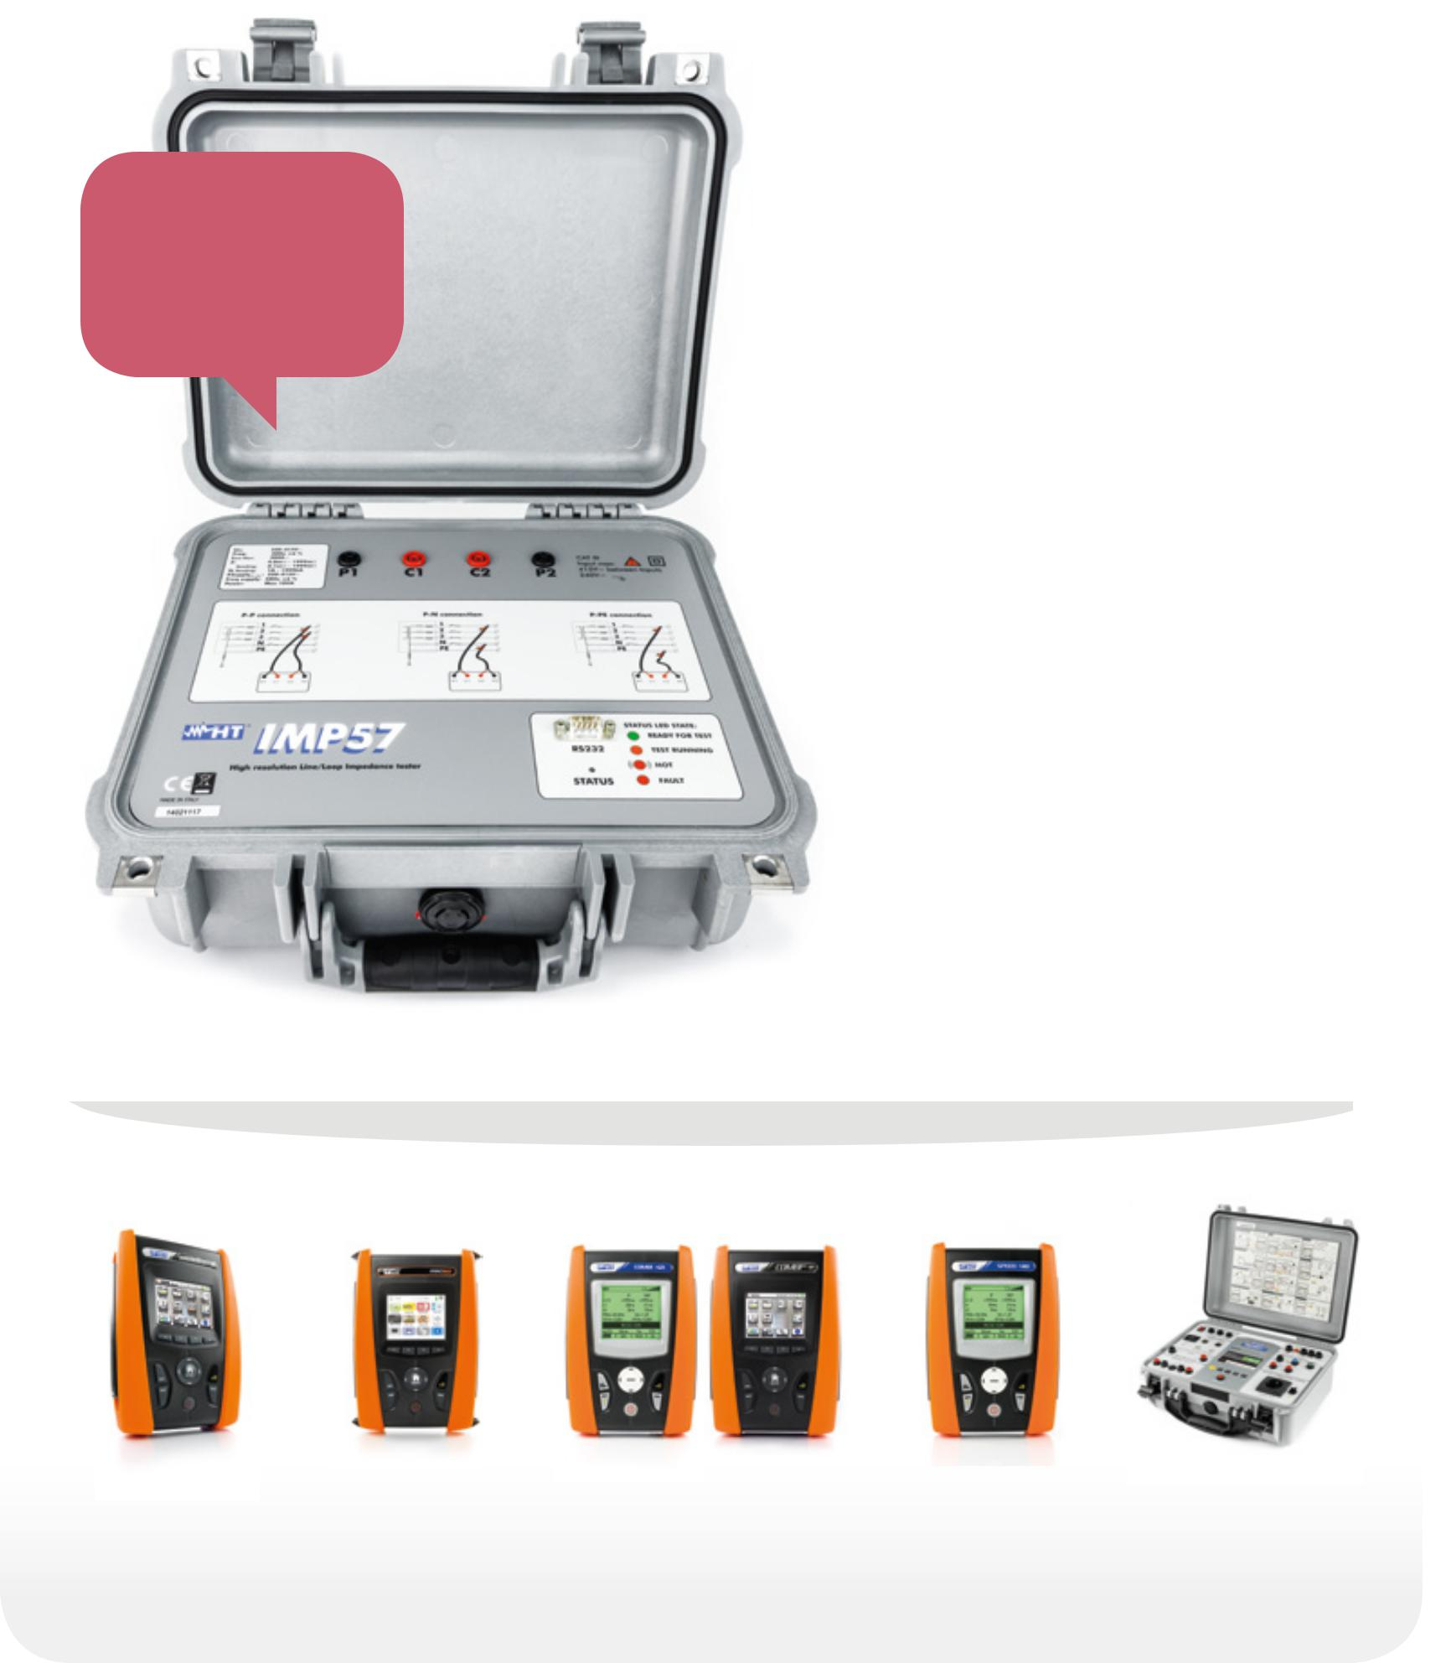

IMP57

ACCESSORY FOR LOOP IMPEDANCE MEASUREMENT WITH HIGH RESOLUTION AND PROSPECTIVE SHORT-CIRCUIT CURRENT UP TO 400kA

IMP57 is an optional to measure Loop/ Line fault loop impedance and calculating the prospective short-circuit current. IMP57 can be used together with the GSC, SIRIUS, Combi and Macrotest Gx series as well as Fulltest3 and Speed418. The high test current (approx. 200A) allows carrying out measurements with high resolution (0.1mΩ), therefore obtaining accurate results even near MV/LV transformer cabinets (TN systems). IMP57 is able to make superior measurements to standard instruments in order to guarantee reliable measurements of prospective short-circuit currents according to the project’s specification. The 4-terminal measuring technique enhances the accuracy by nulling the effect of the provided cables and eliminates the need for preliminary calibrations. IMP57 is provided in a sturdy protective case to protect from weather and shock.
EARTH RESISTANCE
AND STEP/CONTACT
VOLTAGE
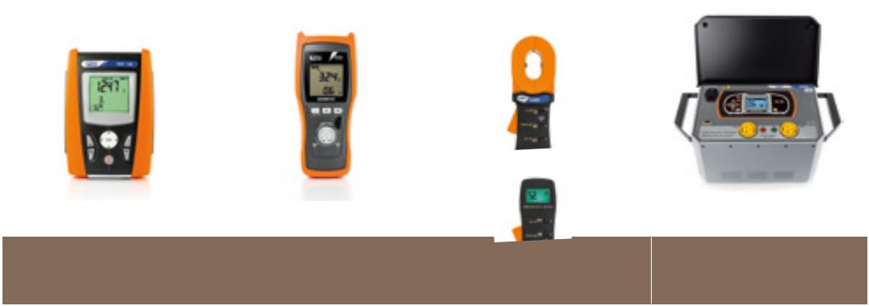
MEASURING DEVICES

Scan the QR code
to discover our whole
line of accessories.

 | GEO416 |  | M71 |  | T2000 - T2100 |  | HT2055
MAIN MEASUREMENTS |  |  | EARTH RESISTANCE |  |  |  | STEP/CONTACT
 |  |  |  |  |  |  | VOLTAGE
TRMS | • |  | • |  | • |  | •
Measuring range | 50KΩ |  | 50KΩ |  | 1KΩ |  | 200Ω
Insulation with voltage 50, 100, 250, 500, 1000VDC | - |  | - |  | - |  | -
Earth resistance by 2 and 3-wire method | • |  | • |  | - |  | •
Ground resistivity by 4-wire method | • |  | - |  | - |  | •
Compensation of disturbance voltages | • |  | • |  | - |  | •
Compensation of test cables | • |  | • |  | - |  | •
Direct measurement on earth probes without any cable | - |  | - |  | • |  | -
interruption
Measurement of leakage current on earth systems | - |  | - |  | • Only for T2000 |  | -
Measurement of step/contact voltage | - |  | - |  | - |  | •
ADDITIONAL CHARACTERISTICS
Measurement category | CAT III 240V |  | CAT III 240V |  | CAT III 150V |  | CAT IV 50V
Detection of disturbance currents on measurement | • |  | • | - |  |  | •
LCD display | • |  | • |  | • |  | •
Backlight | • | - |  |  | • |  | •
AutoPowerOFF | • |  | • |  | • |  | •
Help on line on the display | • | - |  | - |  |  | •
Internal memory | • | - |  |  | • |  | •
Optical/USB serial port for PC connection | • | - |  | - |  |  | • RS-232/USB
USB port for device data download | - | - |  |  | • Only for T2100* | -
Size (LxWxH) (mm) | 225x165x75 |  | 240x100x45 |  | 293x90x66 |  | 230x115x103

IMP57 COMBINATIONS FOR USE

MACROTESTG3 GSC60 COMBIG2 / COMBI42x SPEED418 FULLTEST3

› Page 14 › Page 14 › Page 14/15 › Page 18 › Page 20

Weight in kg (batteries included) | 1,0 | 0,6 | 1,3 | 30,8
Reference standard for safety | IEC/EN61010-1 | IEC/EN61010-1 | IEC/EN61010-1 | IEC/EN61010-1
Order code | HV000416 | HV000071 | HP002000 (T2000) | HN002055
 |  |  | HP002100 (T2100)

* Compatible with Macrotest G1, G2 and G3

16 17

RCD AND LOOP VERIFICATION DEVICES

Scan the QR code
to discover our whole
line of accessories.

MAIN MEASUREMENTS

TRMS

Measuring range of verifiable RCD rated currents

Tripping time of type A, AC General and Selective RCDs

Ramp test for tipping current of RCDs type A, AC Standard

Overall earth resistance with no residual current protection tripping Loop/Line impedance, Phase-Phase, Phase-Neutral, Phase-PE

Loop/Line impedance Phase-Phase Phase-Neutral, Phase-PE with high resolution (0.1mΩ)

Contact voltage

Leakage current with optional clamp

NEW
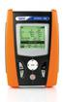
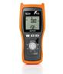
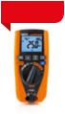

JUPITER | SPEED418 | M73
 | LOOP/RCD
• | • | •
30,100,300mA | 10,30,100,300,500,650,1000mA | 30,30x5,100,300mA
 | • | •
• |  | A = 30mA
Only general | Up to 1A | AC = 300mA
 |  | Only general
• |  | •
 | • | A = 30mA
Only 30mA
 | Up to 650mA | AC = 30mA
only Standard
 |  | Only general
• | • | •
• | • | -
- | •* | -
• | • | •
• | - | •
INSULATION AND CONTINUITY MEASURING DEVICES

Scan the QR code
to discover our whole
line of accessories.

 |  |  |  |  |  |  |  |  |  |  |  |  |  |  |  |  |  |  |  |  | HT7052 | HT7051 | HT701 | EQUITEST | ISO410 | M72 | M70
 |  |  |  |  |  |  |  |  |  |  |  |  |  |  |  |  |  |  |  |  |  |  |  | 5071
MAIN MEASUREMENTS
 |  |  |  |  |  |  |  |  |  |  |  |  |  |  |  |  |  |  |  |  |  |  | INSULATION/CONTINUITY
TRMS |  |  |  |  |  |  |  |  |  |  |  |  |  |  |  |  |  |  |  |  | - | - | • | - | - | • | -
DC test voltage measuring range |  |  |  |  |  |  |  |  |  |  |  |  |  |  |  |  |  |  |  |  | 500V ÷ 10kV | 100V ÷ 5kV | 50,100,250, | - | 50, 100, 250, | 250 / 500V | 250, 500,
 |  |  |  |  |  |  |  |  |  |  |  |  |  |  |  |  |  |  |  |  |  |  | 500,1000V |  | 500, 1000V |  | 1000V
Insulation resistance measuring range |  |  |  |  |  |  |  |  |  |  |  |  |  |  |  |  |  |  |  |  | 120kΩ ÷ 10TΩ | 0.01MΩ | 2MΩ ÷ 22GΩ | - | 0.01MΩ | 0.00MΩ | 0.001MΩ
 |  |  |  |  |  |  |  |  |  |  |  |  |  |  |  |  |  |  |  |  |  | ÷ 9.99TΩ |  |  | ÷ 1999MΩ | ÷ 999MΩ | ÷ 4000MΩ
Dielectric strength in DC |  |  |  |  |  |  |  |  |  |  |  |  |  |  |  |  |  |  |  |  | • | - | - | - | - | - | -
Continuity of protective conductors with 200mA |  |  |  |  |  |  |  |  |  |  |  |  |  |  |  |  |  |  |  |  | - | - | - | • | • | • | •
Continuity 10A |  |  |  |  |  |  |  |  |  |  |  |  |  |  |  |  |  |  |  |  | - | - | - | • | - | - | -
ADDITIONAL FUNCTIONS
Test with programmable ramp |  |  |  |  |  |  |  |  |  |  |  |  |  |  |  |  |  |  |  |  | • steps of 25VDC • steps of 25VDC |  | - | - | - | - | -
Programmable test timer |  |  |  |  |  |  |  |  |  |  |  |  |  |  |  |  |  |  |  |  | • 1s ÷ 30min | • 5s ÷ 100min | - | - | • 10s ÷ 16,6min | - | • 2s ÷ 1min
Setting of measurement limit value |  |  |  |  |  |  |  |  |  |  |  |  |  |  |  |  |  |  |  |  | • | • | - | - | • | - | -
Measurement of polarization index P.I. |  |  |  |  |  |  |  |  |  |  |  |  |  |  |  |  |  |  |  |  | • | • | - | - | - | - | -
Measurement of dielectric absorption ratio D.A.R. |  |  |  |  |  |  |  |  |  |  |  |  |  |  |  |  |  |  |  |  | • | • | - | - | - | - | -

ADDITIONAL FUNCTIONS

DC/AC TRMS voltage and current | • AC+DC, LoZ function | - | •
Phase sequence | • | • | •
Frequency | • | - | •
Resistance | • | - | •
Continuity with buzzer | • | - | •
Data HOLD, MAX/MIN/AVG | • MAX/MIN | - | •

Measurement of dielectric discharge ratio D.D. | • | • | - | - | - | - | -
Measurement of discharge capacity | • | • | - | - | - | - | -
Automatic discharge of target | • | • | • | - | • | • | •
Measurement of DC/AC voltage up to 600V | • | • | • 1000V | - | - | • | •
Measurement of resistance and continuity with buzzer | - | - | - | - | - | • | •
Measurement of phase sequence | - | - | - | - | - | • | -

ADDITIONAL CHARACTERISTICS

Measurement of voltage and current PEAK • - •

Measurement of Voltage/Current harmonics + THD% • - -

Measurement category

Backlight

CAT IV 600V | CAT IV 600V | CAT IV 600V | CAT III 600V | CAT III 265V | CAT III 550V | CAT III 550V
 |  | CAT III 1000V
• | • | • | • | • | - | •

ADDITIONAL CHARACTERISTICS

Measurement category

AUTOMATIC Test

Test with remote lead

Help on line on the display

Internal memory

Optical/USB serial port for PC connection

Size (LxWxH) (mm)

Weight (batteries included)

Reference standard for safety

Order code

* With optional accessory IMP57

CAT IV 600V | CAT III 265V | CAT III 550V
CAT III 690V
- | • | -
- | • | -
- | • | -
- | • | -
- | • | -
175x85x55 | 222x162x57 | 240x100x45
420g | 1kg | 450g
IEC/EN61010-1 | IEC/EN61010-1 | IEC/EN61010-1
HR00JUPI | HV000418 | HV000073

Autocalibration of measuring leads

Guard terminal

Measurements with remote terminal

Internal memory

Recalling on the display the saved results

RS232/optical/USB interface for transferring

data onto the PC

Power supply with rechargeable battery from mains AutoPowerOFF

Power supply

Size in mm (LxWxH)

Weight (batteries included)

Safety

Order code

- | - | - | • | • | • | •
• | • | - | - | - | - | -
- | - | • | - | • | - | -
• | • | • | • | • | - | -
• | • | • | • | • | - | -
• | • | - | • | • | - | -
• | • | - | - | - | - | -
- | • | • | • | • | • | •
6x 1.2V NiMH | Rechargeable | 4 x1.5V tipo AA | 6x 1.5V tipo AA | 6x 1.5V tipo AA | 4x 1.5V AA | 4x 1.5V AA
LR20 | NiMH
360 x 330 x 160 | 360 x 310 x 195 | 207 x 95 x 52 | 225 x 165 x 105 | 222 x 162 x 57 | 240 x 100 x 45 | 240 x 100 x 45
5.5kg | 3.5kg | 630g | 1.7kg | 1kg | 450g | 450g
IEC/EN61010-1 | IEC/EN61010-1 IEC/EN61010-1 |  | IEC/EN61010-1
IEC/EN61557-2 | IEC/EN61557-1-2 IEC/EN61557-1-2 |  | IEC/EN61557-1- IEC/EN61010-1 IEC/EN61010-1 IEC/EN61010-1
 |  |  | 3-4-7
HV007052 | HV007051 | HR000701 | HV005071 | HV000410 | HV000072 | HV000070

18 19

SWITCHBOARDS
AND MACHINE

SAFETY TESTERS

Scan the QR code
to discover our whole
line of accessories.
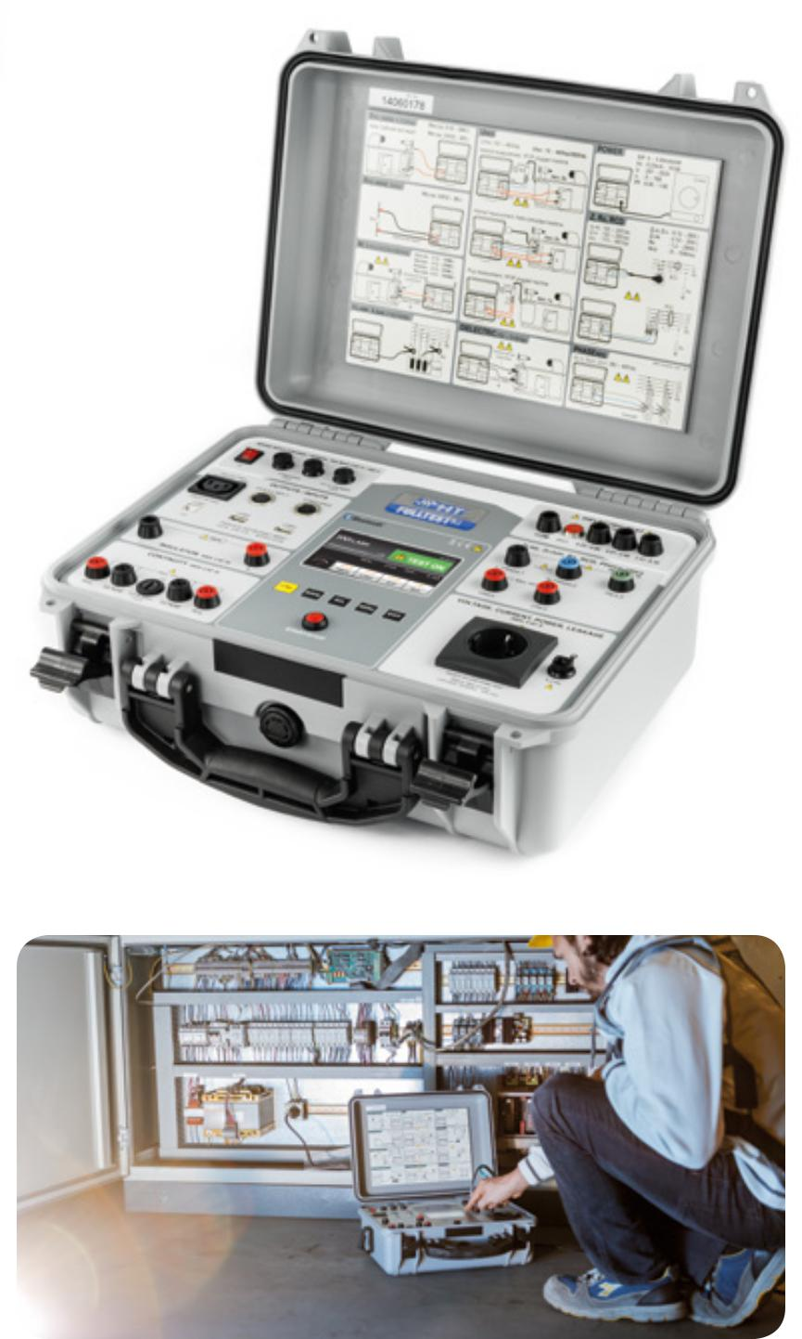

FULLTEST at work
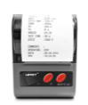

CAT III | CAT II
300V | 300V
SAFETY | FUNCTIONAL
TESTS | TESTS

ORDER CODE HV000003

FULLTEST3

MULTIFUNCTION DEVICE FOR SAFETY TESTS

ON SWITCHBOARDS AND MACHINES ACCORDING TO IEC/EN60204-1:2006 AND IEC/EN61439-1

FULLTEST3 is a cutting-edge device that carries out all measurements required by the new laws IEC/EN60204-1:2006 and IEC/EN61439-1 on electric switchboards and machines. Additionally it measures continuity of protective conductors, insulation and dielectric strength (with test voltage up to 5100V). FULLTEST3 is capable of carrying out tests on RCDs type A, AC and B, General, Selective and Delayed, measurements of Line/ Loop impedance also with high resolution 0.1mΩ (with optional accessory IMP57), measurement of non-trip earth resistance, measurement of leakage current through the on-board outlet or by clamp transducer, and verification of residual voltage on capacitances and phase sequence. FULLTEST3 can also carry out tests on breaking capacity, protection tripping, I2t tests relevant to MCBs in curve B, C, D, K and fuses type gG and aM. FULLTEST3 has a touch-screen colour display and 3 USB ports for connection to PC, memory sticks, printers and bar code readers.
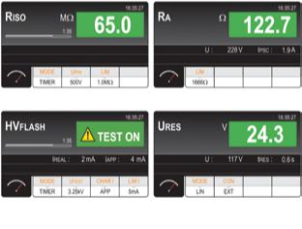

Measurement of insulation resistance Measurement of non-trip earth resistance

Dielectric strength test Residual voltage measurement
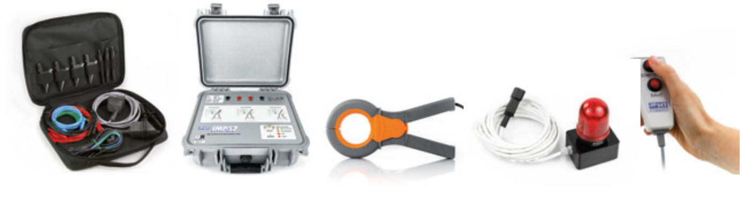

VERIFICATION PHOTOVOLTAIC FIELD
PERFECTION
FOR THE SUN
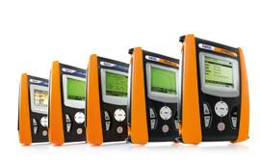

New HT solutions for performance optimization and trou-bleshooting.

Thanks to the decrease in the cost of components and the remarkable increase of performance, installing photovoltaic systems has become increasingly common. In photovoltaic systems, problems connected to safety and to the system’s performance must be checked, and maintenance of strings and single panels must be carried out.

Troubleshooting

- Often, during the operation of a system, some modules may impact the performance of the whole system. When system efficiency is lower than expected, it is necessary to detect the defective modules so that they can be replaced. This can be achieved by measuring the I-V curve with devices such as SOLAR I-Ve, I-V500w and I-V400w.

Commissioning

- When operating a photovoltaic system, it is necessary to certify its safety according to IEC62446. The best device to carry out these verifications is PVCHECKs.

Performance monitoring

- Performance recording is required to make maintenance programs efficient. By monitoring system performance it is possible to certify a production loss quickly and efficiently. SOLAR300N, SOLAR I-Ve and MPP300 are the ideal solution for recording over time the production of a system and the performance check of an inverter.
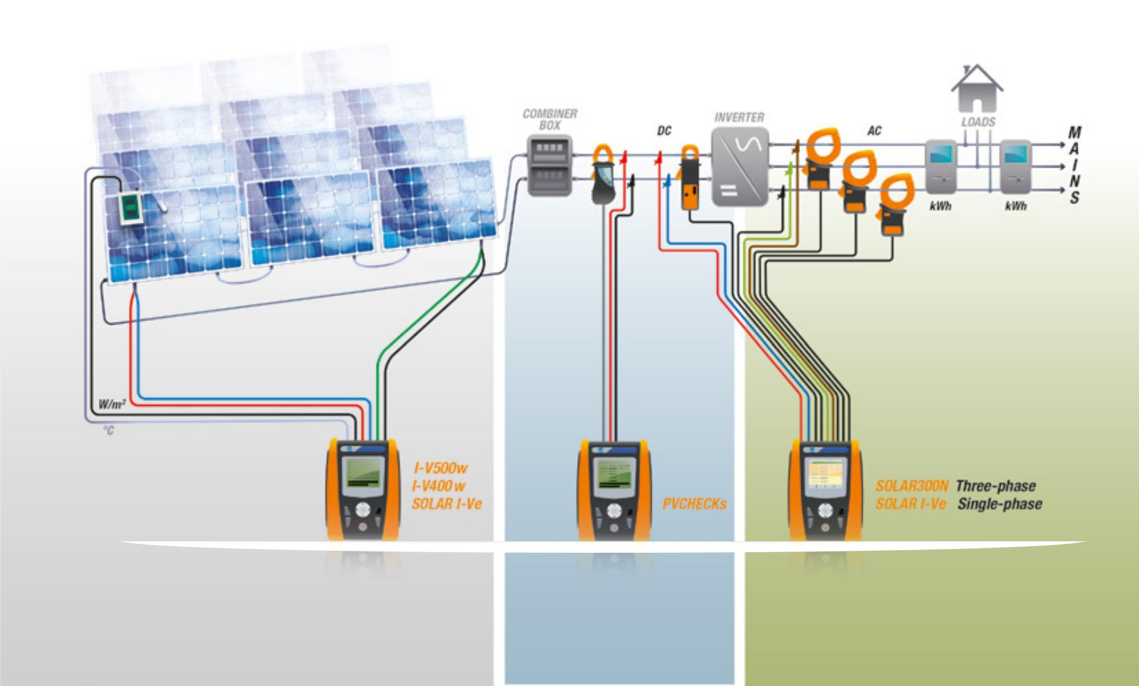

Compact USB printer Soft carrying bag for accessories. IMP57 (Optional) HT96U (Optional) FT3R-GLP (Optional) FT3RMTCT (Optional)

with rechargeable battery

Troubleshooting Commissioning Performance monitoring

20 21

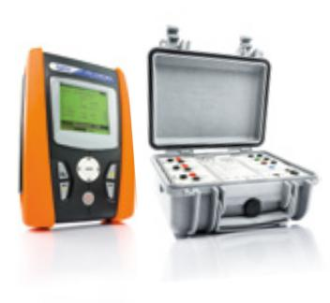
DEVICES FOR PHOTOVOLTAIC FIELDS
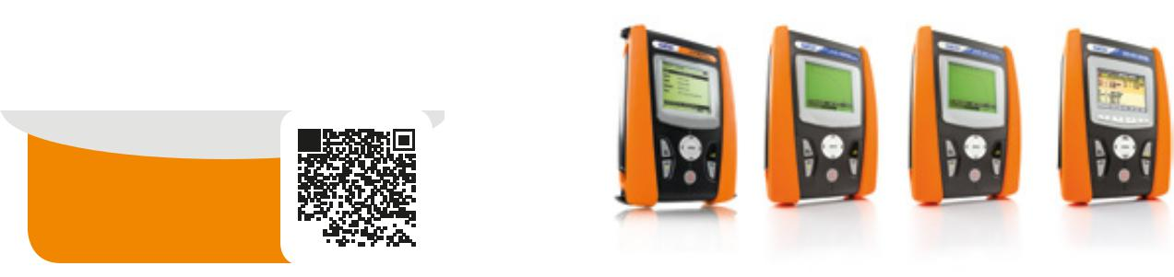

Scan the QR code
to discover our whole
line of accessories.

 |  |  |  |  |  |  |  |  |  |  |  | I-V500w | I-V400w | SOLAR I-Ve SOLAR300N PVCHECKs |  |  | MPP300
MAINTENANCE AND EFFICIENCY |  |  |  |  |  |  |  |  |  |  |  |  | TROUBLESHOOTING, PERFORMANCE AND COMMISSIONING
OF THE PHOTOVOLTAIC SYSTEM
Measurement of I-V curve on PV modules and strings |  |  |  |  |  |  |  |  |  |  |  | • | • | • | - | - | -
Automatic measurement with AutoSequence™* mode |  |  |  |  |  |  |  |  |  |  |  | • | • | • | - | - | -
Quick IVCK test for measuring Voc and Isc on PV modules and strings |  |  |  |  |  |  |  |  |  |  |  | • | • | • | - | • | -
 |  |  |  |  |  |  |  |  |  |  |  |  |  | • 1MPPT | • 1MPPT
Single-phase/three-phase photvoltaic systems’ testing |  |  |  |  |  |  |  |  |  |  |  | - | - | (3MPPT with | (3MPPT with | - | •
 |  |  |  |  |  |  |  |  |  |  |  |  |  | MPP300) | MPP300)
Continuity of protective conductors with 200mA |  |  |  |  |  |  |  |  |  |  |  | - | - | - | - | • | -
PV strings/field insulation with no service interruption |  |  |  |  |  |  |  |  |  |  |  | - | - | - | - | • | -
with test voltage 250, 500, 1000V DC
DC side efficiency of the photovoltaic field |  |  |  |  |  |  |  |  |  |  |  | - | - | - | • | • | -
Use of remote unit SOLAR-02 with USB \ RF connection |  |  |  |  |  |  |  |  |  |  |  | • RF | • RF | • RF | • USB | • RF | • RF
 |  |  |  |  |  |  |  |  |  |  |  |  |  |  |  |  | • USB
Measurement of irradiation with reference cell |  |  |  |  |  |  |  |  |  |  |  | • | • | • | • | • | -
Temperature measurement of cell and environment |  |  |  |  |  |  |  |  |  |  |  | • | • | • | • | • | -
MAINS ANALYSIS
AC/DC voltage in single-phase/three-phase systems |  |  |  |  |  |  |  |  |  |  |  | - | - | - | • | • DC | •
AC/DC current in single-phase/three-phase systems |  |  |  |  |  |  |  |  |  |  |  | - | - | - | • | • DC | •
Cosphi, Power Factor |  |  |  |  |  |  |  |  |  |  |  | - | - | - | • | - | -
Voltage unbalance (NEG%, ZERO%) |  |  |  |  |  |  |  |  |  |  |  | - | - | - | • | - | -
Active P, Reactive Q, Apparent S Power/Energy |  |  |  |  |  |  |  |  |  |  |  | - | - | • Only active P | • | • Only active P | -
Voltage and current harmonics up to the 49th with calculation of THD% |  |  |  |  |  |  |  |  |  |  |  | - | - | - | • | - | -
Voltage anomalies (dips, peaks) with a resolution of 10ms (@ 50Hz) |  |  |  |  |  |  |  |  |  |  |  | - | - | - | • | - | -
Voltage spikes with a resolution of 5µs (200kHz) |  |  |  |  |  |  |  |  |  |  |  | - | - | - | • | - | -
Electric motor starting current (INRUSH) |  |  |  |  |  |  |  |  |  |  |  | - | - | - | • | - | -
Voltage flickers (Pst, Plt) |  |  |  |  |  |  |  |  |  |  |  | - | - | - | • | - | -
Full analysis EN50160 |  |  |  |  |  |  |  |  |  |  |  | - | - | - | • | - | -
Phase sequence |  |  |  |  |  |  |  |  |  |  |  | - | - | - | • | - | -
Neutral-Ground Voltage |  |  |  |  |  |  |  |  |  |  |  | - | - | - | • | - | -
Neutral current |  |  |  |  |  |  |  |  |  |  |  | - | - | - | • | - | -
MEMORY AND RECORDING
Max number of simultaneously selectable parameters |  |  |  |  |  |  |  |  |  |  |  | - | - | 9 | 251 | 5 | -
Recording with selectable integration period |  |  |  |  |  |  |  |  |  |  |  | - | - | 5s-60m | 1s-60m | 5s-60m | 1s-60m
Indicative memory duration (in days @ PI=10min @ max number of parameters) |  |  |  |  |  |  |  |  |  |  |  | - | - | 8 | 90 | - | 8

 |  | I-V500w |  | I-V400w |  | SOLAR I-Ve SOLAR300N PVCHECKs |  |  |  |  |  | MPP300
››› FOLLOWS
 |  |  |  | TROUBLESHOOTING, PERFORMANCE AND COMMISSIONING
Internal memory extension with Compact Flash card |  | - |  | - |  | - |  | • |  | - |  | -
Default and custom recordings |  | - |  | - |  | - |  | • |  | - |  | -
REAL-TIME DISPLAY
Summary table of main electric parameters |  | • |  | • |  | • |  | • |  | •
 |  |  |  |  |  |  |  |  |  |  |  | -
Voltage/current waveforms |  | - |  | - |  | - |  | • |  | - |  | -
Tables or histograms of Harmonics and THD% |  | - |  | - |  | - |  | • |  | - |  | -
Voltage/current vector diagram |  | - |  | - |  | - |  | • |  | - |  | -
ADDITIONAL CHARACTERISTICS
Measuring range of curve I-V / Isc-Voc |  | 1500V / 15A** |  | 1000V / 15A |  | 1500V / 15A** |  | - |  | 1000V / 15A |  | -
 |  |  |  |  |  |  |  |  |  | Isc-Voc only
 |  |  |  |  |  | 1000VDC / |  | 1000VAC-DC |  |  |  | 1000VDC /
Measuring range for photovoltaic testing |  | - |  | - |  |  |  |  |  | - |  | 600VAC
 |  |  |  |  |  | 265VAC |  | 3000A |  |  |  | 3000AC /
 |  |  |  |  |  |  |  |  |  |  |  | 1000ADC
Measurement category |  | CAT III 300V |  | CAT III 300V |  | CAT III 300V |  | CAT IV 600V |  | CAT III 300V |  | CAT IV 300V
Touchscreen colour display |  | - |  | - |  | - |  | • |  | - |  | -
Backlit LCD display |  | • |  | • |  | • |  | - |  | • |  | -
 |  |  |  |  |  | 200 curves I-V |  | 15MB |  | 999 |  | 2MB
Internal memory capacity |  | 200 curves I-V |  | 200 curves I-V |  | 8 days@ PI=10 |  | 90 days@ PI |  |  |  | 8 days@ PI=10
 |  |  |  |  |  |  |  |  |  | Locations
 |  |  |  |  |  | min |  | 10min |  |  |  | min
USB port for data download onto Pen Drive |  | - |  | - |  | - |  | • |  | - |  | -
Provided PC interface with software for Windows |  | • |  | • |  | • |  | • |  | • |  | -
Built-in WiFi communication interface |  | • |  | • |  | • |  | - |  | - |  | -
Custom management of internal PV module database |  | • |  | • |  | • |  | - |  | • |  | -
Power supply with rechargeable battery and battery charger |  | - |  | - |  | - |  | • |  | - |  | •
Auto power off |  | • |  | • |  | • |  | • |  | • |  | •
Indication of recording duration for photovoltaic testing |  |  |  |  |  | • |  | • |  | - |  | -
Reference standard for mains quality |  | - |  | - |  | - |  | EN50160 |  | - |  | -
Help on line on the display |  | • |  | • |  | • |  | • |  | • |  | -
Size (LxWxH) (mm) |  | 235x165x75 |  | 235x165x75 |  | 235x165x75 |  | 235x165x75 |  | 235x165x75 |  | 300x265x214
Weight in kg (batteries included) |  | 1,2 |  | 1,2 |  | 1,2 |  | 1 |  | 1,2 |  | 2,3
Reference standard for safety |  | IEC/EN61010-1 |  | IEC/EN61010-1 |  | IEC/EN61010-1 |  | IEC/EN61010-1 |  | IEC/EN61010-1 |  | IEC/EN61010-1
Order code |  | HV00500W |  | HV00400W |  | HV000IVW |  | HV00300N |  | HV00PVCS |  | HVMPP300
* Optional set of leads KIT KELVIN necessary. | ** Only I-V500w and SOLAR I-Ve (max current @1500V=10A, max current @1000V=15A).

22 23

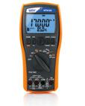
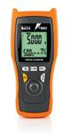
PROCESS
CALIBRATORS

Scan the QR code
to discover our whole
line of accessories.

CALIBRATION MEASUREMENTS |  | HT8051 |  | HT8100
TRMS |  | • |  | •
DC 4-20mA current measurement |  | • |  | •
DC 0-10V voltage measurement |  | • |  | •
DC 4-20mA current generation |  | • |  | •
DC 0-10V voltage generation |  | • |  | -
Measurement of output current of transducers |  | • |  | •
Simulation of an external transducer |  | • |  | •
Loop supply with minimum voltage 24V |  | • |  | •
Generation of selectable ramp |  | • |  | •
Load of 250Ω for testing HART transducers |  | - |  | •
MULTIMETER MEASUREMENTS
AC/DC voltage |  | • MAX 10VDC |  | •
AC+DC voltage |  | - |  | •
AC/DC current |  | • MAX 24mADC |  | • 1A
AC+DC current |  | - |  | •
Resistance and buzzer continuity |  | - |  | •
Frequency |  | - |  | •
Diode test |  | - |  | •
ADDITIONAL CHARACTERISTICS
Measurement category |  | CAT IV 600V |  | CAT IV 600V
Measuring counts |  | - |  | 50.000
Backlight |  | • |  | •
Autorange |  | - |  | •
Auto power off |  | • |  | •
Data HOLD function |  | - |  | •
MIN/MAX function |  | - |  | •
AVG function |  | - |  | •
Relative measurement |  | - |  | •
Internal memory |  | - |  | •
Power supply |  | 1x7.4/8.4V 600mAh Li-ION |  | 4x1.5V AA
Size (LxWxH) (mm) |  | 195x92x55 |  | 207x95x52
Weight (batteries included) |  | 400g |  | 630g
Safety |  | IEC/EN61010-1 |  | IEC/EN61010-1
Order code |  | HV080510 |  | HV008100

INFRARED
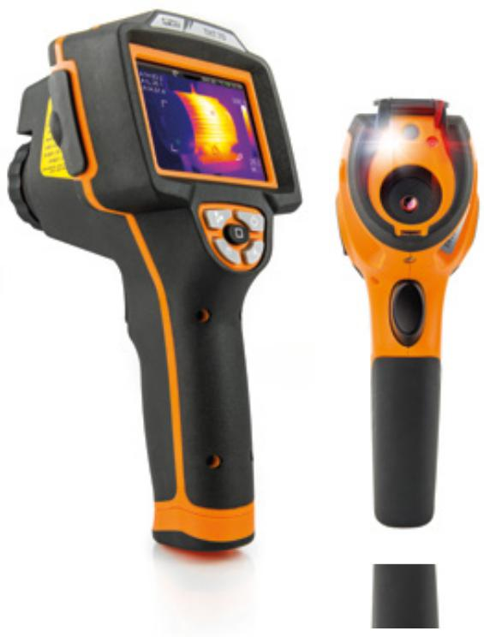
THERMAL CAMERAS
Simply
advanced.
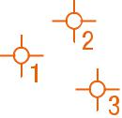

Capacitive |  |  |  |  |  |  |  |  |  |  | Interchangeable | Laser |  | Optical thermal | Integrated | Up to 3 independent | Preset
touch screen |  |  |  |  |  |  |  |  |  |  | optics | pointer |  | camera | Flash LED | pointers | selection
extra-bright |  |  |  |  |  |  |  |  |  |  | Optional equipment |  |  | in visible range |  |  | properties
 |  |  |  |  |  |  |  |  |  |  |  | 384x288 |  |  |  |  | of materials
 |  |  |  |  |  |  |  |  |  |  |  | 160 x120
 |  |  |  |  |  |  |  |  |  |  |  | 80 x | 80
 |  |  |  |  |  |  |  |  |  |  |  | 32 x | 31
 |  |  |  |  |  |  |  |  |  |  |  | p i x | e l |  | PC USB 2.0 connection |  | THT45
Multi-areas |  |  |  |  |  |  |  |  |  |  | Fluid image | High resolution |  | P.i.P. fusion
with independent |  |  |  |  |  |  |  |  |  |  | also on moving | for sharp |  | Overlapping | HDMI video output |  | Use with the
 | pointers |  |  |  |  |  |  |  |  |  | targets | images |  | visual + thermo- |  | Data saving | THTview*** App
 |  |  |  |  |  |  |  |  |  |  |  |  |  |  |  |  | for iOS™ and
 |  |  |  |  |  |  |  |  |  |  |  |  |  | graphic image | on MicroSD card |  | Android™ systems
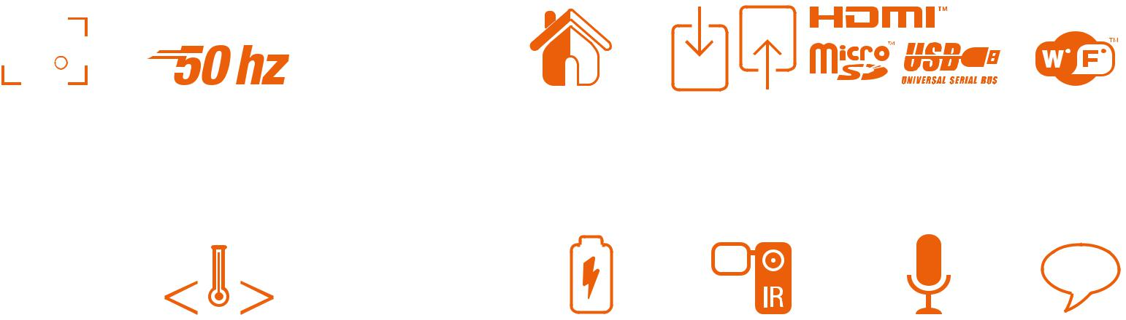

0,06 °C
Temperature | Automatic | Higher | Rechargeable | Recording of | Voice notes | Text notes
range | adjustment | thermal | batteries | of IR videos
−20 +400 °C | of SPAN | sensitivity | and battery
 |  |  | chargers

Industrial, electrical or construction. Excellent in any sector.

The new THT range makes use of a highly innovative technology to deliver performance at affordable prices.

The use of IR technology today applies to many sectors, from industry to construction, from systems to installation. Thanks to the innovative icon display, the wide capacitive touch screen display and the very high infrared resolution with 384x288 pixels and 160x120 pixels (80x80 pixels for THT45), identifying those problems which are not visible to the naked eye becomes simpler and more intuitive.

The new THT thermal cameras are provided with Flash Led*, Laser pointer*, photo-camera for visual images and PiP* and optional interchangeable optics**. With the provided 4GB memory card, with which you will be able to take hundreds of pictures, it will be possible to prepare reports complete with images, audio and text comments. With the new THT thermal cameras, thermographic analysis will be simple and quick.

* THT70, THT60 and THT45. ** Only THT60 and THT70. *** The THTview App is available for free download in the Apple Store™ and Google Play™ store.

24 25

INFRARED
THERMAL |  |  |  |  |  |  |  |  |  |  |  | NEW
CAMERAS
Scan the QR code
to discover our whole
line of accessories.
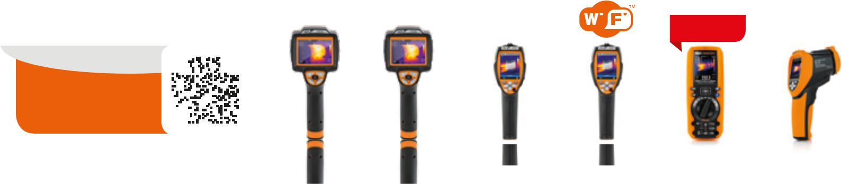

CHARACTERISTICS OF IR IMAGE |  | THT70 |  | THT60 |  | THT46 |  | THT45 |  | MERCURY |  | THT32
IR sensor resolution |  | 384 x 288 |  | 160 x 120 |  | 160 x 120 |  | 80 x 80 |  | 80 x 80 |  | 32 x 31
Temperature range |  | -20 ÷ 400°C |  | -20 ÷ 400°C |  | -20 ÷ 350°C |  | -20 ÷ 350°C |  | - 20 ÷ 260°C |  | -20 ÷ 300°C
 |  | -4 ÷ 752°F |  | -4 ÷ 752°F |  | -4 ÷ 662°F |  | -4 ÷ 662°F |  | - 4 ÷ 500°F |  | -4 ÷ 572°F
Thermal sensitivity |  | < 0.06°C @ 30°C |  | < 0.08°C @ 30°C |  | < 0.1°C @ 30°C |  | < 0.1°C @ 30°C |  | < 0.1°C @ 30°C |  | < 0.15°C @ 25°C
NETD |  | < 60mK |  | < 80mK |  | < 100mK |  | < 100mK |  | < 100mK |  | < 150mK
Spectrum range |  | 8 ÷ 14µm |  | 8 ÷ 14µm |  | 8 ÷ 14µm |  | 8 ÷ 14µm |  | 8 ÷ 14µm |  | 6.5 ÷ 14µm
IFOV (@1m) |  | 1.14mrad |  | 3.33mrad |  | 2.78mrad |  | 3.78mrad |  | 4.86mrad |  | 21mrad
Type of IR sensor |  | UFPA |  | UFPA |  | UFPA |  | UFPA |  | UFPA |  | UPC
Frequency |  | 50Hz |  | 50Hz |  | 50Hz |  | 50Hz |  | 50Hz |  | 9Hz

NEW
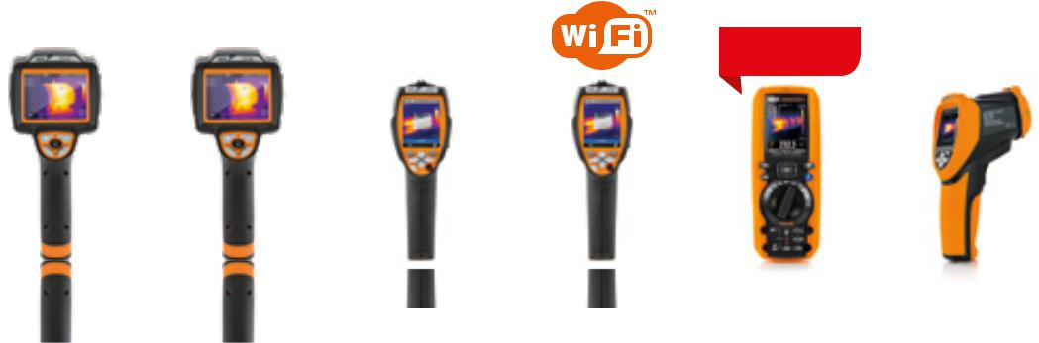

DATA SAVING |  | THT70 |  | THT60 |  | THT46 |  | THT45 |  | MERCURY |  | THT32
Standard format of saved images JPEG |  | • |  | • |  | • |  | • |  | • (BMP) |  | • (BMP)
Saving of IR videos and audio comments in MPEG4 format |  | • |  | • |  | • |  | • |  | - |  | -
Voice and text annotation |  | • |  | • |  | - |  | - |  | - |  | -
ADDITIONAL CHARACTERISTICS
Capacitive touch-screen colour display |  | • |  | • | - |  | - |  | - |  | -
Power supply with rechargeable battery |  | • |  | • |  | • |  | • |  | • |  | •
USB interface to PC and THTLink software |  | • |  | • |  | • |  | • | - |  |  | • (No software)
PAL/NTSC video output |  | • |  | • |  | • HDMI |  | • HDMI | - |  | -
WiFi function for connection to mobile devices | - |  | - |  | - |  |  | • with APP THTview | - |  | -
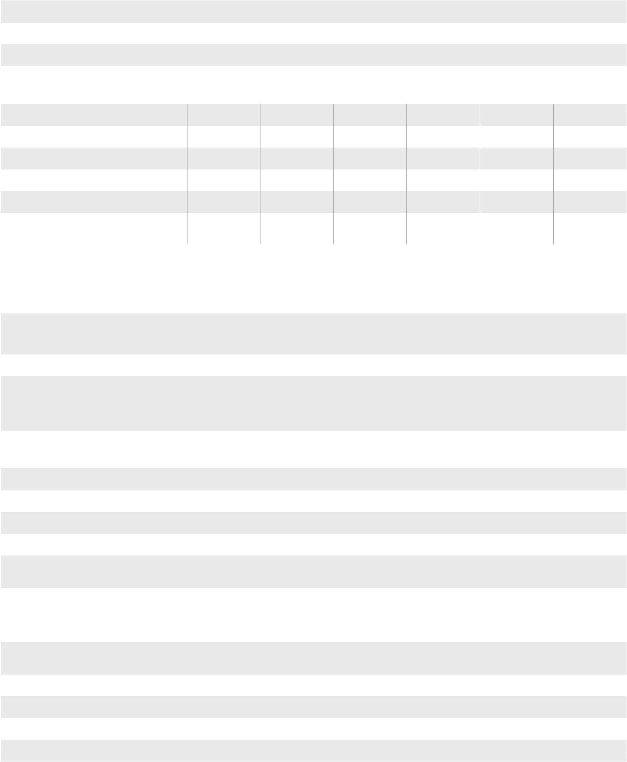

CHARACTERISTICS OF IR OPTICS AND BUILT-IN PHOTO CAMERA

Field of view (FOV)

Focus width of standard lens

Focusing of IR optics

Resolution and FOV of visual camera

Interchangeable optics

FUNCTIONS

Fusion PiP function for combination of thermal and visual images

3 cursors: Central, Min, Max.

Advanced analysis: Spots, Lines,
Areas on images and Isotherm line function

Correction according to distance,
reflected temperature and relative humidity

Colour palettes

Integrated table with emissivity values of common materials

Alarm thresholds on temperature measurement

Readings in °C, °F, °K

Class 2 laser pointer

Integrated white light illuminator

Digital zoom

Manual and automatic span

Vertical and horizontal lines

24.6° X 18.6° | 29.8° X 22.6° | 25° X 19° | 17° X 17° | 21° X 21° | 38° X 38°
(provided optics) | (provided optics)
22mm | 7.5mm | 9mm | 9mm | 7,5mm | 10mm
Manual | Manual | Manual | Manual | Fixed | Fixed
640 x 480pxl, | 640 x 480pxl, | 1.3Mpxl, | 1.3Mpxl, | - | 320 x 240pxl
FOV 62.3° | FOV 62.3° | FOV 59° | FOV 59°
• | • | - | - | - | -

• | • | • | • | - | • (Blending)
• | • | • | • | • | •
• | • | - | - | - | -
 |  | • | • |  | •
• | • | Only reflected | Only reflected | - | Only reflected
 |  | temperature | temperature |  | temperature
• | • | • | • | • | •
8 standard | 8 standard
 |  | 4 standard | 4 standard | 4 standard | 5 standard
+ 10 custom | + 10 custom
• | • | • | • | - | -
• | • | - | - | - | •
• | • | • | • | • | •
• | • | • | • | • | -
• | • | • | • | • | -
1x ÷ 20x | 1x ÷ 20x | 1x ÷ 32x | 1x ÷ 32x | - | -
• | • | • | • | Auto only | Auto only
• | • | - | - | - | -

Bluetooth function for connection to mobile devices | - |  | - |  | - |  | - |  |  | • with APP | -
 |  |  |  |  |  |  |  |  |  | HTMercury
POWER SUPPLY
Battery type |  | rechargeable Li-ION |  | rechargeable Li-ION |  | rechargeable Li-ION |  | rechargeable Li-ION |  | rechargeable Li-ION |  | rechargeable Li-ION
 |  | 7,4V 2700mAh |  | 7,4V 2700mAh |  | 3,7V 2000mAh |  | 3,7V 2000mAh |  | 7,4V 2300mAh |  | 3,7V 1400mAh
 |  | On thermal camera |  | On thermal camera |  | On thermal |  | On thermal |  | External |  | On thermal
Recharging system |  | or external |  | or external
 |  |  |  |  |  | camera |  | camera |  | recharging base |  | camera
 |  | recharging base |  | recharging base
Duration |  | 4.5 hours |  | 4.5 hours |  | 4 hours |  | 4 hours |  | 2 hours |  | 2 hours
 |  | External |  | External |  | External power |  | External power |  | External power |  | External power
 |  | power supply |  | power supply |  | supply
External power supply |  |  |  |  |  |  |  | supply 100/240VAC |  | supply 100/240VAC |  | supply 100/240VAC
 |  | 100/240VAC |  | 100/240VAC |  | 100/240VAC
 |  |  |  |  |  |  |  | (50/60Hz)/5VDC |  | (50/60Hz)/10VDC |  | (50/60Hz)/5VDC
 |  | (50/60Hz)/12VDC |  | (50/60Hz)/12VDC |  | (50/60Hz)/5VDC
GENERAL CHARACTERISTICS
Operating temperature |  | -20°C ÷ 50°C |  | -20°C ÷ 50°C |  | -15°C ÷ 50°C |  | -15°C ÷ 50°C |  | 5°C ÷ 40°C |  | 0°C ÷ 50°C
Operating humidity |  | 10% ÷ 90%HR |  | 10% ÷ 90%HR |  | 10% ÷ 90%HR |  | 10% ÷ 90%HR |  | <80%RH |  | 10% ÷ 90%HR
Storage temperature |  | -40°C ÷ 70°C |  | -40°C ÷ 70°C |  | -40°C ÷ 70°C |  | -40°C ÷ 70°C |  | -20°C ÷ 60°C |  | -20°C ÷ 60°C
Storage humidity |  | 10% ÷ 90%HR |  | 10% ÷ 90%HR |  | 10% ÷ 90%HR |  | 10% ÷ 90%HR |  | <80%RH |  | 10% ÷ 90%HR
Ingress protection |  | IP65 in compliance |  | IP65 in compliance |  | IP50 in compliance |  | IP50 in compliance |  | IP65 in compliance |  | IP42 in compliance
 |  | with IEC529 |  | with IEC529 |  | with IEC529 |  | with IEC529 |  | with IEC529 |  | with IEC529
 |  | 25G, |  | 25G, |  | 25G, |  | 25G,
Shock |  | in compliance |  | in compliance |  | in compliance |  | in compliance |  | - |  | -
 |  | with IEC60068- |  | with IEC60068- |  | with IEC60068- |  | with IEC60068-
 |  | 2-29 |  | 2-29 |  | 2-29 |  | 2-29
Vibrations |  | 2G, in compliance |  | 2G, in compliance |  | 2G, in compliance |  | 2G, in compliance |  | - |  | -
 |  | with IEC60068-2-6 |  | with IEC60068-2-6 |  | with IEC60068-2-6 |  | with IEC60068-2-6
Falling test |  | 2m |  | 2m |  | 2m |  | 2m |  | - |  | -
Size (L x W x H) |  | 243x103x160mm |  | 243x103x160mm |  | 224x77x96mm |  | 224x77x96mm |  | 190x75x55mm |  | 205x155x62mm
Weight (battery included) |  | 0.92kg |  | 0.92kg |  | 0.5kg |  | 0.5kg |  | 0.55kg |  | 0.4kg
Order code |  | HN000070 |  | HN000600 |  | HN000046 |  | HN000045 |  | HR000MER |  | HN000032

26 27

THERMOMETERS
AND THERMO- ^{NEW}
ANEMOMETERS

Scan the QR code
to discover our whole
line of accessories.
NEW
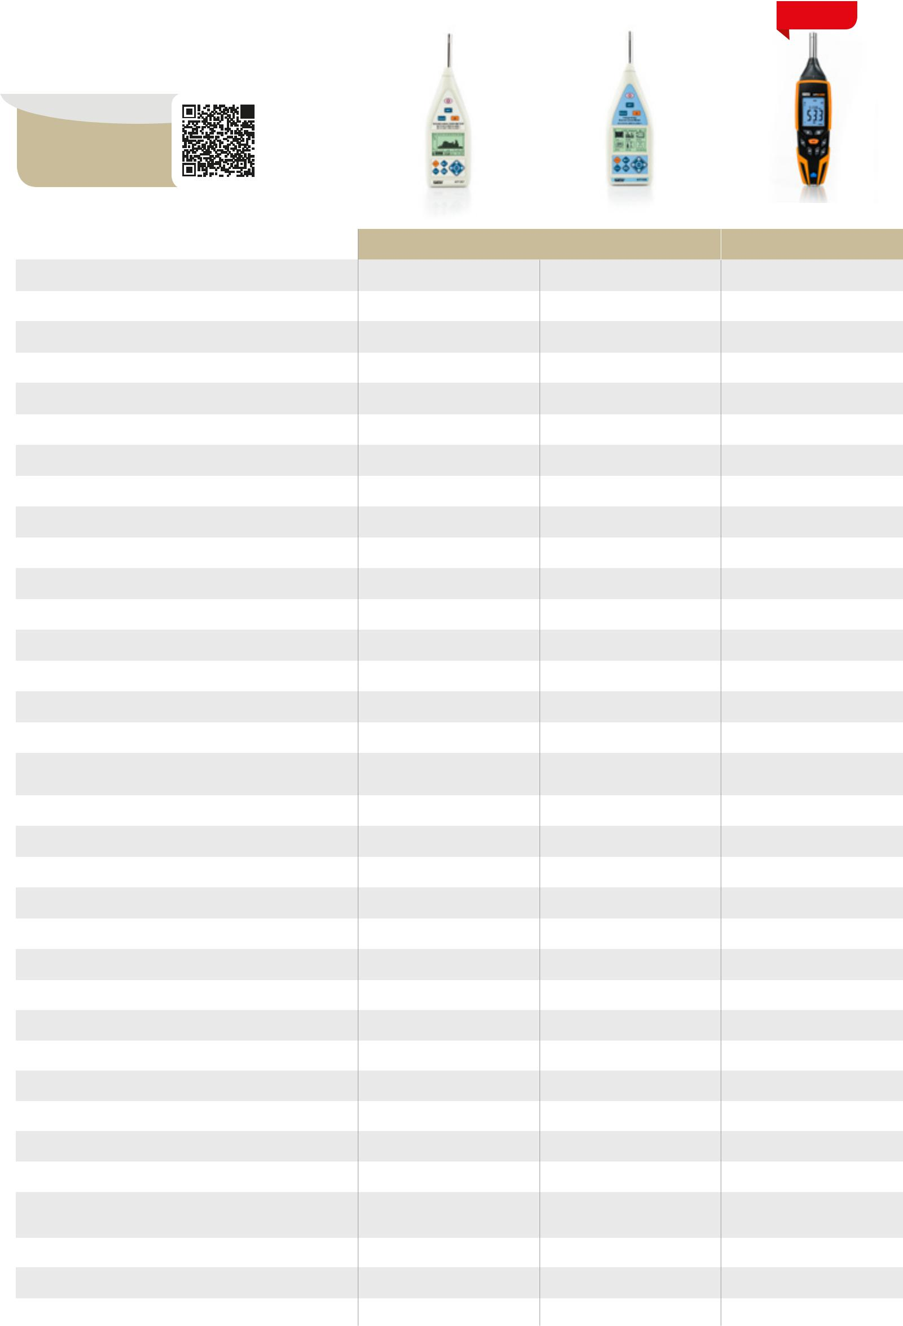

SOUND
LEVEL METERS

Scan the QR code
to discover our whole
line of accessories.

MAIN MEASUREMENTS

Distance / infrared spot ratio

Infrared temperature measuring range

Temperature measuring range with K-type probe

Temperature measurement with K-type probes

Measurement of volumetric capacity (m3/s)
and enthalpy (kW)

Measurement of air relative humidity in %RH

Measurement of wind speed in m/s

4 inputs with PT100 DIN with three wires available

3 outputs with independent relays 5A/250V Integrated photo-camera (640x480pxl) Image saving in JPG format Video saving in 3GP format

Measurement of air temperature/humidity with built-in sensor

Temperature measurement of dew point and of wet bulb

Datalogger function for temperature measure recording

HTA103 | HTA105 |  | HTA106 |  | HTA107 |  | HT3320 |  | HT3302 |  | HT3300 |  | HT950N
 | - |  | - |  | 8:1 |  | 50:1 |  | 12:1 |  | 12:1 |  | -
-
- | - |  | - |  | -50 ÷ 200°C |  | -50 ÷ 1000°C |  | -30 ÷ 500°C |  | -50 ÷ 380°C |  | -
 |  |  |  |  | -58 ÷ 392°F |  | -58°F ÷ 1832°F |  | -22°F ÷ 932°F |  | -58 ÷ 716°F
 |  |  |  |  |  |  |  |  |  |  |  |  | With probe
-250 ÷ 1372°C | - |  | - |  | - |  | -200 ÷ 1370°C |  | - |  | - |  | PT100
-418 ÷ 2502°F |  |  |  |  |  |  | -328 ÷ 2498°F |  |  |  |  |  | 0 ÷ 200°C
 |  |  |  |  |  |  |  |  |  |  |  |  | 32÷ 392°F
• | - |  | - |  | - |  | • |  | - |  | - |  | -
- | • |  | - |  | - |  | - |  | - |  | - |  | -
- | • |  | • |  | • (and materials) |  | • |  | - |  | - |  | -
- | • |  | - |  | - |  | - |  | - |  |  |  | -
 | (hot-wire sensor)
- | - |  | - |  | - |  | - |  | - |  | - |  | •
- | - |  | - |  | - |  | - |  | - |  | - |  | •
- | - |  | - |  | - |  | • |  | - |  | - |  | -
- | - |  | - |  | - |  | • |  | - |  | - |  | -
- | - |  | - |  | - |  | • |  | - |  | - |  | -
- | • |  | • |  | • |  | • |  | - |  | - |  | -
- | - |  | • |  | • |  | • |  | - |  | - |  | -
- | - |  | - |  | - |  | • |  | - |  | - |  | -

 | HT157 | HT155 | HTA102
 |  | CLASS 1 | CLASS 2
Device category (Class) | Class 1 | Class 1 | Class 2
Noise measuring range | 25 ÷ 140dB | 25 ÷ 140dB | 30 ÷ 130dB
Noise measurement resolution | 0.1 ÷ 0.01dB | 0.1dB | 0.1dB
Frequency range | 10kHz ÷ 20kHz | 10kHz ÷ 20kHz | 31.5kHz ÷ 8kHz
Dynamic range | 90dB | 90dB | 50dB
Measurement of sound pressure level (SPL) | • | • | •
Measurement of equivalent noise levels (Leq) | • | • | -
Frequency weighting | A/C/Z | A/C/Z | A/C
Integration over time | Fast/Slow/Impulse | Fast/Slow/Impulse | Fast/Slow
Integration with programmable period | • | • | •
Peak measurements (Peak-, Peak+) | • | • | -
Display of MAX/MIN values of SPL | • | • | •
Statistic analysis of noise with “A” weighting | • | • | -
SPL analysis in 24H | • | • | -
Spectrum analysis with octave-band filter (1/1) | • 19Hz ÷ 16kHz | - | -

ADDITIONAL CHARACTERISTICS

Emissivity adjustment of target | - | - | - | Fixed >0.95 | • | • | Fixed >0.95 | -
Setting of alarm thresholds on measurements | - | - | - | • | • | • | • | -
Continuous measurement | - | - | - | - | • | - | - | •
Class 2 integrated laser pointer | - | - | - | • | • | • (Class 3R) | • (Class 2) | -
Blue LED built-in illuminators for UV function | - | - | - | - | - | • | - | -
Internal memory | - | - | - | • | • | - | - | -
SD Card slot for measure saving | - | - | - | - | • | - | - | -
PC connection through USB cable | - | - | - | - | • | - | - | -
Backlight | • | • | • | • | • | • | • | -
Autorange | • | • | • | • | • | • | • | •
Data HOLD | • | • | • | • | • | • | • | -
MAX/MIN/AVG | • (MAX/MIN) | • (MAX/MIN) | • (MAX/MIN) | • (MAX/MIN) | • | • | • (MAX/MIN) | • MAX
Selection of measuring unit | • | • | • | • | • | • | • | -
 |  |  |  |  | °C \ °F | °C \ °F | °C \ °F | °C
DC analogue output | - | - | - | - | - | - | - | -
Automatic compensation of PT100 cable resistance | - | - | - | - | - | - | - | •
Low battery indication | • | • | • | • | • | • | • | -
Auto Power OFF | • | • | • | • | • | • | • | -
 |  |  |  |  | Rechargeable |  |  | AC/DC
Power supply | 1x9V 6F22 | 1x9V 6F22 | 1x9V 6F22 | 1x9V 6F22 |  | 3x1,5V AA | 1x9V 6F22 | 24 ÷ 240V
 |  |  |  |  | battery
 |  |  |  |  |  |  |  | 50/60Hz
Size in mm (LxWxH) | 185x60x40 | 185x60x40 | 185x60x40 | 185x60x40 | 205x155x62 | 185x104x54 | 136x75x40 | 96x96x110
Weight in grams (batteries included) | 180 | 180 | 180 | 180 | 410 | 380 | 140 | 800
Order code | HN000103 | HN000105 | HN000106 | HN000107 | HA000179 | HA003302 | HA003300 | HA000950

Spectrum analysis with 1/3 octave-band filter | • | - | -
Mobile calibrator provided | • | • | •
 | Class 1 | Class 1 | Class 2
Manual calibration with trimmer | • | • | •
Precise calibration with internal procedure | • | • | -
Pre-polarized “1/2” condenser microphone | • | • | •
AC and DC analogue outputs with 3.5mm jack | • AC only | • AC only | •
Internal memory for data saving | 128 | 128 | •
Recalling of results on the display | • | • | -
Mini-USB interface for PC connection | • | • | •
Transfer of saved data onto USB Pen Drive | • | • | -
Windows software for saved data analysis | • | • | •
Display | LCD 240 x 160 | LCD 240 x 160 | LCD 4 digits
Display backlight | • | • | •
Power supply | 4x 1.5V AA | 4x 1.5V AA | 1x 9V
Provided external power supply | • | • | •
Reference standards | IEC61672 Class 1 | IEC61672 Class 1 | IEC61672 Class 2
 | IEC61620 Class 1
Size (LxWxH) (mm) | 285x90x39 | 285x90x39 | 255x60x40
Weight in grams (batteries included) | 500 | 500 | 265
Order code | HN000157 | HN000155 | HN000102

28 29

LIGHT METERS
AND SOLAR

METERS

Scan the QR code
to discover our whole
line of accessories.

MAIN MEASUREMENTS

Measuring range

Measurement of illuminance in Lux/Fc

Measurement of LED sources’ illuminance

Luminous intensity measurement (Cd)

Solar irradiation measurement W/m2 and BTU/(ft2*h)

ADDITIONAL CHARACTERISTICS

Internal memory for measured data saving

Zeroing

Manual measuring range

Autorange

Data HOLD

MAX/MIN/AVG

Selection of measuring unit

Auto Power OFF

Reference standard

Power supply

Size (LxWxH) (mm)

Weight (batteries included):

Order code
NEW
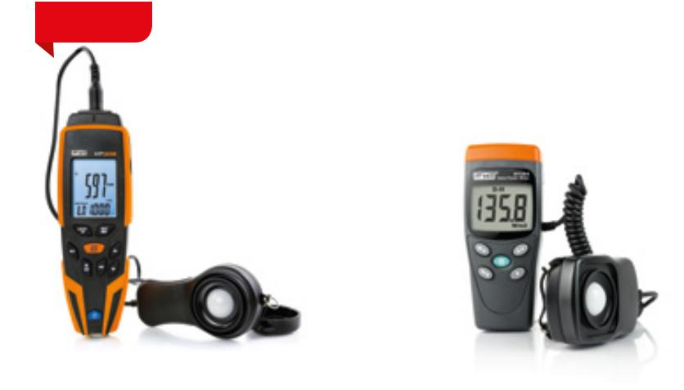

HT309 |  | HT204
LIGHT METERS |  | SOLAR METERS
0.01÷400klux |  | 1÷1999W/m²
0.01÷40kFc |  | 1÷634 BTU/(ft2*h)
• |  | -
• |  | -
• |  | -
- |  | •
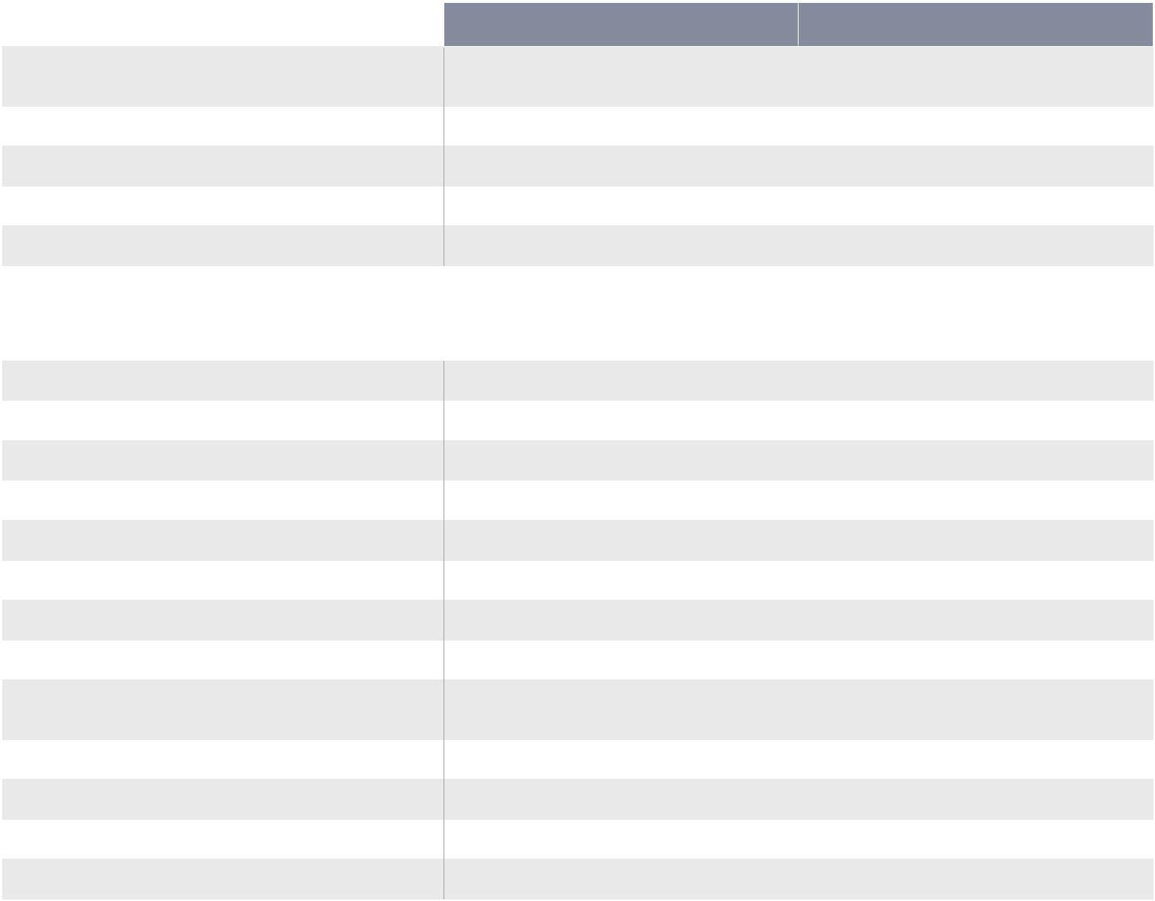

• (Max 99 locations) | -
• | •
- | •
• | -
• | •
• | • No AVG
• | W/m² - BTU/(ft2*h)
• | -
Class A JIS C | -
1609:1993, CNS 5519
1x 9V | 1x 9V
185 x 60 x 40 | 130x55x38
180g | 150g
HA003090 | HA000157

NEW
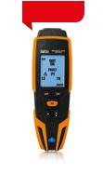
DEVICES FOR
LAN NETWORK
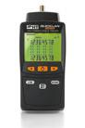
VERIFICATION

Scan the QR code
to discover our whole
line of accessories.
 |  |  |  |  |  |  |  |  |  |  |  |  |  |  |  |  |  | QUICKLAN6050 |  | QUICKLAN6055
MAIN MEASUREMENTS
Wire mapping of LAN cables |  |  |  |  |  |  |  |  |  |  |  |  |  |  |  |  |  | • |  | •
Test on twisted pair cables RJ45 type UTP, STP and FTP |  |  |  |  |  |  |  |  |  |  |  |  |  |  |  |  |  | • |  | •
Test on telephone cables with RJ11 connector |  |  |  |  |  |  |  |  |  |  |  |  |  |  |  |  |  | • |  | -
Verification on COAX cables |  |  |  |  |  |  |  |  |  |  |  |  |  |  |  |  |  | • |  | -
Errors of open pairs |  |  |  |  |  |  |  |  |  |  |  |  |  |  |  |  |  | • |  | •
Errors of shorted pairs |  |  |  |  |  |  |  |  |  |  |  |  |  |  |  |  |  | • |  | •
Errors of reversed pairs |  |  |  |  |  |  |  |  |  |  |  |  |  |  |  |  |  | • |  | •
Errors of crossed pairs |  |  |  |  |  |  |  |  |  |  |  |  |  |  |  |  |  | • |  | •
Errors of split pairs |  |  |  |  |  |  |  |  |  |  |  |  |  |  |  |  |  | • |  | •
Generic errors (MISWIRE) |  |  |  |  |  |  |  |  |  |  |  |  |  |  |  |  |  | • |  | •
Measurement of cable length |  |  |  |  |  |  |  |  |  |  |  |  |  |  |  |  |  | • |  | -
Cable length measuring range |  |  |  |  |  |  |  |  |  |  |  |  |  |  |  |  |  | 1÷255m |  | -
ADDITIONAL CHARACTERISTICS
Display indication of error type |  |  |  |  |  |  |  |  |  |  |  |  |  |  |  |  |  | • |  | •
Test indication OK - NOT OK |  |  |  |  |  |  |  |  |  |  |  |  |  |  |  |  |  | • |  | •
Remote unit recognition |  |  |  |  |  |  |  |  |  |  |  |  |  |  |  |  |  | • |  | •
AutoPowerOFF |  |  |  |  |  |  |  |  |  |  |  |  |  |  |  |  |  | • |  | •
Backlight |  |  |  |  |  |  |  |  |  |  |  |  |  |  |  |  |  | • |  | •
Low battery indication |  |  |  |  |  |  |  |  |  |  |  |  |  |  |  |  |  | • |  | •
Power supply |  |  |  |  |  |  |  |  |  |  |  |  |  |  |  |  |  | 6x 1.5V AAA |  | 1x 9V
Size (LxWxH) (mm) |  |  |  |  |  |  |  |  |  |  |  |  |  |  |  |  |  | 156 x 73 x 35 |  | 128 x 67 x 39
Weight in grams (batteries included) |  |  |  |  |  |  |  |  |  |  |  |  |  |  |  |  |  | 170 |  | 165
Order code |  |  |  |  |  |  |  |  |  |  |  |  |  |  |  |  |  | HV006050 |  | HV006055

30 31

PHASE DETECTORS, SWITCH DETECTORS AND PHASE SEQUENCE INDICATORS

Scan the QR code
to discover our whole
line of accessories.

MAIN MEASUREMENTS

Measuring range

Localization of protection devices

Detection of AC voltage without contact also on insulating sheaths

Indications “R” and “L” on the display to measure phase sequence

Phase sequence and phase concordance without contact also on insulating sheaths

LED and sound indications Network voltage (L-N, L-PE, N-PE) Absorbed phase current

LINESPLITTER | HT82 | HT70 | HT20S | HT38 | HT5
0÷240VAC | 40÷600VAC | 100÷1000VAC | 100÷1000VAC | 200÷250VAC | 60÷250VAC
0÷16A
 | 15÷400Hz | 50÷60Hz | 50÷60Hz | 50Hz | 50÷60Hz
50÷60Hz
- | - | - | - | • | -
- | - | • | • | - | -
- | • | - | - | - | -
- | - | • | - | - | -
- | - | • | • | • | •
• | - | - | - | - | -
• | - | - | - | - | -

LASER METERS

Scan the QR code
to discover our whole
line of accessories.

MAIN MEASUREMENTS

Distance measuring range

Measurement of area and volume

Measurement of heights by indirect method of the Pythagorean theorem

Measurement of tilt and distance

Continuous (dynamic) 2-spot and 3-spot measurements Partial operations (additions/subtractions) with internal memory

ADDITIONAL CHARACTERISTICS

iDM70 |  | DM40
0,05 ÷70m |  | 0,05 ÷40m
• |  | •
• |  | •
• |  | -
• |  | •
• |  | •
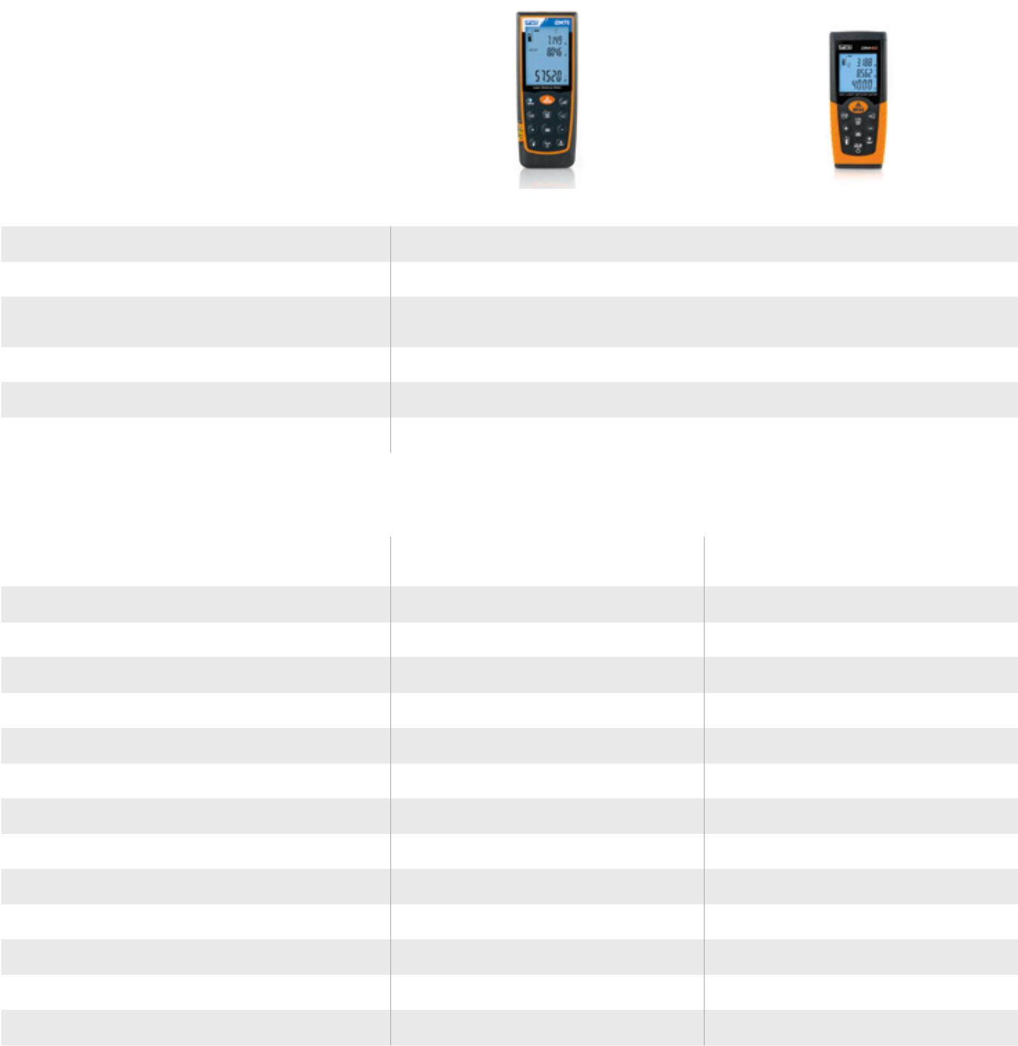

Absorbed phase current multiplied by 10 (for low-power users)

Leakage current on protection conductor

Leakage current measured
in differential mode (L-N)

• | - | - | - | - | -
• | - | - | - | - | -
• | - | - | - | - | -

Connection to iOS/Android devices | • | -
through HTLaserMeter App
Activation of the laser pointer for measurement | • | •
Setting of measuring reference | • | •

ADDITIONAL MEASUREMENTS

Test of neon-filled lamps | - | - | - | - | - | •
Test of internal gas of compact fluorescent lamps | - | - | - | - | - | •
Test of internal gas of energy-saving lamps | - | - | - | - | - | •
Test of internal gas of high and | - | - | - | - | - | •
low-pressure sodium-vapor lamps
Test of internal gas of halogen lamps | - | - | - | - | - | •
Test of internal gas of mercury-vapor lamps | - | - | - | - | - | •
Phase detection function with contact | - | - | - | - | - | •
for AC voltage 60-250V 50/60Hz
Continuity test on non-electronic starters/reactors | - | - | - | - | - | •
Diode test | - | - | - | - | - | •

ADDITIONAL CHARACTERISTICS

Setting of timer for measurements | • | -
Selection of measuring unit | m - ft | m - ft
Backlight | • | •
Air bubble level | • | -
Hole for tripod insertion | • | -
Activation of buzzer upon key pressing | • | -
Auto Power OFF | • | •
Power supply | 2x 1.5V AA | 2x 1.5V AAA
Size (LxWxH) (mm) | 135x53x30 | 110x48x28
Weight (batteries included) | 160g | 135g
Order code | HA000700 | HA004000

LCD display

Sound indications with buzzer

Practical breast pocket holder

Anti-shock protection sheath

Integrated torch

Schuko plug

Measurement category

Reference standard for safety

Power supply

Size (LxWxH) (mm)

Weight in grams

Order code

- | • | - | - | - | -
- | - | • | • | • | •
- | - | • | • | - | -
- | • | - | - | - | -
- | - | - | • | - | •
• | - | - | - | • | -
CAT II 240V | CAT III 600V | CAT IV 1000V | CAT IV 1000V | CAT III 250V | CAT II 300V
IEC/EN61010-1, | IEC/EN61010-1 | IEC/EN61010-1 | IEC/EN61010-1 | IEC/EN61010-1 | IEC/EN61010-1
IEC/EN61010-02-030
240VAC (±10%) | From mains | 2x 1,5V AAA | 2x 1,5V AAA | From mains (HT38T) | 1X 9V
50/60Hz |  |  |  | 1X 9V (HT38R)
210x60x35mm | 130x69x22 | 160x26x20 | 160x26x20 | 95x60x30 | 255x60x40
385g | 130 | 48 | 48 | 140 | 170
HA000951 | HA000156 | HR000070 | HR000296 | HR000038 | HA000138

32 33

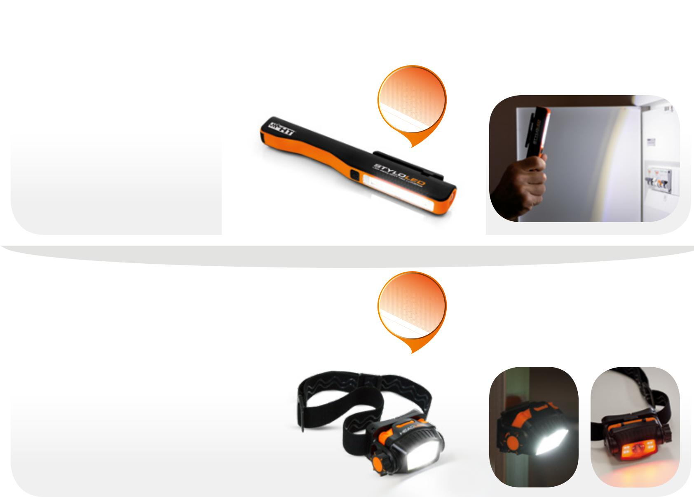
LAMPS

ORDER CODE HA000764
STYLOLED

- Worklight - 150 Lumen

- Flashlight - 60 Lumen

- Rubberized ABS body

- Adjustable strong magnetic clip

ORDER CODE HA000766
HEADLED

NEW

NEW
SCISSORS

COD. METEL HU000743
F30P

- New design, even more ergonomic

- Non-slip grip

- Blade in reinforced steel

- Universal crimper for crimp terminals between 1 and 6 mm2

- Holster with security lock
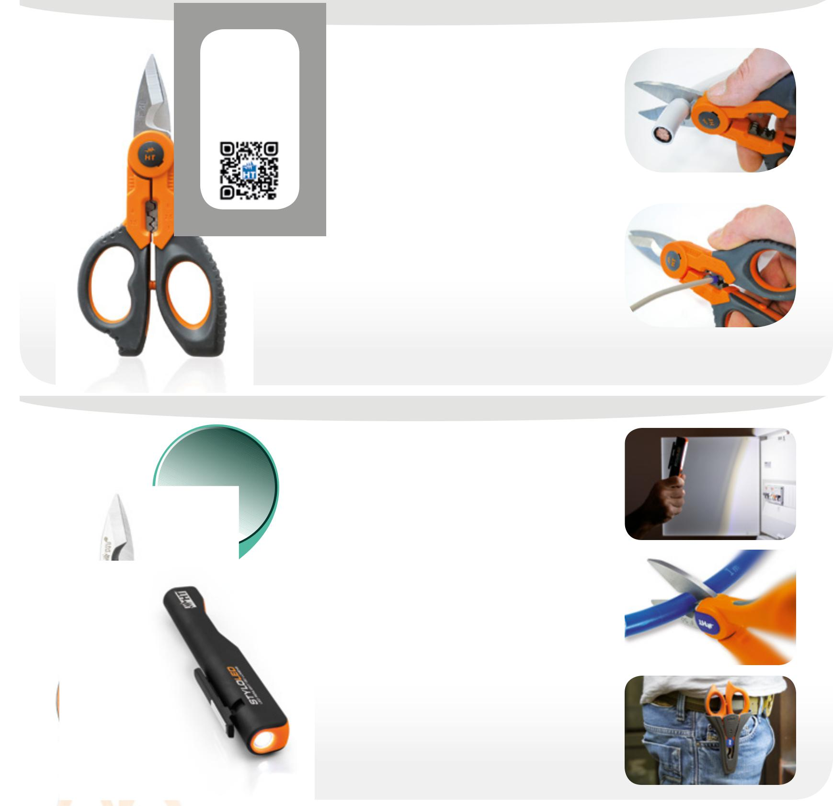

- Lighting (1m): 2000Lux (3W LED), 50Lux (COB LED)

- Easy to use

- Helmet anti-slip belt

- Strong magnetic support

- Special-shaped selector for simple operations even with gloves

Rotary selector: OFF, strong light 3W LED, soft light 3W LED, strong white light COB LED,
soft white light COB LED, red strobe light COB LED
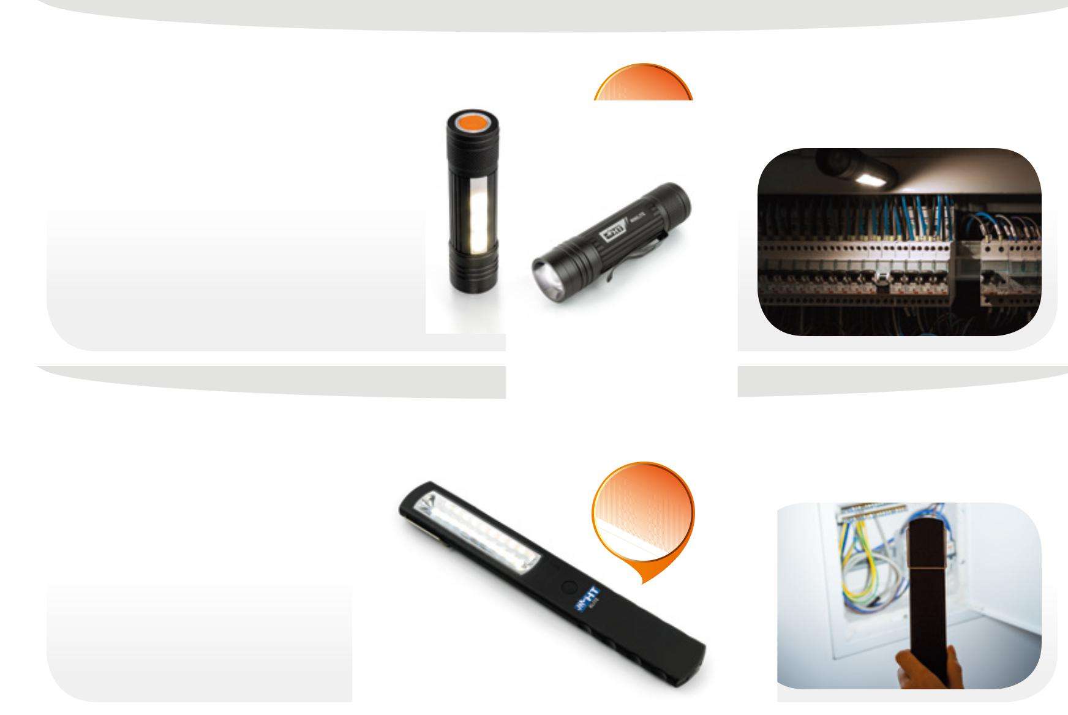

ORDER CODEL HA000759
MINILITE

NEW

Scan
the QR code
to watch
the video
of F40
at work!

COD. METEL HU000697
F40

PROFESSIONAL SCISSORS WITH INTEGRATED CRIMPER FUNCTION
CABLE CUTTER 70mm2 + CRIMPER

- High-quality scissors with rigid case

- Blade in reinforced stainless steel

- Blade width 19mm (0.7”)

- Blade thickness 3.5mm (0.1”)

- Blade for cutting cables up to 70 mm2

- Crimper function for crimp terminals between 1 and 6 mm2, sleeve type

- Long grip for easy cutting

Blade for cutting cables up to 70 mm2

Crimper function for crimp terminals between 1 and 6 mm2, sleeve type

- Low consumption LED light with adjustable beam

- Diffused side light

- Flashing emergency light

- Strong magnet

- Comfortable pocket hook

ORDER CODE HA000760
XLITE

- Ultrathin

- Magnetic support

- Indestructible

- Rechargeable battery

- Battery charger provided

- Ring for easy hanging

- Low consumption LED light

NEW

COD. METEL HU000746
F50 F50LED
+
STYLOLED PROFESSIONAL SCISSOR

WITH CABLE CUTTER UP TO 50mm2 + STYLOLED TORCH

F50

- Non-slip grip

- Reinforced steel blade

- Universal crimping tool for lug, 1 to 6 mm2

- Holster with security lock

- Practical docking system
STYLOLED

- Work light - 150 Lumens

- Upper flashlight - 60 Lumen

- Rubberized ABS body

- Adjustable magnetic clip

34 35

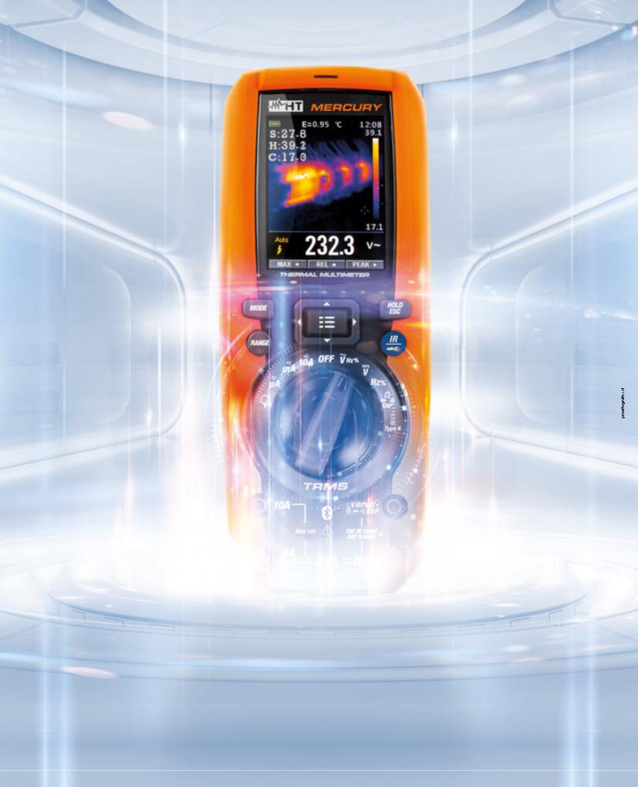

shg_ShortGuide2018_En1-00

MERCURY
TRMS THERMAL MULTIMETER

EXTRA TERRESTRIAL SIGHT
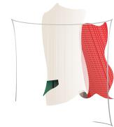

HT ITALIA S.R.L.

Via della Boaria, 40 - 48018 Faenza (RA) Italia

T +39 0546 621002 F +39 0546 621144

E-mail: export@htitalia.it

ht-instruments.com

M A D E
^{I} ^{N}
I T A L Y

